Skills in Practice: Modern Management of venous leg ulceration.
Leanne Atkin, Lecturer practitioner/Vascular Nurse Specialist, School of Human and Health Sciences, University of Huddersfield and Mid Yorkshire NHS Trust, E mail: l.atkin@hud.ac.uk

Patients with lower limb ulceration are common in clinical practice; between 0.6% and 3.6% of adults will develop a leg ulcer in their lifetime, (Graham et al., 2003, Posnett and Franks, 2007). This equates to between 70,000 and 190,000 people in the United Kingdom will have an active leg ulcer in any one day, (Posnett and Franks, 2007). The most common cause of lower limb ulceration is attributed to venous hypertension, venous ulceration is reported to affect up to 1% of all adults, (Christian, 2013). The management of venous ulceration is costly in terms of treatment costs, nursing time and patient suffering, (Atkin, 2015). The National Health Service (NHS) spends a substantial amount of money in the treatment of venous ulceration, mostly through community services, the spend on leg ulceration was estimated to be at least £168-£198 million per year, (Posnett and Franks, 2008). Furthermore, Vowden and Vowden (2009), reported that between 1.22% and 3% of the overall NHS budget was spent on the management of wounds, with wound management taking up between 33% and 41% of community nurses time.

Compression therapy is considered the most important element in the treatment of venous leg ulceration, (Anderson, 2011), and has been confirmed to increase healing rates of venous ulceration, (O'Meara et al., 2012). Compression therapy can be delivered in a number of ways; these include multi-layer bandaging or compression hosiery kits. Recently, compression hosiery kits have been proven to be as equally effective at healing venous leg ulcers compared to multi-layer bandages, (Ashby et al., 2014). Furthermore, hosiery kits have additional advantages over multi-layer bandages: they are less expensive; are less bulky therefore does not restrict patients choice of footwear or clothing; offer guaranteed levels of compression, which is not practitioner dependent; allows patients to self-care; and reduces nursing time as are quicker to apply. Compression hosiery kits consist of two layers of stocking which are designed to provide 40mmHg at the ankle (identical to compression bandaging), the kits consist of an understocking and an over stocking, both layers need to be worn to provide appropriate levels of compression. (Picture of hosiery kit)
Compression hosiery was traditionally used once healing had occurred, patients often were placed in multi-layer bandages in the active ulcer phase and once healed were ‘stepped down’ to compression hosiery. However, due to the published evidence in combination with variety of stockings available this is no longer the case and compression hosiery kits are now a reliable first line option.
Effective management of patients suffering from lower limb ulceration relies on accurate diagnosis. Therefore holistic assessment of the patient is vital, this should include assessment of patient’s arterial supply with the measurement of the Ankle Brachial Pressure Index (ABPI). Normal ABPI measurement is between 0.8 – 1.3, patients who fall outside of these measurements require further assessment by specialists teams. To assess suitability of compression therapy and exclude evidence of significant peripheral arterial disease which may make compression therapy unsuitable or potentially dangerous.
If the patient is considered suitable for compression there needs to be further assessment of the limb and exudate levels to determine which compression system is the most appropriate. Compression hosiery kits are suitable for patients with low to moderate wound exudate levels, where the exudate is maintained within the primary dressing. It is only when exudate levels are high that compression bandages are advantageous by helping to manage the exudate within the padding/absorbent layers.
Patients limb size and shape is also an important consideration, where there is no evidence of oedema Activa leg ulcer kits should be chosen. However, if there is evidence of oedema an Actilymph hosiery kit would be more suitable as the stiffer fabric index will aid oedema reduction and control. In patients where there is substantial limb distortion or significant evidence of oedema a period of compression bandaging may be required to reduce limb volume.
If a period of compression bandaging is required to reduce oedema or control exudate this should be viewed as an ‘intensive treatment phase’, (Tickle, 2015). As soon as limb volume reduction is achieved or when exudate levels have reduced, practitioners should consider ‘stepping down’ the patient onto appropriate compression hosiery kits, (Tickle, 2014).
Once healed patients need to be maintained in compression hosiery to reduce chance of recurrence of ulceration. Patients need to be supplied with the highest level of compression that can be tolerated, evidence supports the use of Class 3 stockings, (Nelson et al., 2006), (Nelson and Bell-Syer, 2014) but many patient’s find this difficult to apply therefore Class 2 stockings are commonly used. Consideration needs to be made with regards patients’ history of oedema, where there is no evidence of oedema patients should be maintained in class 2/3 Activa hosiery, if there is any oedema or patients have history of oedema Actilymph stockings Class 2/3 should be prescribed.
Providing effective leg ulcer care is increasingly challenging due to ever growing caseloads, nursing time demands, and high staff turnover, (Tickle, 2015). Increasing the use of compression hosiery kits will reduce spend, release nursing time and have the potential to increase healing rates due to ensuring appropriate and sustained levels of compression are provided, ultimately this will reduce patient’s suffering and improve quality of care.
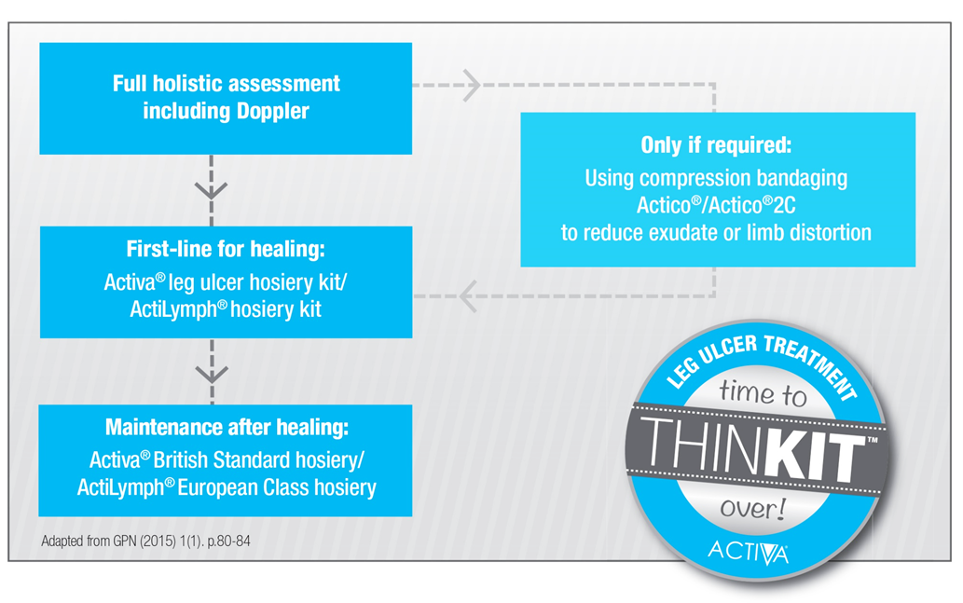

References

ANDERSON, I. 2011. Developments in venous leg ulcer management. Nursing Times, 107, 14- 18.
ASHBY, R. L., GABE, R., ALI, S. & ADDERLEY, U. 2014. Clinical and cost-effectiveness of compression hosiery versus compression bandages in treatment of venous leg ulcers (Venous leg Ulcer Study IV, VenUS IV): A randomised controlled trial. The Lancet (British edition), 383, 871-879.
ATKIN, L. 2015. Ask the expert: How to prevent leg ulcer recurrence when moving into compression hosiery. Journal of Community Nursing, 29.
CHRISTIAN, R. 2013. Compression for preventing recurrence of venous ulcers. International Journal of Older People Nursing, 8, 319-320.
GRAHAM, I., HARRISON, M. B., NELSON, E. A., LORIMER, K. & FISHER, A. 2003. Prevalence of lower-limb ulceration: a systematic review of prevalence studies. Adv. Skin Wound Care, 16 303-316.
NELSON, A. E. & BELL-SYER, S. E. M. 2014. Compression for preventing recurrence of venous ulcers. Cochrane Database of Systematic Reviews, Art. No.: CD002303. DOI: 10.1002/14651858.C D002303.pub3.
NELSON, E. A., HARPER, D. R., PRESCOTT, R. J., GIBSON, B., BROWN, D. & RUCKLEY, C. V. 2006. Prevention of recurrence of venous ulceration: randomized controlled trial of class 2 and class 3 elastic compression. J Vasc Surg, 44, 803-8.
O'MEARA, S. O., CULLUM, N., NELSON, A. E. & DUMVILLE, J. C. 2012. Compression for venous leg ulcers. Cochrane Database of Systematic Reviews, Issue 11. Art. No.: CD000265. DOI: 10.1002/14651858.CD000265.pub3.
POSNETT, J. & FRANKS, P. J. 2007. Skin Breakdown: The Silent Epidemic – The Costs of Skin Breakdown and Ulceration in the UK. The Smith and Nephew Foundation
POSNETT, J. & FRANKS, P. J. 2008. The burden of chronic wound care in the UK. Nursing Times, 104, 44-45.
TICKLE, J. 2014. Unravelling practice: compression therapy for venous leg ulcers. Challenge your Practice Supplement. . Journal of Community Nursing, 28, S9-S13.
TICKLE, J. 2015. Ask the expert: How can I improve leg ulcer care when faced with increasing service demands? Journal of Community Nursing, 29, 20-21.
VOWDEN, K. R. & VOWDEN, P. 2009. The prevalence, management and outcome for patients with lower limb ulceration identified in a wound care survey within one English health care district. Journal of Tissue Viability, 18, 13-19.

