SUFFERING IN FASHION: THE LINKS THAT EXPOSE ISSUES FOR THE FUTURE PRODUCTION OF GARMENTS AND THEIR APPROPRIATION AS FASHIONABLE ITEMS

THE INTERNATIONAL JOURNAL OF FASHION DESIGN, TECHNOLOGY AND EDUCATION - SPECIAL EDITION – ‘THE FUTURE OF FASHION’, VOLUME, SERIES, PAGES 1 -18, MARCH 2010, ISSN: 1754-3266

KEY WORDS: Suffering, Change, Fashion, Body, Garments

ABSTRACT
The paper highlights how distress, pain, misery and ultimately suffering in the wearing and production of fashionable clothes are essential components for initiating change. Suffering in fashion could compare with the religious analogies of suffering, redemption and spiritual enrichment, suffering being a motivating factor for change so the fashion production cycle can seasonally re-invigorate. Suffering in the ways clothes are worn is examined by investigating the design and manufacture of undergraduate fashion student’s collections. This provides a visual analysis of fashion designer’s responses to suffering and the changes it initiates in the skills of production and ultimately the wearing of fashion.

Suffering through pain, anguish or distress is an extreme affliction. Pushing something to its limits of endurance, making it suffer, can undermine order and to survive, it is often reassembled in a new and challenging way. This concept is somewhat akin to Darwin’s ideas about the evolution of the species through a process of random mutation and selective retention known as natural selection (Darwin 1859). His work coined the phrase ‘survival of the fittest’ (Peel, 1992, p.143), which introduced the idea that survival of a species is a struggle against climate and environmental change in nature. In fashion suffering can be instrumental in enforcing the re-invigoration of the product when clothing styles are pushed to the limits of consumer endurance. The ‘fittest’ styles survive through their re-assemblance each season, sustaining the commercial cycle. In the struggle of clothes against clothes, some styles remain, due to their response to change, others are discarded.

Suffering is evident in fashion production. For instance Skillset (formally Skillfast), the UK Government sponsored initiative to develop skills in trade, industry and education have recently met with educationalists on fashion courses (www.skillset-uk.org, 2011). Concerned with preserving skills in industry, (as described in Brown’s (2011) comments: ‘’A lack of skilled workers is strangling growth opportunities’’, p.1), their intention was to investigate ways of working together in order to develop fashion curricula that incorporate more traditional technical skills. The idea evolved through the loss of UK manufacture to overseas production. The increased use of computerized technology has enhanced communication in global manufacturing, yet has distanced the physical connection with the product. This has led to problems in manufacturing as UK retailers and overseas manufacturers suffer through miscommunication. It also exposes the redundancy of skills the UK manufacturing industry has suffered, through which the positive Government sponsored survival strategy of Skillset has evolved. As their website explains; “Skillset manages a range of training funds contributed to by industry and public sources. The aim of these funds is to help ensure that UK creative industries (including fashion) have a workforce with the right level of skills. The funds broaden access to training opportunities, career development and support” (www.skillset-uk.org,2011).

Word Count (including title page and references); 6094

SUFFERING IN FASHION: THE LINKS THAT EXPOSE ISSUES FOR THE FUTURE PRODUCTION OF GARMENTS AND THEIR APPROPRIATION AS FASHIONABLE ITEMS

KEY WORDS: Suffering, Change, Fashion, Body, Garments

METHODOLOGY
Aims/Objectives
The research investigates links related to suffering both in the production of garments and their appropriation as fashionable items. In-depth consideration of how suffering relates to the way clothes are made and worn inspired an investigation into the wider meaning of suffering beyond fashion, identifying four concepts around which the paper is structured. These are: (i) Suffering as a part of life
(ii) Suffering as a pre-requisite for hope
(iii) Suffering as a force for change
(iv) Suffering as a source of creativity.
Each concept is then related to issues of suffering within fashion and connects them to the design and manufacture of garments produced in fashion student’s collections. This substantiates the impact suffering eventually imposes on the production and wearing of fashionable clothes. The issues are;
(i) Fashion Victims
(ii) Fashion and Morality
(iii) Slimming the Body
(iv) Masquerade and Disguise

Research Approach
The nature and tradition of fashion, is such that the research is best informed from a qualitative viewpoint, working with small groups of students. As the author is a design and pattern making tutor for final year undergraduates some of the approach was action based research; recording design activities and garment production in a pedagogic environment. This practical approach developed an in-depth wealth of knowledge related to the skills in garment making and how students use their design skills to ensure they produce fashionable clothes.

The practical approach is combined with object based research and the theoretical. This included examination of historical garments and how they have been worn and appropriated by fashion. Theoretical research considered a dual approach concerning the wider context of what people have termed human suffering and the lived condition, with the perceptions about what constitutes a ‘fashioned body’ (Entwistle 2000) or how a body is decorated to conform to the demands of fashion and the suffering this entails. As the research began a cyclical pattern developed beginning with the research question; establishing issues; collecting data; analyzing data; taking action; evaluating the results and formulating new questions in order to place a future focus on how suffering will impact on fashion and clothing production.

The literature review is embedded within the relevant discussions in the text.

  - SUFFERING
The impact and significance of suffering
To suffer means to experience or endure something unpleasant (Allen 2001). People can view its effect in a positive way. It can build strength of character with which to grow and change, both personally and professionally. When channeled into compassion for the gravity of worldwide suffering, its disillusion and bitterness can motivate people to initiate positive change. For example the film star, Audrey Hepburn was a world renowned fashion icon who suffered for her fashion iconicity by purportedly eating very little to maintain an elfin frame. In her later life she used her status to publicize the suffering of children in her role as UNICEF ambassador and ultimately bring about change and improvement to children’s lives (Spoto 2007). Over the ages, art, literature and religious philosophies have regarded suffering in relation to the four concepts, explained and explored below.

(i) Suffering as part of life.
Suffering is evident in many aspects of everyday life. It plays an important part in religions, particularly in relation to showing compassion and in the Christian example of Heaven or Hell (The Holy Bible 2004). Buddhism considers the ‘Four Noble Truths’ that are the key to its philosophy; the first of which is: “The noble truth that is suffering” (MacMillan, 2004 p.296). The belief is that a person cannot go through life without experiencing some sort of distress to the body and therefore to live is, partly to suffer. The third noble truth describes the path to an enlightened state of living once suffering has been endured: “The noble truth that is the end of suffering” (p.296). The fourth noble truth is the attainment of the ultimate state of nirvana.

In fashion its most dedicated followers are sometimes called: “Fashion Victims” or “junkies of the art of self adornment” (Wilson, 1985, p.228). They make the wearing of fashionable clothing an integral part of their lives and dress in fashionable items regardless of whether or not they are flattering. This state of being is their nirvana, which disregards the ridicule their sometimes un-flattering appearance provokes.

(ii) Suffering as a pre-requisite for hope.
Extreme suffering has the power to instigate a hope for something better. Catholic teaching maintains that suffering strengthens faith: “....we also boast in our sufferings, knowing that suffering produces endurance, and endurance produces character and character produces hope and hope does not disappoint us” (Rom 5:1, The Holy Bible, 2004). Similarly Hinduism decrees that suffering is an opportunity for spiritual progress. Beyond religion, disasters such as war or famine are endured with the hope for a better life. Alternatively Mayerfield (2005) considered that we can be happy and suffer at the same time and that being alive is “a single dimension of happiness and suffering” (p.30).

A body controlled through diet or restricted through empowering fashion items like corsetry and shoulder padding, suggests a disciplined approach. The fashionable consumer is often prepared to endure pain and discomfort in order to project their desired image. This also reflects the evolution of the gendered body in fashionable male and female dress. People often suffer abuse when stepping outside sartorial gender boundaries yet when genders are merged in unisex styles it can impact on fashion (Sims, 1999). An example was the gender blurred look of the early 1980’s when singers such as Annie Lennox and Boy George played with gender disguise and masquerade in their visual images. These looks rapidly impacted on global fashion production and consumption as a major trend through sensationalist reports in the fashion media. This influenced designer collections and the saturated reproduction of gender blurred looks in high street versions of designer collections.

(iii) Suffering as a force for change
When suffering becomes unendurable it either ends in extinction or it enforces change. Amato regarded the two concepts of pain and suffering as interrelated yet separate concepts, emphasizing that humanity must give meaning to its pains and sufferings (Amato, 1990). He particularly considered sacrifice and victims in Christian cultures, where redemption and penance, led to a rebirth or a rethink. Mayerfield considered that physical or mental suffering was something from which people sought relief, arguing that it should be a moral duty in others to alleviate pain and anguish by initiating change (Mayerfield, 2005). In Darwin’s (1859) theory about natural selection a species that cannot adapt to climate and environmental change suffers extinction. The species that changes and adapts to its environment, survives.

In fashion, suffering often enforces changes in attitude to the way people decorate their bodies. Fashion encourages mavericks who push boundaries, for instance Vivienne Westwood (Wilcox, 2004) suffered a moral outrage with her punk clothing in the late 1970’s. She wanted to violate the conformity of the British establishment and appropriated fetish wear and torn clothing in order to shock. This ultimately changed perceptions about what was considered acceptable in fashionable dress.

(iv) Suffering as a source of creativity
Throughout literature and art suffering has been a measure of cultural identity and historical continuity. It has been engaged in by many artists, writers and fashion designers as a means of fuelling creative powers, an example being the romanticized notion of starving artists who sacrifice material well being, to devote themselves to their work. Literature is often linked to suffering and tragedy. Bushnell (2005) identified tragedy as an ancient Greek concept within theatre, in which human suffering offered its audience gratification and was a means of fuelling creative powers. The fashion designer Alexander McQueen explored suffering in his “aggressive aesthetic plunge into the darkest recesses of the soul” (Knox, 2010, p.7), through which themes such as rape, capital punishment and witchcraft were transformed into chic visions. His design aesthetic was also attributed to the depression he suffered which eventually contributed to his suicide (Knox, 2010).

In fashion creativity is an essential component for re-invention and skills and technology need to adapt to creative demands. With the advent of youth fashion at the end of the 1950’s (Baudot 1999), clothing became far more unisex as traditional notions about the gendered body began to change. Youth groups rebelled against accepted dress codes and their suffering was reflected in their fashioned selves as a means of creative expression. Garment technologists had to creatively rethink the ways in which clothes were made in order to produce sartorial looks for these new customers. For both sexes clothes became far less structured in manufacture and fabrication, for instance women abandoned corsetry and girdles towards the end of the decade and wore looser fitting shift shapes which evolved into the easy to wear jersey, man-made fibre and paper mini dresses of the 1960’s.

1.2 THE SIGNIFICANCE OF SUFFERING FOR THE ‘FASHIONED BODY’
Dressing can be regarded as an act of bodily transformation. Sociologists such as Goffman (1963) and Lurie (1981) compared this to a language: “A costume not only appears at a specific place and time, it must be ‘spoken’ – that is worn – by a specific person” (Goffman, 1963, p.14). Entwistle (2000) reflected on dress and adornment as a means of presenting the self to the world and noted that: “Dress transforms flesh into something recognizable and meaningful to a culture” (p.324). The degrees of suffering when conversing through the language of dress can therefore be compared to the struggles we have as individuals in articulating our speech. If we are in pain we communicate through verbal language to get relief. When our ‘fashioned self’ suffers, it communicates through its visual language.

The language of fashionable dress reveals much about our suffering. Fashion can inflict pain and discomfort through the wearing of clothes that deform the body. Clothes can also be a defiant visual canvas to proclaim who we want to be. Writers such as Lurie (1981) and Davis (1992) considered fashion in relation to signs and codes and reflected on perspectives about dress being tied in with the persona. Lurie compared clothing to a visual language with its own grammar and vocabulary. Davis (1992) discredited this as being insufficiently demonstrated, arguing that clothes evoked an aura that “merely suggests” (p.3) who we are. For instance in relation to social displacement, suffering can enforce change through the fashionable appropriation of sub-cultural dress codes. Until 1967, when homosexuality in the UK was decriminalized, gay men had to conceal their sexuality because of fear of imprisonment. They resorted to subtle dress codes in order to communicate their sexuality to others, these included wearing suede shoes or red ties (Cole, 2000). By the year 2000 commentators noted: “Gay style actually sets trends. It’s what straight people take fashion from” (p.214). Dress can therefore challenge pre-conceived concepts through fashionable appropriation. This is re-enforced by Wallerstein (1998), who discusses how emaciated models in 1990’s fashion advertising suggested not a wasted, tragic life, but a disciplined body, that was defiant and proud.

  - THE SIGNIFICANCE OF SUFFERING ON FASHION PRODUCTION

In researching the relationship between garment production, bodily discomfort and suffering, the technology involved in making clothes was examined (Aldrich 2008, Fischer 2009, Jenkyn-Jones 2002, Tarrant 1984) along with social theory (Davis 1992, Goffman 1959, Entwistle 2000, Lurie 1981, Tseelon 1995, Vincent 2009), to consider how different concepts of suffering related to fashion impact upon garment design and production. The fashion industry’s tight deadlines (Jenkyn-Jones, 2002) and fast moving product cycles (Renfrew and Renfrew, 2009), invariably means creativity often needs to be forced from the designer to meet consumer demand. The combination of a highly strung designer with the ruthless needs of commerce can be a breeding ground for volatile emotions. The designer suffers as they are responsible for inventing the product on which the financial success of a company rest, this can eventually be reflected within the work force. The careers of designers such as Ossie Clarke, Alexander McQueen and Charles James are examples of fashion impresarios who traded upon instability and darkness. Their subsequent tantrums, inability to compromise, drug addictions, suicides and murders give credence to this philosophy.

In Frederick Ashton’s ballet ‘A Tragedy of Fashion’ (1926), a struggling couturier stabs himself with his dressmaking shears when one of his creations is rejected by a wealthy client. His reaction typifies: “The enduring romantic figure in literature, in art and our collective imagination of the starving artist” (Wallerstein, (1998), p.131). This cliché has been enacted by several fashion designers and is parodied by actor Richard E. Grant, with his portrayal of a neurotic designer in an episode of the television programme, ‘Absolutely Fabulous’ (1992). Rawsthorn (1997) described Yves Saint Laurent as a designer who “romanticized his depressions” (p.169) and lived in a state of intense creative euphoria comparing him to French Romantic poets such as Baudelaire and Rimbaud “….who drew on their suffering in their writing” (p.169). During the later part of his life, reports began to circulate about Saint Laurent’s emotional and physical well being; The press described him as a man burnt out through ceaseless creation, tortured by the continuous wheel of fashion and the demands of producing four collections a year.

This research argues that degrees of suffering instigate change which undermines production methods, so that clothes need to be re-assembled in new ways. One example, discussed in the following section, is in the struggles with slimming the body in order to wear a fashionably thin, elongated silhouette. This resulted in clothes being cut in vertical panels to suggest slimness. Challenging established methods in the construction of fashion garments, infusing them with a degree of torment can turn garment technology on its head. The re-shaping of the ‘fashioned body’ can be rooted in the skills of making clothes and the redistilling of traditional and new technology with which to intoxicate the fashion consumer. This also reflects the suffering identified at the wider level of the fashion industry, which organizations like Skillset (www.skillset-uk.org, 2011) and other similar worldwide initiatives serve to remedy. The redundancy of manufacturing in the UK, through which many people lost their livelihoods, enforced this positive survival strategy. Skillset, campaigned to retain skills in UK educational curriculums in order to re-educate people about the value of UK production.

SUFFERING FOR FASHION: IDENTIFYING ISSUES
This section identifies specific issues related to suffering within fashion and connects them to the design and production of garments in fashion student’s collections. It substantiates how suffering can be a motivating factor for re-inventing the fashion product. Suffering in the industry is the well from which creative ideas can spring therefore each issue is connected to one of the four concepts around which the research is structured, re-emphasising how suffering has been perceived and explored.

(i) Fashion victims - Suffering as a part of life
A victim is an injured being who has suffered a fatality, bullying or ridicule in their life. The fashion victim is a follower of fashion, whose appearance suffers through its sartorial mistakes. Their slavish devotion to fashion becomes an integral part of their life as they adorn their body through: “….the social hazards of fashion dynamics as these are perceived by the great majority in contemporary western society” (Schiemer, (2010), p.84). The phrase originated in the 1980’s (Wilson, 1985), it denotes someone who dresses in the latest trends but somehow gets it wrong. The victim wears fashionable garments because they are fashionable not because they are flattering or stylish. As Scheimer (2010) described: “A fashion victim follows fashion and in following is sometimes led astray’ (p.85). The television programme ‘Absolutely Fabulous’ (1992), celebrated the fashion victim through the character of fashion PR ‘Edina Monsoon’. Edina wore any designer label because it was a label and thought nothing about throwing together a Jean Muir jacket, over a Christian Lacroix cat suit and Vivienne Westwood platforms, regardless of whether they worked together stylistically. Her daughter’s regular observation was: “You look like you’ve just thrown up” (Absolutely Fabulous, 1992). The fashion victim suffers because other people take pleasure in their failed attempts to look stylish.

Fashion students can make huge sartorial mistakes when styling garments together; this is due to their inexperience as designers. In the images the models are intentionally overdressed as it was requirement of the brief. It capitalized on the student’s tendency to over design, before developing a real understanding of style and understatement. The project was set by The Costume Society, for their conference: ‘The Price of Fashion’ (July 10th-12th, 2010, Metropole Hotel, Leeds, UK). The students were asked to design an outfit that utilized scraps of tweed fabric. These outfits on first analysis had to look over designed however when layers were removed a simpler, more cost effective garment was to be revealed. The garments incorporate an abundance of skills in their construction, which contributes to them being extremely cumbersome to wear. They
include; corsetry, boning, embroidery, ruching, sheering, crinoline construction, tassles, bra making, canvassing, draping, tailoring, studs etc.

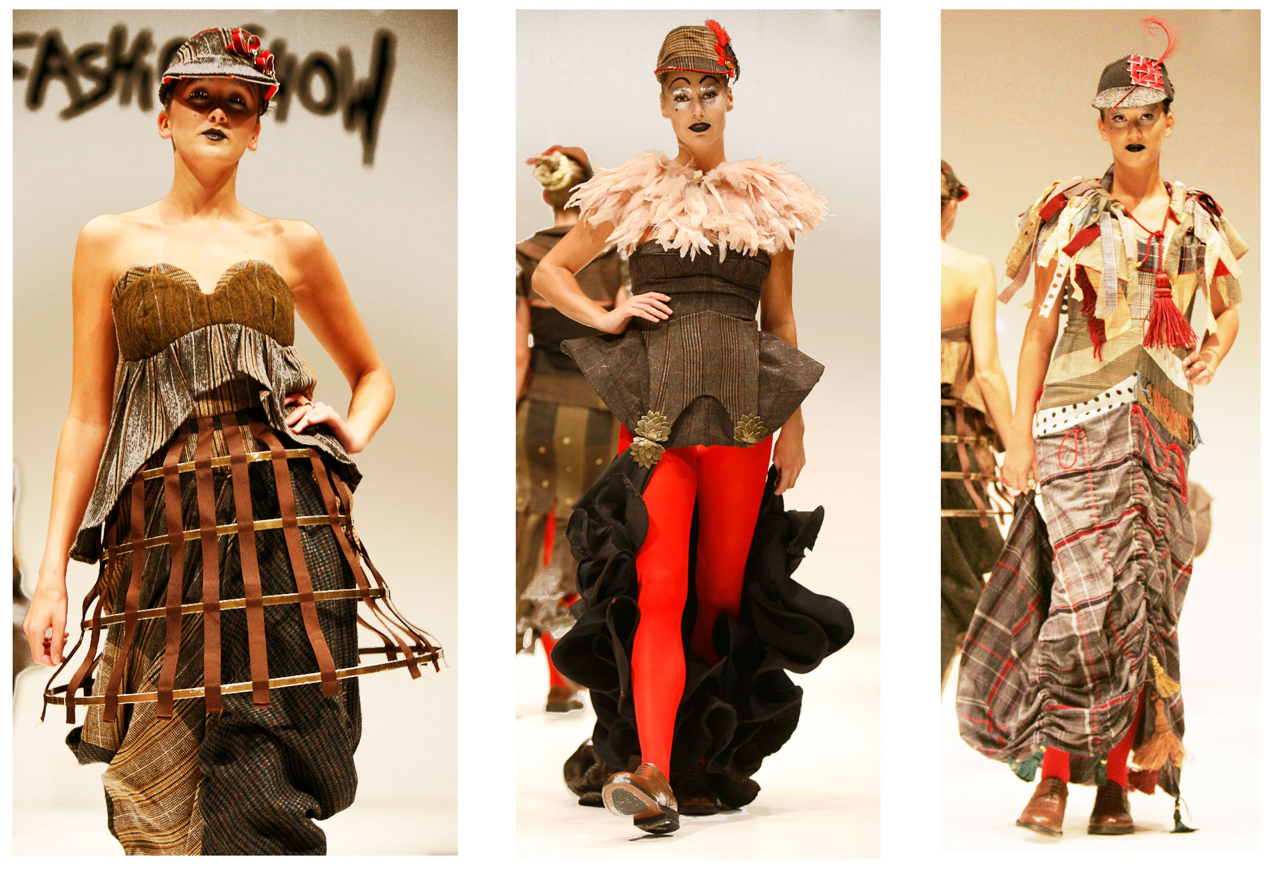

(ii) Slimming the body - Suffering as a pre-requisite for hope
The fashionable shape of the body has been altered through dieting, fattening, exercise, surgery and massage, all of which entail a degree of suffering. Much shaping in fashionable clothing has been applied to the garment through padding or restricting the body, however in order to promote the stylish silhouette, the fashion industry has also promoted the natural body shape. Vincent (2009) argues that: “Dress no longer matters to us. Collectively we are no longer upset, challenged, angered, inspired or captivated by clothes and their appearance on the body” (p.159). This implies that people could be more focused upon body shape than with attaining a fashionable shape through wearing clothes.

At the beginning of the twentieth century dress designers were criticized for dictating the fashionable shape (Stewart, Janovicek, 2001). In response to couturier’s dictates women gradually began to diet and exercise in order to lose weight however suffered prejudice as exercise was considered masculine due to its vigorous movements. It was not until the 1930’s that dieting was advocated for aesthetic reasons with a book entitled ‘Stay Slim’ (1930). In the 1920’s, as the silhouette for a straight waist-less look became fashionable, there was a belief that corsets had been abandoned and that women’s bodies were slimmer as a result. This was untrue as physicians had developed rubberized foundation garments that constricted the abdomen, hips and buttocks to simulate slimness.

Since the early 1990’s there has been controversy about the use of thin models in advertising. This led people to believe that fashion caused low self esteem and anorexia. Wallerstein (1998) argues that this ultra thin look had romantic undertones inspired by the cult of consumptive beauty in nineteenth century Romantic Art: “A disciplined body, a self-possessed body, a body in search of states of intensity, and a defiant body” (p.135). Thinness could also be perceived as a pre-requisite for hope emphasizing how positive attributes such as discipline and control can originate from suffering.

In order to remain thin the fashionable consumer will suffer the rigours of dieting and exercise. Through clever design and pattern cutting it is also possible to suggest thinness. The dresses from Sophie Hudson’s collection suggest this through their cylindrical construction. The high waisted Empire Line eliminates much bodily curvature and the vertical panels of the silk velvet accentuate the slimming column effect. An irony lies in the contrasting figures of the models who wear the dresses, neither have been modified by corsetry or underpinnings applied to the garments. One is voluptuous as her ripe breasts, suppressed by the transparent chiffon bodice demonstrates. She does not fit the garment or capture the slim essence of the vertical lines. The other model is skinny her flat breasted figure liberates the elegance of the designs.

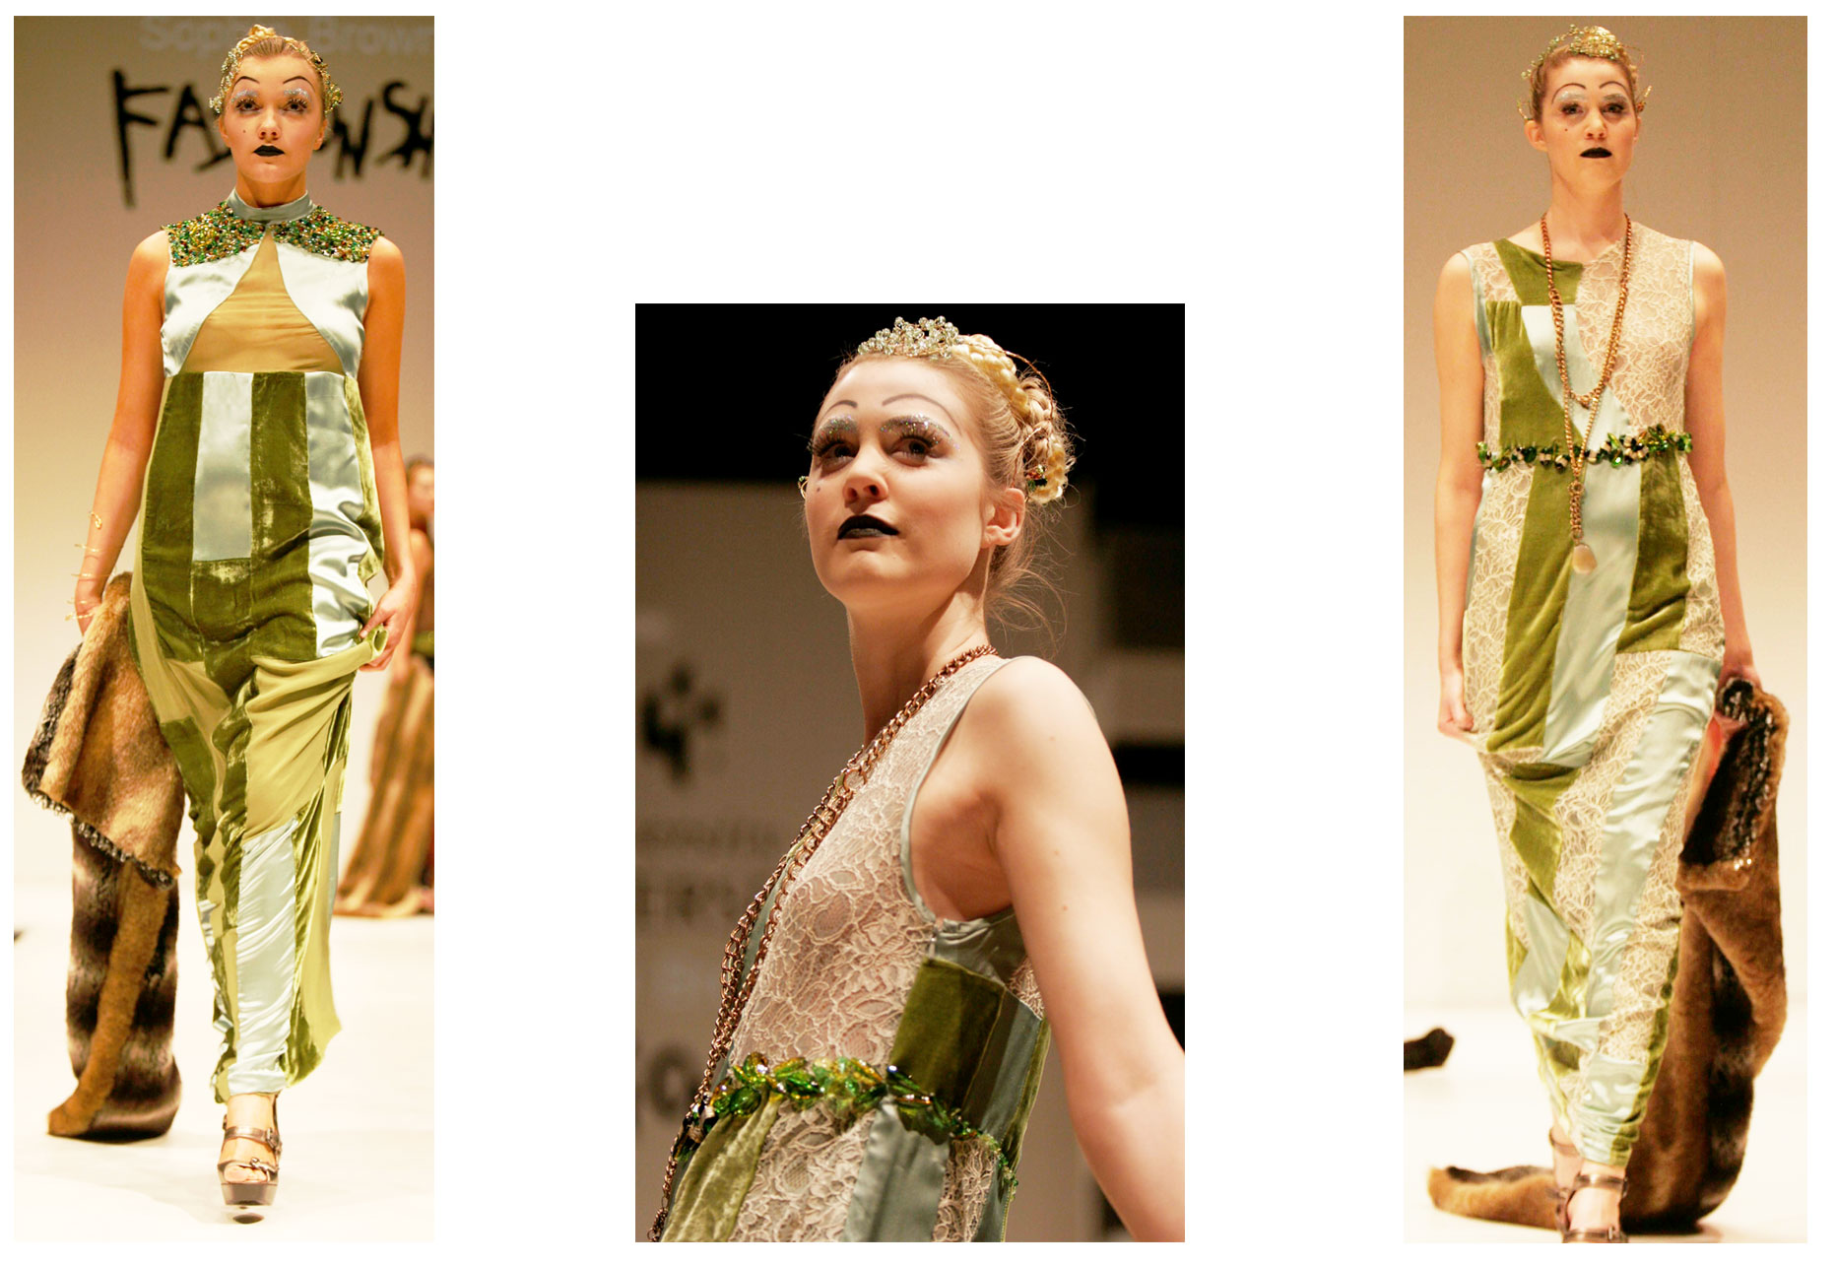

(iii) Fashion and morality - Suffering as a force for change
Morality is a system appropriated by a society to judge its conduct or behavior. It establishes a measure for the rights or wrongs of behavior and attitudes. Morality in fashion usually applies to clothing that is considered sexually disturbing (Ribeiro, 2003). This could be the actual clothing, or the way clothing is worn on the body and the attitudes displayed when worn. Throughout history opinions about morality in dress oscillate. The shock value of particular items of clothing disappears as the item becomes appropriated in the popular consciousness and accepted. For example the punk clothing introduced by Vivienne Westwood in the 1970’s was based on crude fetish wear. Today punk looks have become safe and classic and Westwood, originally labeled an ‘enfant terrible’, in relation to her challenging of moral standards, is lauded as the ‘Grand Dame’ of British fashion (Wilcox, 2004).

Of particular significance, are the ways in which people have suffered due to the immorality of their clothing. The shifting in attitudes, as to which parts of the body are considered sexually enticing, could relate to changes in fashion. It seems illogical that what is considered sexy in one era is considered tame in another yet it: “….constantly pushes at the boundaries of acceptability” (Arnold, 2001, p.x1v). In pushing boundaries, the fashion innovator can become the fashion victim, due to the ridicule and social ostracism their clothes provoke. They can also become fashion heroes, when their look is appropriated as a new idea by the mainstream ensuring fashion products keep moving, supplying consumer demand. The performance artist and fashion designer, Leigh Bowery: “….revelled in constantly recreating himself. His style was an embodiment of resistance to sanitized depictions of the body” (Arnold, (2001), p-84). He used his body to experiment with extreme ideas in presenting the self, employing make-up and clothing that deformed the body, pinning it, corseting it and stretching it as an acute example of the way fashion designers regenerate relationships between body, style and morality.

Rebecca White’s outfits play with several notions of dress and undress, sheer and opaque. In fashion terms, its nothing new or shocking however presented in the 1920’s it would have aroused indignation. Wearing underwear as outerwear was introduced by Vivienne Westwood in the early 1980’s (Wilcox, 2004) and flaunted by Madonna in her Jean Paul Gaultier costumes for the ‘Blonde Ambition’ tour in 1990 (McDowell, 2001). Wearing underwear as outerwear also demands a rethink of cut and construction in order for it to fit. To contemporary eyes there is no real breach of moral dress codes in Rebecca’s collection however as Ribeiro (2003) says: “Total nudity is rarely as sexy as the nude body with some accessories, the implication of clothing” (p.174). The combination of lingerie items, suspenders, panties and the transparency of chiffon hint at loose morals and sexual depravity. The appropriate environment for such outfits to be worn also needs consideration, for instance tight, revealing clothes that are accepted in New York would be far less acceptable in a remote Scottish hamlet (Ribeiro, 2003).

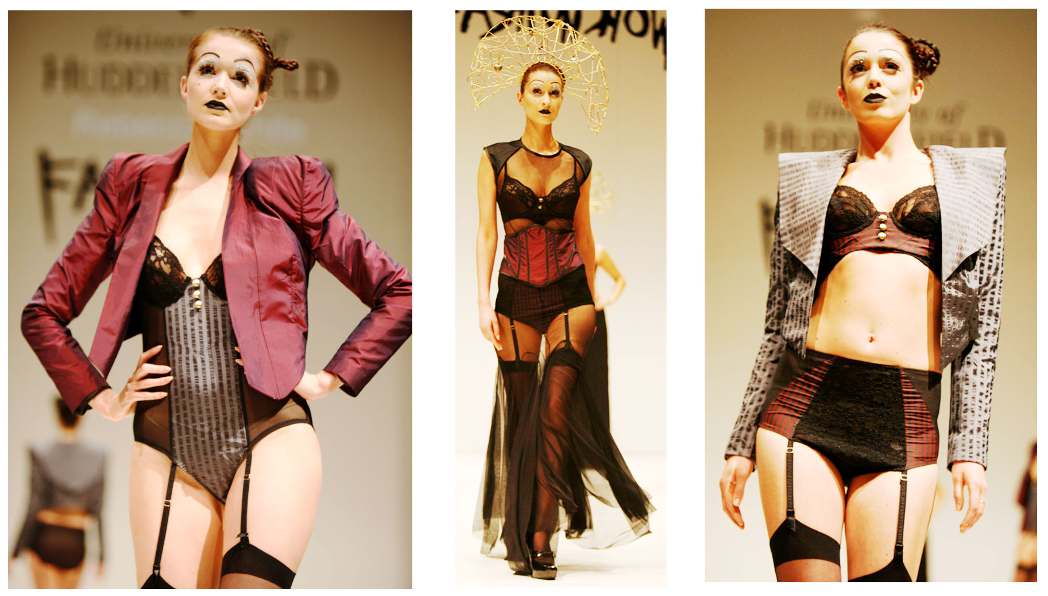

(iv) Masquerade and disguise - Suffering as a source of creativity.
The presentation of the disguised self is often within a supportive, specialist setting, such as a nightclub or sex club and is a source for much creativity. The sociologist Goffman (1963) considered the presentation of self to be a performance that demands the observer take it seriously (p.28). The concept of masquerade suggests that through levels of suffering including: stigma, bullying and social displacement an individual can create an alternative self through a disguised performance. This uses clothing as its central prop yet can also include, as Goffman suggests: “Insignia of office or rank; clothing; sex, age and racial characteristics; size and looks; posture; speech patterns; facial expressions; bodily gestures” (p.34). Fashion historian, Steele (1995) believes that fashion disguises the wearers true self and concludes that: “In the eighteenth century, both fashion and masquerade were frequently used as metaphors for deceit” (p.73)

Laura Treacy’s collection plays with masquerade through the concept of transgender clothing that deceives the eye. The collection was called ‘What’s His is Mine’. Its aim was to produce unisex clothing, cutting garments in one size for wear on both male and female bodies. The outfit’s gender was determined by the wearer. Laura’s research focused upon the ambi-sexual club culture of Berlin in the 1920’s, where both males and females considered cross gender dress codes in order to masquerade idealized self presentations. This experimentation was later labeled perverse by the Nazi regime in the 1930’s and many of its protagonists suffered persecution. Laura’s research identified that contemporary fashion has become far less gender focused; therefore the creation of a unisex collection would result in people being able to share an entire outfit, adjusting it to their personal style. She had to develop pattern blocks to fit a standard UK female size 12 and UK male size 38 and amalgamate the dual sizes into one set of unisex blocks and subsequent pattern development. The widespread adoption of this as a fashionable look could impact on global production as there would need to be a radical and creative rethink of gendered pattern blocks and sizing.

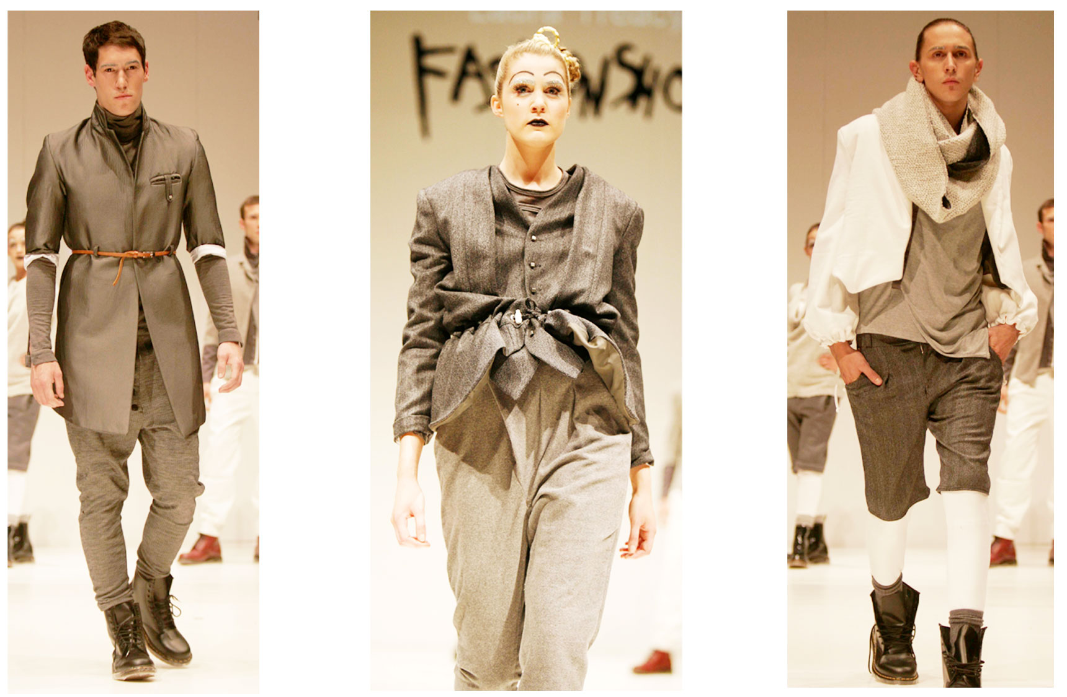

CONCLUSION
The four strands of enquiry run in parallel throughout and are linked to the search for a definition of suffering and subsequently suffering within fashion. Changes in society alter structures relating to social institutions and behaviours. These are predominantly due to the desire within people to move forward. Social revolution such as communism and women’s suffrage are driven by a need to improve social conditions. These are often dictated by economic, religious, cultural, technological and scientific forces. Although positive initiatives such as ambition, a desire to progress and evolution (as in Darwin’s theories, 1859) effect change, it is often routed in the anguish of dissatisfaction and the resultant search for something better. Suffering is also something people want to relieve as Mayerfeld (2005) discussed: “....people plunged into deep misery will always recognize the nature of their condition and struggle mightily to get out” (p.21).

It would be narrow minded to perceive that suffering alone can instigate changes in fashion and the way clothes are produced. Change also initiates from boredom with the product and a desire for something new, the natural desire to evolve. The research considers that through suffering the body can empower positive change through its adornment. Its impact can be assessed by comparing, for example the suffering of the fashion victim with the ravages of dieting or anorexia. This also varies in a social and cultural sense as ridicule is a form of prejudice, and starvation is a result of famine or a slimming regime. The overriding concern is the impact suffering eventually imposes on the production of fashionable clothes. It is therefore emphasized that pushing the ‘fashioned body’ to limits of endurance, through suffering, undermines order so it needs to be re-assembled in a new way for it to survive. In this context suffering in fashion enforces changes in production and the revitalization of the product around the seasonal basis in which the fashion industry operates.

By identifying specific fashion issues related to suffering, the research confirms ideas and new concepts, highlighting the subject as ripe for further investigation. The following can be surmised;
- Suffering as a part of life – a slavish devotion to fashion can be a life long quest yet the consumer runs the risk of being labelled a fashion victim who suffers through sartorial blind vision. They often appropriate garments that are over designed and manufactured.
- Suffering as a pre-requisite for hope - positive attributes such as discipline and control can originate from suffering. This is emphasised with the example of dieting and thinness suggesting a disciplined, defiant body. Fashionable clothing can also be purposely constructed to accentuate slimness.
- Suffering as a force for change – the suffering endured due to immorality in fashionable dress can inspire changes in perceptions about particular types of clothing and the way they are worn and made. For instance wearing underwear as outerwear demands a major rethink of its cut and construction in order to fit.
- Suffering as a source of creativity – the appropriation of fashionable clothing that deviates from gender specifics has caused much suffering and ridicule. The designer has to develop pattern blocks to fit standard male and female sizes, and needs to amalgamate both sizes into one set of unisex blocks and subsequent pattern development, in a creative way.

That suffering can be perceived as positive, is enforced by Wallerstein’s (1998) idea that thin models in 1990’s fashion advertising suggest a disciplined, self reliant body as opposed to starved. This also reflects the suffering in fashion identified by organizations like Skillset. The redundancy of UK manufacturing skills enforced Skillset to launch a positive campaign to retain skills in UK fashion education in order to enrich the quality in UK production. This could pave the way for a future focus in terms of how suffering will manifest itself and impact on fashion production. The ideas could also link to a body of study beyond fashion, embracing the wider creative industries.

Suffering is emphasized as a physical affliction causing bodily discomfort and pain. On the surface this does not link directly to skills in garment making. Ultimately the research identifies two concepts/ideas (i) that suffering can influence change in the way fashionable clothes are designed and worn and (less obviously) (ii), it influences the way clothing is produced and the skills that need to be maintained or developed, in order to produce them. In the future as the world changes and new and different forms of suffering occur, consideration of the positive and negative effects in the relationship between suffering, the fashion industry and the consumer will form a comparative yard stick with which to measure change and the circular relationship in which further suffering will impact on fashion design and clothing production through new methods and techniques that require testing. These changes all relate to the design of clothes, how they become appropriated as fashionable items and the technology in garment production that evolves in order to accommodate consumer demand.

REFERENCES
Aldrich, W. (2008), Metric Pattern Cutting. Oxford: Blackwell
Allen, R. (2001), The Penguin English Dictionary. London: Penguin
Amato, J.A. (1990) Victims and Values: A History and a Theory of Suffering. New York: Praeger
Arnold, R. (2001), Fashion, Desire and Anxiety: Image and Morality in the Twentieth Century. London: I.B.Tauris and Co Ltd
Arnold, R. (1999), The Brutalized Body, published in: The Journal of Fashion Theory, Volume 3, Issue 4. Oxford: Berg
Baudot, F. (1999) A Century of Fashion. London: Thames and Hudson
Boultwood, A, Jerrard, R. (2000), Ambivalence, and its Relation to Fashion and the Body, published in: The Journal of Fashion Theory, Volume 4, Issue 3. Oxford: Berg
Brown, J. (2011). Its do or Die for British Manufacturing, p.1. DR, March 18th,
London: Greater London House
Bushnell, R. (editor) (2005), A Companion to Tragedy. Oxford: Blackwell
Cole, S. (2000), ‘Don we now our gay apparel’: Gay Men’s Dress in the Twentieth Century. Oxford: Berg
Darwin, C. (1859), The Origin of the Species. London: Wordsworth Editions Ltd
Davis, F. (1992), Fashion Culture and Identity. Chicago: The University of Chicago Press
Dherbier Y, B. (2008), Elizabeth Taylor: A Life in Pictures. London: Pavilion Books
Entwistle, J. (2000), The Fashioned Body. Cambridge: Polity Press
Fischer, A. (2009), Basics Fashion Design: Construction. Lausanne: Ava,
Goffman, E. (1959), The Presentation of Self in Everyday Life. New York: Penguin
Hendrickson. (2004), The Holy Bible. London: Hendrickson Publishers
Jenkyn-Jones, S. (2002), Fashion Design. London: Lawrence King
Keogh, P.C. (1999), Audrey Style. Berkley: Autumn Press Ltd
Knox, K. (2010) Alexander McQueen. London: A and C Black
Lurie, A. (1981), The Language of Clothes. London: William Clowes
McDowell, C. (2001), Jean Paul Gaultier. London: Weidenfeld and Nicolson
Macmillan. (2004), Encyclopedia of Buddhism, London: MacMillan
Massala. (1930), Rester Mince (Stay Slim). Paris: Bernardin-Bechet
Mayerfield, J. (2005), Suffering and Moral Responsibility. New York: Oxford University Press
Peel, J.D.Y. (1992), Herbert Spencer: The evolution of a sociologist. England: Gregg Revivals
Rawsthorn, A. (1997), Yves Saint Laurent. London: Harper Collins
Renfrew, C and Renfrew E. (2009), Developing a Collection. Lausanne: Ava
Ribeiro, A. (2003), Dress and Morality. Oxford: Berg
Schiemer, B. (2010), Fashion Victims: On the Individualizing and De-individualizing Powers of Fashion, published in: The Journal of Fashion Theory. Oxford: Berg
Sims, J. (1999), Rock and Fashion. London: Omnibus
Skillset, (2010) Available at: www.skillset-uk.org/ (accessed 08th April 2011)
Spoto, D. (2007), Enchantment: The Life of Audrey Hepburn, London: Arrow
Steele, V. (1995), Fashion, Fetish, Sex and Power, Oxford: Oxford University Press
Stewart, M, L, Janovicek. (2001), Slimming the Female Body? Re-evaluating Dress, published in: The Journal of Fashion Theory, Volume 5, Issue 2. Oxford: Berg
Tarrant, N. (1994), The Development of Costume, London: Routledge
Tseelon, E. (1995), The Masque of Femininity – The Presentation of Women in Everyday Life, London, Sage Publications Ltd
Vincent, S, J. (2009), The Anatomy of Fashion, Oxford, Berg
Wallerstein, K. (1998), Thinness and Other Refusals in Contemporary Fashion Advertisements, published in The Journal of Fashion Theory, Berg
Wilson, E. (1985), Adorned in Dreams, London: Virago
FILMS
Spiers, B, (1992), Absolutely Fabulous, London: BBC Television Newson G and J, (1992), The Look: Yves Saint Laurent, North Sydney: NSW, BBC Worldwide
BALLET
Ashton, F. (1926) The Tragedy of Fashion
CONFERENCE
The Costume Society, July 10th-12th 2010 Conference: ‘The Price of Fashion’, Metropole Hotel, Leeds UK
STUDENT COLLECTIONS
Sophie Hudson
Rebecca White
Laura Treacy

