Abstract—Dress form is an essential tool in the clothing-making process for pattern block development, draping and quality inspection. However, it is noted that a single dress form is not applicable for a large variety body shapes. There are adjustable dress forms and custom-made dress forms to attempt to make up for the insufficiency of conventional dress forms. However, such types of dress forms are rather costly and their effectiveness is debatable. With this is mind, a customised adjustable kit for the dress form was developed, with the aim to cover different sizes and shapes more precisely. The kit adopts 3D printing technology which enables generating and changing the shape of components efficiently.
Application Research of 3D Printing Technology
on Dress Forms
Hye-Won Lim, Thomas Cassidy and Tracy Diane Cassidy

Index Terms—3D printing, adjustable dress form, body shape, dress form, padding.

Introduction
In general, most of all fashion industries are using a dress form in different departments for clothing manufacturing and the dress form manufacturers have been trying to produce advanced and functional dress forms to fulfill customers’ satisfaction. However, the differences of body shape and size are distinctive and the special needs for specific body type cannot be produced [1]. Nowadays, 3D printing technology which helps to realize any creative idea become reality with affordable prices and prompt time is becoming popular [2].
The purpose of this study was to conduct an experiment to develop a prototype for customizing adjustable padding kit using a 3D printer and following a DRM (Design Research Methodology).
The objectives of this study were: (1) To identify the requirements of an adjustable function at the dress forms. (2) To test a design process for the adjustable padding kit. (3) To find out the possibilities to adopt and improve factors.

Procedure for Paper Submission
A dress form is defined as “a replica a human form made of cloth, padded and mounted on a metal base that is used for draping and fitting garments” [2]. One definition of a dress form is: “An adjustable dummy used in dressmaking that can be made to conform to a person's figure” [3]. A dress form which is also called a dummy, a dress stand, a body form, a model form or a figure is a basic requirement in the clothing manufacturing process and is used for pattern block development, draping and quality inspection [1].
Materials for a base shell and a covering are significant parts of the dress form. Lightweight and reinforced plastics, wire, wood, solid caster have been used for the base shell [4] – [6]. The covering materials used include foam, stretch and machine-knitted fabric, high quality canvas, cotton, linen, and hemp fabric [4] – [6]. Nowadays, Kennett & Lindsell Ltd., in the UK use glass reinforced polyester for the base and a padding layer is covered with wrapping linen on the exterior. Siegel & Stockman, in France and the Wolf dress form factory in the USA use a papier mâché shell and linen covering.
Dress forms have developed while adapting to constantly changeable fashion and modifying in shape and measurement to satisfy the demands followed by silhouette changes [7]. The dress form manufacturers have been considering how to develop enhanced and functional dress forms to satisfy mass production processes but also they have to match special needs for specific body types and clothes for better fit [1]. One type is the adjustable dress forms which are modules of shape and padding type. The modular type developed by Singer Direct® has twelve dials to adjust the sizes to their requirements by tightening or loosening (Fig. 1) [8]. The padding type, ‘Uniquely You’ is a pre-shaped dress form to be adjusted which is made of high density soft polyurethane known as foam rubber as it can be squeezed and reshaped easily (Fig. 2) [9].

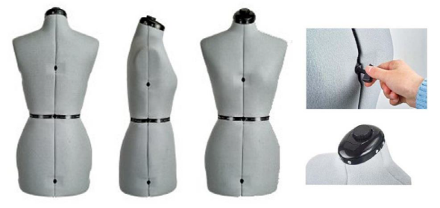
Figure 1: Adjustable dress forms manufactured by Singer Direct®

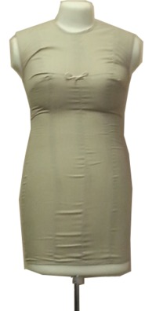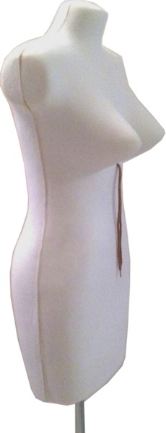
Figure 2: ‘Uniquely You’

Adjustable dress forms provide different sizes to fit for diverse body shapes and help the customers who do not have the measurements sizes the same as the manufactured dress forms. However, to measure and figure out the exact size and shapes is not easy.
Fabulous Fit® in the U.S.A. produce a fitting solution kit by inserting moulded pads under dress form covers to duplicate the targeted size and shape (Fig. 3) [10]. Manual padding up of the dress form is still popularly used to correct the size for a gap between the bodies but this process is time consuming and laborious (Fig. 4) [11, 12].

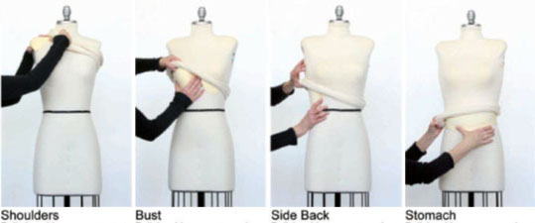
Figure 3: Customising padding kits

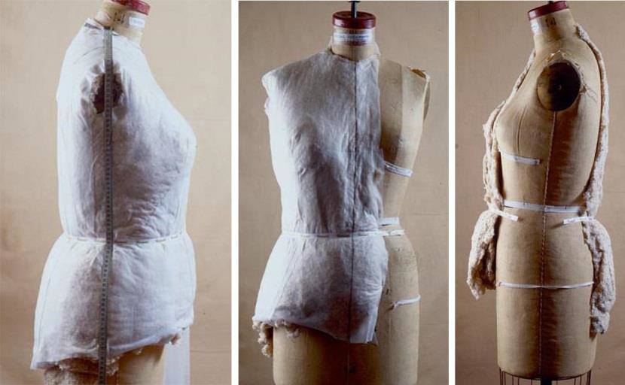
Figure 4: Padding with manual method

Since the later 1990s, some dress form companies started to use 3D body scanners for particular needs. For example, ‘Shapely Shadow’ and ‘Alvanon’ manufacture customized dress forms for certain brands or a fitting model’s measurement sizes using a 3D body scanner. 3D body scanning helps to capture a specific body image to develop a dress form which is perfectly and accurately matched for the needs of garment designers, clothing manufacturers, and retailers [13]. However, this 3D scanning technology for customized dress form is difficult to access by general customers due to high prices and the special knowledge and experience required to use the machine.
The emerging technologies, 3D scanning and 3D printing can help to create any design and shape quickly and efficiently [14]. 3D printing technology can also help to save time and money because 3D printing uses fewer raw materials than a CNC (computer numerical control) machine and can print only the necessary parts [14]. In addition, 3D printing allows any factory to produce the same quality products if they have the same raw materials and blueprints and it helps to saves shipping charges in the export trade [15].
With the help of 3D printing technology, architects, artists, and designers can create unique and complicated shapes of their own design without any limitations. [15]. Fashion design is one of the potential areas to optimize 3D printing techniques and 3D printing technology can be adopted into the fashion design field in two areas; 3D printed fabrication and 3D printed clothing construction. The principle of 3D printed fabric is a combination of each unit or digitalized weaving using calculations and the combinations of algorithms and patterns generated by formulas can create extensive three dimensional forms including fractal dimensions [16] (see Fig. 5).

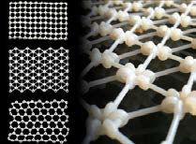
Figure 5: 3D printed fabrics

3D printed clothing is also divided into two types which are combination of units and creations of the intended shape based on the designer’s ideas and inspirations. Fully wearable clothing was developed by XYZ Workshop which was the combination of floral motif of mesh panels using flexible PLA [17]. Their dress was designed based on the 3D scanned torso for fitting onto the body (see the left of Fig. 6) [17]. 3D printing designer Iris van Herpen created her unique design using 3D printing technology and observed that “3D prints finally act with the movement of the body” and “Everybody could have their body scanned and order clothes that fit perfectly" (see the right of Fig.6) [18].

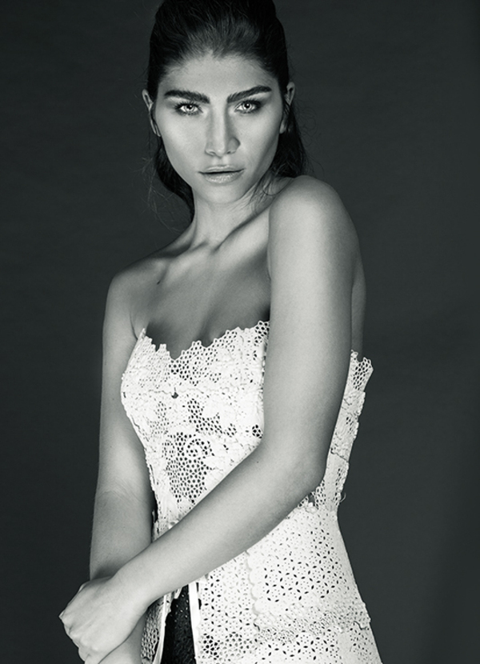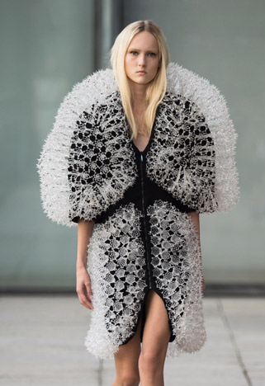
Figure 6: 3D printed clothing:
XYZ Workshop (left) and Iris van Herpen (right)

Materials
The dress form used in this study is a half-scaled (1/2) body or so-called mini body. The material of the dress form is urethane foam sufficiently soft for pinning hempen fabric covering onto it. The dress form in this study is represented the half scale of size 55 which is one of the Korean women’s clothing size; Shoulder length-5.7cm, Bust-43cm, Waist - 33cm, Hip-45.5cm, and Total body length-41.5cm [19].
The name of 3D scanner used was ‘3D Systems Delivers Sense Consumer 3D Scanner’ by ‘3D systems’ in the USA [20]. This 3D scanner was hand-held portable type and it could scan minimum 0.2m×0.2m×0.2m to maximum 3m×3m×3m.
The 3D printer used was a ‘3Dison Multi’, manufactured by ‘Rokit’ in South Korea [21]. The printing method and type of 3Dison Multi are FFF (Fused Filament Fabrication) and an extruder type, respectively. There were two extruders (0.4mm and 0.6mm) with a hot end nozzle and 0.4mm of nozzle was chosen for the PLA (Poly Lactic Acid) filament as an experimental material due to cost and accessibility.

Methods
Design research is a rapidly growing field of study having substantial importance to develop products and to improve quality of design solutions and outputs for society [22]. According to Design Research Methodology (DRM), there are four stages to develop suggestions: Research Clarification, Descriptive Study I, Prescriptive Study and Descriptive Study II (see Fig. 7) [22]. DRM emphasizes that a better understanding of the current situation is necessary to determine the influencing criteria and requirements to complete the practical outcomes of the project [22].

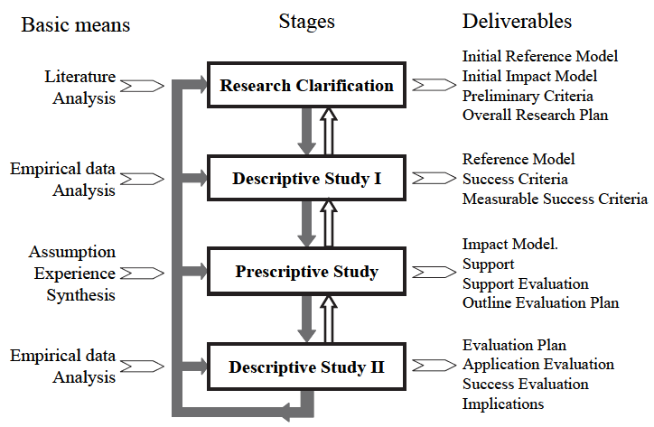
Figure 7: DRM framework: stages, basic means and deliverables

In the Research Clarification (RC) stage, the current materials for dress forms and industrial developments which have been tried to minimize the defects were explored to set the overall research aims which were described at the introduction part. The current understanding of requirements and insufficient adaptability of current manufactured dress forms were revealed from the literature. Improved and supportive design which could compensate for these defects of current dress forms was determined in the Descriptive Study I (DS-I) stage. To enhance the manufactured dress forms drawbacks, which are unified sizes and shapes, the adjustable components for the diverse customers’ varying shapes were designed. The body shape classification by Rasband was adopted to create a representative group of customers and the 3D printer was chosen for developing the component supports because of its accuracy and flexibility [23]. Prescriptive Study (PS) for developing supports in a systematic approach with consideration of the DS I results was followed. The practical outcomes of adjustable padding kits were produced by 3D printer after 3D scanning and modeling. Finally, Descriptive Study II (DS-II) was conducted to evaluate the supports’ accuracy and suitability based on the criteria developed at earlier stage.

Design Process
The development process of the customized adjustable kit was planned in five stages; ‘idea design’- ‘3D scanning of the dress form’ - ‘3D modeling of the kits’- ‘3D printing of the developments’ - ‘post processing’ (see Fig. 9). It has been shown that the 3D printing technology’s main three phases are modelling, printing and finishing of the product [23], however, two earlier phases for adjusting the idea were considered in this study.
The customized adjustable kit was designed to create a wide or large size or shape than the fixed sized dress forms. Because to make a dress form smaller is physically impossible and an image processing of smaller size is not allowed on the program.
First, each section for adjusting body parts were selected to create specific body shapes according to the body shape classification (see Fig. 8). Rasband classified the body types of female body into six different shapes; ‘Triangle shape’, ‘Inverted triangle shape’, ‘Rectangle shape’, ‘Hourglass shape’, ‘Diamond shape’, and ‘Rounded shape’ Each shape is targeted to describe a specific wider or bigger body types [24].
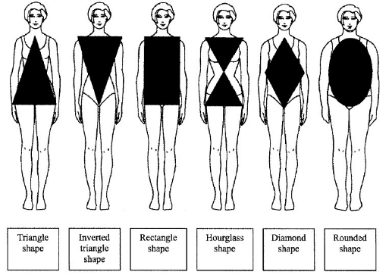
Figure 8: Classification of Body shapes by Rasband

In this study, the components for creating the four body types from Rasband’s classification* and additional wider waist, protruding bust and hip were developed. The added amounts for each part were all 1cm (see Table 1). However, the size of circumferences were divided half excluding shoulder length because the components were developed only right side following manual padding method.

Table 1: Original sizes, added amounts, and intended shape of the dress form
Body Parts | Original Size | Added Amounts | Intended shape
Shoulder Length | 5.7cm | 1cm | Inverted triangle shape*
Bust/2 | 21.5cm | 1cm | Protruding bust
Waist/2 | 16.5cm | 1cm | Wider Waist
Side hip/2 | 22.5cm | 1cm | Triangle shape*
Hip/2 | 22.5cm | 2cm | Protruding hip
Shoulder + Hip/2 | 9.25cm/ 22.5cm | 1cm/2cm | Hourglass shape*
Waist + Side Hip/2 | 16cm/22.5cm | 1cm/1cm | Rectangle shape*

Secondly, the experimental dress form was 3D scanned. When the dress form was in focus, the 3D scanner was moved around the dress form. 3D scanned images were captured several times and those images were merged to create one complete image. After generating the scanned image of the dress form, the surfaces of the image were modified to cover the gap in the meshes.
Thirdly, the shape of each component was developed into 3D CAD images using 3D CAD program, ‘Z Brush’. The original scanned images were copied as the new layer of skin and the parts of intended shapes were extracted with added amount. The offset 3D images outline were trimmed smoother and thinner to fit the experimental dress form without any gap.
Finally, the generated 3D CAD files consisting of cross-sections were inputted to the 3D printer. Some options such as layer height, thickness, infill percentage, printing speed, raft and supports were set. Each layer based on a cross section were accumulated layer by layer and, after printing all layers from the images, the developments were produced. In this study, one side of component was developed because the draping and padding were conducted on only half of the dress forms and the right side traditionally to save time and effort (see Fig. 4) [12].
Lastly, some extra supporters were removed and surfaces were trimmed smoothly using an emery cloth. The 3D printed padding kit was attached to the dress form using double-sided adhesive tapes. As with manual padding methods, the adjustable kits were attached at the right side.

Stage 1. Idea design | Stage 2-3. 3D scanning and  3D modeling
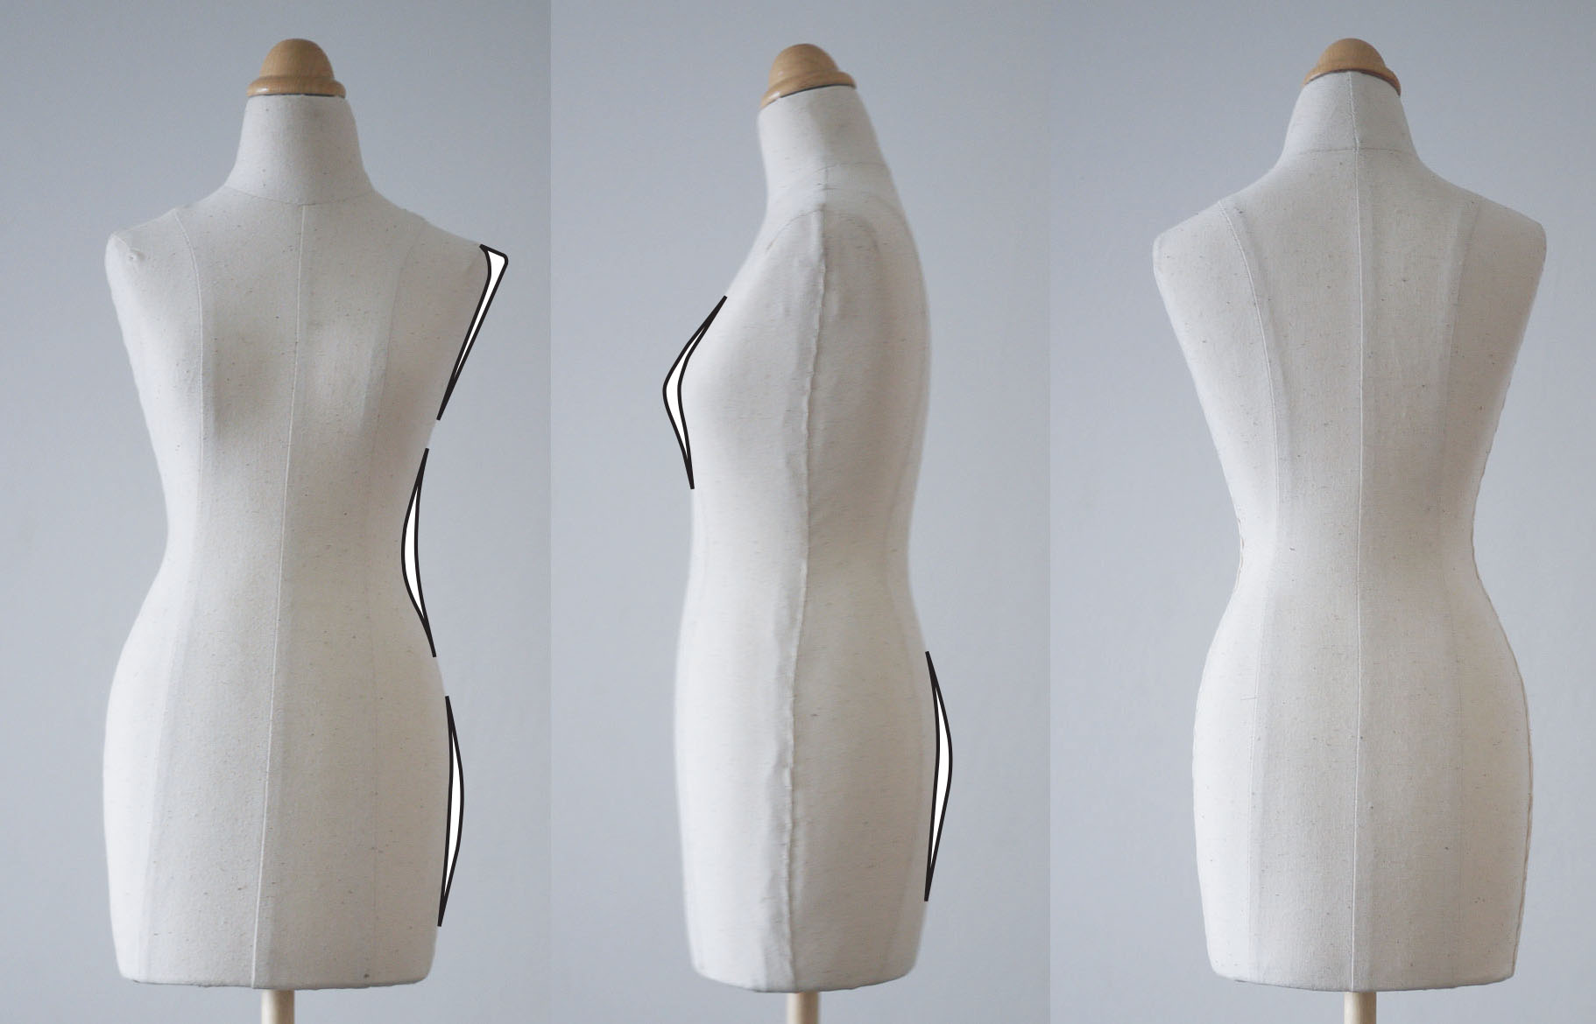 | 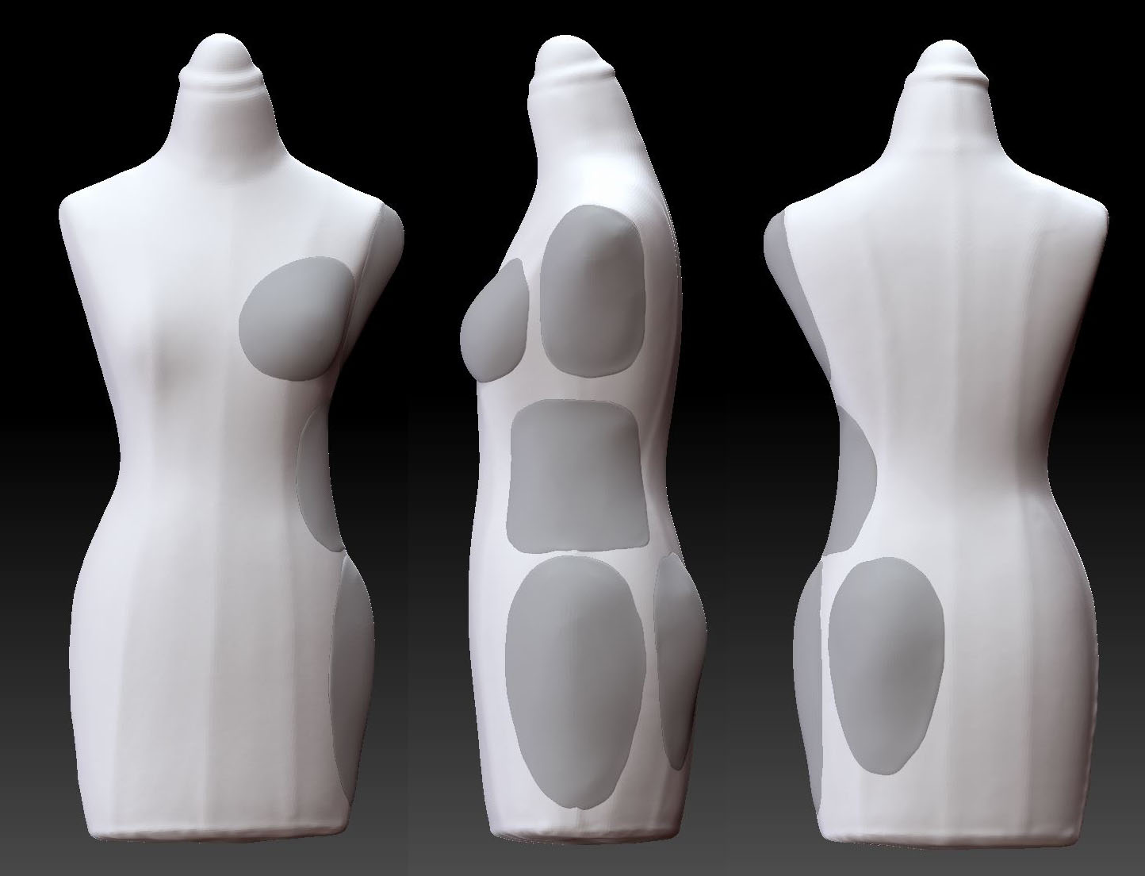
Stage 4. 3D printing | Stage 5. Post processing
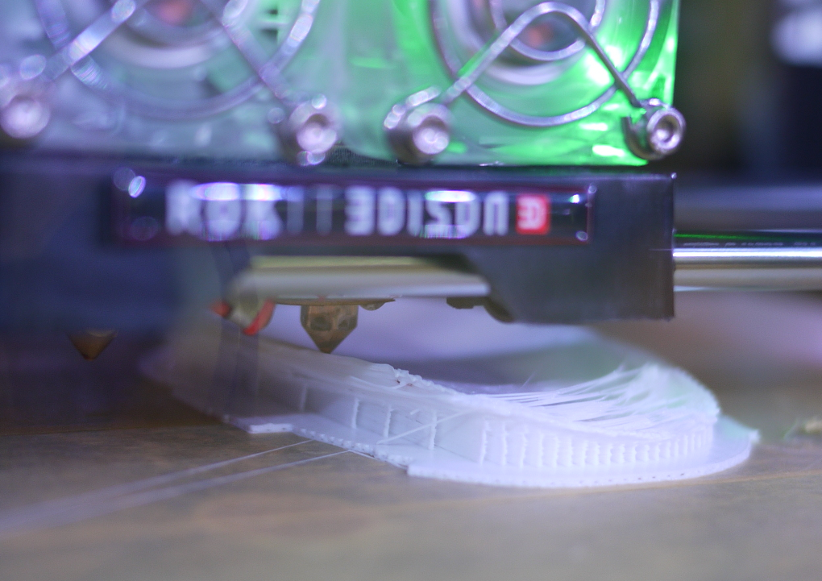 | 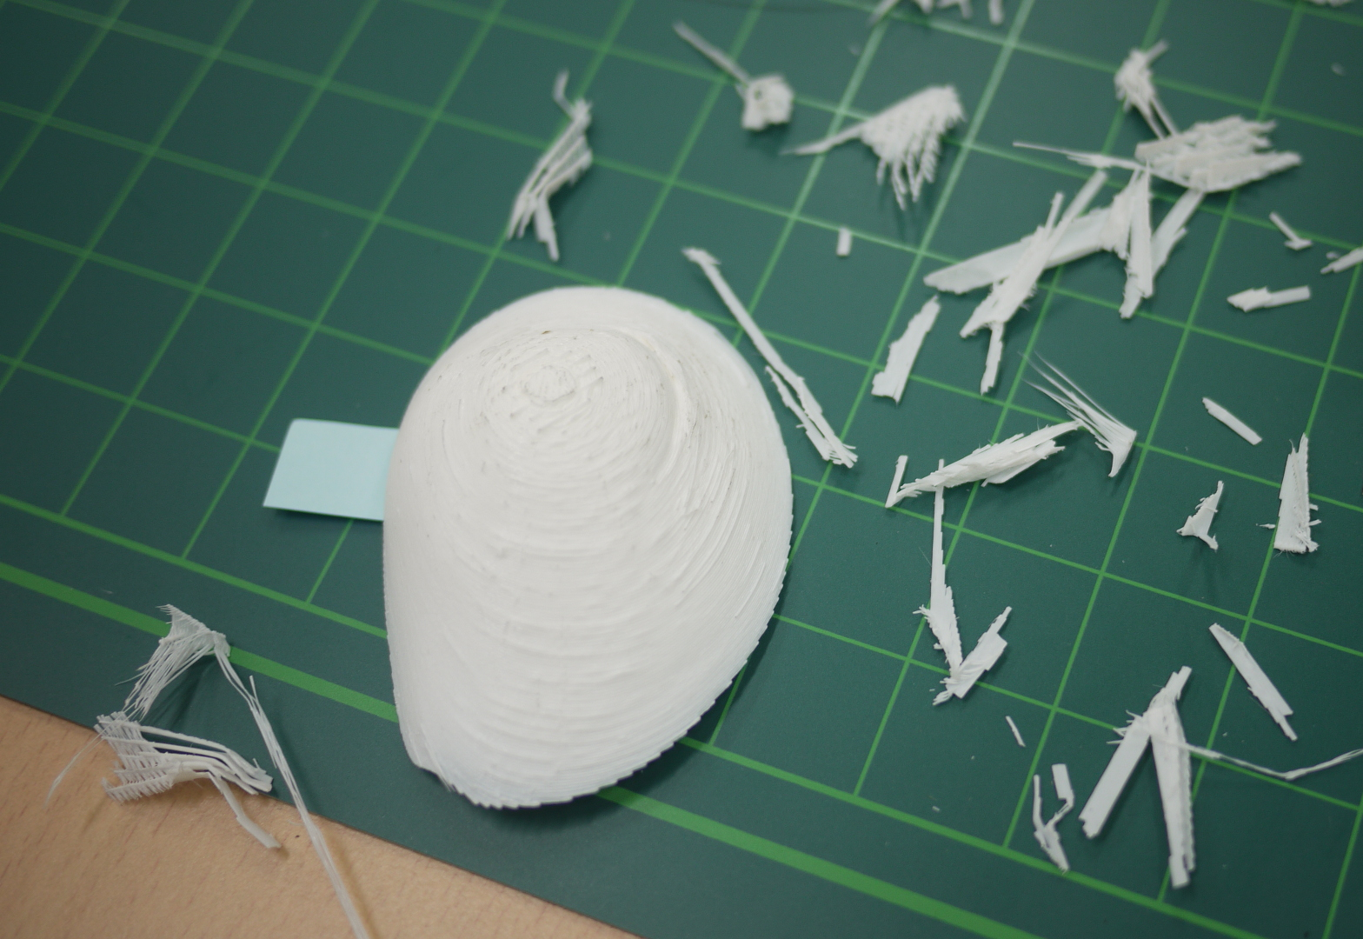
Figure 9: Customized adjustable kit development process.

There were twice of 3D printing stages because of developing more accurate and delicate shapes into the dress form. The final version of 3D CAD images were modified after first trial of 3D CAD images development and 3D printing process. The initial version of hip was changed into the covering both side of hip due to creating accurate size and shape. The initial version of hip component also can be seen on the third law of the left side of Fig.11.

Results
The developed components of the customized adjustable kit are shown on the Fig. 10. Based on design process stages from DRM, the DS-II stage needed to focus on the evaluation of the supports. The evaluation was conducted by measuring whether the added amounts were adopted onto each component and the intended shapes were produced properly and accurately. The overall shapes of all components were produced as same as those were intended. There was a subtle gap between the components and the dress form around the edges even though the nozzle size of the experimental 3D printer was only 0.4cm. The most of components were adhered to the dress form affordably but the side hip part had a slight gap and it was not matched tightly than the other parts. The reason was referred that the overall shape of side hip part was rather flatter and also covered large part of the body than the other parts. In addition, the added amounts at the waist would be necessary to put more amount for generating distinctive ‘Rectangle shape’.
For the evaluation for accurate size generation, first, the center and back front lines were marked onto the dress form to divide each side while checking each side division was same. The measurement of each body parts were followed by dress form measurement method from Armstrong: ‘Shoulder length: Measure form shoulder-neck to shoulder tip at pin mark, Bust circumference: ADD , Hip circumference: ADD [7]. The half measurement sizes of original dress form were compared with the sizes after the components were applied (see Fig 11).

Shoulder Length | Bust Circumference
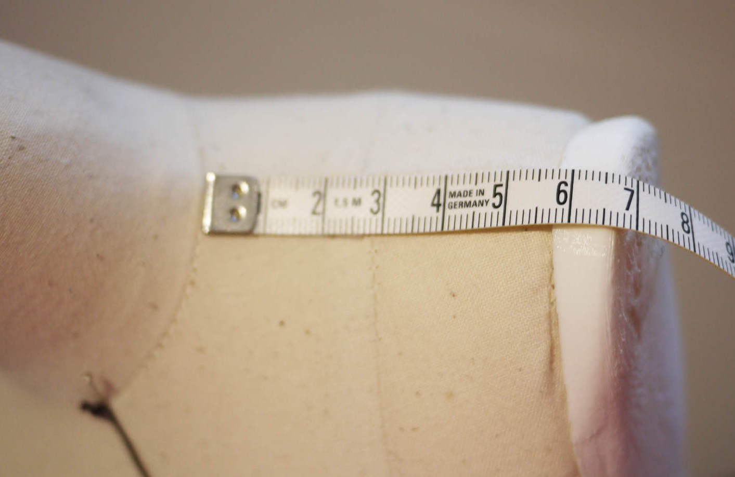 | 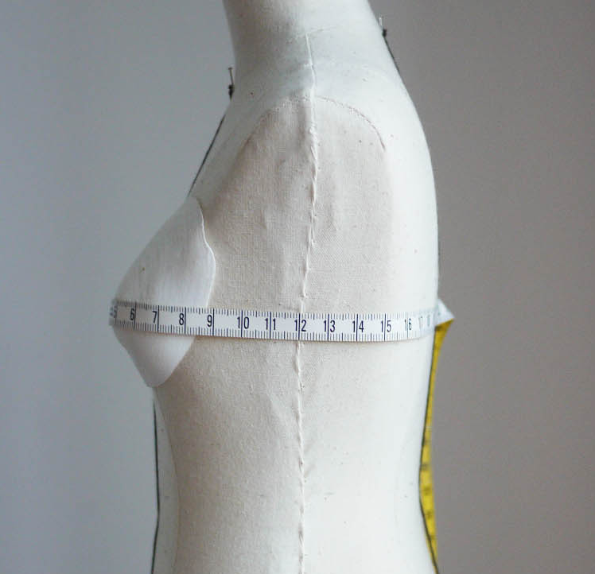
Waist Circumference | Side hip Circumference
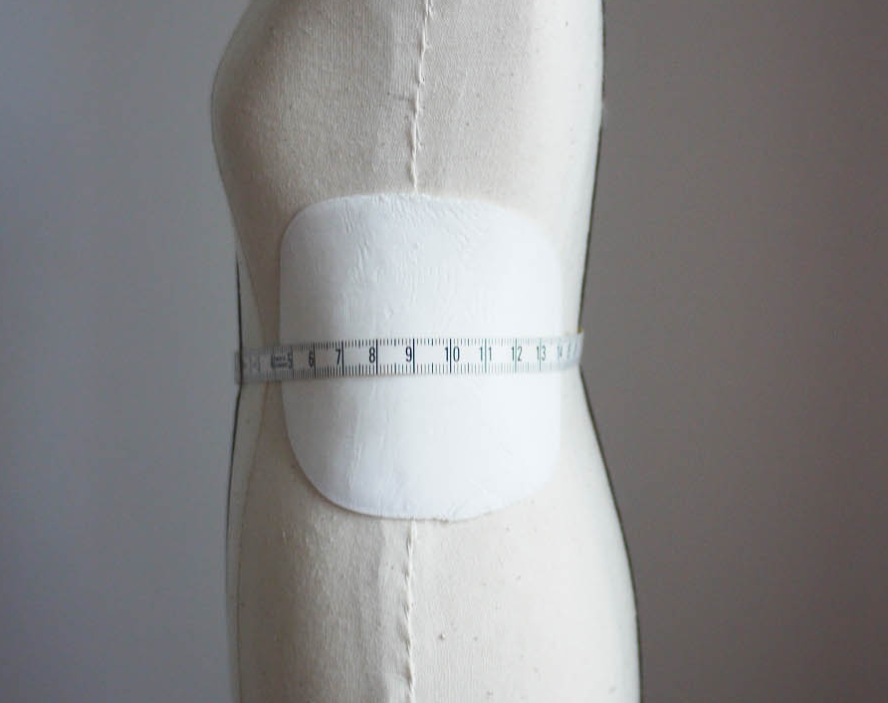 | 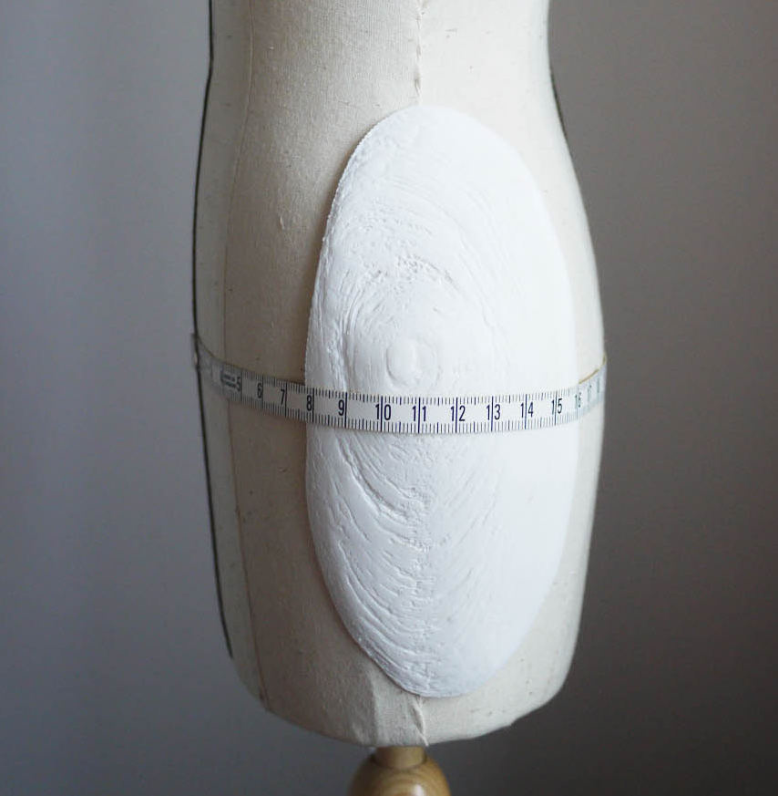
Hip Circumference  (Initial Trial) | Hip Circumference  (Final Version)
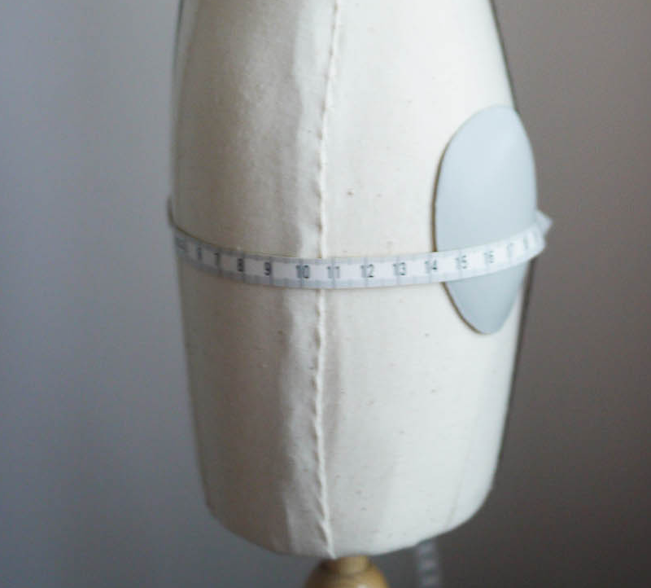 | 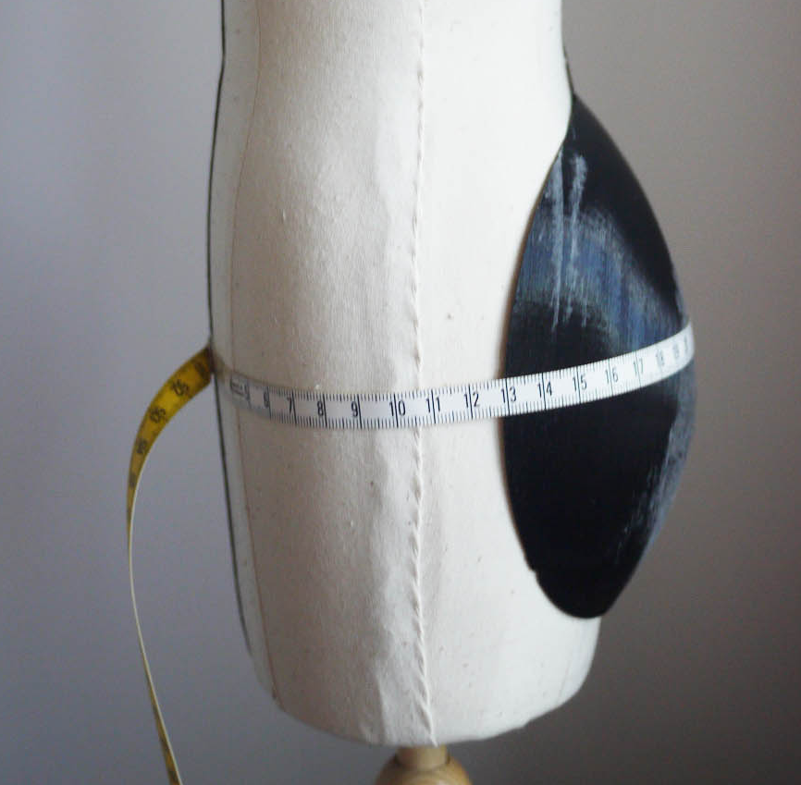
Figure 11: Customized adjustable kit evaluation

Bust | Hip | Combinations  (Shoulder + Hip, Waist + Side Hip)
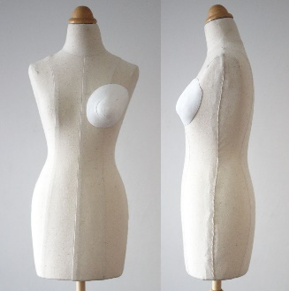 | 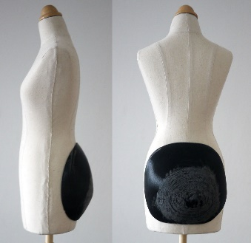 | 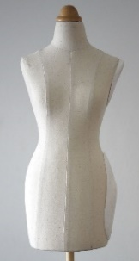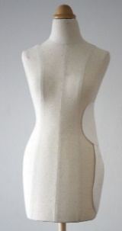
Side Hip | Waist | Shoulder
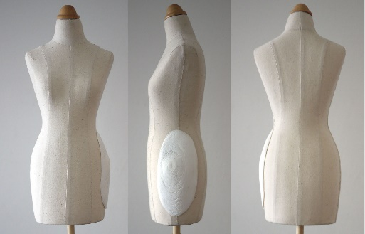 | 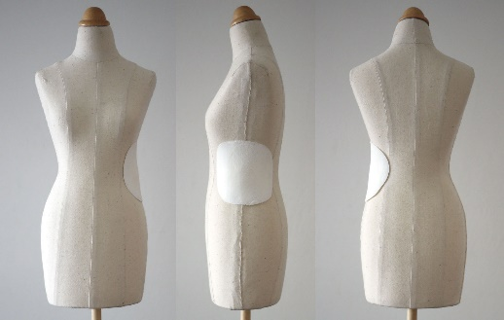 | 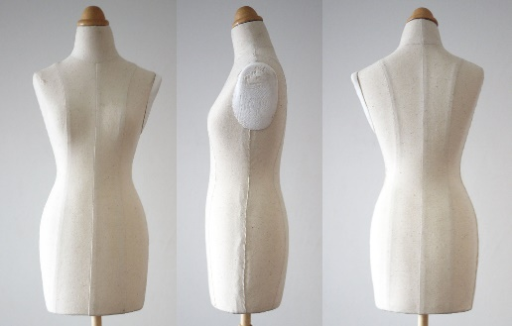
Figure 10: Adjustable padding kit development

In total, the outcomes of 3D printing were convincing in consideration of the experiment. The size of the components were printed with minor differences (less than 0.3cm) when these are compared with the idea design shown on the screen of the 3D CAD program (see Table 2).

Table 2: Original sizes and the sizes with components
Body Parts | Original Size | Intended sizes | Size with components
Shoulder Length | 5.7cm | 6.7cm | 6.7cm
Bust/2 | 21.5cm | 22.5cm | 22.2cm
Waist/2 | 16.5cm | 17.5cm | 17.6cm
Side hip/2 | 22.5cm | 23.5cm | 23.2cm
Hip/2 | 22.5cm | 24.5cm | 24.5cm

In case of the material of the kit, the suitability of the component coverings was not totally satisfactory even though this weakness was expected at the idea design stage. The hardness was adequate enough to match the material of the dress form but pinning which is the most required function of the dress form was not possible. However, a manufactured dress form cover with a soft foam layer could be covered and the thickness of the cover could be calculated at the 3D modelling stage. Furthermore, the rubber or flexible material which can be put into the inside easily and different added amount components can be developed in further developments. Those developments will be evaluated by customers to address those applicability and to build more reliability.

Conclusions
In this study, an experiment of developing an adjustable padding kit was conducted for the precise duplications which targeted specific body shapes using 3D scanning, 3D modelling and 3D printing technology. It was founded that the applicability and effectiveness of developments of an adjustable padding kit has a possibility to be adopted due to its size accuracy and convenience. There is no difficulty to produce any adjustable body parts. Thickness can also be changed easily when 3D scanned images were available. This study can be extended to apply to other materials and other body parts and those can be evaluated.
References
- Y. Hyun and B-J Shim, “A Basic Study for the Development of Educational Dress Forms for Male Adults -Survey of Male Dress Forms for Men’s Apparel Company and the Education for Men’s Wear in Fashion Dept. of University”. Journal of Fashion business. Vol 8. No 1, p. 100-114, 2004
- A. Joanne and F. Sterlacci, Historical Dictionary of the Fashion Industry.Scarecrow Press, 2007.
- Collins English Dictionary – Complete and Unabridged Harper Collins Publishers. Available: http://www.thefreedictionary.com/_/misc/HarperCollinsProducts.aspx?English, 2003
- D. Shackell, Accent on sewing. London: Mills & Boon, 1967
- N. Hollis. Successful sewing: a modern guide. London: Faber, 1969
- H. Stanley. Flat pattern cutting and modelling for fashion. Leckhampton: Stanley Thornes, 1991
- H. J. Armstrong. Draping for apparel design. New York : Fairchild; Oxford, 2008
- Singer Direct. Available: http://www.singerdirect.co.uk/
- Uniquely You. Available: http://www.allbrands.com/products/3900-uniquely-you-pinable-foam-dress-form-customize-cot
- Fabulous Fit®. Available: https://www.fabulousfit.com/
- E. Kopp, V. Rolfo and B. Zelin: How to draft basic patterns. New York: Fairchild Fashion & Merchandising Group, 1991.
- S.P. Stern. Padding a Dress Form. Threads issue. Vol. 44. Available: http://www.threadsmagazine.com/item/22940/padding-a-dress-form
- A. Joanne and S. Francesca. The A to Z of the Fashion Industry (The A to Z Guide Series). Scarecrow Press; 96th revised edition, 2009.
- B.J. Park and Y.S. Nam. (August 2013). The patent of the 3D printer can print anything is expired in early of 2014, Hankyung. Available: http://www.hankyung.com/
- H. Lipson and M. Kuman, Fabricated: the new world of 3D printing, Indianapolis : John Wiley & Sons, 2013
- Scrawford (May 2011) 3D Printing Flexible Grids. Available: http://lmnarchitects.com/tech-studio/fabrication/printed-flexgrids/
- XYZ workshop. Available from: http://www.xyzworkshop.com/
- Iris van Herpen uses 3D printing and magnets to form Spring Summer 2015 fashion collection. (October 2014). http://www.dezeen.com/?p=557546
- Mannequin World. Available: http://www.mnqworld.com/
- 3D Systems Delivers Sense Consumer 3D Scanner. Available: http://www.3dsystems.com/
- 3Dison Multi 3D printer. Available: http://en.3disonprinter.com/
- L.T.M. Blessing and A. Chakrabarti: DRM, a Design Research Methodology. Springer, 2009.
- A.Pîrjan & D.Petrosanu. “The Impact of 3D Printing Technology on the Society and Economy”. Journal of Information Systems & Operations Management. 1-11, 2013
- M-E Faust, S. Carrier, P.Baptiste. “Variations in Canadian women’s ready-to-wear standard sizes”. Journal of Fashion Marketing and Management. Vol 10. No 1, 71-83, 2006
Hye-Won Lim is a PhD student in School of Design at the University of Leeds, UK from 2013. She obtained her MA degree in Fashion Design from the same school in 2011 and she had acquired BSc degree in Clothing and Textiles from the Chonbuk National University, South Korea. She worked as a part-time lecturer teaching clothing construction, draping, and tailoring from 2006 to 2008 in South Korea. She also worked as a clothing CAD pattern developer in Seoul, South Korea before joining the University of Leeds. Her research interests are pattern making and clothing construction. She is currently studying about human body shape analysis and clothing sizing systems.


Thomas Cassidy holds the Chair of Design in the University of Leeds. He holds four degrees (ATI, MSc, MBA and PhD) and is a fellow of the Design Research Society (FRDS). He has carried out many consultancies, both nationally and internationally since the late 1970s, for agencies such as the UN, ODA and Hong Kong Polytechnic University. Professor Cassidy is a regular reviewer for the Textile Research Journal, Measurement Science and Technology, the Journal of the Textile Institute and many other academic journals. He has published over thirty journal papers, 25 conference papers, co-authored one book and published 5 chapters in books. He is on the editorial board of Textile Progress and the Journal of Fiber Bioengineering and Informatics. He has supervised twenty-two PhD students and three MPhil students to completion.


Tracy Diane Cassidy is a trained knitwear designer experienced in knitwear and bespoke bridal-wear design, manufacture and retail. She obtained her PhD through the investigation of Colour forecasting and is the first author of the book Colour Forecasting (Blackwell). Tracy is a Reader in Fashion & Textiles, at the University of Huddersfield, and continues to conduct research in fashion and textile design, trends and marketing. While trends and colour have remained particular areas of research interest in both design and marketing applications, more recently research interests include home furnishings and interiors encompassing fashion and textiles in a much broader context. Tracy recently trained as a master upholsterer using both modern and traditional materials and techniques. Upholstery and furniture decoration are the mainstay of her practice. She is an established author with international presence, a reviewer for many reputable journals, and editorial board member. Further chapters Tracy has published in the area of Colour forecasting include Sustainable Colour Forecasting in Gardetti & Torres’ ‘Sustainable Fashion & Textiles’ (2013) and Colour Forecasting: Seasonal Colours’ in DeLong & Martinson’s ‘Colour & Design’ (2012). Tracy’s research into subcultures includes an exploration of Lolita Fashion (Fashion, Style and Popular Culture, 2015: 2: 2); The rise of vintage fashion and the vintage consumer (Journal of Fashion Practice, 2012: 4: 2) and Youth identity ownership from a fashion marketing perspective (Journal of Fashion Marketing & Management, 2011: 15: 2).


 Manuscript received November 26, 2015. Hye-Won Lim is a PhD candidate in School of Design, University of Leeds, UK. LS2 9JT (e-mail: sd10hwl@leeds.ac.uk). Thomas Cassidy is the Chair Professor in design at the University of Leeds and a Fellow of the Design Research Society (e-mail: T.Cassidy@leeds.ac.uk) Tracy Diane Cassidy is the Reader in Fashion and Textiles at the University of Huddersfield and the Textiles Thinking Research Center leader. (e-mail: T.D.Cassidy@hud.ac.uk)

