A SPACE OF WASTE

ABSTRACT

Exported waste clothing, emanating from a western context, saturate indigenous African markets but satisfy local clothing needs. This produces a dichotomy in ways in which it is viewed and the necessary actions needed to address the issues of waste within a circular economy. Experiences and outputs from recycling clothing waste in a UK based context are applied to that of a Tanzanian context and methods for re-appropriating this waste back into manufacturing systems are explored. These include ideas for re-exporting remanufactured garments back to their place of discarding and of working cross culturally with local designers and businesses to address indigenous clothing and manufacturing capacities and needs

KEY WORDS

Re-appropriation; second-hand clothes; recycling; co-design, circular thinking.

INTRODUCTION

Ketchup Clothes, a remanufacturing social enterprise established by the author in 2004 and based in the North of England, was set up to transform garments and textiles that, through no fault of their own, had become viewed as waste and no longer required by their original owners. Through a process of transformation and remanufacturing, new garments were imagined, produced and sold, and insight gained into the social, political and environmental dimensions of garment rubbish. Ketchup Clothes was essentially a one-person operation although assistance through student placements and collaborations with similar enterprises was also gained. In the time it maintained itself financially, and whilst there were not large profits, there was enough to put back into the enterprise to keep it going. The key sources of finance included sale of clothing (40%), payment for the delivery of workshops (30%) and external funding for business start up (30%). This implied that as a viable business opportunity it had potential to grow and when the opportunity arose to showcase the techniques within a Tanzanian context it seemed the perfect place to further the debate as to whether the techniques could be developed for economies that are defined by the importation of clothing waste, have a failing mass production system but a thriving informal and small-scale sector. Similarities and differences could be drawn across the cultures in the ways in which products were manufactured and consumed. Of particular interest was the way in ‘circular thinking’ undertaken within the context co-design can be extended to foster an environment in which waste exported to one context could be reused. In August, 2016 a catalogue of these ideas and processes was produced and used, within the context of a co-design workshop undertaken in Dar Es Salaam, Tanzania, in order to investigate perspectives on recycling and the value of western waste, experienced in the form of second-hand clothes (mtumba) (Shah, 2016a). This was part of a wider study into the development of a National dress for Tanzania where discussion centred upon the potential for using second-hand clothes (or mtumba) within the production process (Shah & Kahabi, 2016).

The purpose of this paper is to establish the extent which methods and techniques for transforming waste clothing from the streets of Leeds, UK can be applied to a global context, particularly that of Tanzania. The overall aim is to investigate and develop appropriate manufacturing and re-appropriation techniques that will have resonance on circular notions of production and tackle the mountains of clothing waste that we find spread across the globe. It will achieve this through a discussion and exploration of techniques used to date by the author and primary empirical research gathered during the course of workshops. This will include practice-based outputs that have the potential to be up-scaled, applied to varying scales of production and potentially incorporated into CAD/Apparel Systems. In the course of this exploration aspects such as key spaces of waste will be critically evaluated and differing perspectives and discourses will be analysed.

CONTEXTUALISING THE PROBLEM

A key hypothesis underlying this paper, and indeed wider research interests, is that something has gone array in our production and consumption systems to produce such a vast amount of waste and that this is having a detrimental impact on both intrinsic and extrinsic environments (Scanlan, 2005;Braungart & McDonough, 2008; Farrant et.al, 2010; Foote & Mazzolini, 2012) . We are spreading this waste across the globe where it enters systems that are not set up to receive it in a safe manner and there is the worry that this will have a lasting impact on our planet, psyche and well being (Bauman, 2003; Ritzer, 2004; WRAP, 2012; BBC, 2016; Wheeler, 2016). A large part of the problem arises out of the need for companies to keep producing – not just to satisfy demand - but to remain profitable and create new demand. Forward and backward linkages within the fashion industry are complex but tend to be centred upon forward inertia in that everything is geared towards the end product. Materials and resources are pushed forward in the creation of an object and there they tend to finish. There are obviously incidences in which waste comes back into the same system from which it came but they can so small-scale or fragmented that they appear insignificant.

The export of second-hand clothes is one situation in which waste in one context is brought back to life in a new one (Cline, 2015; Brooks; 2015). The markets and streets of Tanzania are overflowing with piles of clothes that were once considered of no use, now seeming to perform an important function (Isla, 2013) (Figure 1).

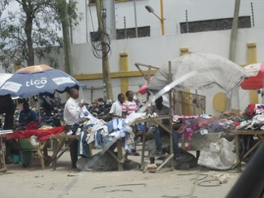

Figure 1: Second-hand clothes stalls on the side of the road, Dar Es Salaam: Image: Shah August 2016

In the bustling second-hand markets, workspaces have been set up to repair and transform clothes, shoes etc. and vendors state that business is good and profitable (Shah, 2016b). Seen in this light the problem becomes a solution for a related activity – that of clothing our backs to satisfy both basic and complex social, environmental and cultural demands. As positioned by Isla (2013), in relation to the various discourses we can use to investigate second-hand fashion trade and consumption, she argued that at one end is a noticeably modern and functional outlook and on the other is a distinctly postmodern and consumerist perspective (p.222). This was seen to give rise to the coexistence of both positive and negative orientations and connotations and she posited that:

“…while the United States and western Europe tend to frame second-hand fashion consumption almost entirely with the notion of constructed identity and other “postmodern” notions, African feelings could very well be located towards the middle of the continuum with their recognition of functional and rational socio-economic motivations in used clothing consumption, as well as consumption practices that are informed by local cultural norms and through which identities are constructed and contested.”

In this context second-hand clothes (SHC) serve a function and provide a much needed resource. They satisfy the need for affordable, available and quality clothing and the sorting, distribution and sale of the SHCs provide valuable income-generating opportunities for tailors, fixers and entrepreneurs. As stated by Brooks (2015)

Poor people may have little agency in shaping used clothing systems of provision, but they can and do respond in creative and unanticipated ways to imports of used garments. Imports have diverse affects within different societies. Norms of dress are transmitted by the prevalence of Western clothing. Yet rather than everyone being passive receivers of clothing culture evidence shows how individuals give textiles a new lease of life and create their own creolized trends (Brooks, 2015:145)

This represents the potential for second-hand clothing and the positive manner in which it is adopted within a developmental context. It also provides insight into how indigenous designers could utilize second-hand clothes within national schemes of dress and creolized styles.

Pressures are now being placed on the export of waste clothing, with Tanzania being just one of the African countries seeking to ban its import (BBC, 2016). Thus inventive ways of utilizing second-hand clothing are needed that address measures to make its remanufacturing and processing more appealing to producers, governments and future generations. Consideration for both local and export markets would help to close the loop and highlight the issues that occur when waste exported from one context is subsumed within a different socio-economic location, In this way the clothing waste become circular in the way in which it is reabsorbed and contribute to the development of both export markets and local manufacturing capacity.

MEANS TO A SOLUTION

The means to the solution that is proposed through this research is to propose methods for reintroducing clothing waste back across the scale of manufacturing systems from small to mass. Its presence within niche and designer markets has great value and potential but there is also an imperative to introduce clothing waste at a mass scale (Brown, 2014). The reasoning behind this is, that in the main, it is this system that has produced the waste in the first place and therefore it should shoulder more responsibility to re-appropriate it. Designer and couture pieces do end up within the global clothing redistribution system but these are far and few between. The bulk of that which is exported tends to come from high street names and brands. In manufacturing terms solutions are thus framed around current approaches to clothing production and of developing improved techniques that have resonance to both local and global manufacture. These include the development of a range of clothing made from second-hand clothes/mtumba that would be suitable for western markets and the incorporation of waste clothing and textiles into a national dress for Tanzania.

Flow charts detailing the process of clothing recycling and its potential for re-appropriation into larger scales of production have been developed and these demonstrate the opportunities that exist for remanufacture (Dissanayake & Sinha; 2015). However, the emphasis on managerial structures and the limited design appeal of these investigations suggest that whilst re-appropriation of clothing waste into larger manufacturing has potential it needs a clearer design philosophy and aesthetic. Further consideration of cultural preferences, design tendencies and manufacturing capacities are also needed. Design research, by the author, to date has centred upon the generation of garments utilizing pattern generation and shape development adopted by both mass production systems and designer one-off processes. This has resulted in a bank of design and pattern cutting methods from which to draw upon and hypothesise as to how they may be applied to a number of cultural and manufacturing scenarios. Within the context of this practice-based research fabrics such as denim (mainly from jeans), cotton jersey (mainly from T-shirts) and woven cotton (mainly from shirts and household linen) were utilized to produce a variety of design outputs.

Co-design

Co-design, as a concept for developing more meaningful design outputs for both consumers and producers would appear to have resonance to circular notions of design and consumption since an active dialogue is encouraged in order to produce design solutions. In the case of the transferal of methods for recycling clothes in a UK context to that of a Tanzanian context this process was actively pursued through the means of workshops in Dar Es Salaam University and the subsequent sharing of ideas via an online communication system, Whatsapp. Discussions as a result of the workshops revealed that there were definite correlations between small-scale activities set within a UK to that of the Tanzanian tailor. Both were small-scale in operation and utilized waste clothing to a lesser or greater effect. For the Tanzanian tailor it was cited how they would often have a stock of second hand clothing to use for trims, buttons and for converting into alternative products such as pillowcases. Whilst there was not much evidence of tailors or designers making full garments out of second-hand clothes there was a sense that these practices were seeping into teaching practices. Observations during a visit to a second-hand market revealed a thriving undercurrent of fixing, mending and alterations but interviews revealed how these activities paid well but were not a profession that they would want their children to go into. Finding means through which these activities could be given a higher status through the production of upscaled outputs would therefore have resonance to circular manufacture.

Drawing on the experiences gained as a result of submersion in Ketchup Clothes, techniques and methods of recycling were developed and discussed with participants. These centred upon the utilization of second-hand t-shirts, jeans/denim and traditional Tanzania ‘kanga’ fabric and all sought the need to address both export and local markets.(Figures 2-7) In addition feedback on a previous process, was introduced as a potential means of getting the fabric to lay flat and suitable for printing on and presenting for manufacture.

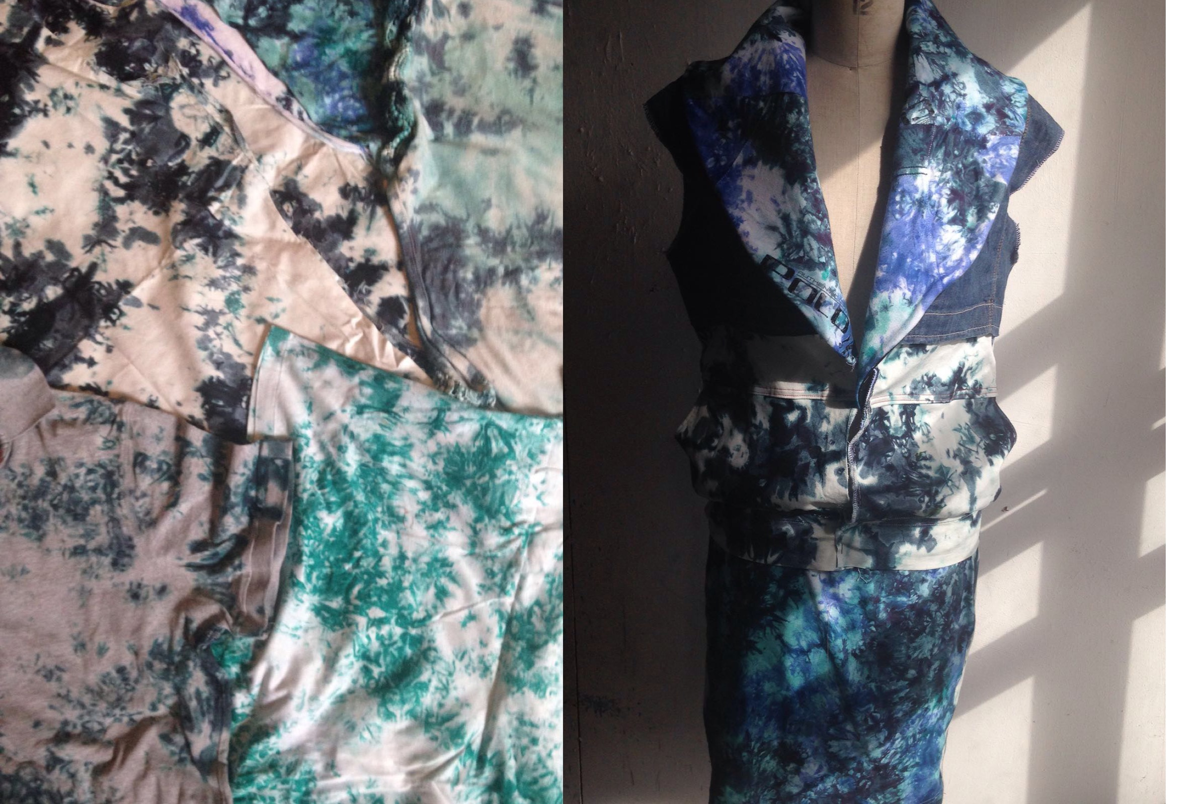

Figure 2: Mtumba t-shirts with applied batik process & refashioned into western style garment (L: NED; R: Shah, 2016)

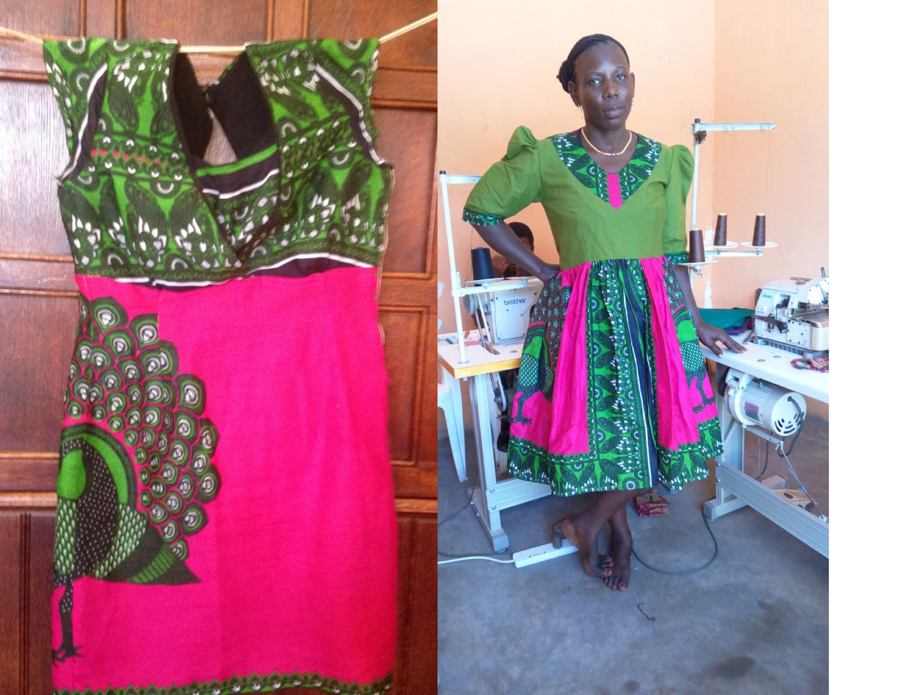
Figure 3: Western and Tanzanian Interpretations of Traditional Kanga Fabric (L: Shah, R: NED, 2016)

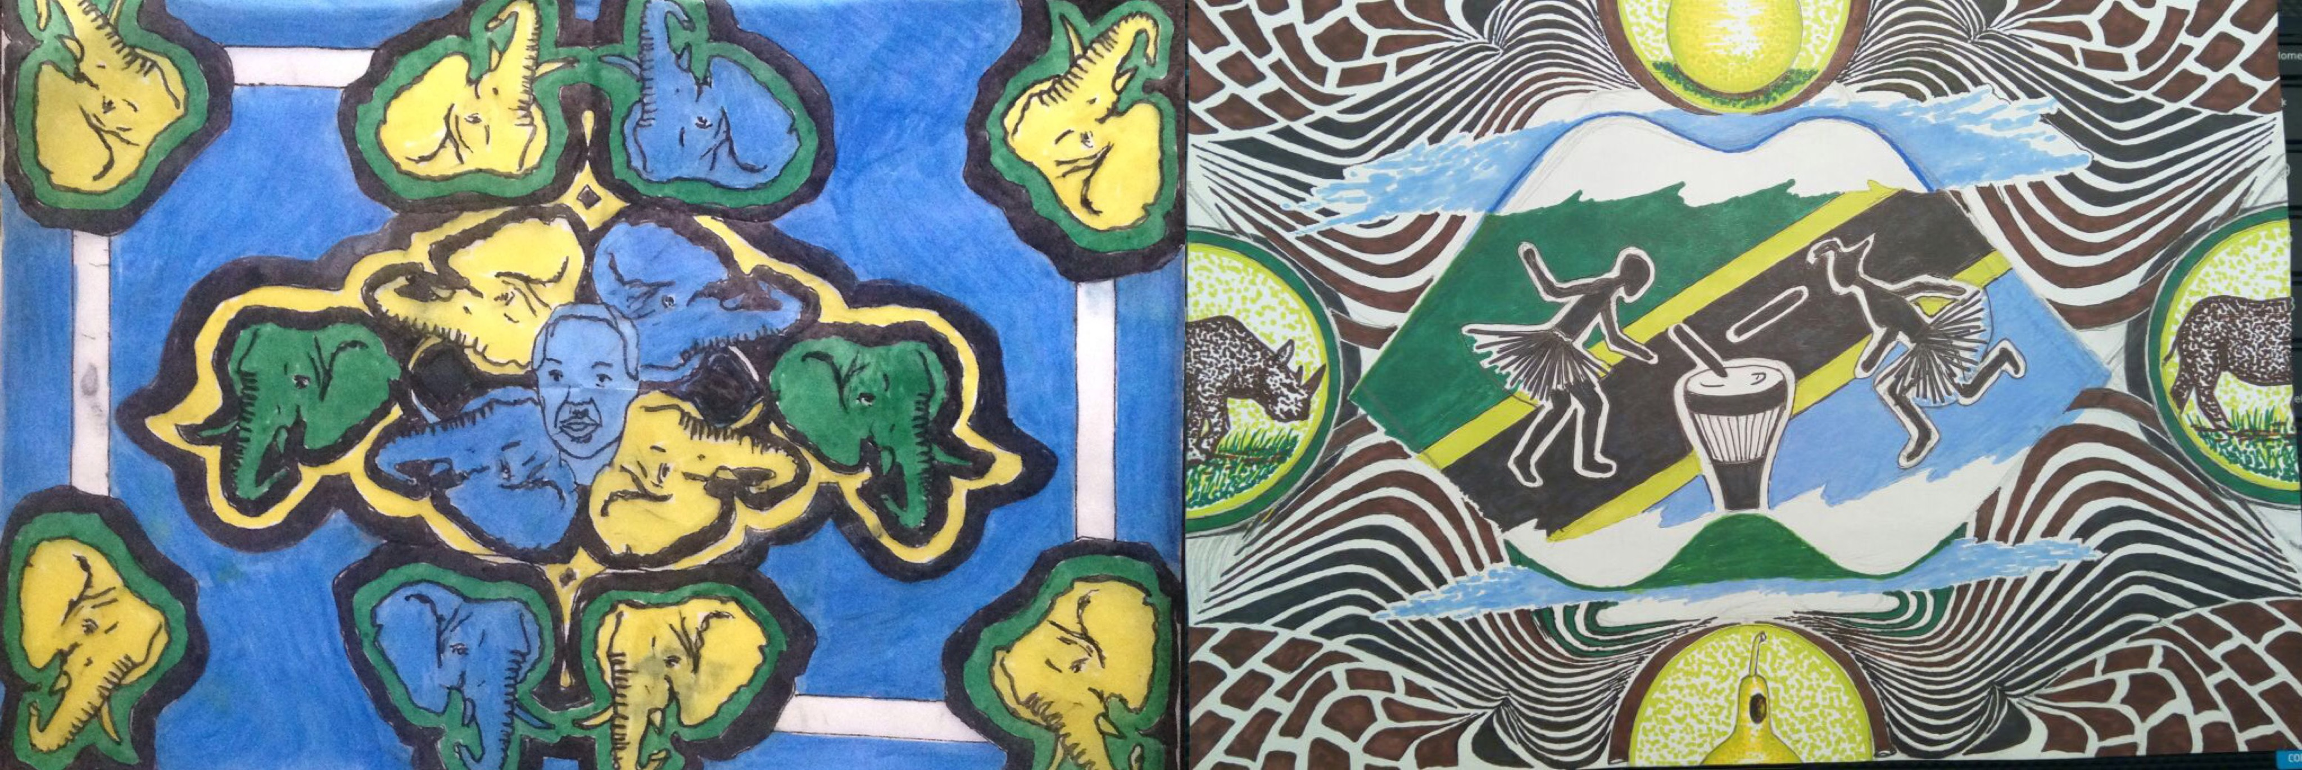

Figure 4: Interpretations of National Identity in Kanga Design (L: Shah, R: Kahabi, 2016)

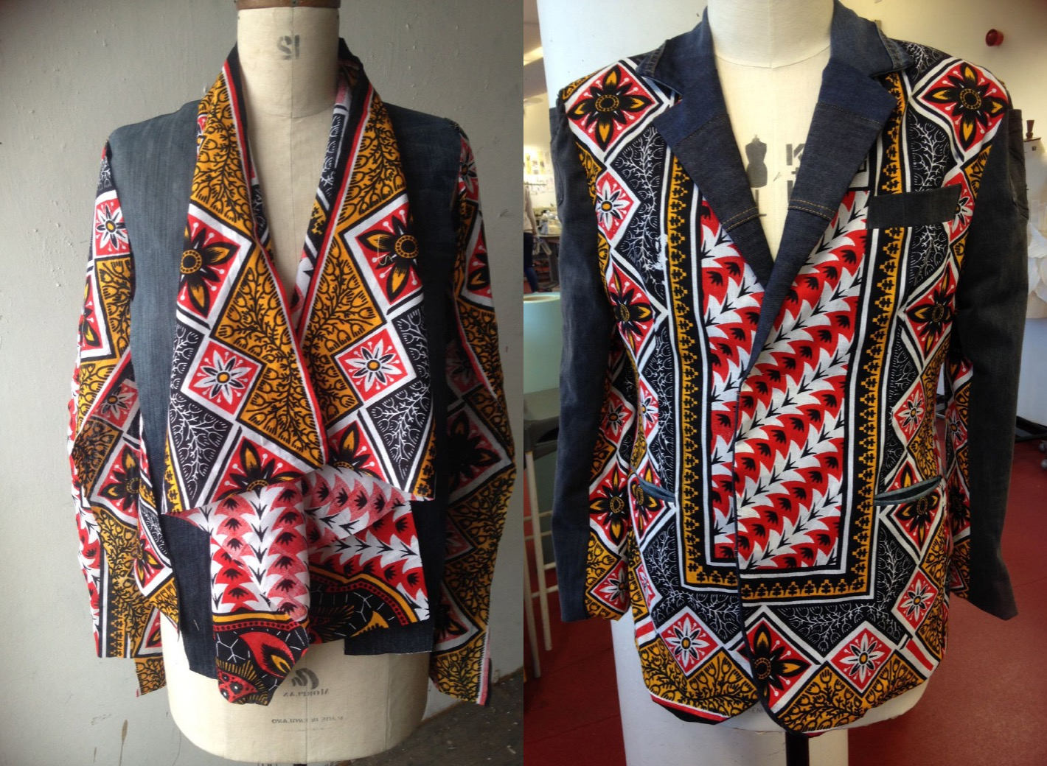

Figure 5: Mixing Kanga fabric with recycled denim/jeans (Shah, 2016)

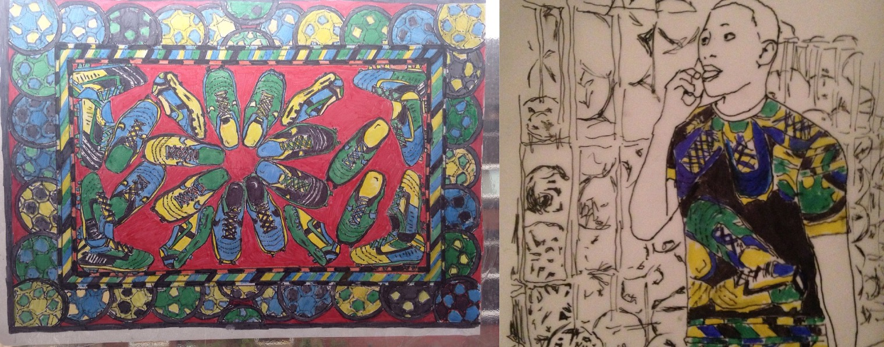

Figure 6: Football Kanga design and imagined as contemporary garment (Shah, 2016)

Laying Flat
This technique was developed as a potential solution for re-appropriating waste into production systems that necessitate the need for the fabric to be presented flat for textile finishing and manufacture (Shah, 2016b). One of the key characteristics of recycling is that there is little uniformity in either the size or quality of pieces of fabric and that an element of deconstruction needs to take place in order to extricate fabric from the original garment. Once this is done pattern pieces can be laid on the fabric or it can be presented to a mannequin to begin the design development and cutting out process. Traditional production, on the other hand is characterized by its uniformity of inputs and outputs and thus waste inputs need to be formalized and in an appropriate state to be acceptable to systems of manufacture. Drawing on methods of dealing with animal skins in the fashion industry and series of fabric samples were developed that presented the fabric in a flat form ready for cutting and manufacture. In this process ‘patches’ of fabric were collected from the waste item (cutting out defects, stains and holes), butted together and then joined. This resulted in a skin of fabric from which a pattern could be laid on top and cut out. As a preliminary investigation collaboration was sought with a CAD/Apparel Systems company (AssystBulmer) who helped to visualize how the skin of fabric may be uploaded onto relevant systems prior to cutting out and manufacture and also how the garment would look. This gave good results and showed that irregular shapes of fabric could be uploaded into the system and from there digitally manipulated to not only show the lay of the pattern on the fabric but also how the garment would go together (Figures 8-10.

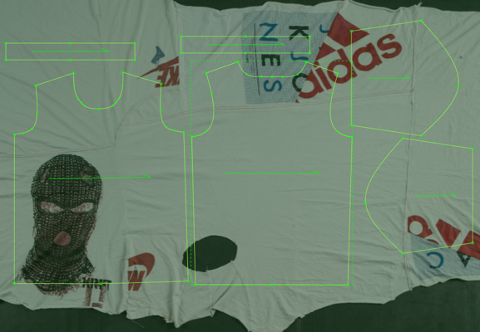

Figure 8: Fabric ‘skin’ that has been produced from a number of discarded T-shirts and with superimposed pattern pieces for a simple T-shirt and resultant computer simulated top (Geoff Ward, Assyst Bulmer, 2016)

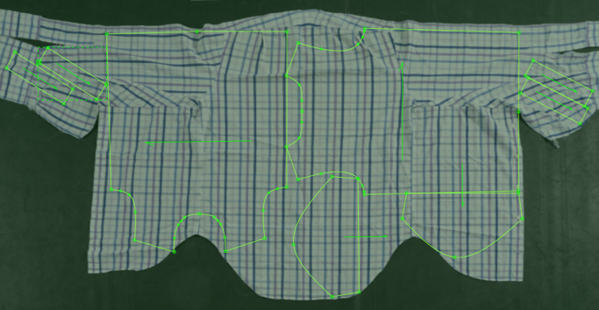

Figure 9: Pattern pieces superimposed onto flattened shirt and computer simulation of resultant top (Shah & Ward, 2016)

To take the research further more skins of fabric will be produced and investigation will be undertaken to apply print and seaming details to see if a range designs can be produced that are appropriate for a number of manufacturing scenarios.. One of the key issues in designing for traditional production is the need for consistency, standards and quality control – all of which become problematic when introducing a resource that is inherently inconsistent, of varying quality and un-uniform in both aesthetic, fibre composition and fabric structure. The focus for investigation will include the cotton jersey T-shirts, cotton shirts and household linen and jeans/denim items, after which efforts will be undertaken to connect with and foster production systems both in the UK and Tanzania.

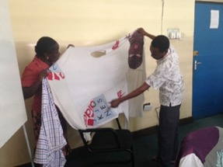
Figure 10: Tailors at co-design workshop handling fabric and assessing fabric potential

SUBSTANTIATION

The means through which ideas developed in the UK were measured for their feasibility and appropriateness in a Tanzanian context occurred during the course of a co-design workshop, and subsequent communication, concerned with whether it was possible and/or appropriate to use second-hand clothing in the development of a national dress for Tanzania. Participants of the workshop included local tailors, businesses, designers, teachers and researchers/students as well as representatives from the Textile Standards Board, Dar Es Salaam University, the Arts Council of Tanzania and representative from an AIDS charity. Participants were organized in specialist and mixed groups and this provided the opportunity to share ideas and debate the key issues. Activities included focused presentations on varying topics, feedback presentations, a field trip and design and making tasks. Field visits to local markets, an interview with a prominent Tanzanian fashion designer Manjou, discussions with Kanga (fabric) sellers and a trip to a tourist market, all in Dar Es Salaam, formed the basis for design discussions and development. Analysis of interviews and observations helped to substantiate conclusions in terms of re-appropriation and the circular economy by devising the following hypothesis.

To move into a circular economy necessitates the development of circular manufacturing systems. These systems can operate on a variety of scales but are reliant to the closing of loops and of having appropriate resources in terms of quality and design appeal. In the case of the export of second-hand clothing to Africa, the remanufacture of SHC and its export back to America would appear to the joining of these two parts. It would generate income for the sender and an opportunity for the receiver to reflect upon their shopping habits. To facilitate this joining certain conditions exist. These include a commitment by the western fashion system to address its overproduction and consumption and to more fully assess the impact of the export of second-hand clothes, many of which carry their labels. Together with the development of remanufacturing workshops to help convert waste and the generation of styles and designs that are more fully embedded with meaning and capable of being coveted for longer.

Discussions with participants of the workshop revealed how second-hand clothing, as in the discarding of ones clothes is not a common practice but that if they did find that they no longer required something that it was likely to be passed down through the family or taken back to their village when they returned for holidays. However, it was revealed that this was changing and that internal recycling of clothes existed through charities and certain networks. There was generally a very positive attitude towards the consumption of second-hand clothing saying that it offered individuality, quality, affordability and availability. The negatives being that the shopping environment was generally not conducive to trying on clothes and could entail sorting through large piles of clothes just in the hope that you would find something. It was also concluded that a National Dress was needed in Tanzania to satisfy the demand for items that could be worn at special events and to boost National identity. It was recommended that this should be acceptable to all, communicate notions of individuality and also of unity and be made of cotton (and possibly mtumba). In terms of manufacture it should link into both small/medium activities currently operating and also investigate the potential and feasibility of larger scale operations. It should take account of religious beliefs, with appropriate motifs related to nature, animals and relevant political symbols and iconography.

CONCLUSIONS

Embedding recycling practices, and utilizing second-hand clothes/mtumba in the development of products suitable for both local and export markets did at first appear a rather strange proposition to some of the participants of the workshops. There was a real concern that there were many health hazards in handling the mtumba and that alternative methods for dealing with the waste were needed. These included ragging and converting the materials back into polymers, areas of research that appeared to be developing at the University. Issues to do with capacity and equipment were also raised. However, it was concluded that the co-design process had been a success and rather than closing a loop in a circular way it had actually opened up a spiral. Cross-cultural communication is key to closing gaps and how we moving forward in the development of circular practices. Many activities need to function side by side in order to succeed with design playing a large part. Initiatives for processing materials and bringing them back into a circular manufacturing system will take time but could provide a great benefit to a country such as Tanzania. There is potential for the embedding of meaning into design outputs that will communicate not only aspects of nationality but also identity and aspirations. In developing garments for export an opportunity exists to send garments back from where they came and in the process use income as a source of investment for the indigenous clothing and textile industry. The development of a National Dress, based on recycling second-hand clothes, would generate interesting insight into the processes of design and how it may be used as a tool to convey complex political issues, social conditions. The development of new cloth could also be used as a way of embedding meaning into items made from waste. Just maybe, the westernized fashion system may have something to learn about how we can design for longevity, meaning and environmental justice.

Bibliography

Bauman, Z., 2005, Wasted lives: Modernity and its outcasts, Polity Press, London
BBC, (2016), Why East Africa Wants to Ban Second-hand Clothes”, www.bbc.co.uk/
Braungart, M. & W. McDonough, 2008, Cradle to Cradle: Re-Making The Way We Make Things, Vintage Books, London
Brooks, A., 2015, Clothing Poverty: The Hidden World of Fast Fashion and Second-Hand Clothing, Zed Books.
Brown, S., 2011 Eco Fashion, Laurence King, London
Brown, S., 2014, Refashioned – Cutting Edge Clothes from Up-cycled Materials, Laurence King, London
Cline, E., (2014), “Where Does Discarded Clothing Go ?” www.theatlantic.com/ business/archive/2014/07/where-does-discarded-clothing-go/374613
Dissanayake, G., & Sinha, P. (2015). An examination of the product development process for fashion remanufacturing. Resources, Conservation and Recycling, 104, 94-102.
doi:10.1017/S0960777313000192
Farrant L, Olsen SI, Wangel A (2010) Environmental benefits from reusing clothes. Int J Life Cycle Assess 15(7):726–736.
- Foote, S., & Mazzolini, E. (2012). Histories of the dustheap: Waste, material cultures, social justice. US: Mit Press.
Isla, V. L. 2013. Investigating second-hand fashion trade and consumption in the philippines: Expanding existing discourses. Journal of Consumer Culture, 13(3), 221-240.
Ritzer, G. (2004). The globalization of nothing. Thousand Oaks, Calif; London: Pine Forge.
Scanlan, J., 2005, On garbage, Reaktion Books, London
Shah, 2016a, Ketchup clothes: a catalogue of ideas , https://designforinteractivity.files.wordpress.com/2015/05/part-1.pdf
Shah, K 2016b ‘From Skip to Catwalk: An Investigation into Viable Pattern Cutting Techniques for Recycled Clothing.’. In: The Second International Conference for Creative Pattern Cutting, 24th - 25th February 2016, University of Huddersfield, UK
Shah & Kahabi, 2016, Revolutions come in cycles: mapping new paradigms in fashion research and practice to social change in Fashion: Exploring Critical Issues 8th Global Meeting 5-7th September, Mansfield College, Oxford, UK https://designforinteractivity.files.wordpress.com/2016/09/revolutionscomeincyclesfinal.pdf
Wheeler, A, (2016), Clothing Industry Wakes up to Sustainability in Recycling and Waste World : A Catalyst for Positive Change in the Resource Mangement Community
- Whiteley, G. (2011). Junk: Art and the politics of trash, London: I.B.Tauris.
Wrap, 2012, Valuing our clothes: the true cost of how we design, use and dispose of clothing in the UK www.wrap.org.uk/clothes

