The Value of Design in Craft for a More Sustainable Future
Tracy Cassidy
University of Huddersfield

Abstract:
Key concepts of sustainability in the contemporary consumer society include cradle-to-cradle, slow-fashion, locally-made, re-use, recycle and re-make (or upcycle). Each of these concepts focuses on the design and manufacture of products that are essentially made to comply to a theoretical sustainable framework, thus enabling people to live in harmony with our planet. In an ideal world we would consume and waste less however, to be truly sustainable we also require a healthy economy and so there is dichotomy to be resolved in our consumption behaviours and economic needs; Craft practices have been identified as fitting the bill rather aptly allowing us, in theory, to consume goods at less expense to the environment. Currently we are experiencing a period of, let’s call it Crafts Nouveau, unlike the Arts and Crafts Movement of the late nineteenth and early twentieth centuries where craft was employed by designer-entrepreneurs, and unlike the Art Nouveau Movement which again harnessed the skills of designers and artists, today amateur craft-workers are joining the trained artisans in bringing hand-crafted items to the marketplace in their droves. Online platforms such as eBay and Etsy are helping such keen, but untrained producers of craft articles to set up micro businesses to sell their wares adding considerably to the amount of stuff available to consumers. As Luckman (2013: 260) states with regard to Etsy, there is ‘no gatekeeping around formal training’ and that this ‘inclusiveness’ potentially fixes a price of less value to all craft items, including the work of those with comparatively higher skill sets and expertise. The Craft Council (2014) reported 11,620 craft businesses operating in the UK employing around 43,250 people, of which, almost 17% are unregistered microbusinesses; while it is not to say that all of these unregistered businesses are run by amateur crafters, but the concept of devaluing skilled craft labour may still be appreciated within this.
This paper explores the value of design in craft from a theoretical perspective, drawing on a broad range of texts beyond those confined to craft to bring about a more holistic understanding within the context of sustainable production, with the addition of observations and insights from personal experience. The personal insights originate from the researcher’s accounts and observations of the journey from crafter to trained designer to master class practitioner in order to better understand the role of design in craft in the applied sense. The researcher continues to practice secondary to academia for the purpose of pleasure, experimentation and for further learning and research purposes. Research approaches are used to develop this inquiry to evaluate the role of design in the wider concept of craft as a sustainable means, both economically and socially. While the larger body of research considers a range of crafts, the emphasis in this paper is on those related to textiles given the researcher’s experience and the relationship with fashion, trends and marketing, which must not be discounted as a driver of the current craft revival. As the research study is still in its infancy the purpose of this paper is to attempt to begin to consolidate a range of perspectives gained from theory and observational research in order to invite a critical debate around the value of design in craft and the new craft movement in the context of sustainable futures.

Brief personal background and rationale for the study
Crafts have always played an important part in the life of the author beginning with childhood activities such as bobbin knitting, painting by numbers, cross stitch and making small textile animal toys. Some of the activities were undertaken at home and others at school and at Brownies / Girl Guides. Prior to leaving school hand knitting had become not just a hobby but also a means for creating exciting unique wears. There was of course the added attraction of being able to watch television and listen to popular music while making a new garment to show-off at the next high school event or weekend disco at the local town hall. Having learned basic needlework and dressmaking skills at school it felt natural to use these for a new business venture making bespoke bridal-wear after deciding that selling fashion on a market stall had lost its appeal due to the limited stock variations available at wholesalers. The author is blessed to have been taught pattern drafting and pattern cutting by a wonderful elderly lady at adult college who had a lifetime’s worth of experience clothing all members of her family. While bridal-wear design and production was a highly fulfilling and privileged occupation the love of creating the textile as achieved through knitting was sorely missed and instigated a move back to knit. In order to fully appreciate knit design and to refine and expand on production knowledge and skills, at a mature age, the author embarked on an undergraduate degree, BSc (Hons) Knitwear Design & Production, and continued through to Master’s and PhD before establishing an academic career.
Forever the student, the author’s love of antiques and vintage for the home led to an interest in upholstery and a master class course was undertaken working with traditional and contemporary techniques and materials. It was at this point that the principles of design and design integrity came to the forefront of the craftwork undertaken; and hence the development of the rationale for this theoretical study based upon reflections of practice and the current popularity of craft-based micro businesses, predominantly through online platforms and craft fairs. Recycling, or re-using products is considered to be highly beneficial to the environment. Similarly restoring items and using upcycle techniques to create new products from old with a higher monetary and aesthetic value have become popular practice incorporating the concept of sustainability. Such practice has enabled many individuals and small companies (micro-businesses) to establish hobby / part-time or full-time enterprises. However, while this practice keeps product from landfill, as new product still floods the market, then there is even more product in circulation and therefore the competition for sales increases. We are all well aware of the compromise on quality for low cost production, it is the quality of the resulting products in the marketplace from the craft-based enterprises operating predominantly through online platforms such as eBay and Etsy that is in question in this study, as individuals with no formal design knowledge or training can easily enter the market; and hence exploring the value of design in craft from a sustainability perspective.

An example of poor design in upholstery
The chair shown in figure 1 below shows a mid-nineteenth century nursing / arm chair fully re-upholstered in a contemporary fabric and otherwise traditional materials (horse-hair) and techniques. The shaping of the inner upholstery works with the chair frame shown in the two images in figure 2. Figure 3 shows two images of the chair in its previous re-upholstered state where no consideration had been given to the design of the chair frame, nor to the end aesthetic, nor to the use of appropriate materials. While one may profess artistic licence the customer of the chair in figure 3 is getting a substandard product made with materials that are particularly damaging to the environment when discarded to landfill. The author agrees with William Arthur Smith Benson of 1893 (Adamson, 2010: 16) that there is a the need for the student (craftsperson / entrepreneur) to understand ‘beauty’ and to realise a ‘lifelong respect for craftsmanship’ and similarly with Hal Riegger’s insistence when speaking of pottery, the ‘responsibility’ of the craftsperson ‘for the whole process’ having ‘an ethical as well as a practical aspect’ and that ‘apparently simple techniques can often require more rather than less skill, because they lack the safeguards of more technically complex processes’ (Adamson 2010: 34); thus inferring in this that individuals with no knowledge or regard for design and craftsmanship will invariably compromise on product quality, if not also the design aesthetic.
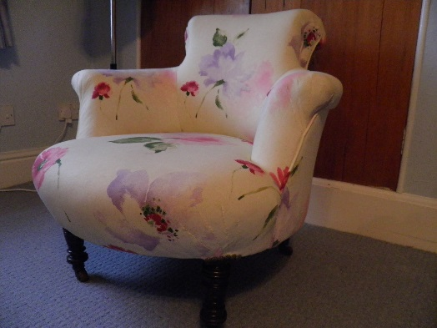
Figure 1: Newly upholstered mid-nineteenth century nursing / arm chair re-upholstered in a contemporary fabric with traditional materials and techniques with deep consideration of the frame design in relation to the intended aesthetic look of the end result.
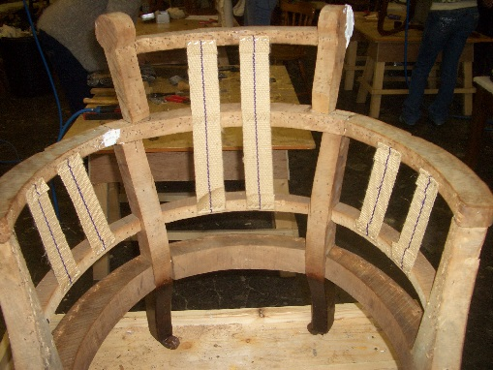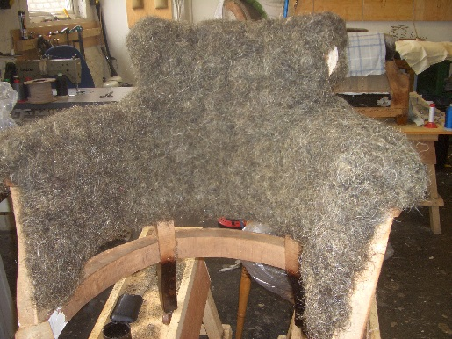
Figure 2: The stripped chair frame with new webbing (left-hand image) and (right-hand image) the chair frame with the beginnings of the horse hair stuffing applied to the inner back and sides (traditional materials and techniques).

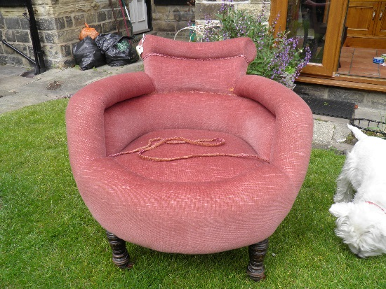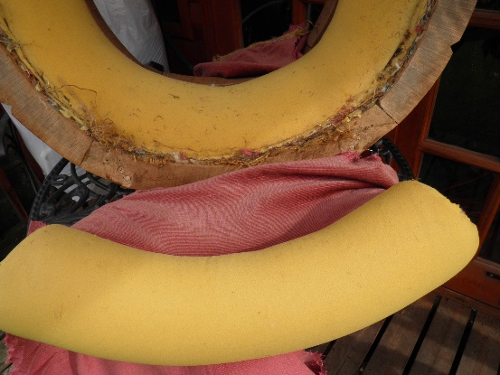
Figure 3: Previously re-upholstered c. 1970s with modern foam materials. The left-hand image shows the over-all re-design and the right-hand image shows the non-traditional material padding which is considered to devalue the chair in relation to its age. The stuffing materials are also harmful to the environment when disposed of.

The chair shown in figure 3 above was purchased from a local auction house. The materials used suggest that the chair was re-upholstered in the 1970’s at a time when the craft of upholstery experienced a revival. The quality of the upholstery work itself would suggest that of an upholsterer with some degree of experience. However, the attempt at changing the shape of the chair resulted in a rather bulky and disproportionate appearance for the size of the chair. The seat is approximately 12 inches (30 centimetres) from the floor and the top of the chair back 28 inches (72 centimetres) from the floor, the maximum width to the outer points of the chair’s arms is only 29 inches (74 centimetres). The chair in its formerly re-upholstered state was rather uncomfortable as the shaping was intrusive as opposed to offering comfortable but firm support for the sitter. As can be seen in the left-hand image of figure 4, the original stuffing was retained and poor quality foam was simply applied over to achieve the change of shape. The top fabric is typical of 1970’s upholstery. There were minor structural defeats that the previous upholsterer had failed to repair. The necessary repairs made during the recent upholstery work can be seen in the right-hand image of figure 4.
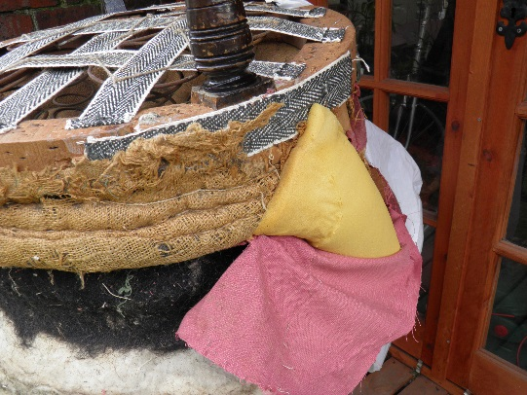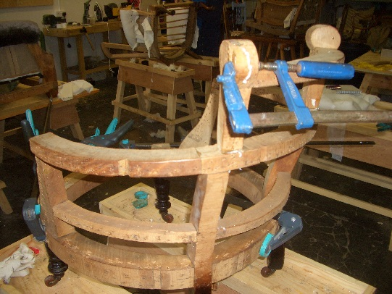
Figure 4: The left-hand image shows the original stuffing materials that were exposed when removing the top fabric and the foam stuffing that had been applied during the previous re-upholstery work. The repairs necessary to ensure a safe and sturdy chair frame are shown in the right-hand image. The clamps hold the frame in place while the wood glue dries around the wooden dowels.

It was common practice in the 1970’s to simply replace the top fabric or to do minor repairs to the stuffing. This was not however a sustainability solution, rather it was a low-cost re-upholstery solution.
While sustainability was not at the forefront of production and craft practice in the 1970s, having stripped this chair and others, the understanding of sustainability issues and how these realistically impact the practice of amateur crafters is in question in this study; in addition to the role of design and craftsmanship.

Craftsmanship
Frayling (2011: 1) speaks of the fashion-ability of craftsmanship increasing in times of economic downturn and that craft itself, as an activity, requires ‘skill’, skills that Richard Sennett (2008: 9) may akin to the need for a ‘desire to do a job well’. The author’s concern is mirrored in Fraying’s (2011) modern day notion of craft being one from the television viewer’s perspective ‘watching [the experts] from a distance, while sometimes encouraging less skilled punters to have a go themselves’. Where the activity is cookery or gardening the efforts of the novice will of course only affect their nearest and dearest, but when engaging with crafts for the sake of selling their wares to an unsuspecting marketplace good intentions may still result in products of low quality and low sustainable design consideration. As Richard Sennett (2008: 59) states, ‘craft, the pleasure of making and the time taken in improving skills are just as important to the functioning of a modern society as they were in the medieval era of the guilds’. The problem today may be considered to rest in the lack of quality control that was instilled through the crafts guilds; and the lack of mindfulness of design by the novice craftsperson, in addition to lacking sound knowledge of the chosen craft practice.

The current position of craft in the hand-made marketplace
The craft movement in the UK and Europe is of a similar make-up to the Indie Craft or Indie Design Movement that appears to be more predominantly promoted as happening in America. Indie for some comes from individual, for others from independent, but always comprises those who would describe themselves as craftspeople, designers or artists. The inclusion of design in their making processes appears to be rather intrinsic which would suggest that resulting products are more ethically and sustainably produced for those who enjoy craft items. Products are sold through online platforms, particularly Etsy and also through organised street markets and craft fairs. Andrew Wagner (Levine and Heimerl 2008: 1) believes that some embrace craft items for the craftsmanship quality recognising the crafter’s time and effort, and others enjoy the uniqueness of the items. While Sabrina Gschwandtner (Levine and Heimerl 2008: 26) realises a need for people to ‘maintain a tactile relationship [with] the world’. The resurgence of craft, evident across the UK, Europe, American and Australia predominantly, in accordance to Luckman (2013: 249) is largely due to younger consumers coupled with the potential of the internet for small-business capability, ‘where amateur producers with no formal training can set up a creative business’. The ease of networking and incorporating the internet into the supply chain is considered to be a ‘vital’ element of online business models that has aided the ‘renaissance of craft practice’ (Luckman 2013: 251). It is this ‘stripped-back value chain, the satisfaction of buying direct from the artist that made the work’ which contributes to the sense of local and ethical practice (Levine and Heimerl 2008: ix).
James Evans (Johnson 1998: 39), when talking about craft practice, proposes that ‘significant work involves focus, skill, instinct, poetics of the body, movement, commitment to the object, determined realisation, continual absorption of all past methods, rhythm, spontaneous improvisation, and a veritable jazz dance of the hands’. The expectation of designers and artists achieving all of this may be considered by some to be unachievable, let alone to expect this level of skill, knowledge and appreciation from novice crafters! Such levels of expertise have been questioned by author and craft practitioner Mary Butcher (Johnson 1998: 57) who states, ‘as a basket-maker, often working with traditional makers of whom may take part in an industrial process, I have been concerned with the levels of technical expertise in and with the form, in relation to its function’. Platforms such as Etsy openly welcome amateur crafters (Luckman 2013: 261), in doing so the value of design within craft items and the quality of the products is to be determined by consumers, who often cannot make such an informed evaluation in the online environment that can be achieved when viewing goods physically off-line. A further consideration is the possibility of enhancing the look of products digitally, Garth Johnson (Levine and Heimerl 2008: 30) suggests it is reasonable to assume that Etsy and other such commercial site users may indeed ‘tailor their work to look good on an LCD screen’ implying that products are designed more for marketability than for functionality and sustainability; or worse, artificially enhanced with digital graphics tools. Obviously sellers on Etsy will want to develop trusting long-term relationships with their buyers for continued sales, this in itself does not guarantee that the craft-seller will ensure that their work meets the same degree of quality that trained designers, artists and master-class practitioners strive for.

Design and Sustainability
In 1972, designer and educator, Victor Papanek, famed for his advocacy of responsible design, socially and ecologically, had accused designers of ‘creating useless, unnecessary and unsafe products’ and promoting ‘materialistic lifestyles’; obviously the opposite of what we would determine to be sustainable design and practice also today; and today still consumer industries are over-producing goods and encouraging excessive consumption habits, creating what Papanek coined an emphasis on ‘stuff-lust’. A concept that Chris Sherwin (2012), head of sustainability at Seymour-Powell design and innovation consultancy, had also questioned at the onset of the 2012 London Design Week perceiving the next lot of emerging product as destined for landfill. The value of product, or perhaps more precisely, the cost of product goes a long way to devalue the products we buy and determines the length of time we take ownership of those products. Sherwin however did realise that design skills are to be more intrinsic in the production of sustainable products where ‘creativity, entrepreneurship, innovation and practical solutions’ are purported to be central to the next ‘wave of sustainability’. Trend Forecaster Lidewij Edlekoort (n.d.) reported the timeliness of ‘empowering goods with their own character, an invisible energy locked into the design process’ as ‘design and craft meet’ through the hand-made. Edlekoort declares that ‘only when design [is] empowered with emotion will we be able to create a new generation of things that will promote and sell themselves; able to seduce even the most hardened consumers’ when design acquires ‘a soul’ and that ‘craft holds this promise’. Of course, the ethics of such thinking is to be questioned as it further supports the creation of stuff and the promotion of stuff-lust that is contributing to the problems of sustainability. With a slow-down of trends and improved design quality of products the need for regular trend updates would be obsolete, a fact that the trend forecasters know only too well! However Edlekoort does states that ‘some of the craft items will become new design collectibles within a matter of decades’. This could only be possible if products were suitably designed using high quality materials and techniques to better ensure a longer life-cycle. Such product surely could only be realised through experienced, as in well-trained, designers and artisans who have a clear understanding of their craft in relation to sustainability, and a high regard for design and craftsmanship.

Value and cost
Another theoretical area of interest that deserves some consideration is the concept, or perception of value in relation to cost. William Poundstone (2010: 5) proposes that consumers do not really ‘know what anything should cost, and that judgements of monetary value are based on aspects such as ‘weight, brightness, loudness etc.’, this concept, known psychophysics suggests that consumers are somewhat guided by market prices in order to make assessments of what they determine to be value for money. Unfortunately, mass-produced items of low-cost, low-design consideration, low-sustainability consideration, and therefore of low value and marked-up at low price points are invariably creating the anchor price that Poundstone discusses at great length. According to Poundstone (2010: 14) anchoring, ‘an artefact of guessing’, is a monetary value that a person believes to be a true representation of the items worth, at least what it is worth to them. This is not necessarily a low price, as in relation to a person’s personal monetary value of that item a lower than expected price may suggest to that individual that the product is in some way substandard. Higher prices will generally suggest a higher quality product but individuals’ will have a top limit that they are willing to pay even if they can afford the expense. Interestingly Poundstone (2010: 9) quotes Dan Ariely et al (2003), who, when researching car boot sales conclude ‘prices are made up numbers that don’t always carry much conviction’. This also suggests that sellers, as well as buyers work with price in a subjective manner. The advantage of a car boot sale is that both parties can, and often do, engage in a bargaining, or negotiation process where a price can be agreed where both seller and buyer feel that they have achieved a fair price for the item. This process is also possible between crafter and buyer at craft fairs and of course on sites such as eBay where the best price may be achieved from the auction process and the seller can protect their lowest offer. This is not however possible on sites such as Etsy where negotiation is not an option for either the seller or for the buyer. This is to ensure that craft-sellers achieve their asking price in order to operate a profitable business and to therefore not be exploited by the marketplace. Another noteworthy point is competition on sites such as eBay and Etsy, most sellers will attempt to entice a potential buyer’s interest through a low price strategy. Buyers will see low prices as the anchor price, as discussed above, and therefore makes it more difficult for sellers of high quality product to sell at a fair price for their work. Of course the craft worker must justify their prices and deliver on these promises for consumers of their craft items; implicit in this must surely be value for money through design (materials, processes and aesthetics), which brings us back to craftsmanship.

Reflection on practice
The role of design in craft and craftsmanship in practice has been fully appreciated by the author on a very conscious level through reflections on practice, both retrospectively, on practice, and more recently through practice while engaging with the master class training in upholstery. The reflections however have happened largely due to being an academic researcher with a breadth of knowledge of research practice and methodologies; one could ask if this would have happened to the same level otherwise.
As a crafter the emphasis was on enjoying the craft process and having pride in the end product with a conscious effort to improve techniques and to work at a comfortable speed. When later engaging with the formal and structured learning of the adult class the emphasis shifted towards professionalism as craft skills were now the basis of a business venture. During the undertaking of the BSc degree the learning was obviously more involved as there were now a number of modules to engage with simultaneously that each added more value to the design process, including developing sound knowledge of fibres, materials, structures, tools and techniques, and applying this knowledge to the design of products for a range of commercial applications and considerations. The emphasis now became proficiency and sound knowledge, not just of the craft (for bespoke practice and industrial practice) but also of the wider marketplace and potential consumer. On reflection therefore from crafter to designer there was a conscious move from solely developing practical skills. The importance of the fibre content, the yarn construction, the colour – in particular as this now has a long standing presence in the author’s research portfolio – drape and handle in knitwear, all of the foundations of design were not previously considered let alone engaged with as a crafter. The ability to take more control of the design decisions and to conceptualise end products, using a range of researched inspirations for more unique outcomes was liberating. Understanding the commerciality of products and designs moved the boundaries of designing for one-off pieces towards the concept of mass production. However, there was never any ambition, nor real interest to operate, or to be involved in industrial practice. Rather, the area of small-scale production and uniqueness in products became ever more important, though it was not considered wrong to use machines and power tools when the process of making can be improved in some way. Reflecting on this, there can be equal skill in operating some machinery as in the hand-craft method, being able to make informed choices of which technique to use adds somewhat to the individuality of the particular item being made, and therefore can be used as an integral part of the design process. What stands out very clearly at this point in the reflection process is that of designing products in the hope of them selling, something that can happen at craft level and most definitely happens in mass production practice. In terms of sustainability such products tantamount to waste; wasted materials, wasted energy; wasted time and invariably wasted marketing efforts. This is equally as disastrous as used products entering the end-of-lifecycle stage. The importance of experimenting to improve the design of the product is paramount. The industry prefers to engage with this process in digital form to reduce material waste and may actually be counter-productive in aiding industry to design unwanted goods, perhaps a more creative use of the material waste after a physical experimental process may better serve the industry; though this is of course the thought of the author and would need to be substantiated.
At the time of studying for the Degree sustainability was still little considered at the end-of-product-life stage, there was more emphasis on the environmental impact of fibre / yarn / fabric production, particularly with the by-product and toxic waste resulting from the processes used to create yarns, and dyeing and finishing applications. Consumer behaviour and the disposal of products was little considered at that time as it is now in formal design education. Understanding consumer behaviour is now more integral and of equal importance in the design to produce more desirable and better functioning products, yet in reality we have a serious waste issue to deal with and ever more product in the marketplace. Consumers appear to be little educated and aware of their responsibility in the consumption process and industry is still more concerned with creating ‘stuff-lust’. The practice of the trend forecasting industry sector aids the industry in its quest for encouraging sales through excess consumption and therefore contributes in their own way to some of the sustainability issues faced today. The concept of trend forecasting, particularly in relation to colour led to PhD study. Through this reflection, engaging with theory is now considered to be a very important part of the process of exploring the role of design both in craft and in the wider context of sustainable practice, rather, it would be fool-hardy to believe that sustainable practice could only be appropriated through practice. Essentially the practice of life-long learning is more in order and poses the question of how well informed those amateur crafters who earn a living through micro and small-scale enterprises (MSE’s) are of the importance of understanding the wider industry that they are operating within; and do they fully understand sustainability and sustainable practice? If not, how can one presume to be operating sustainably? There are numerous questions to be asked here for inclusion in the larger research study.
The master class upholstery course opened another opportunity to re-think sustainable practice in the craft context and the role design plays in this. Learning the traditional and modern upholstery techniques and understanding the different materials for these very different applications was particularly interesting in terms of one’s own development process from a skills perspective, but also in fully understanding the concept of ‘added value’ and hence the value of design in a craft activity. While undertaking a variety of upholstery projects, each involving the stripping back of all existing materials to the bare frame, connections were easily realised of similarities between the fashion designer who works with the dress stand, or Human form (the client), and the upholsterer. In the case of the upholsterer, when working with a stripped frame it is akin to working with the skeletal framework of the Human body. From this basic form designers / crafters visualise the desired look of the end result and set to work on manipulating materials to achieve this. Craft-workers who are not trained in this process or sufficiently intuitive enough to naturally operate in this way will produce something more haphazard, which may have appeal to the marketplace but is unlikely to be a very sustainability-friendly item. There is unlikely to be any consideration of how to reduce waste from the production process or what to do with waste acquired let alone how the consumer will use and ultimately dispose of the item. In learning traditional processes the reasons for not cutting corners in the use of appropriate materials and the time taken to ensure the processes are done correctly regardless of time involvement is evident. Rather than devaluing the end product it is more desirable to practice the craft until the crafter can work at a speed that will still ensure that a fair price can be achieved but not at the expense of quality. This surely must be considered to be more sustainable practice.

Conclusion
In this paper the early development of a larger research study is purposely deliberated in order to invite critical debate around the value of design in craft in relation to the new craft movement and in the context of sustainability. Currently sustainability and sustainable practice is considered more in large scale business practice and consumer behaviour aspects predominately creating waste and landfill challenges. This paper considers sustainability in the craft sector as craft practices are purported to offer appropriate solutions. The paper considers the further influx of product in the marketplace through online sites such as eBay and Etsy and physical sites such as craft fairs as more amateur crafters are using these as a basis for micro and small-scale businesses. While the author would like to encourage more such practice in order for this to happen in a sustainable manner then it is believed that crafters require highly developed practical skills, a sound knowledge of their craft and the wider commercial sector that their business sits within, competence and proficiency in their craft practice and a full understanding of the materials they work with including the threats and implications those materials can have on sustainability concerns. Essentially craft-workers should have formal design knowledge and experience having high regard for the role of design in their craft practice. The paper makes these conclusions through a reflection on own practice development and theory from a broad range of texts to bring about a more holistic exploration of the subject. Opportunities for further debate is sought and grant applications are on-going to undertake a rigorous research study in the future.

References
Benson, William Arthur Smith (2010) ‘Elements of handicraft and design’, in Glenn Adamson (ed.) The Craft Reader, Oxford, England: Berg, pp. 16-21.
Butcher, Mary (1998) ‘Personal practice and expression of theoretical principles in traditional and modern basket-making’, in Pamela Johnson (ed.) Ideas in the making: Practice in theory, London, England: Crafts Council, pp. 57-66.
Edlekoort, L. (n.d.) ‘Trend Tablet’ www.trendtablet.com/10019-when-design-craft-meet/ [Accessed 18 January 2016]
Evans, James (1998) ‘Significant work: Towards a framework for the understanding of craft practices’, in Pamela Johnson (ed.) Ideas in the making: Practice in theory, London, England: Crafts Council, pp. 33-40.
Frayling, Christopher (2011) On Craftsmanship: Towards a new Bauhaus, London, England: Oberon Masters Books.
Gschwandtner, Sabrina (2008) ‘Knitknit, NY’, in Faythe Levine and Cortney Heimerl (ed.) Handmade Nation: The rise of DIY, Art, Craft and Design, New York: Princeton Architectural Press, pp. 26-29.
Johnson, Garth (2008) ‘Down the tubes: In search of internet craft’, in Faythe Levine and Cortney Heimerl (ed.) Handmade Nation: The rise of DIY, Art, Craft and Design, New York: Princeton Architectural Press, pp. 30-35.
Luckman, S. (2013) ‘The aura of the analogue in a digital age: Women’s crafts, creative markets and home – based on labour after Etsy’, Cultural Studies Review 19, 1: 249-70.
Poundstone, William (2011) Priceless: The hidden psychology of value, Oxford: Oneworld
Riegger, Hal (2010) ‘Primitive Pottery’, in Glenn Adamson (ed.) The Craft Reader, Oxford, England: Berg, pp. 34-39.
Sennett, Richard (2008) The Craftsman, London, England: Penguin Books.
Sherwin, C. (2012) ‘Sustainability is the ultimate design brief’, The Guardian, 17 June, www.guardian.com [Accessed 20 August 2015]
The Craft Council (2014) Measuring the Craft Economy, Report 3, London, England: TBR’s Creative & Cultural Team.
Wagner, Andrew (2008) ‘Preface’ in Faythe Levine and Cortney Heimerl (ed.) Handmade Nation: The rise of DIY, Art, Craft and Design, New York: Princeton Architectural Press, pp. 1-3.

