A novel method to estimate the stiffness of carbohydrate polyelectrolyte polymers based on the ionic strength dependence of zeta potential

Atiga Abodinarª, Alan M. Smith^{b} and Gordon A. Morris^{a,}
ªDepartment of Chemical Sciences, School of Applied Sciences,
University of Huddersfield, Huddersfield,
HD1 3DH, UK
^{b}Department of Pharmacy, School of Applied Sciences,
University of Huddersfield, Huddersfield,
HD1 3DH, UK

Corresponding author
Tel: +44 (0) 1484 473871
Fax: +44 (0) 1484 472182
Email: g.morris@hud.ac.uk

HIGHLIGHTS
- A novel method for estimating the Smidsrød-Haug stiffness parameter (B) is proposed
- B can be estimated using the ionic strength dependency of zeta potential
- B values are consistent with traditional estimates
- Values of B can be used to estimate the intrinsic persistence length

ABSTRACT
Polysaccharides have received a great deal of attention from, for example, the food, cosmetic and pharmaceutical industries. Their conformations (flexibility/ stiffness) span a wide range of conformational flexibilities with large hydrated volumes, these properties are important in relation to polysaccharide structure - function relationships.

Perhaps the simplest parameter available to estimate the dilute solution conformation of polysaccharides is the Smidsrød-Haug stiffness parameter (B) where the stiffness of polyelectrolytes can be estimated by measuring the intrinsic viscosity at a number of different ionic strengths.

In this paper we propose an alternative method for estimating the Smidsrød-Haug stiffness parameter (B) using the ionic strength dependency of zeta potential. For this purpose we have studied a number of different polysaccharides.

KEYWORDS: intrinsic viscosity; zeta potential; polysaccharide conformation; persistence length

- INTRODUCTION
Polysaccharides have received a great deal of attention from, for example, the food, cosmetic and pharmaceutical industries. Their conformations (flexibility/ stiffness) have been characterised using a variety of hydrodynamic techniques including sedimentation velocity, size exclusion chromatography – multi-angle light scattering (SEC-MALS) and viscometry. Results have shown that polysaccharides span a wide range of sizes and conformational flexibilities with large hydrated volumes, these properties are important in determining polysaccharide structure - function relationships.

Perhaps the simplest parameter available to estimate the dilute solution conformation of polysaccharides is the Smidsrød-Haug stiffness parameter (B). This is a simple conformational parameter based on the intrinsic viscosity; however it is only applicable to polyelectrolytes. In brief, the stiffness of polyelectrolytes can be estimated by measuring the intrinsic viscosity at a number of different ionic strengths and then extrapolation to infinite ionic strength as shown in equation 1 (Pals and Hermans, 1952):

(1)

where [η]∞ is the intrinsic viscosity at infinite ionic strength and S is stiffness parameter which can be used to estimate the conformation of different polyelectrolyte polymers, with the constraint however, that they be of the same molar mass and in identical solvent conditions. Smidsrød and Haug (1971) suggested a new parameter (B) which removed these restrictions by comparing the intrinsic viscosity at a fixed ionic strength (typically 0.1 M) and B is defined in equation 2:

(2)

where v has been shown experimentally to be approximately 1.3 ± 0.1. Therefore B can be estimated from a plot of [η] versus I^{-1/2}.

Furthermore in addition to assessing the screening of charges on a polyelectrolyte by measuring intrinsic viscosity at a number of different ionic strengths, it is also possible to measure the zeta potential of polyelectrolyte under the same conditions. The zeta potential is defined as the electrical potential at the hydrodynamic shear plane of charged particle with respect to the bulk solvent (McConaughy, Stroud, Boudreaux, Hester and McCormick, 2008). When a small amount of electrolyte is added to a biopolymer solution it does not greatly affect the solvation of the biopolymer and therefore it is probable that the reduction in viscosity due to the electroviscous effect may be due to decreased potential at the electrical double layer and hence a decrease in zeta potential (Masuelli and Sansone, 2012). This is demonstrated in equation 3 (Masuelli and Sansone, 2012; Rubio-Hernandez, Carrique and Ruiz-Reina, 2004; Rubio-Hernandez, Gomez-Merino, Ruiz-Reina and Carnero-Ruiz, 1998).

(3)

where υ is Einstein shape factor, which has a theoretical minimum of 2.5 for a compact sphere (Einstein, 1911), φ is the volume fraction, η₀ is the viscosity of the solvent, κ is the thickness of the electrical double layer, R_{H} is the hydrodynamic radius, ε_{r} is the dielectric constant of the liquid medium, ε₀ is the vacuum permittivity and ζ is the zeta potential.

In this paper we propose an alternative method for estimating the Smidsrød-Haug stiffness parameter (B) using the ionic strength dependency of zeta potential. For this purpose we have studied several polysaccharides, including chitosan (polycation), pectin and alginate (polyanions).

- MATERIALS AND METHODS
2.1 Materials
Chitosan medium M_{v} (~ 295 000 g/mol) was obtained from Sigma-Aldrich (Gillingham, UK) and reported to have an average degree of deacetylation (DD) of ~ 75 - 85 %. Low-methoxyl pectin (GENU®) M_{v} (~ 120 000 g/mol) and high methoxyl pectin (HM) (GENU®) M_{v} (~ 115 000 g/mol) were obtained from CP Kelco (Leatherhead, UK) and were reported to have average degrees of methyl esterification (DM) of 36 and 71 % respectively. Alginates were obtained from Sigma-Aldrich (Gillingham, UK) and FMC Biopolymer (Drammen, Norway) respectively and were reported to have M:G ratios of 1:0.6 (low G, M_{v} ~ 290 000 g/mol) and 1:2 (high G, M_{v} ~ 25 000 g/mol) respectively. Glacial acetic acid, sodium acetate trihydrate and sodium chloride were obtained from Sigma-Aldrich (Gillingham, UK). All materials were used without any further purification.

2.2 Sample preparation
2.2.1. Chitosan sample preparation with different ionic strengths
A stock solution of chitosan (5 x 10⁻³ g/mL) was prepared by dissolving 500 mg of chitosan in 100 mL of the appropriate ionic strength pH 4.3 sodium acetate buffer (0.05, 0.1, 0.15, 0.2, 0.3, 0.5 and 0.8 M). Dissolution was achieved after 3 h of mild stirring at room temperature. Stock solutions were diluted to appropriate range of concentrations for intrinsic viscosity and zeta potential measurements (2.5 x 10⁻⁴ g/mL – 2.0 x 10⁻³ g/mL).

2.2.2. Pectin and Alginate sample preparation with different ionic strengths
A stock solution of chitosan (5 x 10⁻³ g/mL) was prepared by dissolving 500 mg of pectin or alginate in 100 mL of the appropriate sodium chloride buffer (0.05, 0.1, 0.15, 0.2, 0.3, 0.5 and 0.8 M). Dissolution was achieved after 3 h of mild stirring at room temperature. Stock solutions were diluted to appropriate range of concentrations for intrinsic viscosity and zeta potential measurements (2.5 x 10⁻⁴ g/mL – 5.0 x 10⁻³ g/mL).

2.3 Determination of intrinsic viscosities
Solutions and reference solvents were analysed using a 15 mL Oswald viscometer (Rheotek, Burnham-on-Crouch, UK) under precise temperature control (25.0 ± 0.1 ºC). The relative, η_{rel} and specific viscosities, η_{sp} were calculated as described in equations 3 and 4, respectively:

(4)

(5)

where t is the average (of 3 replicates) flow time of the polyelectrolyte solution at each concentration, t_{o} is the flow time for the appropriate buffer, ρ is the density of the polyelectrolyte solution at each concentration, ρ_{o} is the density of the appropriate buffer and because of the low concentrations used, ρ/ρ_{o} = 1 (Harding, 1997).
Measurements were made at different concentrations and extrapolated to infinite dilution using both equations 6 (Huggins, 1942) and 7 (Kraemer, 1938):

(6)

(7)

where the intrinsic viscosity [η] is taken as the is the mean of the intercepts from equations (6) and (7) and K_{H} and K_{K} are the Huggins (1942) and Kraemer (1938) constants respectively.

2.4. Determination of zeta potentials, ζ
Zeta potential (ζ) was determined using Malvern Zetasizer NANO-Z (Malvern Instruments Limited, Malvern, UK). Measurements were performed by using folded capillary cell at 25.0 ± 0.1 °C. Each data value is an average of three measurements. For consistency zeta potential was measured at each concentration, however no concentration dependency of zeta potential was observed over the series of concentrations studied.

- RESULTS AND DISCUSSION
The intrinsic viscosity and zeta potential for chitosan, pectin and alginate are shown in Figures 1 and 2, revealed the expected behaviour for polycations and polyanions. As the ionic strength of the solvent increases the intrinsic viscosity of the polyelectrolyte solution decreases and the net charge on the polymers is reduced. The slopes of the plots in Figure 1 can be used to calculate the Smidsrød-Haug stiffness parameter, B from equation 2 and an alternative version where the intrinsic viscosity was substituted for zeta potential (equation 8) can be used to estimate B from the slopes of the plots in Figure 2.

(8)

The corresponding values of B from the both the traditional intrinsic viscosity and novel zeta potential estimation are shown in Table 1. Although the absolute values from both estimations are different and considerably so in the case of both low and high-methoxyl pectin they are generally in good agreement with those previously found in the literature.

Furthermore the Smidsrød-Haug stiffness parameter, B has been related to the intrinsic persistence length, L_{p} (Smidsrød and Christensen, 1991) via the following empirical relationship (equation 9):

(9)

The estimates from both procedures are typical of random or semi-flexible coils and are in general agreement with the current literature values for the intrinsic persistence length calculated from the stiffness parameter B of approximately 1 – 14 nm (chitosan), ~ 6 nm (alginate) and 2 – 14 nm (pectin) although the values estimated from intrinsic viscosity are in all cases higher (Table 1).

- CONCLUSIONS, LIMITATIONS AND FUTURE PERSPECTIVES
The novel method of estimating the Smidsrød-Haug stiffness parameter using the ionic strength dependency of zeta potential rather than intrinsic viscosity is a promising development in the estimation of the dilute solution conformation of polysaccharides (provided they are polyelectrolytes). The results from this new approach are consistent with previous estimates in the literature.

We have demonstrated that different approaches (e.g. intrinsic viscosity and zeta potential) used in the estimation of the Smidsrød-Haug stiffness parameter can lead to a bias in the results (Table 1) and therefore it is more appropriate to characterise macromolecules using several techniques. This has been demonstrated previously in the estimation of persistence lengths of for example, pullulan and konjac glucomannan (Morris, et al., 2014; Kök, Abdelhameed, Ang, Morris and Harding, 2009). The estimation of conformation is sensitive to the choice of model and it is therefore important that when trying to estimate solution conformation of polysaccharides (or any other flexible macromolecule) the quality of the estimate is determined by the amount of experimental data available.

- ACKNOWLEDGEMENTS
The authors would like to thank the University of Huddersfield and the Libyan Government for funding this project.

- REFERENNCES
Axelos, M. A. V. and Thibault, J-F. (1991). Influence of the substituents of the carboxyl groups and of the rhamnose content on the solution properties and flexibility of pectins. International Journal of Biological Macromolecules, 13, 77-82.
Anthonsen, M. W., Varum, K. M. and Smidsrød, O. (1993). Solution properties of chitosans - conformation and chain stiffness of chitosans with different degrees of n-acetylation. Carbohydrate Polymers, 22, 193-201.
Berth, G., Dautzenburg, H. and Peter, M. G. (1998). Physico-chemical characterization of chitosans varying in degree of acetylation. Carbohydrate Polymers, 36, 205-216.
Brugnerotto J, Desbrières J, Roberts G, Rinaudo M. (2001). Characterization of chitosan by steric exclusion chromatography. Polymer, 42, 9921–9927.
Cölfen H., Berth, G. and Dautzenburg, H. (2001). Hydrodynamic studies on chitosans in aqueous solution. Carbohydrate Polymers, 45, 373-383.
Christensen, B. E., Vold, I. M. N. and Varum, K. M. (2008). Chain stiffness and extension of chitosans and periodate oxidised chitosans studied by size-exclusion chromatography combined with light scattering and viscosity detectors. Carbohydrate Polymers, 74, 559-565.
Curti, E. and Campana-Filho, S. P. (2006). Viscosity behavior of chitosan and N,N,N-trimethylchitosan chloride salts in acid-free aqueous solution. Journal Of Macromolecular Science-Pure and Applied Chemistry, A43, 555-572.
Dentini, M., Rinaldi, G., Risica, D., Barbetta, A. and Skjåk-Bræk, G. (2005). Comparative studies on solution characteristics of mannuronan epimerized by C-5 epimerases. Carbohydrate Polymers, 59, 489-499.
Einstein A (1911) Correction to My Paper: "A new determination of molecular dimensions" berichtigung zu meiner arbeit: "eine neue bestimmung der molekuldimensionen". Annalen der Physik, 34, 591-593.
Gartner, C. and Lopez, B. L. (2012). Stiffness of chitosan in solution through intrinsic viscosity measurements. Revista Facultad de Ingenieria-Universidad de Antioquia, 53, 20-29.
Harding, S. E. (1997). The intrinsic viscosity of biological macromolecules. Progress in measurement, interpretation and application to structure in dilute solution. Progress in Biophysics and Molecular Biology, 68, 207-262.
Huggins, M. L. (1942). The Viscosity of Dilute Solutions of Long-chain Molecules. IV. Dependence on Concentration. Journal of the American Chemical Society, 64, 2716-2718.
Jiang W. and Han, S. (1998). Sensibility of the chitosan to the addition of salt by viscometry. Acta Polymerica Sinica, 1, 567-572.
Kasaai, M. R. (2006). Calculation of Mark–Houwink–Sakurada (MHS) equation viscometric constants for chitosan in any solvent–temperature system using experimental reported viscometric constants data. Carbohydrate Polymers, 68, 477-488.
Lamarque, G., Lucas, J-M., Viton, C. and Domard, A. (2005). Physicochemical behavior of homogeneous series of acetylated chitosans in aqueous solution: role of various structural parameters. Biomacromolecules, 6, 131-142.
Kök, M. S., Abdelhameed, A. S., Ang, S., Morris, G. A., and Harding, S. E. (2009). A novel global hydrodynamic analysis of the molecular flexibility of the dietary fibre polysaccharide konjac glucomannan. Food Hydrocolloids, 23, 1910-1917.
Kraemer, E. O. (1938). Molecular weights of cellulose and cellulose derviatives. Industrial and Engineering Chemistry, 30, 1200-1203.
Masuelli, M. A. and Sansone, M. G. (2012). Hydrodynamic properties of gelatin – studies from intrinsic viscosity measurements. In: Products and Applications of Biopolymers, Verbeek J. (Ed.), InTech: Rijeka, Croatia, pp 85-116.
Mazeau K. and Rinaudo M. (2004). The prediction of the characteristics of some polysaccharides from molecular modelling. Comparison with effective behaviour. Food Hydrocolloids, 18, 885–898.
McConaughy, S. D., Stroud, P. A., Boudreaux, B., Hester, R. D. and McCormick, C. L. (2008). Structural characterization and solution properties of a galacturonate polysaccharide derived from Aloe vera capable of in situ gelation. Biomacromolecules, 9, 472-480.
Morariu, S., Brunchi, C. E. and Bercea, M. (2012). The behavior of chitosan in solvents with different ionic strengths. Industrial & Engineering Chemistry Research, 51, 12959-12966.
Morris, G. A., Adams, G. G., and Harding, S. E. (2014). On hydrodynamic methods for the analysis of the sizes and shapes of polysaccharides in dilute solution: a short review. Food Hydrocolloids (in press).
Morris, G. A., Castile, J., Smith, A., Adams, G. G., and Harding, S. E. (2009). Macromolecular conformation of chitosan in dilute solution: a new global hydrodynamic approach. Carbohydrate Polymers, 76, 616-621.
Pals, D. T. T. and Hermans, J. J. (1952). Sodium salts of pectin and of carboxy methyl cellulose in aqueous sodium chloride. I. Viscosities. Recueil des Travaux Chimiques des Pays-Bas, 71, 433-457.
Rubio-Hernandez, F. J., Carrique, F. and Ruiz-Reina, E. (2004). The primary electroviscous effect in colloidal suspensions. Advances in Colloid and Interface Science, 107 51– 60.
Rubio-Hernandez, F. J., Gomez-Merino, A. I., Ruiz-Reina, E. and Carnero-Ruiz, C. (1998). The primary electroviscous effect of polystyrene latexes. Colloids and Surfaces A: Physicochemical and Engineering Aspects, 140, 295–298.
Schatz, S. Viton, C., Delair, T. Pichot, C. and Domard, A. (2003). Typical physicochemical behaviors of chitosan in aqueous solution. Biomacromolecules, 4, 641-648.
Smidsrød, O. and Christensen, B. E. (1991) Molecular structure and physical behaviour of seaweed colloids as compared with microbial polysaccharides. In: Seaweed Resources in Europe: Uses and Potential, Guiry, M. D. and Blunden, G. (Eds.) John Wiley & Sons Ltd.: New York, U.S.A., pp 185-217.
Smidsrød, O. and Haug, A. (1971). Estimation of the relative stiffness of the molecular chain in polyelectrolytes from measurements of viscosity at different ionic strengths. Biopolymers, 10, 1213-1227.
Terbojevich, M. Cosani, A., Conio, G., Marsano, E. and Bianchi, E. Chitosan: chain rigidity and mesophase formation. Carbohydrate Research, 209, 251-260.
Trzcinski, S., Varum, K. M., Staszewska, D. U. Smidsrød, O. and Bohdanecky, M. (2002). Comparative studies on molecular chain parameters of chitosans and poly(diallyldimethylammonium chloride): the stiffness B-parameter and the temperature coefficient of intrinsic viscosity. Carbohydrate Polymers, 48, 171-178.
Tsaih, M. L. and Chen, R. H. (1997). Effect of molecular weight and urea on the conformation of chitosan molecules in dilute solutions. International Journal of Biological Macromolecules, 20, 233-240.
Velásquez, C. L., Albornoz, J. S. and Barrios, E. M. (2008). Viscosimetric studies of chitosan nitrate and chitosan chlorhydrate in acid free NaCl aqueous solution. E-Polymers, 014.
Vold, I. M. N. (2004). Periodate Oxidised Chitosans: Structure and Solution Properties. PhD Dissertation, Norwegian University of Science and Technology, Trondheim, Norway.

Table 1: Estimates for the Smidsrød-Haug stiffness parameter, B, and the corresponding intrinsic persistence length, L_{p}, for chitosan, pectin and alginate using both the tradition intrinsic viscosity ([η]) and the novel zeta potential (ζ) methods and their comparison with the previous literature values.
 | Smidsrød-Haug stiffness parameter | Intrinsic persistence length, L_{p} (nm) | Reference
Chitosan | B_{[η]} = 0.03 ± 0.01 | 6 – 14 | This study
 | B_{ζ} = 0.05 ± 0.01 | 4 – 6 | This study
 | B_{[η]} = 0.07 | 3 | Jiang and Han, 1998
 | B_{[η]} = 0.11 | 2 | Curti and Campana-Filho, 2006
 | B_{[η]} = 0.04 – 0.09 | 3 – 6 | Christensen, Vold and Varum, 2008
 | B_{[η]} = 0.11 – 0.15 | 1 – 2 | Tsaih and Chen, 1997
 | B_{[η]} = 0.10 | 2 | Trzcinski, Varum, Staszewska, Smidsrød and Bohdanecky, 2002
 | B_{[η]} = 0.02 – 0.10 | 2 – 14 | Anthonsen, Varum and Smidsrød, 1993
 | B_{[η]} = 0.06 - 0.12 | 2 – 4 | Gartner and Lopez, 2012
 | B_{[η]} = 0.06 | 4 | Morariu, Brunchi and Bercea, 2012
 | B_{[η]} = 0.02 - 0.15 | 1 – 14 | Kasaai, 2007
 | B_{[η]} = 0.08 - 0.11 | 2 – 3 | Velásquez, et al., 2008
LM-pectin | B_{[η]} = 0.03 ± 0.01 | 6 – 14 | This study
 | B_{ζ} = 0.10 ± 0.02 | 2 – 3 | This study
 | B_{[η]} = 0.03 – 0.04 | 6 – 9 | McConaughy, et al., 2008
 | B_{[η]} = 0.02 – 0.07 | 3 – 14 | Axelos and Thibault, 1991
HM-Pectin | Β_{[η]} = 0.03 ± 0.01 | 6 – 14 | This study
 | Β_{ζ} = 0.16 ± 0.04 | 1 – 2 | This study
Alginate  (high G)  Alginate (low G) | Β_{[η]} = 0.031 | 9 | Dentini, Rinaldi, Risica, Barbetta and Skjåk-Bræk, 2005
 | Β_{[η]} = 0.020 ± 0.001 | 13 – 15 | This study
 | Β_{ζ} = 0.050 ± 0.002 | 5 – 6 | This study
 | Β_{[η]} = 0.04 | 6 | Smidsrød and Christensen, 1991; Dentini, Rinaldi, Risica, Barbetta and Skjåk-Bræk, 2005
 | Β_{[η]} = 0.022 ± 0.001 | 12 – 13 | This study
 | Β_{ζ} = 0.050 ± 0.003 | 5 – 6 | This study
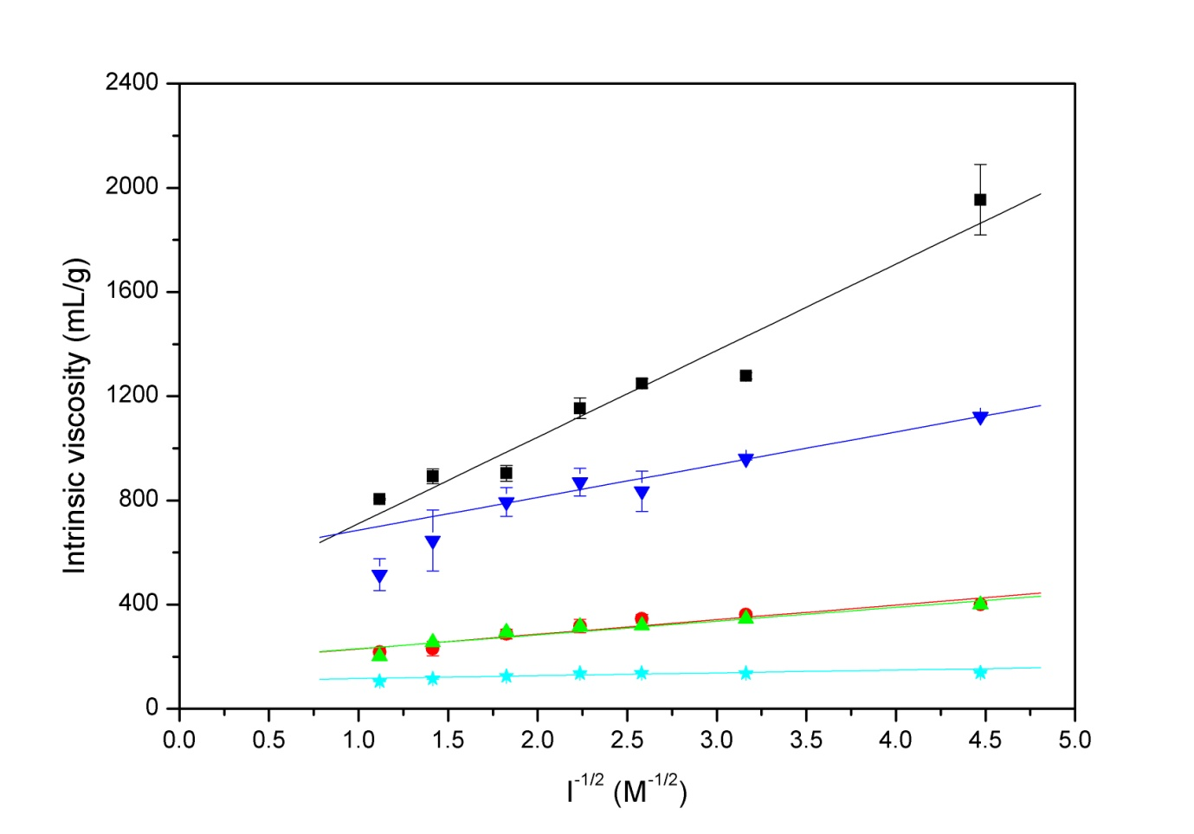
Figure 1: Observed behaviour for intrinsic viscosity ([η]) of chitosan (■), low-methoxyl pectin (•), high-methoxyl pectin (▲), low G alginate (▼) and high G alginate () as function of inverse square-root of ionic strength.
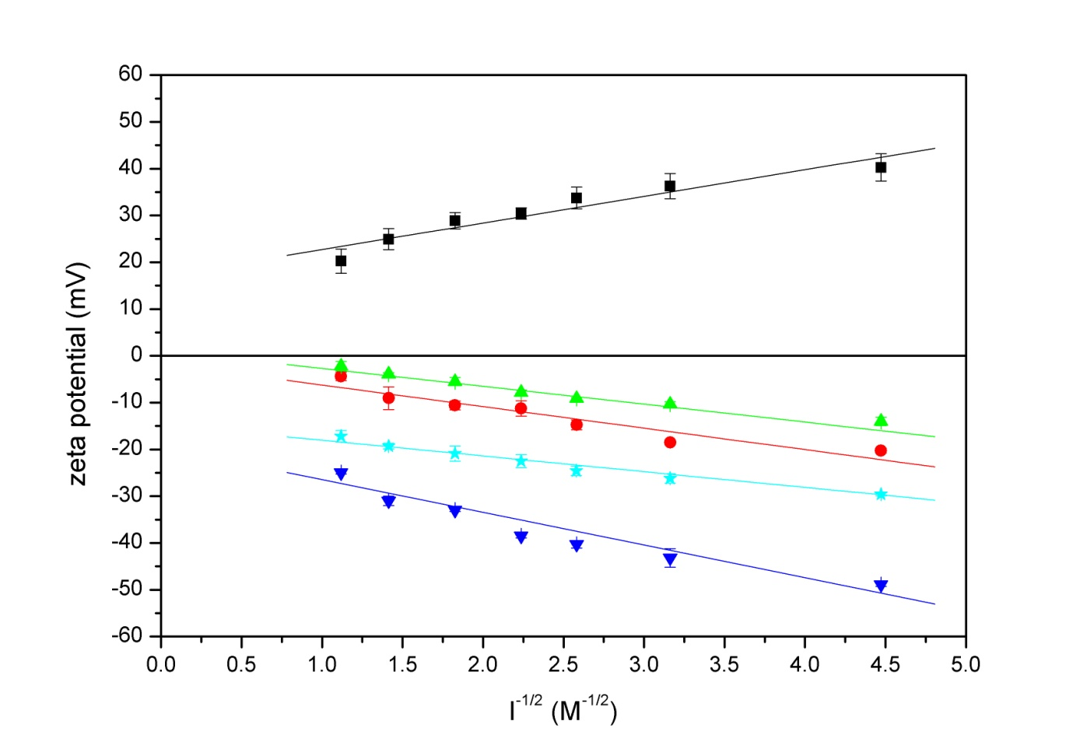
Figure 2: Observed behaviour for zeta potential (ζ) of chitosan (■), low-methoxyl pectin (•), high-methoxyl pectin (▲), low G alginate (▼) and high G alginate () as function of inverse square-root of ionic strength.

