An Adaptive Secondary Mirror Demonstrator:

Construction and Preliminary Evaluation

Jun Ho Lee, David D. Walker, A. Peter Doel

Abstract. Adaptive optics combines technologies that enable the correction of the wavefront distortion caused by the earth‘s atmospheric turbulence in real time. Adaptive secondary mirror (ASM) systems have been proposed and are now being developed. ASMs have advantages over conventional AO systems in terms of throughput, polarisation and IR emissivity. Previously, we reported the design of an ASM demonstrator along with its predicted performance. This paper reports the construction techniques and the results from the preliminary static and dynamic testing of such a demonstrator. In particular assembly methods that preserve the optical quality of the mirror are presented along with experimentally measured mirror influence functions and closed loop tip/tilt performance.
Subject terms: adaptive optics, deformable mirror, wavefront corrections, secondary mirror

- Introduction
Adaptive optics systems remove the wavefront distortion introduced by the earth’s atmosphere (or other turbulent medium) by introducing a controllable counter wavefront distortion which both spatially and temporally follows that of the atmosphere[1]. Adaptive secondary mirrors (ASMs) were proposed by Beckers [2]. Since the ASM uses an existing optical surface (the secondary mirror), the approach has several advantages compared to the conventional (and often complex) adaptive optics implementation. These advantages are: 1) optical throughput is enhanced, 2) negligible extra IR emissivity is introduced, which is a crucial advantage for a system intended to operate primarily in the infrared, and 3) no extra polarisation is added.
Tip/tilt secondary mirrors were first developed at the Steward Observatory[3] and in a collaboration between the Royal Observatory Edinburgh (ROE) and the Max-Plank Institute$f\overset{¨}{u}r$Astronomic Heidelberg (MPIA)[4]. Currently, deformable secondary mirrors are being developed at the Steward Observatory in collaboration with ThermoTrex[5], and at the Optical Science Laboratory (OSL)[6,7,8,9,10].
The OSL previously demonstrated the optical efficacy and mechanical feasibility of performing the adaptive correction and IR chopping with an adaptive secondary mirror and proposed a design for a 1m diameter ASM with 90 actuators compatible with possible future requirements of the Gemini project. Recently we have developed a prototype (or demonstrator) of the 1m ASM (figure 1), the purpose of which is to evaluate features and capabilities applicable to the full-size system.
The design of the demonstrator together with the Finite Element Analysis (FEA) predicted performance (figure 1) has been previously presented[9]. This paper describes the construction, assembly techniques and subsequent preliminary static and dynamic performance evaluation. As discussed in the next section, the key considerations in building an ASM are reliability and safety. It is shown that the demonstrator can satisfy the principal requirements.
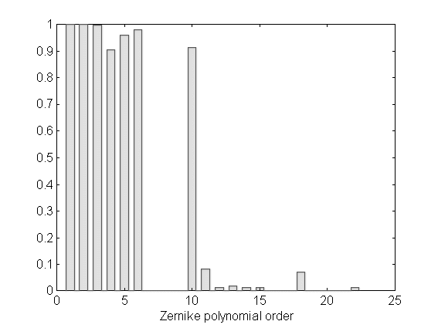
Figure 1: Ability of the demonstrator to fit Zernike terms. A z-axis value of 1 means perfect matching while 0 means zero-ability to fit the term.
- Principal Requirements in building an ASM
An ASM is an integral part of the telescope rather than an independent instrument. Therefore, the telescope as a system will fail if the ASM control fails. Moreover, when near Zenith-pointing, the secondary mirror is directly over the telescope primary, which is therefore potentially vulnerable to any catastrophic stress induced fracture of the secondary.
Therefore, there are compelling advantages for ASM systems to use rugged engineering materials not subject to brittleness or stress-induced failure at defects. Certain elements of the control system (particular power supplies, power drivers) may usefully be duplicated to provide redundancy, if this can be made consistent with the allowable mass and mass-moment budgets.
There is also a very strong pointer towards incorporating a switch-off mode, so that the secondary will still provide scientifically useful imaging (even if degraded and/or for use only in the infrared) in the event of a complete control-system failure. In the case of a partial failure (e.g. one actuator goes to maximum extent), stresses applied to the mirror substrate should lie at an adequate safety margin below the yield strength.

- Construction
3.1 Design of the demonstrator
The design of the demonstrator was presented in the previous paper[9] as shown in figure 2.The 10mm thick meniscus faceplate has seven tapped blind holes in the back surface to which the actuators are interfaced via flexures. The reaction (or backing) plate provides the resistance to the reaction forces of the actuators, and the interface to the telescope. It is currently a simple plate for laboratory tests and it will eventually be replaced with a light-weight stiff aluminum structure.
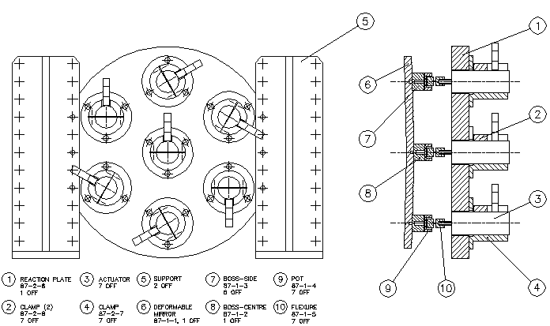

Figure 2: Mechanical drawing of the assembled demonstrator

An aluminium alloy was chosen as the material for the mirror substrate since it is a ductile material with some twenty times the yield strength of polished glass and fifty times that of ground glass. The yield strength is not reduced by accidental damage unlike glass or glass ceramics. Therefore, aluminium alloy can achieve the safety margins we require. It can also carry threaded holes for attachment to actuators. The flexures and reaction pate were chosen to be all of the same material to minimise thermal distortion.

3.2 Faceplate
The mirror faceplate was machined, ground, thermally cycled, pre-polished, electroless nickel plated and re-polished using proprietary polishing techniques. The nickel coating of the faceplate was necessary due to the soft nature of aluminum which will not directly take an optical polish and which can corrode.

3.3 Actuators and Displacement sensors
One of the major drivers in the selection of the actuators used for the demonstrator was their long term reliability. Based on manufacturer’s data for stroke, frequency response and service life, which were confirmed independently by our lab testing[10], magneto-strictive (MS) actuators with a stroke of ± 25μm were chosen as the positioning devices. A strain gauge was selected as the displacement sensor because it could be easily packaged together with the actuator.

3.4 Assembly
The assembly process is one of the key features which the demonstrator project aims to develop. In particular the goal of a switched off mode requires the mirror to keep its optical quality during the assembly process.
During assembly (figure 3), the bosses carrying cups were screwed into the rear of the mirror faceplate, using a locking compound to secure them in place. Figure 4 shows a schematic diagram of coupling between the faceplate and an actuator. The mirror faceplate was placed face down on an isolating mandrel, with a compliant layer between, for this operation. The rear system comprising backing pate, actuators, flexures and pistons was then assembled. The following procedure was then implemented to preserve the stress free state of the mirror faceplate whilst it was attached to the actuators. The rear system was carefully lowered on to the back of the mirror faceplate so that the actuator pistons lay within, but not touching, the cups. The cups were then filled with epoxy, which was then cured to complete the assembly without disturbing the optical surface. By the these processes, we achieved the assembly with a change in the mirror overall shape of 10nm RMS. Figure 4 shows a picture of the mirror unit after assembly.
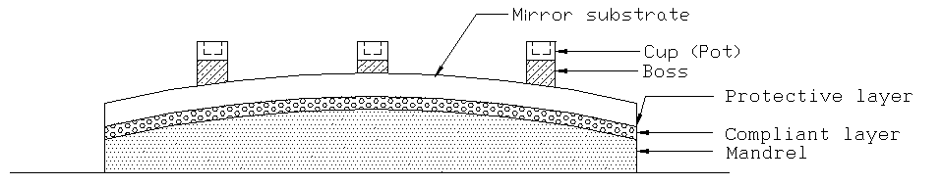
Figure 3: Schematic diagram of the assembly setup.

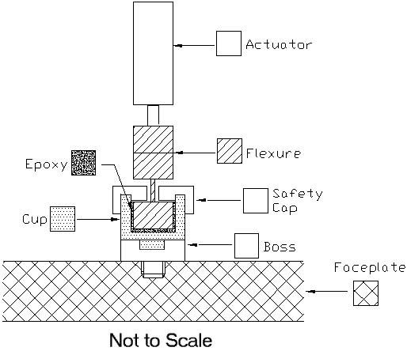

Figure 4: Schematic diagram of coupling between the faceplate and an actuator

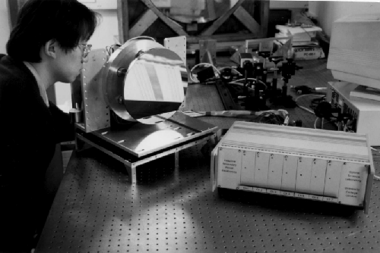

Figure 5: The demonstrator unit after assembly.

3.5 On and Off process
As discussed in the previous section, the ASM should be able to provide scientifically useful images even when in power-off mode. This also requires the mirror to be disturbed as little as possible during switch-off process. Simply turning off the mirror was found to leave distortions depending on the positions of the actuators because of their hysteresis. Therefore, a controlled switch-off method was required to overcome the residual hysteresis problem.
The controlled switch-off method can be summarised as the following:
- During the assembly, all the actuators were zero positioned on the hysteresis curve by applying a sinusoidal voltage which slowly decayed to zero.
- In service, the actuators were switched off by applying decaying sinusoidal signals from the drive electronics. In case of the control system failure, the process can be done by an independent hard-wired backup system powered from a rechargeable battery.

The effectiveness of the technique was tested by switching off the mirror, powering it up and cycling the actuators, then switching off again. Following the above procedure the initial and final interferograms were compared and revealed an optical path difference (OPD) of 77nm RMS, corresponding to a change of 38nm RMS in the mirror shape.

4. Static Testing
The influence functions of the demonstrator were measured by comparing the OPDs before and after movement. The OPDs were measured by a phase-shift interferometer (a WYKO 6000[11]). Since the interferometer can not measure the piston effect of OPD, independent measurements using an eddy current sensor were carried out. Figure 6 shows the measured influence functions of the central and one outer actuator. The influence functions were normalised to have a maximum displacement of 1 micron. Comparison of the measured influence functions with the FEA derived ones (figure 7) shows excellent correspondence.

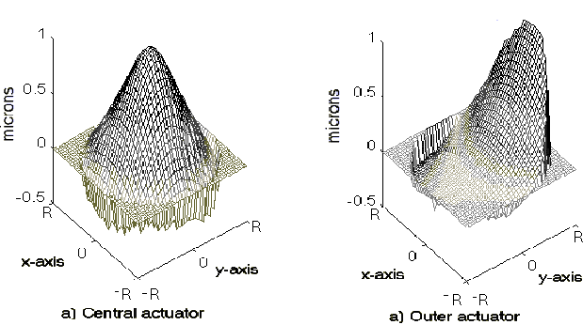
Figure 6: Measured influence functions of the central and outer actuators. The influence functions have been scaled to have a maximum of 1 m. R is the radius of the mirror.
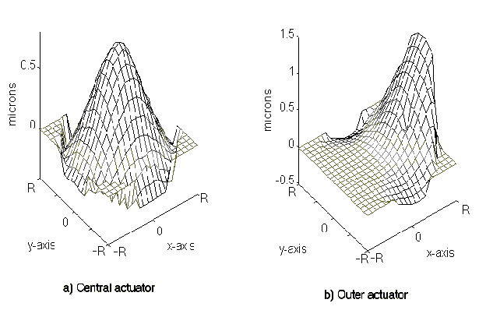

Figure 7: FEA-derived influence functions of the central and outer actuators with a stroke of 1 m respectively. R is the radius of the mirror.

The demonstrator was then deformed to match the low order Zernike polynomial terms. The control signals were derived as described in [9]. Because of non-linearity (hysteresis and thermal expansion) of the prototype actuators and electrical noise in the displacement sensors, the actuator control signals required to match the Zernike terms were slightly different from those calculated using the measured influence functions. To correct for this the actuator voltages were tuned to match the exact theoretical Zernike deformation by reference to the interferograms measured by the WYKO. The RMS residual errors were reduced down to 35nm. Figure 8 shows the measured mirror deformation optimised to match the Zernike terms (two tilts defocus, astigmatism), and the residual errors for these terms are shown in figure 9. More accurate fitting can be achieved if the residual non-linearity of the actuators is reduced or compensated for, or if the system were operated with feedback from a wavefront sensing camera.
The demonstrator was predicted[9] by FEA to provide near-perfect tip/tilt, defocus and astigmatism and the experimental results confirmed this prediction. Unlike conventional tip/tilt mirrors, the tip/tilt motion of the demonstrator is not a pure rigid body motion due to the mechanical moment caused by the flexure joints in the actuator connections to the mirror substrate. It is worth noting that the tip/tilt component is responsible for 87% of the total atmospheric variance so removing tip/tilt well is a fundamental requirement for the demonstrator. The importance, therefore, of the experimental proof that demonstrator can perform almost perfect tip/tilt can not be over emphasised.

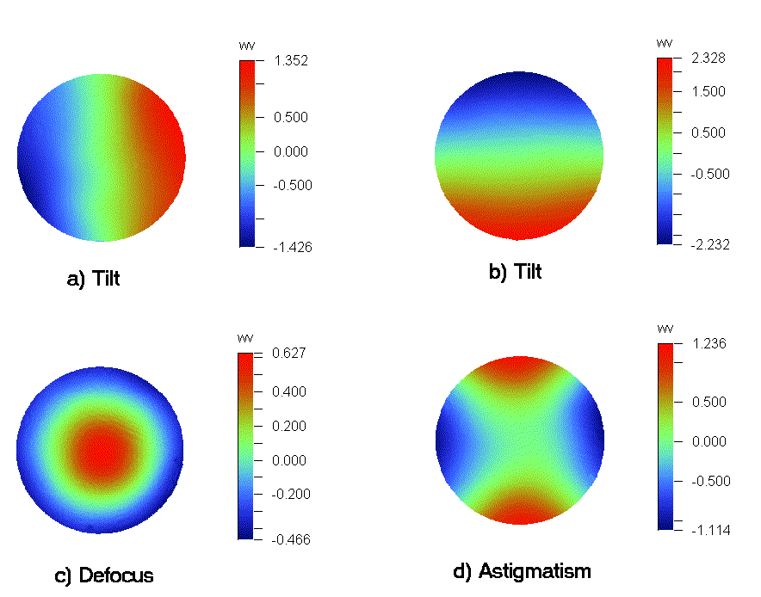

Figure 8: The measured mirror deformation to match the first four Zernike terms: Two tilts, defocus, astigmatism.

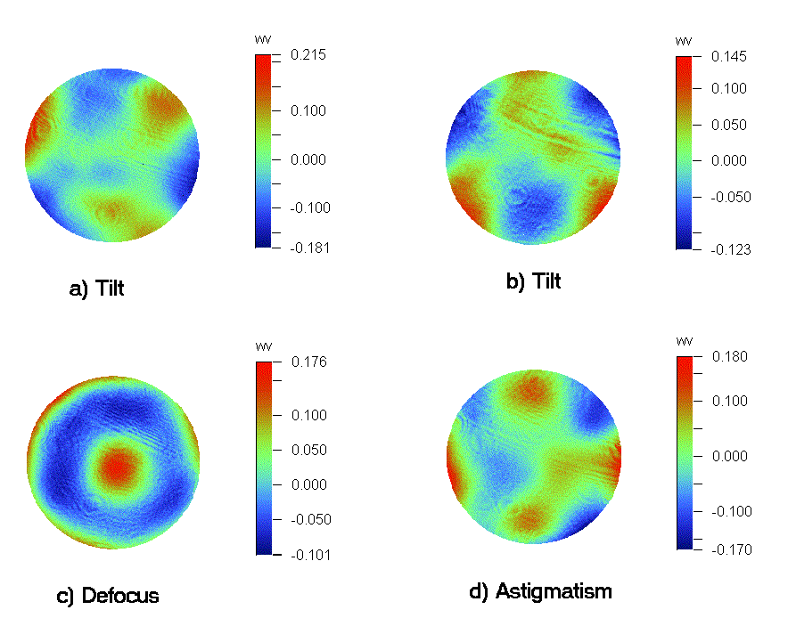
Figure 9: The measured residual errors of the mirror deformation matching the Zernike terms: Two tilts, defocus, astigmatism.

5. Dynamic Testing
Before carrying out a dynamic test of the mirror, separate analysis and experiments were performed to estimate and test the performance of the positioning system. These show that the positioning system a dynamic cut-off frequency of 60Hz, which is twelve times higher than the typical Greenwood frequency (≈5Hz) of the AO operation at infrared waveband (2.2μm). Together with the results of the simulation and experiments of the static performance, the results of positioning system tests show that the demonstrator is capable of correcting time-varying tip/tilt aberration at least up to the cut off frequency.
As a preliminary experiment the demonstrator was operated in a closed-loop with a quad-cell detector. The optical layout for the dynamic experiment (figure 10) is the same as for the static test except that a beam splitter was added as a pick-off for the quad-cell. The interferometer is out of the loop but provides a reference measurement of the mirror deformation. Periodic tip/tilt wavefront errors (0.73Hz) were introduced by rotating an inclined sheet of window glass in the laser optical beam.
Figures 11 and 12 show the tip/tilt signals from the quad cell when tip/tilt wavefront aberrations were introduced and demonstrator system was respectively open and closed via the quadcell detector. Calibration of the quadcell signal was done using the interferometer.
These two figures clearly show that the demonstrator is capable of compensating a time-varying tip/tilt wavefront. The amplitude of periodic tip/tilt aberration was suppressed from 2 to 0.2 arcsec.
During experimentation, residual hysteresis was found in the actuators at a level of 2% and 8% for a cycle of amplitude of ~9 and 25μm. This is believed to be due to incorrect bonding of the strain gauge to the actuator, which will be remedied in the next generation of actuator. Furthermore, the prototype actuators had only a single strain gauge, which will be replaced with bridge configuration to provide thermal compensation.
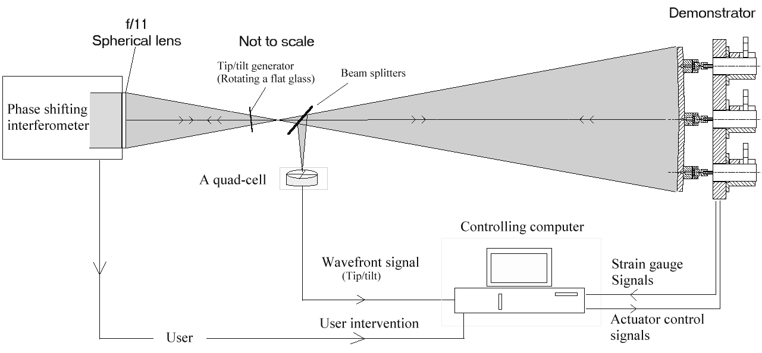

Figure 10: Optical setup for dynamic evaluation of the demonstrator.
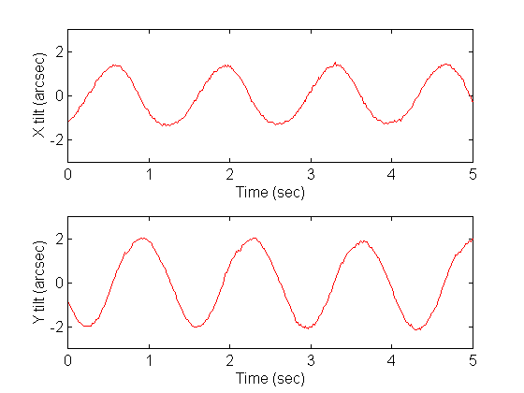
Figure 11: Tip/tilt signals from the quadcell when tip/tilt wavefront aberrations were introduced by rotating the glass and the demonstrator system was in open loop operation.
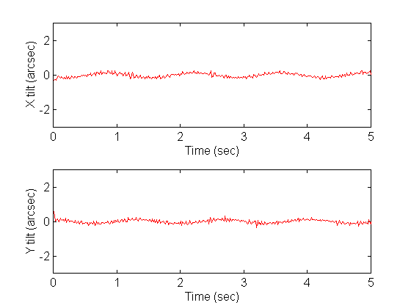
Figure 12: Tip/tilt signals from the quadcell when tip/tilt wavefront aberrations were introduced by rotating the glass and the demonstrator system was in closed loop operation.

6. Conclusion
The application of aluminium mirror technology is a primary feature of the demonstrator. This is one of the first adaptive optics systems to use a metal mirror as a deformable wavefront corrector. The ability of preserving the optical quality of the aluminium mirror during assembly and that of deforming the mirror shape as required are fundamental requirements of adaptive secondaries. To that end error-free assembly techniques were developed and successfully implemented resulting in the errors in the mirror shape of less than 10nm RMS. The ability of the metal mirror to fit lower order Zernike terms was initially predicted in simulation using FEA[9] and was later confirmed by laboratory tests.
These successful results open the possibility of future adaptive optics systems using this metal mirror technology. An attractive application of this outside astronomy is the compensation of self-induced free-air turbulent in very high power laser systems, where the adaptive metal mirror lends itself ideally to liquid cooling.
The demonstrator is planned to be tested on the optical bench in the Ground-based High Imaging Laboratory (GHRIL) at the William Herschel Telescope (WHT) to investigate ASM performance under real seeing conditions. To achieve this, the faceplate is going to be re-figured/polished and the demonstrator is tested with a fast wavefront sensor.

7. Acknowledge
The work described in this paper has been financed from a number of sources, including the Satellite Technology Research Center (SaTReC) of the Korea Advanced Institute of Science and Technology (KAIST), the UK Gemini project office, and the UK Particle Physics and Astronomy Research Council.

8. Bibliography
- J.M. Beckers, “Adaptive Optics for Astronomy: Principles, Performance and Applications”, Annual Review of Astronomy and Astrophysics, Vol. 31, pp. 13--62, 1993
- J. M. Beckers, “A proposal to the National Science Foundation”, the NOAO 8-M Telescope Technical Description Vol. II, by the Association for University Research in Astronomy, 1989
- L.M. Close, D.W. McCarthy, “High-Resolution Imaging with a Tip/Tilt Cassegrain Secondary”, Pub. Of the Astronomical Society of the Pacific, 106, pp 77-86, 1994
- E. Pitz, R.R. Rohloff, H. Marth, “UKIRT 5-axis tip/tilt secondary eletro-mechanical and optical design”, Proc. ESO, Garching, Germany, 1993
- P. Salinari, D.G. Sandler, “High order adaptive secondary mirrors: Where are we?”, Proc. SPIE, Vol. 3353, pp. 742-753, 1998
- D.D. Walker, R.G. Bingham, B.C. Bigelow, “Adaptive Correction at Telescope Secondary Mirrors”, Proc. ESO No.48, pp. 255-260, 1993
- B.C. Bigelow, D.D. Walker, R.G. Bingham, P. D’Arrigo, “A Deformable Secondary Mirror for Adaptive Optics”, Proc. ESO No. 48, pp. 261-266, 1993
- D.D. Walker, J.H. Lee, R.G. Bingham, D. Brooks, M. Dryburgh, G. Nixon, H. Jamshidi, S.W. Kim, B. Bigelow, “Rugged adaptive telescope secondaries: experience with a demonstrator mirror”, Proc. SPIE, Vol. 3353, pp. 872-877, 1998
- J.H. Lee, D.D. Walker, A.P. Doel, “An Adaptive Secondary Mirror Demonstrator: Design and Simulation”, Sep, 1999, in press, (Ref: OE 990017)
- B.C. Bigelow, D.D. Walker, G. Nixon, “Testing of a Magnetostictive Actuator for Adaptive Secondary Mirrors”, Proc. SPIE, Vol. 2871, pp. 910-919, 1996
- WYKO Corporation, 2650 East Elvira Road, Tucson, Arizona 85706, USA

