MANUSCRIPT TITLE: The effects of 120 minutes of simulated match-play on indices of acid-base balance in professional academy soccer players.

ABSTRACT

This study investigated changes in indices of acid-base balance during 120 minutes of simulated soccer match-play that included a 30 min extra-time (ET) period. Eight English Premier League academy soccer players participated in a simulated soccer match that required varying intensities of intermittent exercise including 15 m sprints and soccer dribbling throughout. Blood samples were obtained prior to (i.e., baseline, pre-exercise) and throughout exercise (i.e., 15, 30, 45, 60, 75, 90, 105, 120 min), and at half-time. Sprint speeds over 15 m reduced in ET compared to the first (-0.39 ± 0.37 m∙s⁻¹, -7 ± 6%, p = 0.021) but not the second half (-0.18 ± 0.25 m∙s⁻¹, -3 ± 4%, p = 0.086). At 105 min, blood lactate concentrations reduced compared to the opening 30 min (-0.9 to -1.2 mmol·l⁻¹, p < 0.05). Blood pH (-0.03 to -0.04 units), base excess (-0.95 to -1.48 mmol·l⁻¹) and bicarbonate concentrations (-0.9 ± 0.8 mmol·l⁻¹) were depressed at 120 min compared to 105 min, baseline and half-time (all p < 0.05). There were no significant correlations between changes in acid-base balance and sprint speed (all p > 0.05). Although the perturbations in acid-base balance during ET were statistically significant, the decreases in blood pH, lactate, base excess, and bicarbonate concentrations may not represent metabolic acidosis or impairments in buffering capacity that are likely to explain reduced physical performance. Further research is warranted to investigate mechanisms of fatigue during ET and to develop interventions that attenuate decrements in performance.

KEY WORDS: extra-time, fatigue, football, intermittent, buffer, skill

INTRODUCTION
Soccer is a high-intensity intermittent team sport with matches typically played for 90 minutes (min). However, in certain cup and tournament scenarios (e.g., FIFA World Cup, UEFA European Championships, and Lamar Hunt U.S. Open Cup) an additional 30 min period of play (termed extra-time; ET) is necessary when an outright winner is required. Of the 16 knockout phase matches played at both the senior and U20 World Cup competitions in 2014 and 2015, 50% necessitated ET. Furthermore, 32% of senior World Cup knockout matches have required ET in competitions played since 1986 (www.FIFA.com). Compared to studies reporting responses to 90 min of soccer-specific exercise (5, 27, 30, 37), relatively few have investigated the demands of ET (16, 18, 36).

Findings from our research group have indicated differential effects of ET when compared to the opening and closing periods of the normal duration of soccer match-play (16, 18, 36). Specifically, indices of technical (i.e., number of passes and dribbles), and physical (i.e., 15 m and 20 m sprint times) performance are reduced during ET. However, the precise mechanisms underpinning these decrements in performance have yet to be demarcated. Perturbations in acid-base balance have been implicated in soccer-specific fatigue responses during 90 min of both simulated (34) and actual match-play (22). Indeed, Russell and Kingsley (34) reported a reduction in blood pH and altered buffering capacity throughout 90 min of simulated soccer-specific exercise in English Championship academy level soccer players.
Traditionally, metabolic acidosis has been associated with a multitude of fatiguing processes including the impairment of metabolic enzyme activity (14), diminished excitation-contraction coupling (1), and amplified K⁺ efflux from the exercising musculature (25). However, the role of acidosis in fatigue remains a debated topic (10, 12, 39). Nevertheless, due to the high-intensity nature of team sport exercise, preventing acidosis is considered important (28, 34). Furthermore, endogenous bicarbonate concentrations, and therefore the ability to buffer metabolic by-products produced as a consequence of high-intensity intermittent exercise, may be compromised during 90 min of simulated soccer match-play (34). However, comparable data during ET has yet to be reported.

In summary, changes in acid-base balance have been postulated to contribute to the multifaceted fatigue profile observed during 90 min of soccer-specific exercise. However, no data currently exists which has profiled acid-base balance responses during prolonged durations of soccer-specific exercise (i.e., those games requiring an ET period). Therefore, the aim of this study was to investigate changes in acid-base balance across 120 min of simulated soccer match-play in professional academy soccer players. We hypothesized that ET would influence indices of acid-base balance relative to the demands of the previous 90 min.

METHODS

Experimental Approach to the Problem
To investigate the effects of 120 min of soccer-specific exercise on acid-base balance and sprint performance, eight professional academy soccer players completed a simulated soccer match with physiological measurements taken at regular intervals. The dependent variables included in this study were indices of exercise intensity and performance (i.e., 15 m sprint velocities, heart rate, rating of perceived exertion; RPE, blood calcium, and potassium concentrations); measures of acid-base balance (i.e., blood pH, base excess, lactate, haemoglobin, and bicarbonate concentrations); and hydration status (i.e., plasma and urine osmolality, plasma volume, and body mass changes).

Subjects
This study received ethical approval from the Health and Life Sciences Ethics Committee at Northumbria University, Newcastle upon Tyne, UK. As part of a larger study design, eight male soccer players were recruited from an English Premier League club academy (mean ± SD; age: 16 ± 1 years, stature: 1.73 ± 0.05 m, mass: 68.5 ± 5.3 kg, estimated V̇O_{2 max}: 55 ± 9 ml∙kg⁻¹∙min⁻¹) and provided written informed consent. Parental consent was also sought as all players were under the age of 18 years. All players played for a professional soccer academy for > 12 months prior to the start of the study.

Procedures
Players undertook two preliminary visits prior to the main trial. The first visit sought to estimate maximum oxygen uptake (V̇O_{2 max}) using the Yo-Yo intermittent recovery test one (6) and the second visit habituated players with the main trial procedures. Players performed a coach-led 45 min tactical training session (involving positional and tactic-specific drills), abstained from caffeine ingestion, and completed self-reported food diaries (analyzed retrospectively; Nutritics Ltd., UK) in the 24 h prior to the main trial. After an overnight fast, players arrived at the testing center at ~08:00 h and were asked to provide a mid-flow urine sample. A standardized breakfast (2079 kJ, 77.1 g carbohydrates, 12.3 g fats, and 14.3 g proteins) was provided to each player, including 500 ml of a fluid-electrolyte beverage (Mineral Water, Highland Spring, UK) following a fingertip capillary blood sample. Measures of body mass and stature (Seca GmbH & Co., Germany) were then taken. Following a post-breakfast rest period of ~90 minutes, another fingertip capillary blood sample was taken. Players then undertook warm-up procedures consisting of speed drills, dynamic stretching, and ball work while drinking 200 ml of the fluid-electrolyte beverage.

Utilising a modified version of the Soccer Match Simulation (SMS) (35), a valid and reliable soccer-specific protocol (33), players performed 120 min of soccer-specific activity, including intermittent exercise and ball dribbling. In line with FIFA regulations, the SMS was split into two 45 min halves separated by a 15 min break (half-time; HT) and two additional 15 min halves separated by a two min break (ET) (Figure 1). Players ingested 500 ml of the fluid electrolyte beverage during HT. A five min passive rest period followed the initial 90 min period prior to ET. During this period, body mass was measured and players were provided with 200 ml of the fluid-electrolyte drink and two 66 g energy-free gels (High5 Ltd., UK). Players covered a total distance of ~14.4 km, reflective of a match requiring ET (36) while intermittently performing 15 m sprints (Brower-TC Systems, Brower Timing Systems, USA) and ball dribbles through cones set over an 18 m distance.

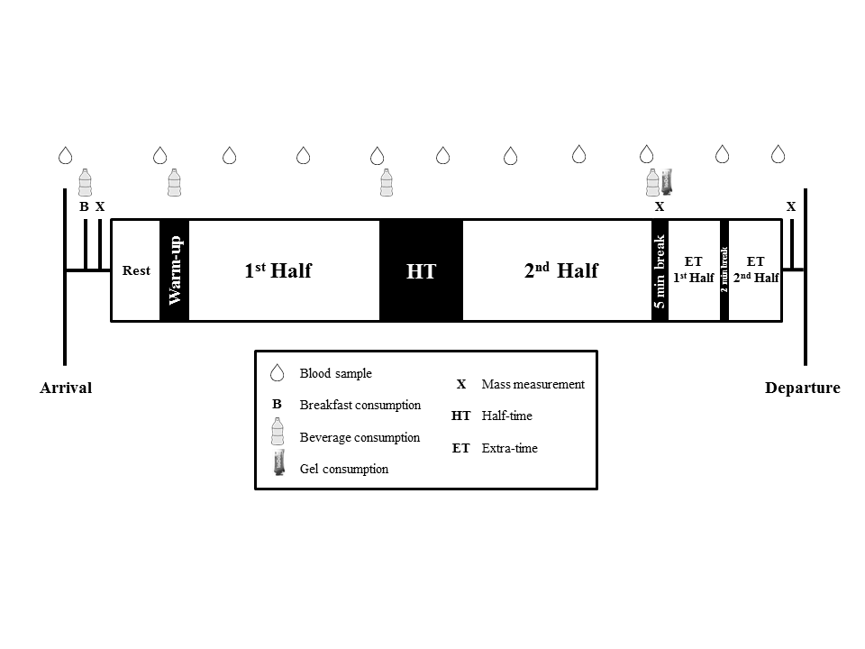

Figure 1 Schematic of main trial procedures.

Capillary blood samples (170 µl) were collected from the fingertip upon arrival (baseline), pre-exercise (pre), HT and at 15, 30, 45, 60, 75, 90, 105 and 120 min (Figure 1) and subsequently analyzed for blood lactate, pH, haematocrit (Hct), bicarbonate (HCO3⁻), calcium, and potassium concentrations (GEM Premier 3000; Instrumentation Laboratory, UK; CV’s: 0.003-2.2%) (8). Haemoglobin (Hb) concentrations were also measured (Hemocue 201+; HemoCue AB, Sweden). Hct and Hb concentrations were used to measure plasma volume changes throughout exercise (13). Base excess concentrations were calculated using equation 1 according to the manufacturer’s instructions (GEM Premier 3000; Instrumentation Laboratory, UK) using the values derived from HCO3⁻, Hb, and pH:

Eq’n 1: Base Excess = (1 – 0.014 x Hb) x [HCO3⁻ - 24 + (1.63 x Hb + 9.5) x (pH – 7.4)]

Urine and plasma osmolality (Advanced Model 3300 Micro-Osmometer; Advanced Instruments Inc., USA), urine-corrected mass changes, and ratings of perceived exertion (9) were recorded during each trial. Environmental conditions were measured during exercise (Technoline WS-9032; Technotrade GmbH, Germany) and mean and peak heart rate (HR_{mean} and HR_{peak}, respectively) were recorded using short-range telemetry (Polar RS400; Polar Electro, Finland). A mid-flow urine sample was collected post-exercise and body mass was assessed before the players were allowed to leave the testing center.

Statistical Analysis
Statistical analyzes were carried out using IBM SPSS Statistics software (Version 22.0; IBM Inc., USA). Data are reported as mean ± standard deviation (SD). Statistical power was calculated using commercially available software (GPower v3.1, Germany) and a sample size of eight was deemed sufficient for ≥ 70% power to detect statistical differences in pH, base excess, and 15 m sprint speed. Paired sample t-tests were performed for data with two time points (i.e. plasma and urine osmolality) and repeated measures analysis of variance (ANOVA) were conducted for data with more than two time points (i.e., exercise intensity and acid-base balance parameters). The Greenhouse-Geisser correction was applied if the assumption of sphericity was violated. Significant main effects of time were analyzed post-hoc using a least significant difference (LSD) test. Relationships between 15 m sprint performance and changes in acid-base balance parameters were tested using a Pearson product-moment correlation coefficient. Significance was set at p ≤ 0.05.
RESULTS
Environmental conditions were 19.2 ± 1.5°C, 75 ± 8%, and 1017 ± 4 mmHg for ambient temperature, humidity, and barometric pressure, respectively. Dietary analyses revealed that the players were not taking any performance enhancing supplements and compromised of 8.5 ± 0.7 MJ∙d⁻¹, of which 42 ± 5%, 25 ± 1%, and 33 ± 6% of energy intake was obtained from carbohydrates, proteins, and fats, respectively.

Exercise Intensity
Exercise influenced RPE with higher RPE values during ET (15 ± 4) compared to the first (10 ± 4) and second (12 ± 4) halves (both p ≤ 0.001). RPE values were also higher during the second half compared to the first half (p = 0.035). Sprint velocities were lower during ET compared to the first (-7 ± 6%, p = 0.021) but not the second (-3 ± 4%, p = 0.086) half (Figure 2). HR_{peak} and HR_{mean} remained the same throughout exercise (F_{(2,14)} = 3.658, p = 0.063, η² = 0.343 and F_{(2,14)} = 2.973, p = 0.084, η² = 0.298). Concentrations of blood calcium (F_{(4,31)} = 1.081, p = 0.387, η² = 0.134) and potassium (F_{(3,23)} = 0.794, p = 0.520, η² = 0.102) were not influenced by exercise (Table 1).

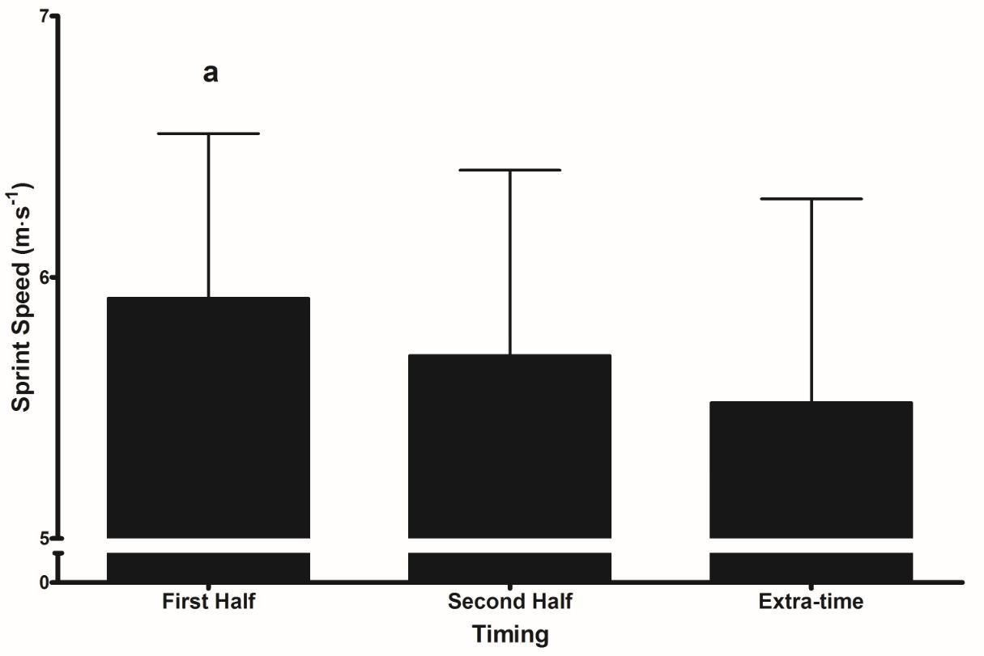
Figure 2 Sprint velocities (15 m) during the trial (mean ± SD). a = significant difference compared to extra-time (p < 0.05).

Acid-Base Balance Response
Exercise influenced blood lactate (F_{(3,19)} = 5.834, p = 0.007, η² = 0.455) and pH (F_{(2,18)} = 3.192, p = 0.054, η² = 0.313) responses. Blood lactate concentrations were lower at 105 min compared to 15 min (-27 ± 28%, p = 0.022) and 30 min (-26 ± 14%, p = 0.009) (Table 1). At 105 min, blood pH was higher compared to 15 min (+0.4 ± 0.4%, p = 0.011) and 30 min (+0.4 ± 0.4%, p = 0.030), but lower compared to 75 min (-0.3 ± 0.2%, p = 0.010) (Figure 3A). At 120 min, blood pH was lower compared to 105 min (-0.5 ± 0.4%, p = 0.012). Notably, blood pH was lower at 120 min compared to baseline (-0.3 ± 0.3%, p = 0.015), and HT (-0.4 ± 0.4%, p = 0.017) (Figure 3A).

Exercise influenced base excess (F_{(3,25)} = 6.107, p = 0.002, η² = 0.466), HCO3⁻ (F_{(3,22)} = 5.802, p = 0.004, η² = 0.453), and Hb concentrations (F_{(5,32)} = 6.459, p ≤ 0.0005, η² = 0.480). Base excess concentrations at 120 min were lower than at HT (-110 ± 159%, p = 0.013), during the whole of the second half (46-90 min, all p < 0.05) and at 105 min (-219 ± 280%, p = 0.001) (Figure 4). Base excess at 105 min was also higher than at 15 min (+1011 ± 2307%, p = 0.031) and 60 min (+20 ± 143%, p = 0.031) values (Figure 4). HCO3⁻ concentrations were lower at 120 min compared to 105 min (-3.7 ± 3.3%, p = 0.017) and higher at 105 min compared to HT (-2.2 ± 1.4%, p = 0.003) (Figure 3B). Hb concentrations were higher at 120 min compared to baseline (+6.8 ± 5.6%, p = 0.015) and pre-exercise (+7.9 ± 9.0%, p = 0.040) (Table 1). Hb concentrations were also higher at 105 min compared to baseline (+6.1 ± 4.1%, p = 0.005) but lower at 105 min compared to both 60 min (-5.5 ± 5.2%, p = 0.019) and 75 min (-6.2 ± 5.8%, p = 0.019) (Table 1). There were no significant correlations between changes in 15 m sprint performance and blood pH, lactate, Hb, base excess, or bicarbonate concentrations (all p > 0.05).
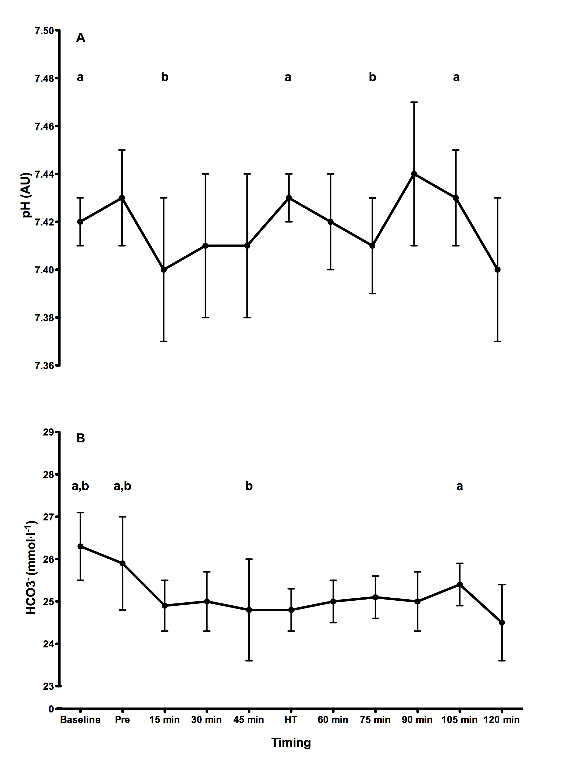
Figure 3 Blood pH (A) and HCO3⁻ (B) concentrations throughout the trial (mean ± SD). Pre represents pre-exercise and HT represents half-time. a = significant difference compared to 120 min (p < 0.05). b = significant difference compared to 105 min (p < 0.05).
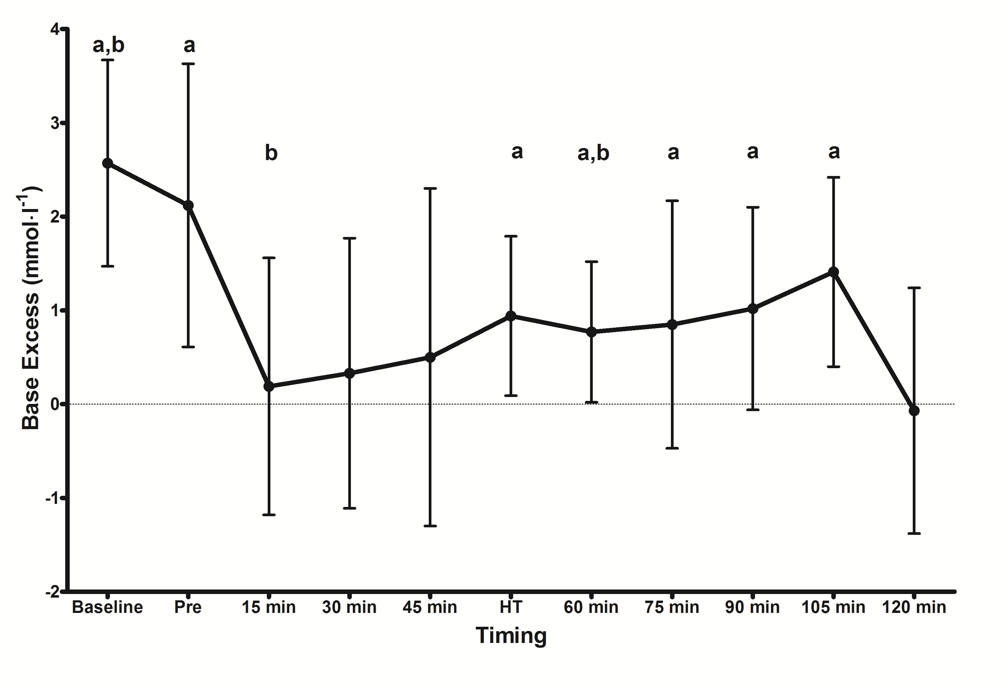

Hydration Status
Exercise influenced body mass (F_{(1,6)} = 28.337, p = 0.001, η² = 0.825) with participants exhibiting lower body mass values post-exercise (67.8 ± 5.1 kg) compared to both pre-exercise (69.1 ± 5.3 kg, p ≤ 0.0005) and 90 min (68.3 ± 5.1 kg, p = 0.015). Plasma volume was influenced by exercise (F_{(4,25)} = 9.332, p ≤ 0.0005, η² = 0.571). Plasma volume was lower at 120 min (-7 ± 7%) compared to 105 min (-2 ± 7%, p = 0.048). Plasma volume was higher at 105 min compared to 15 min (-10 ± 6%, p = 0.014), HT (-3 ± 6%, p = 0.003), and 60 min (-11 ± 9%, p ≤ 0.0005). Urine osmolality was unchanged during exercise (p = 0.605), whereas plasma osmolality was higher post-exercise (330 ± 11 mOsmol.kg⁻¹) compared to pre-exercise (309 ± 6 mOsmol.kg⁻¹, p = 0.005).

DISCUSSION
This is the first study to assess changes in acid-base balance during 120 minutes of soccer-specific exercise. In line with our hypotheses, ET influenced markers of acid-base balance, specifically; blood pH, HCO3⁻, Hb, and base excess concentrations in eight English Premier League academy soccer players. However, the concentrations observed at 105 and 120 min would suggest that acid-base balance and buffering capacity are not compromised during ET. Furthermore, the lack of any significant correlation between changes in performance and the indices of acid-base balance measured may indicate performance was not modulated by changes in acid-base balance.

We observed reductions of 0.01-0.03 pH units in the last 15 min of ET compared to baseline, HT, and the first 15 min of ET (Figure 3A). Despite the statistical significance of these findings, this magnitude of change in blood pH is unlikely to be the cause of the reduced physical performance observed in the present study (Figure 2) and previous investigations on ET (16, 18, 37). This is supported by the lack of any relationship between decrements in 15 m sprint performance and reductions in blood pH (p > 0.05). Furthermore, reductions in pH of <0.2 units are unlikely to reflect acidosis or cause a reduction in exercise performance (10, 20). Indeed, the previously held notion that acidosis limits exercise performance has been challenged (10, 23, 39) as contractility of mammalian muscle in-vitro is unaffected even at a pH as low as 6.67 units (40). Moreover, it has been postulated that intracellular acidosis may actually protect muscle function through its ameliorative effect on extracellular potassium accumulation (26). Therefore, the drops in blood pH observed are incongruous with metabolic acidosis and thus may not be a limitation during soccer-specific exercise.

Blood lactate concentrations did not exceed 3.4 ± 1.6 mmol·l⁻¹ during exercise (Table 1). Lactate concentrations of this magnitude are not reflective of those observed during exercise-induced acidosis (15, 31). Despite being lower than during some previous investigations in soccer players (5, 34), the observed lactate concentrations are comparable to those observed in Danish lower league players during a 90 min soccer match simulation (7).

Blood lactate concentrations were lower during ET compared to the first 15 min of exercise (Table 1). This may be indicative of a decelerated rate of substrate level phosphorylation during ET and a shift in substrate utilisation. Although not measured in the present investigation, previous findings from our laboratory have shown significant increases in plasma epinephrine, non-esterified fatty acids, and glycerol during ET with concomitant reductions in blood lactate and plasma insulin (19). As successful high-intensity exercise performance such as sprinting is reliant on glycogenolysis (4, 29), an increased reliance on fat oxidation for fuel during ET may explain the reductions in 15 m sprint performance observed in the present investigation; however, this remains speculative. Future research opportunities therefore exist to assess transient changes in muscle glycogen concentrations during ET.

Total buffering capacity was influenced by exercise, with reductions in Hb (Table 1), HCO3⁻ (Figure 3B), and base excess (Figure 4) concentrations during the last 15 min of ET compared to earlier periods of exercise. Despite the presence of statistically significant differences, the relatively small changes in these variables may not indicate physiologically meaningful alterations in buffering capacity (15). Furthermore, we observed no correlation between alterations in buffering capacity and reductions in sprint speed, possibly indicating performance was not influenced by changes in buffering. A previous study investigating acid-base balance changes across 90 min of simulated soccer match-play found much lower HCO3⁻ values in the second half compared to any time point during exercise in the present investigation (34) despite the same method of analysis. This could be explained by the playing level and age of the player recruited. HCO3⁻ concentrations observed in the present investigation are similar to those observed in male athletes performing high-intensity intermittent exercise while ingesting sodium bicarbonate (20).

Physical (15 m sprint velocities) performance was negatively impacted during ET. Similar observations have been found during simulated (16, 17) and actual (18, 36) match-play. Previous work from our research group has noted depressed sprint velocities and countermovement jump heights during ET (16, 17), as well as reductions in technical performance markers (i.e., the number of successful passes and dribbles) (18). Moreover, Russell et al. (36) observed significant reductions in total distance covered, high intensity distance covered, and the total number of sprints, accelerations, and decelerations during an ET period in an English Premier League reserve match .

Temporal fatigue during soccer match-play and simulated soccer exercise is likely to be multifactorial in origin, both during 90 min and ET (16, 22, 30). Compromised muscle glycogen stores (32), disturbances in muscle ion homeostasis (24), and dehydration (38) have all been linked to reduced soccer performance. ET negatively impacted both body mass and plasma osmolality. The players lost an additional 0.5 ± 0.4 kg of body weight in ET compared to 90 min and plasma osmolality was significantly higher post-exercise compared to baseline. This may indicate further dehydration in ET which could be a putative factor explaining the decrease in exercise performance (16, 38).

Although blood potassium was not influenced by exercise (Table 1), we observed individual values > 6 mmol·l⁻¹ at 120 min, similar to those observed following an exhaustive Yo-Yo Intermittent Recovery Test (21). However, the mean value of all participants was 5.1 ± 0.9 mmol·l⁻¹ (Table 1), analogous with those observed during soccer match-play (22). It is unlikely that concentrations of blood potassium of this degree explain the reductions in performance (22). Further work is required to isolate the influence of muscle ion fluctuations on performance during an ET period. Due to a disassociation between interstitial and extracellular ionic concentrations, disturbances in muscle ion homeostasis are more reflective of fatigue than changes at the extracellular level (11, 20, 25). Accumulation of inorganic phosphate (P_{i}) in the muscle has been implicated as the major factor in tempered force production and increased fatigue during exercise (2, 3, 12, 39); however, changes in P_{i} have yet to be explored during soccer-specific exercise of any duration.

PRACTICAL APPLICATIONS
This data adds to the developing body of literature related to both the performance and physiological responses during simulated and actual match-play requiring a soccer ET period. Practitioners and coaches should be cognisant of the fact performance is adversely impacted by ET and potential methods of attenuating diminutions in performance should be sought (i.e., acute nutritional interventions (16), and training programme design). The magnitude of the physiological changes observed as a consequence of 120 min of intermittent exercise in this study highlight that metabolic acidosis and perturbations in buffering capacity are not likely to be performance-limiting factors in ET. Further research utilising invasive techniques such as muscle biopsies to assess ionic, P_{i} and glycogen disturbances during 120 minutes of soccer match-play is required.

REFERENCES

1. Allen. DG, Lamb, GD, and Westerblad, H. Skeletal muscle fatigue: cellular mechanisms. Phys Rev 88: 287-332, 2008.

2. Allen DG and Trajanovska S. The multiple roles of phosphate in muscle fatigue. Front Physiol 3: 463, 2012.

3. Allen DG and Westerblad H. Role of phosphate and calcium stores in muscle fatigue. J Phys 536: 657-665, 2001.

4. Bangsbo J. Energy demands in competitive soccer. J Sports Sci 12: S5-12, 1994.

5. Bangsbo J, Iaia FM, and Krustrup P. Metabolic response and fatigue in soccer. Int J Sports Physiol Perform 2: 111-127, 2007.

6. Bangsbo, J, Iaia, FM, and Krustrup, P. The Yo-Yo intermittent recovery test : a useful tool for evaluation of physical performance in intermittent sports. Sports Med 38: 37-51, 2008.

7. Bendiksen, M, Bischoff, R, Randers, MB, Mohr, M, Rollo, I, Suetta, C, Bangsbo, J, and Krustrup, P. The Copenhagen Soccer Test: physiological response and fatigue development. Med Sci Sport Exerc 44: 1595-1603, 2012.

8. Beneteau-Burnat, B, Bocque, M, Lorin, A, Martin, C, and Vaubourdolle, M. Evaluation of the blood gas analyzer Gem PREMIER 3000. Clin Chem Lab Med 42: 96-101, 2004.

9. Borg, GA. Psychophysical bases of perceived exertion. Med Sci Sports Exerc 14: 377-381, 1982.

10. Cairns, SP. Lactic Acid and Exercise Performance: Culprit or Friend? Sports Med, 2006.

11. Cairns, SP and Lindinger, MI. Do multiple ionic interactions contribute to skeletal muscle fatigue? J Physiol 586: 4039-4054, 2008.

12. Debold, EP. Recent insights into muscle fatigue at the cross-bridge level. Front Physiol 3: 151, 2012.

13. Dill, DB and Costill, DL. Calculation of percentage changes in volumes of blood, plasma, and red cells in dehydration. J Appl Physiol 37: 247-248, 1974.

14. Fitts, RH. Cellular mechanisms of muscle fatigue. Physiol Rev 74: 49-94, 1994.

15. Hanon, C, Savarino, J, and Thomas, C. Blood lactate and acid-base balance of world-class amateur boxers after three 3-minute rounds in international competition. J Strength Cond Res 29: 942-946, 2015.

16. Harper, LD, Briggs, MA, McNamee, G, West, DJ, Kilduff, LP, Stevenson, E, and Russell, M. Physiological and performance effects of carbohydrate gels consumed prior to the extra-time period of prolonged simulated soccer match-play. J Sci Med Sport, 2015. In Press.

17. Harper, LD, Watson, A, West, DJ, Stevenson, E, Russell, M. Physiological and performance responses to 120 minutes of soccer-specific exercise. In: European College of Sport Sciences Annual Congress, Amsterdam, Netherlands, 2014.

18. Harper, LD, West, DJ, Stevenson, E, and Russell, M. Technical performance reduces during the extra-time period of professional soccer match-play. PloS ONE 9: e110995, 2014.

19. Harper, LD, West, DJ, Stevenson, E, Russell, M. Metabolic and physiological responses to 120 minutes of soccer-specific exercise. In: American College of Sports Medicine Annual Meeting, San Diego, USA, 2015.

20. Krustrup, P, Ermidis, G, and Mohr, M. Sodium bicarbonate intake improves high-intensity intermittent exercise performance in trained young men. J Int Soc Sports Nutr 12: 25, 2015.

21. Krustrup, P, Mohr, M, Amstrup, T, Rysgaard, T, Johansen, J, Steensberg, A, Pedersen, PK, and Bangsbo, J. The yo-yo intermittent recovery test: physiological response, reliability, and validity. Med Sci Sports Exerc 35: 697-705, 2003.

22. Krustrup, P, Mohr, M, Steensberg, A, Bencke, J, Kjaer, M, and Bangsbo, J. Muscle and blood metabolites during a soccer game: implications for sprint performance. Med Sci Sports Exerc 38: 1165-1174, 2006.

23. Mainwood, GW, and Renaud, JM. The effect of acid-base balance on fatigue of skeletal muscle. Can J Physiol Pharmacol 63: 403-416, 1985.

24. Mohr, M, Krustrup, P, and Bangsbo, J. Match performance of high-standard soccer players with special reference to development of fatigue. J Sports Sci 21: 519-528, 2003.

25. Nielsen, JJ, Mohr, M, Klarskov, C, Kristensen, M, Krustrup, P, Juel, C, and Bangsbo, J. Effects of high-intensity intermittent training on potassium kinetics and performance in human skeletal muscle. J Physiol 554: 857-870, 2004.

26. Nielsen, OB, de Paoli, F, and Overgaard, K. Protective effects of lactic acid on force production in rat skeletal muscle. J Physiol 536: 161-166, 2001.

27. Paul, DJ, Bradley, PS, and Nassis, GP. Factors affecting match running performance of elite soccer players: shedding some light on the complexity. Int J Sports Physiol Perform 10: 516-519, 2015.
28. Rampinini, E, Sassi, A, Azzalin, A, Castagna, C, Menaspa, P, Carlomagno, D, and Impellizzeri, FM. Physiological determinants of Yo-Yo intermittent recovery tests in male soccer players. Eur J Appl Physiol 108: 401-409, 2010.

29. Reilly, T. Energetics of high-intensity exercise (soccer) with particular reference to fatigue. J Sports Sci 15: 257-263, 1997.

30. Reilly, T, Drust, B, and Clarke, N. Muscle fatigue during football match-play. Sports Med 38: 357-367, 2008.

31. Robergs, RA, Ghiasvand, F, and Parker, D. Biochemistry of exercise-induced metabolic acidosis. Am J Physiol Regul Integr Comp Physiol 287: R502-516, 2004.

32. Rollo, I. Carbohydrate: The Football Fuel. Sports Sci Exch 27: 1-8, 2014.

33. Russell, M, Benton, D, and Kingsley, M. The effects of fatigue on soccer skills performed during a soccer match simulation. Int J Sports Physiol Perform 6: 221-233, 2011.

34. Russell, M and Kingsley, M. Changes in Acid-Base Balance during Simulated Soccer Match Play. J Strength Cond Res 26: 2593-2599, 2012.

35. Russell, M, Rees, G, Benton, D, and Kingsley, M. An exercise protocol that replicates soccer match-play. Int J Sports Med 32: 511-518, 2011.

36. Russell, M, Sparkes, W, Northeast, J, and Kilduff LP. Responses to a 120 min reserve team soccer match: a case study focusing on the demands of extra time. J Sports Sci, 2015. In Press.

37. Russell, M, West, DJ, Harper, LD, Cook, CJ, and Kilduff, LP. Half-time strategies to enhance second-half performance in team-sports players: a review and recommendations. Sports Med 45: 353-364, 2015.

38. Shirreffs, SM, Sawka, MN, and Stone, M. Water and electrolyte needs for football training and match-play. J Sports Sci 24: 699-707, 2006.

39. Westerblad, H, Allen, DG, and Lannergren, J. Muscle fatigue: lactic acid or inorganic phosphate the major cause? News Physiol Sci 17: 17-21, 2002.

40. Westerblad H, Bruton JD, and Lannergren J. The effect of intracellular pH on contractile function of intact, single fibres of mouse muscle declines with increasing temperature. J Physiol 500 (Pt 1): 193-204, 1997.

ACKNOWLEDGEMENTS
No financial assistance was associated with this study. The authors would like to thank all personnel at Sunderland AFC for their co-operation during the present investigation. The authors would also like to thank Ms. Meghan Brown and Mr. Dean Allerton for their valuable contribution to data collection. The results of the present study do not constitute endorsement by the NSCA.

Variable | Baseline |  | Pre |  | 15 min |  | 30 min | 45 min | HT | 60 min | 75 min | 90 min | 105 min | 120 min | Timing Effect  p value
Blood Lactate (mmol.l⁻¹) | 0.7 ± 0.2 ab |  | 1.6 ± 0.7 |  | 3.4 ± 1.6 b |  | 3.0 ± 1.2 b | 3.1 ± 1.7 | 2.4 ± 0.5 | 2.4 ± 0.7 | 2.3 ± 0.7 | 2.4 ± 1.0 | 2.2 ± 0.7 | 3.3 ± 2.2 | 0.007
Blood Potassium (mmol.l⁻¹) | 4.4 ± 0.3 |  | 5.0 ± 0.8 |  | 4.8 ± 0.5 |  | 4.9 ± 0.3 | 5.0 ± 0.9 | 4.8 ± 0.3 | 4.9 ± 0.4 | 5.0 ± 0.6 | 5.0 ± 0.5 | 4.9 ± 0.4 | 5.1 ± 0.9 | 0.520
Blood Hb (mg·dl⁻¹) | 134 ± 6 a |  | 133 ± 13 a |  | 149 ± 10 |  | 145 ± 6 | 142 ± 4 | 139 ± 10 | 151 ± 9 b | 152 ± 8 b | 144 ± 12 | 143 ± 9 | 145 ± 12 | ≤0.0005
Blood Calcium (mmol.l⁻¹) | 1.20 ± 0.02 |  | 1.24 ± 0.05 |  | 1.23 ± 0.05 |  | 1.24 ± 0.02 | 1.23 ± 0.04 | 1.21 ± 0.01 | 1.22 ± 0.03 | 1.22 ± 0.03 | 1.23 ± 0.02 | 1.23 ± 0.02 | 1.22 ± 0.04 | 0.387
Table 1 Physiological variables as a function of timing throughout exercise (mean ± SD). Pre = pre-exercise and HT = half-time. a = significant difference from 120 min (p < 0.05). b = significant difference from 105 min (p < 0.05).

