**Structural characterisation and rheological properties of a polysaccharide from sesame leaves (*Sesamum radiatum* Schumach. & Thonn.)**

E. I. Nep1,2, S. M. Carnachan3, N.C. Ngwuluka2, V. Kontogiorgos4, G. A. Morris5, I. M. Sims3*and A. M. Smith1*

*1Department of Pharmacy, University of Huddersfield, Queensgate, Huddersfield, HD1 3DH, UK.*

*2Department of Pharmaceutics and Pharmaceutical Technology, Faculty of Pharmaceutical Sciences, University of Jos, Nigeria*

*3TheFerrier Research Institute, Victoria University of Wellington, 69 Gracefield Road,*

*Lower Hutt 5040, New Zealand*

*4Department of Biological Sciences, University of Huddersfield, Queensgate, Huddersfield, HD1 3DH, UK.*

*5Department of Chemical Sciences, University of Huddersfield, Queensgate, Huddersfield, HD1 3DH, UK.*

**\*Corresponding authors:**

Dr. Alan M. Smith Dr. Ian M. Sims

Tel: +44 1484 472350 Tel: +64 4 4630062

Fax: +44 1484 472350

[a.m.smith@hud.ac.uk](mailto:l.m.grover@bham.ac.uk) ian.sims@vuw.ac.nz

**For Submission to:**

Carbohydrate Polymers

**Abstract**

A polysaccharide from the leaves of *Sesamum radiatum* was extracted by maceration in deionized water followed by ethanol precipitation then chemically and physically characterised. Monosaccharide composition and linkages were determined by high performance anion exchange chromatography (HPAEC), gas chromatography-mass spectrometry (GC-MS) and nuclear magnetic resonance (NMR) spectroscopy respectively. Sesamum gum was composed of glucuronic acid, mannose, galactose, and xylose with trace quantities of glucose, rhamnose and arabinose. Proton and 13C NMR spectroscopy, and linkage analysis revealed a glucuronomannan based structure comprising a backbone of →4)-β-D-Glc*p*A-(1 →2)-α-D-Man*p*-(1→ with side-chains of galactose and xylose. Hydrated sesamum gum displayed temperature independent viscoelastic properties with no thermal hysteresis. Intrinsic viscosity was determined to be 3.31 and 4.40 dLg-1 in 0.1 M NaCl and deionised water respectively, while the critical concentration was determined to be 0.1 % w/v. The characterisation performed in this study will help direct potential applications of this material in foods and pharmaceuticals.

***Keywords:*** *Sesamum radiatum*; sesamum, polysaccharide, neutral sugars, uronic acid, rheology

**1. Introduction**

Renewable sources of materials for the pharmaceutical industry are receiving increasing attention in recent times because they possess great advantages over their synthetic or semi-synthetic counterparts, especially in the developing world. In particular, the pharmaceutical sector depends heavily on petrochemicals due to the majority of pharmaceutical materials being imported (Nep, Asare-Addo, Ghori, Conway & Smith, 2015). This inflates the cost of medicines beyond the reach of the local populations despite an abundance of sources of plant polysaccharides that may be more affordable and safe raw materials. However, for such plant materials to be exploited for use in industry, it is imperative to characterise the material by evaluating those properties which determine the nature and function of the material.

A polysaccharide extracted from the leaves of the annual plant *Sesamum radiatum* (Pedaliaceae) has recently been evaluated for its binding properties in tablet formulations (Allagh, Meseke & Ibrahim, 2005) and as matrix formers for sustained release tablets (Nep, Asare-Addo, Ghori, Conway & Smith, 2016). There are, however, no reports in the literature of the physicochemical characterisation of the polysaccharides extracted from members of this genus. The present study was therefore aimed at chemically characterising the gum from *Sesamum radiatum* to provide relevant structural information. In addition, the physical properties of the hydrated gum were also investigated at concentrations comparable to those encountered with other similar polysaccharides in food and pharmaceutical applications.

**2. Materials and Methods**

*2.1. Extraction of sesamum gum*

*Sesamum radiatum* leaves (800 g fresh weight of leaves) were macerated in 5 L of distilled water for 30 min at room temperature. The mucilage was filtered from the leaves using a muslin cloth and then precipitated with 2 volumes of 96% v/v ethanol. The precipitate was filtered using a 200 µm sieve and oven dried at 50 °C for 24 h. The composition and rheological properties of the extracted sesamum gum (1.81% w/w yield) were analysed without further purification.

*2.2. General analyses*

Moisture content was determined by oven-drying at 80 °C for 24 h. Total protein, determined as nitrogen x 6.25, and ash contents were analysed by an accredited chemical laboratory (Campbell Microanalytical Laboratories, University of Otago, Dunedin, New Zealand). All determinations were performed in duplicate.

*2.3. Constituent sugar analysis*

The constituent sugar composition of the sesamum gum preparation was determined by high-performance anion-exchange chromatography (HPAEC) after hydrolysis of the polysaccharides present to their component monosaccharides, as described by De Ruiter, Schols, Voragen & Rombouts (1992) with modifications (Wee, Matia-Merino, Carnachan, Sims & Goh, 2014). Samples (0.5 mg) were hydrolysed with methanolic HCl (3 N, 500 μL, 80 °C, 18 h), followed by aqueous TFA (2.5 M, 500 μL, 120 °C, 1 h). The resulting hydrolysates were dried, re-dissolved in distilled water (0.05 mg mL-1) and aliquots (20 μL) were separated at 30 °C on a CarboPac PA-1 (4 x 250 mm) column equilibrated in 25 mM NaOH and eluted with a simultaneous gradient of NaOH and sodium acetate at a flow rate of 1 mL min-1. The sugars were identified from their elution times relative to standard sugar mixes (hydrolysed at the same time as the samples), quantified from response calibration curves at different concentrations of each sugar and expressed as weight percent anhydro-sugar as this is the form of sugar present in a polysaccharide.

*2.4. Glycosyl linkage analysis*

Prior to glycosyl linkage analysis, uronic acid residues were reduced to their dideuterio-labelled neutral sugars (Sims & Bacic, 1995). Sesamum gum (10 mg) was dissolved in 500 mM imidazole–HCl (10 mL, pH 8.0), cooled to 4 °C and reduced with NaBD4. Excess NaBD4 was destroyed by addition of acetic acid and the samples were dialysed (6–8 kDa molecular weight cut-off) for 24 h against distilled water and freeze-dried. The free uronic acids were then activated by addition of 1-cyclohexyl-3-(2-morpholinoethyl)-carbodiimide-*metho*-*p*-toluenesulfonate (400 μL, 500 mg mL-1) and reduced overnight with either NaBD4 or NaBH4. The carboxyl-reduced samples were dialysed against distilled water and freeze-dried. Following analysis of the constituent sugar composition by HPAEC, which showed a considerable amount of uronic acid was still present, the samples were subjected to a further three reductions following carbodiimide activation. Constituent sugar analysis of this material, subjected to a total of four reductions, showed that the uronic acid content was <5%.

Carboxyl-reduced samples (0.5 mg, in duplicate) were methylated using the method of Ciucanu & Kerek (1984) except that samples were dispersed in DMSO (200 µL). After extraction into chloroform, the methylated samples were hydrolysed with 2.5 M TFA (2.5 M, 200 µL, 120 °C, 1 h), dried and neutralised by addition of 2 M NH4OH (100 μL). The neutralised hydrolysates were reduced with 1 M NaBH4 in 2 M NH4OH (100 µL) overnight at 25 °C. The reaction was stopped by adding glacial acetic acid (50 μL). Borate was removed as volatile trimethylborate by adding 5% v/v acetic acid in MeOH (3 x 0.5 mL), and the sample concentrated under an air stream at 40 °C, followed by addition of MeOH (3 x 0.5 mL) and evaporating to dryness under an air stream at 40 °C. The resulting alditols were acetylated in acetic anhydride (600 µL), ethyl acetate (200 µL), acetic acid (40 µL) and perchloric acid (60%, 23 µL) for 15 min at room temperature. Water (2 mL) and 1-methylimidazole (40 µL) were added to the acetylated sugars to decompose the acetic anhydride. Dichloromethane (DCM) (2 mL) was added to extract the alditol acetates from the aqueous phase. The aqueous phase was removed and the DCM extracts were washed, successively, with 0.5 M sodium carbonate (2 mL) and then 2 x water (2 mL). The washed solvent phase containing the alditol acetates was evaporated to dryness in a stream of air. The alditol acetates were re-dissolved in acetonitrile (0.5 mL) and evaporated to dryness to remove any residual water, and re-suspended in an appropriate volume of acetone. The partially methylated alditol acetate (PMAA) derivatives produced were separated by GC on a BPX90 fused silica capillary column (SGE Analytical Science, Australia; 30 m x 0.25 mm i.d., 0.25 μm film thickness) with the GC oven programmed from 80 °C (held for 1 min) to 130 °C at a rate of 50 °C min-1, then to 230 °C at a rate of 3 °C min-1 and detected by MS using a Hewlett Packard 5973 MSD. Identifications were based on peak retention times relative to an internal standard, myo-inositol, and on comparisons of electron impact spectra with the spectra obtained from reference PMAA standards prepared by the method of Doares, Albersheim & Darvill (1991).

*2.5. Fourier transformed Infrared Spectroscopy*

FT-IR spectroscopy was carried out on samples using a Nicolet 380 FTIR Spectrometer (ThermoElectron Corporation, Waltham, USA) over the range 4000–400 cm-1 at 2 cm-1 resolution averaging 100 scans.

*2.6. Nuclear Magnetic Resonance (NMR) spectroscopy*

Sesamum gum was exchanged with deuterium by freeze-drying with D2O (99.9 atom%) three times. Samples were dissolved in D2O and 1H and 13C (both 1H coupled and decoupled) spectra were recorded on a Bruker Avance DPX-500 spectrometer at 90 °C. The 1H and 13C chemical shifts were measured relative to an internal standard of Me2SO (1H, 2.70 ppm; 13C, 39.5 ppm; Sims & Furneaux, 2003). Assignments were made from heteronuclear single quantum coherence (HSQC) COSY experiment and by comparing the spectra with published data.

*2.7. Size-exclusion chromatography-multi-angle laser light scattering (SEC-MALLS)*

The molecular weight of the sesamum gum was determined using size-exclusion chromatography coupled with multi-angle laser light scattering (SEC-MALLS). Samples (2 mg/mL) were dissolved in 0.1 M NaNO3, allowed to hydrate fully by standing at room temperature overnight and centrifuged (14000 x *g*, 10 min) to clarify. The soluble material was injected (100 µL) and eluted with 0.1 M NaNO3 (0.7 mL min-1, 60 C) from two columns (TSK-Gel G5000PWXL and G4000PWXL, 300 x 7.8mm, Tosoh Corp., Tokyo, Japan) connected in series using a Waters 2690 Alliance separations module. The eluted material was detected using a Waters 490E variable wavelength detector (280 nm), a DAWN-EOS multi-angle laser light scattering detector with a laser at 690 nm (Wyatt Technology Corp., Santa Barbara, USA) and a Waters 2410 refractive index monitor. The data for molecular weight determination was analysed using ASTRA software (v6.1.84, Wyatt Technology Corp., Santa Barbara, USA) using a refractive index increment, *dn/dc* of 0.141 mL g-1 (Wee et al., 2014).

*2.8. Intrinsic viscosity and critical coil overlap concentration*

Sesamum gum was dispersed at concentrations ranging between 0.001–3.2 % w/v in deionized water (pH 7) and left overnight under continuous stirring to ensure complete solubilisation in sealed glass vials. Intrinsic viscosity [] of sesamum gum for concentrations ranging from 0.001–0.01% w/v was determined at 20 °C using an Ubbelohde capillary viscometer (PSL, UK). For the concentrations in the semi-dilute regime, ranging from 0.02–3.2%, zero shear viscosity measurements were carried out at 20 °C using a Bohlin Gemini 200HR Nano-rotational rheometer (Malvern Instruments, Malvern, UK) equipped with a Peltier temperature controller and fitted with a cone-and-plate geometry (55 mm diameter, cone angle 2°). All measurements were performed between 0.1–100 s-1. Calculations were obtained by extrapolation of viscometric data to zero concentration according to the Huggins equation (Eq. 1) (Huggins, 1942):

ηsp/c= [η] +kH[η]2c (1)

where ηsp= (ηsolution/ηbuffer) - 1 and kH is the Huggins (1942) constant.

*2.9. Rheological measurements*

Steady shear viscosity measurements and small deformation oscillatory measurements (frequency sweeps, heating and cooling scans) of a 1% dispersion of sesamum gum prepared at pH 7 was performed on a Bohlin Gemini HR Nano rheometer (Malvern Instruments, UK) fitted with a 55 mm, 2° cone-plate geometry with gap of 70 µm. Steady shear viscosity measurements were performed at 20 C between 0.1–100 s-1. Small deformation oscillatory measurements of storage modulus (G′) and loss modulus (G″) were taken between 0.1–100 rad s−1 at 20 °C and a constant strain of 1% (using the same geometry parameters used for the viscosity measurements). Temperature sweeps were performed by cooling from 80 °C to 5 °C and then heating from 5 °C to 80 °C at a rate of 2 °C min-1 (holding at 5 °C or 80 °C for 90 sec), using an oscillation frequency of 10 rad s-1. A strain of 1% was used in all oscillation experiments which was within the linear viscoelastic region determined by amplitude sweeps. Moisture loss from samples during all rheological measurements was minimized by using a thin layer of silicone oil and a solvent trap on the geometry.

**3. Results and Discussion**

*3.1. Composition of sesamum gum*

The total sugar content of sesamum gum determined by HPAEC was just below 67%, comprising mostly mannose, galactose, glucuronic acid and xylose (Table 1). In addition, the amount of protein, moisture and ash were 2.2%, 3.2% and 27.7% w/w, respectively. A similarly high ash content has been shown for aqueous extracts of durian seed gum (Amid, Mirhosseini & Kostadinović, 2012) and an ash content of more than 16% has been reported for leaves of *S. radiatum* (Oduntan, Olaleye Akinwande, 2012). The exact mineral composition of the ash was not investigated, but Smith, Clegg, Keen & Gravetti (1996) showed that *Cerathoteca sesamoides*, another member of the Pedaliaceae, contained high levels of minerals, particularly iron and magnesium.

**Table 1. Chemical composition of sesamum gum.**

|  |  |
| --- | --- |
|  | Weight %a |
| Rhamnose | 0.2 |
| Arabinose | 0.2 |
| Xylose | 7.4 |
| Mannose | 19.0 |
| Galactose | 18.8 |
| Glucose | 0.8 |
| Glucuronic acid | 20.2 |
| Total sugars | 66.6 |
| Protein (N x 6.25) | 2.2 |
| Moisture | 3.2 |
| Ash | 27.7 |

aValues are the averages of duplicate analyses.

*3.2. Structural analyses of sesamum gum*

*3.2.1. Linkage analysis*

As the constituent sugar analysis of sesamum gum showed the presence of uronic acids, these residues were reduced to their respective 6,6'-dideuterio labelled neutral sugars prior to linkage analysis (Table 2). The analysis of the carboxyl-reduced polysaccharide showed high proportions of 2,3-linked mannopyranosyl (2,3-Man*p*), 4-linked glucopyranosyluronic acid (4-Glc*p*A) and 3,4-Glc*p*A, consistent with the presence of a glucuronomannan comprising of a backbone of 2-Man*p* and 4-Glc*p*A, branched at O-3 of most of the Man*p* and about 45% of the Glc*p*A residues. The other major linkages detected were terminal xylopyranosyl (T-Xyl*p*) and terminal galactopyranosyl (T-Gal*p*) residues, indicating that these residues were attached to the branch-points of the backbone. The highly branched nature of sesamum gum was evident from the methylation analysis data, with more than 45% of the glycosyl residues present as branch points. One would expect the total terminal residues to be roughly equal to total branch point residues, but only 29.4% terminal residues were detected. Comparison of the linkage analysis data with the constituent sugar composition (Table 1) indicated that the proportion of galactosyl residues detected in the linkage analysis was much lower than expected. Needs and Selvendran (1994) observed that, in the glycosyl linkage analysis of a complex glucuronomannan from kiwifruit, the perchloric acid-catalysed acetylation procedure, as used here, resulted in detection of a much lower proportion T-Gal*p* residue compared with base-catalysed acetylation. Thus, it appears that the proportion of T-Gal*p* detected is about half of that expected in order to account for all of the branched residues observed.

In addition to the peaks that were identified as partially methylated alditol acetates (PMAAs) derived from the linkages shown in Table 2, there were three small peaks (each <2% of the total peak area) detected in the total ion-chromatograms with fragmentation patterns that did not correspond to any of the standard PMAAs expected from plant polysaccharides (Fig. S1). One possible explanation is that these derivatives resulted from β-elimination during the methylation reaction of 4-linked uronic acids that were not reduced by the carboxyl reduction reaction.

**Table 2. Glycosyl linkage composition of carboxyl-reduced sesamum gum.**

|  |  |  |
| --- | --- | --- |
| Sugar | Deduced linkagea | Relative amount  (mol %)b |
| Xyl*p* | terminal | 12.4 |
|  | 4- | 0.4 |

|  |  |  |
| --- | --- | --- |
| Araf | 3- | 1.0 |
| Man*p* | 2- | 0.6 |
|  | 4- | 0.4 |
|  | 2,3- | 34.0 |
| Gal*p* | terminal | 16.8 |
|  | 4- | 0.3 |
|  | 6- | 1.2 |
| Glc*p* | terminal | 0.2 |
|  | 4- | 5.2 |
| Glc*p*A | 4- | 14.7 |
|  | 3,4- | 12.4 |

a Terminal Xyl*p* deduced from 1,5-di-*O*-acetyl-2,3,4-tri-*O*-methylxylitol, etc.

b Values are the averages of four separate analyses.

*3.2.2. FTIR spectroscopy*

The FTIR spectrum of sesamum gum shown in Fig. 1 was typical of polysaccharides, with two major peaks in the region between 3600 and 1800 cm−1 corresponding to O–H stretching absorption due to inter- and intramolecular hydrogen bonding (3000–3600 cm−1) and C–H absorption at 2930 cm−1, which typically includes CH, CH2 and CH3 stretching vibrations (Chatjigakis et al., 1998, Gnanasambandam & Proctor, 2000). The region of the spectrum below 1800 cm-1 indicates the fingerprint region for polysaccharides (Alba, Laws & Kontogiorgos, 2015). The peak at 1590 cm-1 showed stretching of free carboxyl groups and that at 1400 cm-1 COO- symmetric stretching. There is also evidence of a large uronic acid content. Coimbra, Barros, Barros, Rutledge & Delgadillo (1998) have previously demonstrated that samples rich in uronic acids show two intense peaks at 1110 and 1018 which are clearly present in the seasamum gum spectrum. A peak at ~1730 cm-1 can be used to estimate the degree of esterification in uronic acid containing polysaccharides such as pectin and grewia gum (Nep et al., 2016). A noticeable feature of this spectrum, therefore, was the absence of a peak at 1730 cm-1 which suggested that the uronic acids were non-esterified.

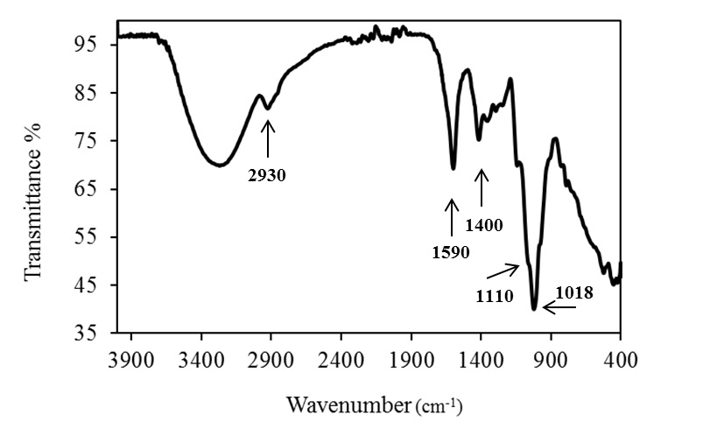

**Figure 1. FTIR spectrum of sesamum gum.**

*3.2.3. NMR spectroscopy*

The 1H and 13C NMR spectra of sesamum gum (Fig. 2) resembled the spectra of the polysaccharide mucilage isolated from leaves of *Dicerocaryum zanguebaricum* (Barone et al., 1996). The 1H NMR spectrum (Fig. 2A) showed H-1 signals from 4.37–5.49 ppm and the 13C NMR spectrum (Fig. 2B) showed C-1 signals from 98.9–104.5 ppm. The spectra were partially assigned on the basis of the HSQC experiment and by comparison with published spectra of similar molecules (Table 3: Barone et al., 1996; Wagner et al., 2004; Wagner et al., 2007; Wagner et al., 2008; Wee et al., 2014).

**Table 3. Summary of 1H and 13C NMR chemical shifts (δ, ppm) for sesamum gum.**

|  |  |  |
| --- | --- | --- |
| *Deduced residue* | *Proton* | *Carbon* |

|  |  |  |
| --- | --- | --- |
| α-Manp | 5.49 | 98.9 |
| 5.37 | 99.3 |
| α-Gal*p* | 5.24–5.27 | 101.7 |
| 102.1 |
| β-Xyl*p* | 4.84 | 104.6 |
| β-Glc*p*A | 4.37–4.47 | 103.4 |

|  |  |  |
| --- | --- | --- |
|  |  | 103.9 |

The two signals at H-1/C-1 5.49/98.9 ppm and 5.37/99.3 ppm were assigned to α-D-Man*p* residues and the H-3/C-3 signal at 3.81/83.7 ppm was consistent with O-3 substitution of these residues as observed in the glycosyl linkage analysis (Table 2). Similarly, two signals at H-1 4.37–4.47 and C-1 103.4 and 103.9 ppm were assigned to β-D-Glc*p*A residues. The presence of a carbonyl signal in the 13C NMR spectrum at 174.5 ppm (data not shown) and the H-1/C-1 signal at 3.37/73.7 confirmed the presence of this uronic acid residue (Barone et al., 1994). Signals at H-1/C-1 5.24–5.27/101.7–102.1 were assigned to α-D-Gal*p* residues and that at H-1/C-1 4.84/104.6 was assigned to a β-D-Xyl*p*. The methylene signal at 66.3 ppm was consistent with the presence of T-β-D-Xyl*p* (Sims & Newman, 2006), which was the major xylose linkage observed. Similarly, the methylene signals at 61.9 and 62.4 ppm were assigned to α-D-Man*p* and α-D-Gal*p* residues, but were not distinguished from each other. Integration of the C-1 signals showed similar proportions of the four major sugars to that obtained by the constituent sugar analysis (Table 1). The absence of signals at 13C 54 ppm and 1H 3.8 ppm was consistent with the absence of any *O*-methyl esterification which supported the FTIR data (Fig. 1).

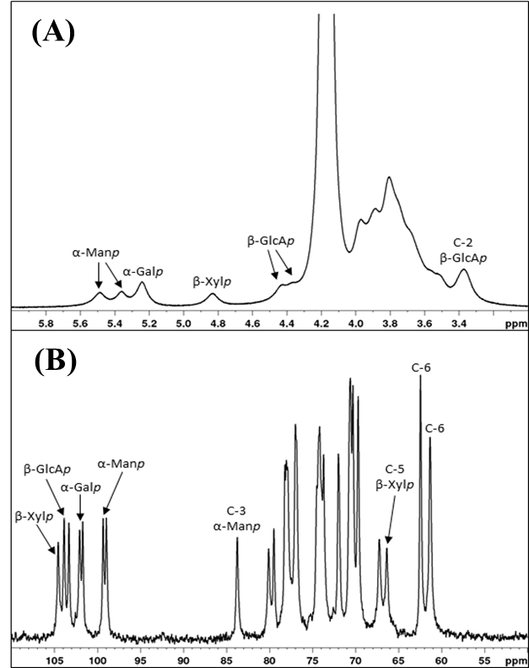

**Figure 2. Selected regions of the 1H (A) and 13C (B) NMR spectra of sesamum gum.**

A possible structure for sesamum gum is shown in Figure 3, in which the backbone of →4)-β-D-Glc*p*A-(1→2)-α-D-Man*p*-(1→ is branched at O-3 of most of the Man*p* residues and about half of the Glc*p*A residues. Polysaccharides comprising a similar repeating backbone are found as major components of a number of mucilages and exudate gums. Indeed, a similar glucuronomannan has been found previously in another African member of the Pedaliaceae, *D. zanguebaricum* (Barone et al., 1996). These polysaccharides are produced by mucilage trichomes that are found on leaves of members of the Pedaliaceae, and such trichomes have been described for *Ceratotheca triloba* (Naidoo, Karim, Heneidak, Sadashiva & Naidoo, 2012) and *Harpagophytum procumbens* (Naidoo, Heneidak, Bhatti, Kasim & Naidoo, 2014). Histochemical analysis indicated that the mucilage produced by *H. procumbens* was rich in polysaccharide, but also contained phenolic compounds and lipids (Naidoo, et al., 2014). The role of these mucilages in the plant is not entirely clear, although they may act as a lubricant during leaf expansion. Interestingly, however, *D. zanguebaricum*, *C. triloba* and *H. procumbens* are all traditional medicinal plants from southern Africa and the mucilage from *D. zanguebaricum* has been used both as a medicine and as a personal care product.

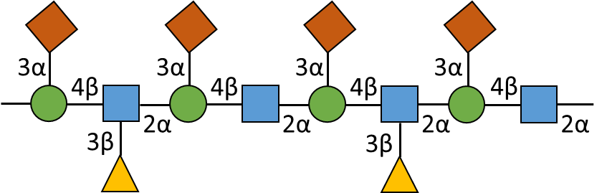

**Figure 3.Possible structure for sesamum gum;  = mannose,  = glucuronic acid,  = galactose and  = xylose.**

*3.2.4. Size-exclusion chromatography-multi-angle laser light scattering (SEC-MALLS)*

Size-exclusion chromatography of the water-soluble portion of sesamum gum shows a large RI peak detected at an elution volume range of 10.5–15 mL, representing ~85% of the eluted material, together with several smaller later-eluting peaks (~15% total eluted material) (Fig. 4). The UV absorbance trace (not shown) suggested that there was little protein present, as indicated by the nitrogen content (Table 1). The weight-average molecular weight (Mw) of the major peak was determined to be 1.46 x 106 Da, with a polydispersity index (Mw/Mn) of 1.33 and a radius of gyration of 89 nm.

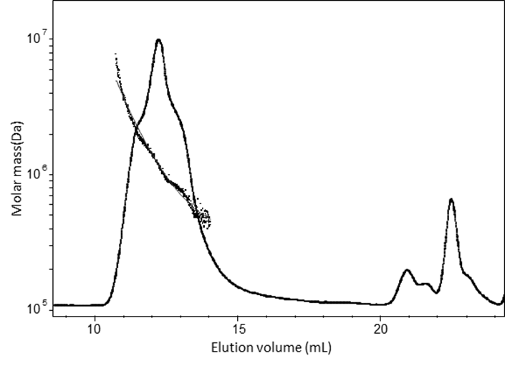

**Figure 4. Molecular weight analysis by size-exclusion coupled with multi-angle laser light scattering (SEC–MALLS) of purified sesamum gum.**

*3.3. Physical analysis of sesamum gum*

*3.3.1. Intrinsic viscosity and determination of critical concentration*

The intrinsic viscosity of sesamum gum was determined in deionised water, but to obtain intrinsic viscosity values in the absence of electrostatic interactions measurements were also performed under the electrostatic screening provided by 0.1 M NaCl (Kontogiorgos, Margelou, Georgiadis, & Ritzoulis, 2012; Ndjouenkeu, Akingbala, & Oguntimein, 1997).The intrinsic viscosity of sesamum gum was determined as 4.40 dl/g and 3.31 dl/g in deionized water and NaCl respectively.

The viscosity of the sesamum gum was tested in the semi-dilute range of concentrations between 0.02%–3.2% w/v and shear rates from 0.1–100 s-1. All the samples in this concentration range exhibited shear-thinning behaviour (Fig.S2), which is apparent in other glucuronomannans, such as gum ghatti (Kaur, Singh, & Singh, 2009).

Recent studies on another, structurally similar, glucuronomannan extracted from the New Zealand black tree fern, *Cyathea medullaris*, showed very different rheological properties with a shear thickening event that occured in the semi-dilute range (Goh, Matia-Merino, Hall, Moughan, & Singh, 2007; Wee et al., 2014). The major structural difference between the sesamum gum and the glucuronomannan from *C. medullaris* is the absence of *O*-methyl esterification of the uronic acids in sesamum gum. The presence of *O*-methyl esterification and, more importantly, the lack of charge on the glucuronic acid residues in backbone of the glucuronomannan from *C. medullaris* results in a compact folded chain structure where intramolecular interactions dominate within each chain. This would explain the relatively low viscosity and Newtonian behaviour at low shear rates, reported by Goh et al. (2007) and Wee et al. (2014). As shear rate increases these compact chains begin to unfold and elongate, exposing the functional groups present along the backbone of each chain encouraging intermolecular interactions to occur, leading to shear-thickening behaviour (Wee et al., 2014). In contrast, the absence of *O*-methyl esterification in the sesamum gum glucuronomannan causes the chains to be extended and stiff favouring intermolecular entanglement to dominate over intramolecular interactions. This would explain the relatively high viscosity of sesamum gum at low concentrations compared with that of the glucuronomannan from *C. medullaris*.

To examine the behaviour of sesamum gum in the dilute and semi-dilute regime, double-logarithmic plots of (ηsp) vs. c[η] were constructed to determine the critical concentration (c*) at which the transition from the dilute to concentrated regime occurs (Morris, Cutler, Ross-Murphy, & Rees, 1981). The critical concentration c* was estimated at 0.1 % w/v (Fig. 5). In general, polymers that have high [η] will also exhibit a transition from the dilute to concentrated region at lower polymer concentration due to the increased number of intermolecular interactions. It has been reported that for most random coiled polymers there is a sharp change in slope from 1 to approximately 3.3 on transition from the dilute to concentrated regime (Morris et al., 1981; Ndjouenkeu et al., 1997; Wee et al., 2014). The exponent of the double logarithmic plot for the dilute and the semi-dilute regions in sesamum gum were determined as ~0.55 and ~2.02, respectively, and therefore comply with this generalisation (Fig. 5).

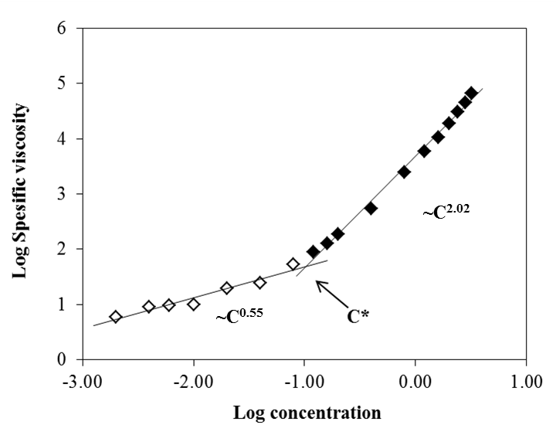

**Figure 5. Double logarithmic plots of zero shear specific viscosity (ηsp)ovs. reduced concentration c[η].**

*3.3.2. Rheological measurements*

At neutral pH the uronic acids in polysaccharides are deprotonated carrying a negative charge. It is proposed that the highly charged backbone of sesamum gum would cause a degree of intra-molecular repulsion resulting in an extended conformation that facilitates intermolecular interactions between the chains. To determine the nature of these interactions small deformation oscillatory measurements were performed on a 1 % w/w solution of sesamum gum. The mechanical spectrum showed that G′ was greater than G″ throughout the frequency range tested indicating that there were intermolecular interactions between the polymer chains (Fig. 6A). There was some frequency dependence of the measured moduli with both G′ and G″ gradually reducing and becoming much closer to one another at low frequencies. This indicated that the intermolecular interactions were most likely due to polymer entanglement rather than the formation of a weak gel network, as the increased time between oscillations allows the polymer to disentangle which manifests as a reduction in the measured moduli. Examining this further, according to the empirical Cox-Merz rule, the complex dynamic viscosity η∗ (as a function of angular frequency, ω, rad/s) can be superimposed onto a plot of shear viscosity as a function of shear rate (1/s) if the interactions of the polymers in solution are due to entanglement and are not the result of aggregation or specific physical interactions (Cox & Merz, 1958). The sesamum gum at the concentration tested (1% w/v) was shown to follow the Cox-Merz relationship (Fig. 6B) indicating the absence of aggregation or specific physical interactions and supporting the interpretation that the intermolecular interactions were due to polymer entanglement. Taking into consideration the chemical and structural analysis of the sesamum gum, it is reasonable to argue that the extended conformation and extensive branching of neutral sugar residues (Fig. 3) provide multiple attachment points for intermolecular entanglement that dominate over the electrostatic repulsion expected from the deprotonated glucuronic acid residues present on the polymer backbone.

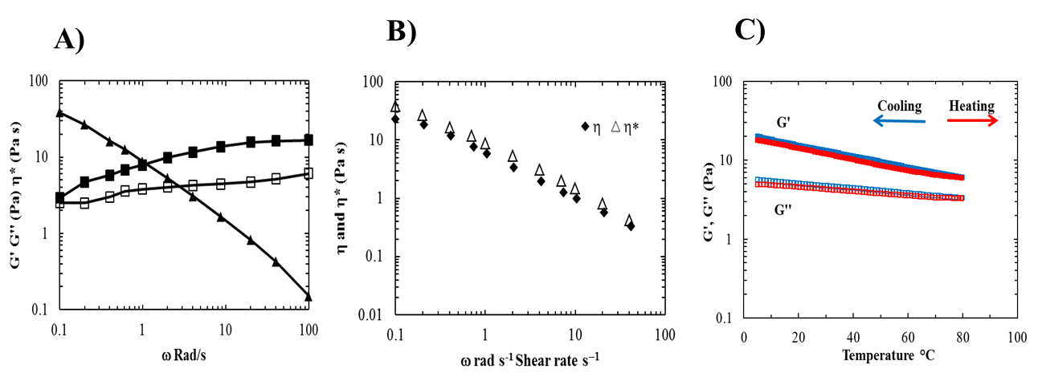

**Figure 6. Rheological properties of sesamum gum; A) frequency dependence of G′, G″ and * of a 1% SG dispersion, B) Cox–Merz superimposition of and * for 1% w/v sesamum gum dispersion and C) Temperature dependence of G′ and G″ on cooling and heating.**

Rheological behaviour on cooling and heating for sesamum gum was also investigated and results are shown in Fig. 6C. No notable thermal transitions or hysteresis were observed on heating or cooling showing the inability of the material to form permanent binding partners that result in macroscopic network formation. This is likely due to the highly branched nature of the isolated polysaccharide restricting rearrangements that could become centres of structures with short-range order.

**4. Conclusion**

The structure and some physicochemical properties of gum extracted from the leaves of the annual plant *S. radiatum* have been evaluated. The results show that the gum is mostly high molecular weight polysaccharide, containing mannose, galactose, xylose and glucuronic acid as the main monosaccharide components. It is a glucuronomannan having a →4)-β-D-Glc*p*A-(1→2)-α-D-Man*p*-(1→ backbone with side-chains of neutral galactose and xylose. In the hydrated state the gum exhibits a viscoelastic behaviour consistent with intermolecular entanglement within the linear viscoelastic region and shear–thinning behaviour under steady shear conditions. The polysaccharide from the leaves of *S. radiatum* gum may have potential as food ingredient or excipient in pharmaceutical dosage forms, and these should be investigated further.

**Acknowledgements**

This project was funded by the Royal Society through the Newton International Fellowship scheme grant number NF120704.

**References**

Alba, K., Laws, A. P., & Kontogiorgos, V. (2015). Isolation and characterisation of acetylated LM-pectins extracted from okra pods. *Food Hydrocolloids*, *43*, 726–735.

Allagh, T. S., Meseke, A., Ibrahim, Y. K. E. (2005). Evaluation of the tablet binding properties of *Sesamum radiatum*. *Nigerian Journal of Pharmaceutical Research, 4*, 46–50.

Amid, B. T., Mirhosseini, H., & Kostadinović, S. (2012). Chemical composition and molecular structure of polysaccharide-protein biopolymer from *Duriozibethinus* seed: extraction and by purification process. *Chemistry Central Journal, 6*, 117.

Barone, G., Corsaro, M. M., De Castro, C., Lanzetta, R., Mangoni, L., & Parrilli, M. (1994). Structural investigation of *Ceratozamia spinosa* mucilage. *Carbohydrate Research, 260*, 259–270.

Barone, G., Corsaro, M. M., Giannattasio, M., Lanzetta, R., Moscariello, M., & Parrilli, M. (1996). Structural investigation of the polysaccharide fraction from the mucilage of *Diceroaryum zanguebaricum* Merr. *Carbohydrate Research, 280*, 111–119.

Chatjigakis, A. K., Pappas, C., Proxenia, N., Kalantzi, O., Rodis, P., & Polissiou, M. (1998). FT-IR spectroscopic determination of the degree of esterification of cell wall pectins from stored peaches and correlation to textural changes. *Carbohydrate Polymers, 37*, 395–408.

Ciucanu, I., & Kerek, F. (1984). A simple and rapid method for the permethylation of carbohydrates. *Carbohydrate Research, 131*, 209–217.

Coimbra, M. A., Barros, A., Barros, M., Rutledge, D. N., & Delgadillo (1998) Multivariate analysis of uronic acid and neutral sugars in whole pectic samples by FT-IR spectroscopy *Carbohydrate Polymers, 37*, 241–248.

Cox, W. P., & Merz, E. H. (1958). Correlation of dynamic and steady flow viscosities. *Journal of Polymer Science, 28*, 619–622.

De Ruiter, G. A., Schols, H. A., Voragen, A. G. J., & Rombouts, F. M. (1992). Carbohydrate analysis of water-soluble polysaccharides with high-performance anion-exchange chromatography using methanolysis combined with TFA hydrolysis is superior to four other methods. *Analytical Biochemistry, 207*, 176–185.

Doares, S. H., Albersheim, P., & Darvill, A. G. (1991). An improved method for the preparation of standards for glycosyl-linkage analysis of complex carbohydrates. *Carbohydrate Research, 210*, 311–317.

Gnanasambandam, R., & Proctor, A. (2000). Determination of pectin degree of esterification by diffuse reflectance Fourier transform infrared spectroscopy. *Food Chemistry, 68*, 327–332.

Goh, K. K. T., Matia-Merino, L., Hall, C. E., Moughan, P. J., & Singh, H. (2007). Complex rheological properties of a water-soluble extract from the fronds of the black tree fern, *Cyathea medullaris*. *Biomacromolecules, 8*, 3414–3421.

Huggins, M. L. (1942). Some properties of solutions of long chain compounds. *Journal of the American Chemical Society, 64*, 2716–2720

Kaur, L., Singh, J., & Singh, H. (2009). Characterization of gum ghatti (*Anogeissus latifolia*): A structural and rheological approach. *Journal of Food Science, 74*, 328–332.

Kontogiorgos, V., Margelou, I., Georgiadis, N., & Ritzoulis, C. (2012). Rheological characterization of okra pectins. *Food Hydrocolloids, 29*, 356–362.

Morris, E. R., Cutler, A. N., Ross-Murphy, S. B., & Rees, D. A. (1981). Concentration and shear rate dependence of viscosity in random coil polysaccharide solutions. *Carbohydrate Polymers, 1*, 5–21.

Naidoo, Y., Karim, T., Heneidak, S., Sadashiva, C. T., Naidoo, G. (2012). Glandular trichomes of *Ceratothecatriloba* (Pedaliaceae): morphology, histochemistry and ultrastructure. *Planta 236*, 1215–1226.

Naidoo, Y., Heneidak, S., Bhatti, A., Kasim, N., & Naidoo, G. (2014). Morphology, histochemistry, and ultrastructure of foliar mucilage-producing trichomes of *Harpagophytum procumbens* (Pedaliaceae). *Turkish Journal of Botany, 38*, 60–67.

Needs, P. W., & Selevendran, R. R. (1994). A critical assessment of the one-tube procedure for linkage analysis of polysaccharides as partially methylated alditol acetates. *Carbohydrate Research, 254*, 229–244.

Nep, E. I., Asare-Addo, K., Ghori, M. U., Conway B. R., & Smith, A. M. (2015). Starch-free grewia gum matrices: Compaction, swelling, erosion and drug release behaviour. *International Journal of Pharmaceutics, 496*, 689–698.

Nep, E. I., Asare-Addo, K., Ghori, M. U., Conway, B. R., & Smith, A.M. (2016). Evaluation of sesamum gum as an excipient in matrix tablets. *British Journal of Pharmacy*, *In Press*.

Ngwuluka, N. C., Akanbi, M., Agboyo, I., & Uwaezuoke, O. J. (2012). Characterization of gum from *Sesamum indicum* leaves as a suspending agent in a pediatric pharmaceutical suspension. *World Journal of Pharmaceutical Research, 1*, 909–924.

Ndjouenkeu, R., Akingbala, J. O., & Oguntimein, G. B. (1997). Emulsifying properties of three African food hydrocolloids: okra (*Hibiscus esculentus*), dika nut (*Irvingia gabonensis*), and khan (*Belschmiedia* sp.). *Plant Foods for Human Nutrition, 51*, 245–255.

Oduntan A. O., Olaleye O., & Akinwande, B. A. (2012). Effect of plant maturity on the proximate composition of *Sesamum radiatum* Schum leaves. *Journal of Food Studies 1*, 69–76.

Sims, I. M., & Bacic, A. (1995). Extracellular polysaccharides from suspension cultures of *Nicotiana plumbaginifolia*. *Phytochemistry, 38*, 1397–1405.

Sims, I. M., & Furneaux, R. H. (2003). Structure of the exudate gum from *Meryta sinclairii*. *Carbohydrate Polymers, 52*, 423–431.

Sims, I. M., & Newman, R.H. (2006). Structural studies of acidic xylans exuded from leaves of the monocotyledonous plants *Phormium tenax* and *Phormium cookianum*. *Carbohydrate Polymers, 63*, 379–384.

Smith, G. C., Clegg, M. S., Keen, C. L., & Grivetti, L. E. (1996). Mineral values of selected plant foods common to southern Burkina Faso and to Niamey, Niger, West Africa, *International Journal of Food Sciences and Nutrition, 47*, 41–53.

Wagner, R., Simas, F. F., Pereira, G. C. Z., Angeli, A., Brito, J. O., Woranovicz-Barreira, S. M., Delgobo, C. L., Sassaki, G. L., Iacomini, M., & Gorin, P. A. J. (2007). Structure of a glycoglucuronomannan from the gum exudate of *Vochysia tucanorum* (family Vochysiaceae). *Carbohydrate Polymers, 69*, 512–521.

Wagner, R., Simas, F. F., Sassaki, G. L., Iacomini, M., da Silva, M. A., & Gorin, P. A. J. (2008). A high-viscosity glycoglucuronomannan from the gum exudate of *Vochysia thyrsoidea*: Comparison with those of other *Vochysia* spp. *Carbohydrate Polymers, 72*, 382–389.

Wagner, R., Woranovicz-Barreira, S. M., Iacomini, M., Delgobo, C. L., Pimentel, N. M., & Gorin, P. A. J. (2004). Structure of a glycoglucuronomannan from the low-viscosity gum of *Vochysia lehmannii*. *Carbohydrate Polymers, 57*, 269–275.

Wee, M. S. M., Matia-Merino, L., Carnachan, S. M., Sims, I. M., & Goh, K. K. T. (2014). Structure of a shear-thickening polysaccharide extracted from the New Zealand black tree fern, *Cyathea medullaris*. *International Journal of Biological Macromolecules 70*, 86–91.

**Table Legends**

Table 1. Chemical composition of sesamum gum.

Table 2. Glycosyl linkage composition of carboxyl-reduced sesamum gum.

Table 3. Summary of 1H and 13C NMR chemical shifts (δ, ppm) for sesamum gum.

**Figure legends**

Figure 1. FTIR spectrum of sesamum gum.

Figure 2. Selected regions of the 1H (A) and 13C (B) NMR spectra of sesamum gum.

Figure 3. Possible structure for sesamum gum;  = mannose,  = glucuronic acid,  = galactose and  = xylose.

Figure 4. Molecular weight analysis by size-exclusion coupled with multi-angle laser light scattering (SEC–MALLS) of purified sesamum gum.

Figure 5. Double logarithmic plots of zero shear specific viscosity (ηsp)ovs. reduced concentration c[η].

Figure 6. Rheological properties of sesamum gum; A) frequency dependence of G′, G″ and * of a 1% sesamum gum dispersion, B) Cox–Merz superimposition of and * for 1% w/v sesamum gum dispersion and C) Temperature dependence of G′ and G″ on cooling and heating.

Figure S1. Total ion-chromatogram (top) and fragmentation patterns (bottom) of unidentified peaks (A, B & C) in GC-MS traces of partially methylated alditol acetates of sesamum gum. (NS – not sugar; arrows indicate unidentified peaks)

Figure S2. Viscosity curves of sesamum gum at concentrations of 0.2 – 3.2 % w/v.