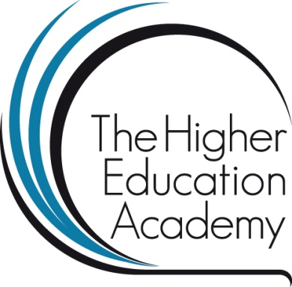

**Students as Teaching and Learning Consultants - project funded by the Higher Education Academy**

At the University of Huddersfield the Students' Union and the Teaching and Learning Institute developed a scheme where students worked as teaching and learning consultants in partnership with staff. The role of student teaching and learning consultant was developed to get beyond a hierarchical student/staff relationship and for staff to engage with a student perspective outside more formal quality enhancement processes. One aspect of implementing the scheme was the creation of a space where students and staff could engage in informal conversations about teaching and learning. At times the scheme included the blurring of student/staff identities; for example some of the student consultants reported that they felt they were engaging with staff on a more equal footing, that they had a greater understanding of how people learn in different ways and of the complexities involved in teaching. We argue that the scheme has enabled the student consultants to gain new perspectives on teaching and learning and allows staff to see their practice from a student point of view. Academic staff reported that they found the student perspective valuable, the feedback useful and were better informed about what students think. The project was funded by the Higher Education Academy and it builds on work by Crawford (2012) and Cook-Sather (2011).

**Project aims**

* to promote authentic student engagement in the enhancement of teaching and learning and explore the nature and construct of inspirational teaching
* to create opportunities for student and staff to engage in reflection and dialogue around teaching and learning approaches
* offer academic staff a qualified student perspective (at points of need) that goes beyond the typical end of module evaluation response or NSS survey

**How**

* Adopt a partnership approach
* Recruit and train students to be Teaching and Learning Consultants
* Match up students and staff to ensure they come from different academic schools

**Consultation process**

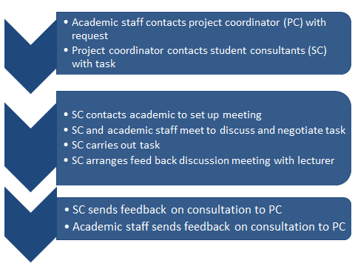

**Outcomes/Resources**

Project blog posts tagged with #HEASTLC at [http://theinstituteblog.co.uk](http://theinstituteblog.co.uk/)

All outcomes and resources available at: <http://www.hud.ac.uk/tali/central_init/heastlc/>

**References**

Cook-Sather, A. (2011) ‘Layered learning: student consultants deepening classroom and life lessons’, *Educational Action Research*, 19:1, 41-57.

Crawford, K. (2012) Rethinking the student/teacher nexus: students as consultants on teaching in higher education. In: *Towards teaching in public: reshaping the modern university*. Continuum.

[Creative Commons Licence](http://creativecommons.org/licenses/by-sa/4.0/)

This work is licensed under a [Creative Commons Attribution-ShareAlike 4.0 International License](http://creativecommons.org/licenses/by-sa/4.0/).