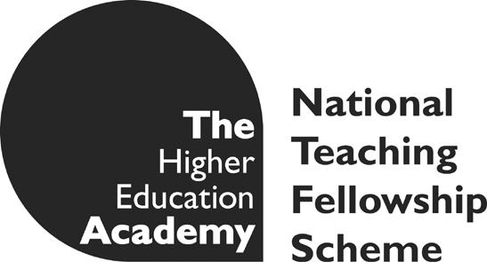 | NTFS Projects  Final Report

Project lead institution | University of Huddersfield
Project title | REQUALLO: Reusable Qualitative Learning Objects: Resources to support the learning of methods of qualitative data analysis in the social sciences
Lead contact name | Graham R Gibbs
Authors | Graham R Gibbs
Project lifespan | August 2007 – December 2010
Submitted by | Graham R Gibbs
Date submitted | 31.5.12

Table of contents

1. Table of contents 2
2. Acknowledgements 3
3. Executive summary 3
4. Background 5
5. Aims and objectives 7
6. Methodology 8
Case studies of research projects nearing completion. 8
User feedback 8
Online survey of teachers of qualitative analysis 9
Web analytics 9
Standards 10
7. Implementation 11
Creating the case studies and their material 11
Website development and Flash 13
Jorum 16
Designing for different types of user 16
8. Outputs and findings 18
The case studies 18
Evidence of usage 20
Feedback from user sessions 23
Results of the online survey 24
9. Outcomes 26
What affects the decision to use educational resources 27
Dissemination 29
10. Conclusions 30
11. Implications 31
12. Recommendations 32
13. Appendix 1 33
Synopses of the five case studies and interviews carried out. 33
Case 1 - Frances Rogers 33
Case 2 - Emma Turley 33
Case 3 - Sally Jones 33
Case 4 - Nicola Swan 33
Case 5 - Karl Kitching 33
14. Appendix 2 34
Additional video materials included in the website 34
Prof. Nigel King on Template Analysis 34
Talks on aspects of qualitative data analysis 34
Five short videos from a lecture on Grounded Theory 34
15. Appendix 3 35
Presentations about or including reference to the REQUALLO project 35
16. References 36

Acknowledgements

The project was a result of the National Teaching Fellowship Scheme project strand initiative funded by the Higher Education Funding Council for England (HEFCE) and managed by the Higher Education Academy.
We wish to acknowledge the help given to the project by the many students (undergraduate and postgraduate) who used the materials in their learning and gave us feedback about their experience. We also wish to thank fellow teachers who, in the hands-on sessions and the focus groups gave us valuable information about the design and the use of the materials and the website that contains them.
Project partners:
University of Surrey (Ann Lewins and Christina Silver)
University of Greenwich (Colm Crowley)
University of Huddersfield (Graham R Gibbs, Dawn Clarke)

Executive summary

This project aimed to produce a number of case study/exemplars based on the detailed examination of how researchers undertook the qualitative analysis of their data in their research projects. The intention was to produce a range of teaching materials openly available for academic teachers and students to find and use in their teaching and learning. Five case studies were developed and a range of textual materials, audio and video capturing the details of the analytic process the researchers undertook was created. Qualitative research is a popular method and in some disciplines, such as psychology, is growing in popularity. We felt that such resources might help teaching staff deal with the larger classes and the different ways of teaching that mass education in this field requires.

The researchers used in the case studies were all doctoral students near the end of their studies. As of writing 4 of the 5 have now gained their PhDs. They came from a range of disciplines, psychology, business studies, sociology and education and were undertaking work in a wide range of topics. Two of them used NVivo software at some stages of their analysis and one used Atlas.ti. All the materials produced were incorporated into the OnlineQDA website that has been in existence since 2005. The video materials appear on this site but have also been made available on the YouTube website.

We obtained feedback in the design process from student user groups (in undergraduate and postgraduate classes) from workshop sessions using the materials, from conference presentations and from an online survey of 96 teachers of qualitative methods.

Materials are freely available for use and re-use and consequently we have gradually adopted the creative commons (CC) licence on the materials to encourage re-use (http://onlineqda.hud.ac.uk/Tutorials/index.php).

Background

Research methods form a compulsory element of social science disciplines such as sociology, psychology, education, health studies, anthropology and cultural studies as well as business and organisational studies. Qualitative research is a key aspect of this and has been growing in popularity and importance over the last 20 years. Many qualitative approaches, common to a wide range of disciplines, such as grounded theory, ethnography, template analysis, discourse analysis, narrative analysis, interpretative phenomenological analysis and qualitative content analysis, are now available and offered to students.

Qualitative research is as old as quantitative research, but was traditionally taught as a craft skill using an apprenticeship learning model. (Lave & Wenger, 1991) This model of teaching worked well in the traditional context of postgraduate study with its one-to-one supervisory relationship, but it is ill suited to working with the larger numbers of undergraduates who now have to use the approach. Despite the recent availability of texts such as Boeije, Charmaz and Grbich that examine how to analyse data generated by qualitative research they still tend to discuss this at a theoretical level . The actual techniques and process of analysis remain inscrutable and hidden.

The problem is that learning how to undertake qualitative data analysis (QDA usually involves the application of considerable interpretation by the researcher. It is thus very difficult to set down guidelines in a generalised way and difficult for learners to appreciate and apply such guidelines. It is the common experience of those teaching QDA that students find the interpretative stages, such as coding and theme development, very challenging. Two of the team (Gibbs in sociology, criminology and politics and Crowley in psychology and education) have found this to be an issue in their teaching of undergraduates. Indeed we have found a similar hurdle at postgraduate level. Good quality examples that show students the thinking that lies behind the analysis, that work with the same data set at all stages and show the analysis step-by-step are therefore needed. Lewins, a member of the project team, has detected a similar difficulty in those researchers attending computer assisted qualitative data analysis (CAQDAS) training sessions who are not very methodologically grounded or are novice qualitative researchers who come to a project and the use of software at same time. They find it hard to grasp the interpretative thinking involved in coding and code development and need to make progress towards thinking analytically and beyond the making of superficial descriptive explanations. In some cases they even erroneously believe that the software can do that for them.

An additional pressure is encountered in those disciplines, such as psychology, where the discipline is still dominated by quantitative approaches but where qualitative methods have recently been made compulsory and interest is growing (British Psychological Society, 2002; QAA, 2002). This not only means that students are typically ill-prepared for qualitative work, but often that they apply to their analysis inappropriate ideas which they have mistakenly extrapolated from quantitative methods (Gough et al., 2003). The HE Academy Psychology working group on teaching qualitative research methods at undergraduate level has identified the need for resources (such as exemplars) to support teachers and students especially in a subject like psychology where there is a growing demand from students and professional bodies for such teaching but where staff with expertise are in short supply (Koutsopoulou et al., 2006)

From 2004-5 Gibbs and Lewins worked on an ESRC funded project (RES-333-25-0009) “Online QDA” (http://OnlineQDA.hud.ac.uk) that addressed the need for online materials for researchers learning CAQDAS. We undertook a needs analysis in which we surveyed (n=250) and interviewed (n=16) a range of qualitative researchers including many postgraduate students. (Gibbs, et al. 2006). Many of them, and especially the more recently trained who had not benefited from an apprenticeship approach to acquiring research skills, pointed to the difficulty of learning how to undertake qualitative analysis and in particular of understanding the detailed work that transforms collected data into final analysis and reports. There was a frequent request for illustrative data sets that show learners the detail of the analytic process. What our users identified was not only that for most projects a detailed analysis is not published (and therefore those new to analysis find it hard to learn about it) but also that this process involves many implicit and unstated thought processes, which may not even be recorded in researchers’ field notes and memos. These analytic activities involve the kind of interpretative and creative thought processes, associated with inductive analysis, that even the researchers themselves may not have been aware of at the time and capturing them necessitated actually interviewing the researchers about them.

Aims and objectives

- Develop six case study exemplars of QDA learning resources derived from existing research projects. These will represent a range of analytic techniques and will cover a range of disciplines.
Ultimately we completed only five case studies (For synopses see Appendix 1.). It was clear (as one of our reviewers had suggested) that we were too optimistic about what we had time to complete. In part this was because of the multistage process we adopted with each case to begin with (see the methodology section below) which took up too much time. We also realised that video was more popular with students and so we changed our focus to that rather than audio. We also did produce an additional range of videos that were not case studies but were linked to the analytic work (See Appendix 2 for details).
- In at least two of these, show how the analysis may be supported using CAQDAS software.
- Include, in each exemplar, the raw data, video interviews with the respective researchers, examples of different stages of the analysis with step-by-step instructions and interactive exercises.
We have only been able to make available a varying amount of raw data and other linked analytic documents for each case. Complete sets of raw data were hard to get because of the researcher’s desire to preserve the anonymity of the participants in their research. Selections of data and other materials have been included where possible.
- Make the material available at various levels of granularity for different learning and teaching uses ranging from lecture examples to full, self-directed learning, Thus each exemplar could be used as a whole (for example as the basis for a full term course on QDA), or parts of it could be used independently as exercises targeting different stages of the analysis.
- Make the material useable at a range of student levels, from first year undergraduate to taught postgraduate. Create subsets of the materials (in terms of size or of analytic scope) and identify, for teachers and students, what level they are intended for.
- Incorporate the resources developed into the existing Online QDA website and RLO repositories (e.g. Jorum). For teaching use they will have ‘wrappers’ indicating possible teaching uses and learning outcomes.
- Investigate and evaluate and then report what makes a good RLO design in QDA, what works best in creating awareness of the resources amongst teachers and students and what affects their decision to use the RLO.

Methodology

Case studies of research projects nearing completion.
We wanted to collect data from research projects nearing completion as we thought that at that stage researchers would be in a position to talk more confidently about the analytic details. If we had left it till a year or two after the project was finished then we believed a great deal of detail would have been forgotten and the story of the analytic process we might receive would be the ‘cleaned-up’, reconstructed version which might give a clear and well justified account of the analysis but would omit the false starts, blind alleys and other confusions which the researcher actually experienced. In fact, in most cases, we did successfully manage to capture the real process rather than the idealised one that might get written up later in theses and publications. The cases we included were all PhD students at the time of undertaking the study they were interviewed about. Subsequently, three have become university lecturers – one before the interview was actually carried out. We found that researchers working on their own, like PhD students, were undertaking research under conditions that would most closely match that of the students we were trying to address. In the original plan each would be interviewed (and audio recorded) once or twice and then interviewed again on camera to produce video materials. The research fellow on the project along with the PI would analyse this interview data and write it up into learning objects which would include web page narrative, audio and video extracts and links to and/or notes on the data, theoretical ideas, analytic processes and general literature to which they referred. All these materials would be included in the OnlineQDA website. We had a little technical assistance in the studio on campus at Huddersfield, but in fact all of the audio and video editing work was undertaken by the PI. Two of the cases were interviewed off campus (one in Surrey and one in London) and all the camera work and audio recording was done by the PI.

User feedback
We obtained user feedback and evaluation of the outputs of the project in a variety of ways. We used early versions of the materials in teaching at Huddersfield and at Greenwich Universities. These were both sessions where we used the materials in class and made it available as supplementary material for student to consult later. A simple questionnaire was used to collect data. At Huddersfield the students were in a small group (n=10) taking a master’s module on qualitative research (part of a masters on social research methods used as postgraduate research training). At Greenwich, the students (n= 34) were a group of undergraduates taking a research methods module as part of a degree in Psychology.
We presented the materials at five different workshop venues (three conferences in London and two workshops in Manchester) and used these as focus group sessions to get the views both of the postgraduate students who attended and the academic teachers who attended. A major activity at these sessions was a hands-on use of the materials following a distributed schedule of tasks. This lasted about 40 minutes and was followed by about 30 minutes of focus group discussion around design and usability issues that we asked the groups to discuss. These sessions were not audio recorded but one of the research team took notes as the other led the focus group discussion. This gave us important information about the detailed design of the web interface and about what kinds of audio and video materials were most appropriate for undergraduate or postgraduate learners.

Online survey of teachers of qualitative analysis
In order to obtain a broader view of how qualitative methods and particularly qualitative analysis is taught we undertook an online survey of teachers. This was done in January 2011 using the Bristol Online Surveys facility. 96 replies were received from across the world (with the largest national groups coming from the UK and the USA.) We were a little disappointed in the number responding as two of us had undertaken a similar online survey on software use in qualitative analysis in 2005 to which we received 256 replies. We think the lower response rate now reflects two issues. Teachers of qualitative research methods are a hard-to-reach group. We used a variety of methods to contact possible respondents. We searched for relevant JiscMail and other discussion lists and where we could circulate details of our survey. We used lists of departmental contacts from relevant HEA subject centres, though the problem here is that such contacts might not necessarily themselves be involved in teaching qualitative methods and we had to request them to pass the details on to relevant colleagues. We circulated contacts kept by the CAQDAS networking centre at University of Surrey. (One of the project team was based at the centre). We also did a manual search of departmental websites in the UK looking for e-mail details of any academics who might be teaching qualitative methods. We consider that teachers of qualitative methods are less likely than many other groups to be on such lists (at least compared with the users of computer software that assists in qualitative analysis and we are sure that many teachers did not find out about the survey. The other reason for a lower response than our previous survey is, we suspect, a kind of online survey fatigue from the sheer number that are now circulated. For the results, see Section 8.

Web analytics
We used two kinds of analytics to assess how the online materials were being accessed. The main OnlineQDA site was set up to generate Google Analytics and these were used to investigate the website usage, the access to specific pages, where users were coming from and how they were finding out about the site.
Part way through the project we started putting the video materials on YouTube and we used YouTube analytics to judge not only the number of views of the material but also to some extent how they were being viewed.

Standards
Originally we envisaged collecting complete data sets from the researchers we interviewed. This turned out to be impossible. For ethical reasons, researchers were unwilling to give us access to all their primary data. It therefore was less relevant that we adhere to the standards for the archiving of data sets being developed by Qualidata, the ESRC Data Archive at University of Essex. In fact all the research materials we did collect from the researchers, which were mainly samples of their work, are stored on the website in widely accessible Microsoft Word .doc and .rtf formats.
It was always intended that the outputs from this project would be freely available to any student or teacher who wanted to use them. The widespread adoption during the project of the CC (Creative Commons) licence for educational materials meant that we have been able to clarify the conditions of use of our materials and, where possible, we have used a CC licence.

Implementation

Creating the case studies and their material
Most of the implementation activities in the project revolve around the creation of learning and teaching materials based on case studies of qualitative researchers. Having decided to use PhD students nearing the end of their theses, the next challenge was to find a number of such researchers using the methods we were interested in in the subject areas we wanted who were willing to be open about their analysis. We used a variety of methods to find such researchers. In two cases they were students of colleagues at the University of Huddersfield. We actually approached a number of possible contributors at Huddersfield but were turned down on several occasions usually for ethical reasons. The researchers did not feel they were able to be open about their methods and with their data commonly because the ethical conditions under which their work was undertaken did not include teaching use and they were unwilling or did not consider it possible to go back to their participants to obtain this clearance. Such ethical and confidentiality issues caused us great difficulty in getting volunteers to work with us on the project. We also think this reflects a deeper insecurity on the part of the volunteers. Researchers are not used to being so open about the details of their research activities and feel threatened about their work being judged inadequate or sloppy. In fact several of them compared the experience of being interviewed about their research as like what they imagined the PhD viva would be like. We became very aware of this and attempted to be as supportive as possible, without jeopardising the supervisor’s role. Again, several of them found that discussing their research work in this way clarified for them many issues in their thesis work.

Two of the cases we used were contacted for us by a member of the project team who worked in London and Surrey. In the former case it was through contacts he had with supervisors at the Institute of Education in London, and in the latter it was by accessing PhD students who had in the past been assisted by the CAQDAS networking project at Surrey. Both these cases involved long distance travel by other team members in order to interview and record or video record them. At one point we were having such a struggle finding volunteers, and we were very aware that we did not want a large proportion of them to come from one university that we used the network of National Teaching Fellows to find more. This was very useful in providing us with a number of possible volunteers in the north of England and in the end one PhD student from the University of Leeds took part in the project.

Where necessary we worked with the volunteers to obtain the appropriate ethical clearance and contacted their supervisors (in those cases where they were still working on the PhD) for clearance. The methodology section above describes the procedure we adopted to collect the data, audio and video recordings we needed. To start with, our focus was on textual materials and audio recordings with a smaller video element. But as the project developed it became clear that video materials were much more important for both student use and for teaching use. For example, one of the outcomes from our user testing with early versions of the materials was how engaged students were by the video material. We were particularly struck when comparing the open courseware materials to be found, for example, on iTunes with the video material to be found, for example, on YouTube. The former was commonly audio material based on hour-long lecture capture and required some dedication and commitment for users to listen to the whole broadcast. In contrast, many materials on YouTube are restricted to 10 minutes (now 15 minutes) or less. This has proved very popular, not just for entertainment but also for educational purposes. In fact more recent video material available via iTunes from the Open University has adopted the short, 10-minute format. Consequently, we began to give more emphasis to video work and also made sure that the teaching and learning resources we were creating could be read, listened to or watched in around 10 to 15 minutes. The appropriateness of this choice was confirmed by results from the feedback sessions with students and academics.

Volunteers were briefed by email or by phone before interview sessions about what they would be asked about and what information they should contribute. In four of the cases, we undertook one or two interviews (which were audio recorded). At these we were able not only to clarify what information we needed but also to begin to collect both textual material (the interviews were transcribed) and audio material that could be built into learning materials. It also meant we were familiar enough with the study the volunteer was undertaking that we could then plan, prepare and undertake an interview session on video. The more we knew about the volunteer’s PhD research and the more they understood about the kind of details we were hoping to include in the learning resources the more productive the video sessions could be. The last case was undertaken slightly differently. This student had actually finished his PhD a year earlier and was now a university lecturer. He had published some papers based on the thesis and by reading these we could get a very good idea about his research. By this stage we could also be very clear what materials we were looking for that he could provide and consequently we were able to get good quality materials from just a video interview. See Appendix 1 for details about the sessions undertaken with each volunteer.

All recording sessions lasted about 60 to 90 minutes, including the video sessions. However, in common with radio and TV productions, we edited this down to a much smaller amount of material for each case that we made available on the web. Translating the recordings or videos into learning objects or learning resources turned out to be a very labour intensive phase of the project. It is very hard to quantify this as there is so much variability depending on:
- The kinds of discussions and answers given (some volunteers were more coherent and usable in their explanations),
- The degree to which topics were discussed together or appeared at different points and had to be edited,
- How much and what kind of extra editorial material had to be written
- The preparation of complementary materials, such as annotations, references and examples of text,
- The technical quality of the recordings, and
- The degree of audio and video editing required.

Typical times would include the following:
Transcription of a session (done for the audio sessions) 6 hours
Initial analysis of one interview session and write up 4 days
Preparation of script, including editorial commentary 5 days
Web page preparation 1 day
Audio preparation and editing 3 days
Video editing and preparation 5 days
Background research (reading papers etc) 3 days

In some ways what we undertook when we processed our interview data was similar to the qualitative analysis that is the subject of the learning resources we created. In other ways, it is similar to script writing in TV and film. In fact what we had to do is probably closest to what radio and TV news reporters and producers do to create news items. Reporters have to investigate the issue or topic and then record or film some interviews. Then they and the producer have to build this into an understandable and coherent story for broadcast. One clear difference is that the average news item lasts just a few minutes at most. The combined materials we produced for each of our cases last in excess of half an hour.

Website development and Flash
Our intention was to make all the materials we produced available to student and academics on the OnlineQDA website. This was established with funding from an ESRC grant in 2005 was the object of dissemination as part of that funded project and has been running ever since. Consequently it has a good presence on the web; there are links to it from many other related website and it always appears high up on a Google search on related terms. Despite the name (which stands for Online Qualitative Data Analysis) the original funding was focussed on providing materials to support the use of software for qualitative analysis. However, we did establish as part of that project that there was also a need for some basic instructional materials in qualitative analysis as many researchers starting to use the software has a poor understanding of how to undertake a qualitative analysis and we believed that such an understanding was necessary before a proper use of the software could be achieved. Thus the REQUALLO materials could be fairly easily integrated into the existing website.
However, one key issue we had to tackle was how to present the audio and video material we were creating. Originally the idea was to have all materials playable directly from the web page (where it an accompanying text material appeared) by all browsers and on all operating systems. We came to the view early on that Flash was the only solution that provided such cross-browser and cross-platform functionality and even then it needed tweaking to work properly for Internet Explorer. After surveying the Flash players that were available we decided that we would use Flowplayer, a Flash player for video and audio for which there was a free version. At that time (2010) we thought that academic staff who wanted to use the materials might want to download the media files for use in other circumstances. The video flv files that the Flowplayer used were not easy to download or to use once downloaded, so we also included other versions of the media files (along with the document files for each case) on the website so that teachers could download them for re-use.

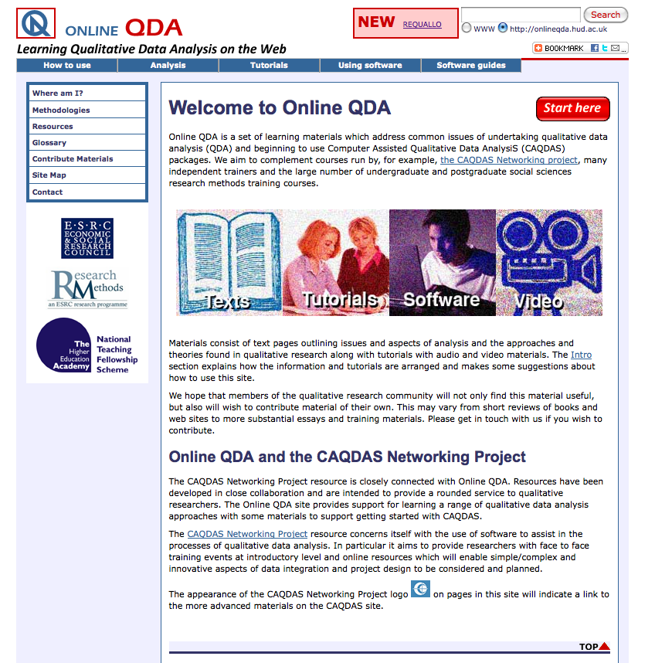
Figure 1. The OnlineQDA home page

Another issue we needed to decide on at the start of the project was the audio and video standards we would use. In the case of audio we decided to record sound as MP3. Whilst such recordings are compressed and not the highest quality (WAV or AIFF files are uncompressed and can be recorded at the same quality as CD recordings) they have the great advantage that they are playable by most software and devices that students and teachers would have. This is the format that most podcasts use. The compression leads to some loss of quality, but we found, as have many podcasters, that this is entirely acceptable for voice recordings. However, we did discover that our original recordings of sessions should be made in an uncompressed format (we used WAV) because the editing we undertook to prepare the audio for the website tended to degrade the quality if we used MP3 as the original source. Other than being widely playable, the great advantage of MP3 files is that they are about one tenth the size of uncompressed audio files. As well as editing to select the most appropriate sections of the recordings, the post processing of the sound files included some normalisation and the use of an Expander/Noise Gate Filter. Our user testing revealed that these were important issues partly because good quality recordings give a professional feel to the materials and promotes the user’s trust in them, but also, significantly, because for some students with a hearing disability, a clear sound with good volume is usable whereas a poor quality sound, especially with a lot of background noise and interference can be hard to follow.

At the start of the project most video was at standard definition (SD) though high definition (HD) TV was just taking off and there were some, albeit rather expensive, prosumer video recorders. There was also a tendency for HD files to be very large and that meant we would have to use shorter video files for download on the web. However, things have changed very rapidly in the last few years. New compression standards (H264) have meant that HD on the web is possible and sites like YouTube and Vimeo are encouraging users to upload in HD. HD camcorders are now much cheaper and more widely available. However, for this project all the equipment we had access to and all the video we recorded was at SD. HD is clearly an advantage in an educational context as small details and small text are more easily distinguished on screen. However, all our recordings were of “talking heads” and the viewer soon forgets that the material is at SD. We just had to ensure that when we introduced textual material in post-production, it had to be clear enough to be read on a SD recording.

Flash was a good solution when we started as we thought users would access the material on computers via the web or download the files to play on computers. Flash players are widely and freely available for computers. However, in the last few years there has been a very strong move of users to smart phones (3G and now 4G) and tablet devices (particularly the iPad). This move particularly affects student users who are now more likely to access websites on their mobile or tablet than on a laptop or desktop computer. Many such devices (such as the iPhone and the iPad) do not support Flash and so cannot use our files with Flowplayer. Initially we responded by having Mpeg versions of the videos available alongside the Flash versions (with an iPhone icon to indicate this). But a better solution was to upload the video to YouTube which was always playable on iPhones and iPads. In the longer term we are considering a redesign of the website using HTML5, though this brings with it problems of ensuring accessibility to users with older browsers on computers.

Jorum
Our original intention was to make all materials available on Jorum. However, the way this has developed and in particular the limitations of its search tool and its display of items on the web page meant that we focussed much more on the OnlineQDA website as this could be designed to meet user expectations. There were two significant problems with Jorum. First its classification mechanisms which focus on disciplinary identity were poorly designed to deal with materials on social research methods that span a large number of different disciplines. Many users would be more interested in material on, say, grounded theory, than whether it was being used in sociology, psychology, education, nursing or business studies. This means that the potential user needs to rely on the free text search facility, and how well this works depends entirely on how well depositors have added meta data to their material. The second issue was revealed on another Jisc funded project that the PI was engaged with. This investigated the issues around the dissemination and discovery of open educational resources in social research methods. One of the key findings that we derived from the focus groups with academics that we undertook was that users preferred the way in which a Google search gives a little bit of text that can be used to make a quick decision about the relevance of the material found . Doing a search in Jourm left them uncertain and confused about what they had found and its relevance. We have put some links into Jorum, to use this as a kind of additional link to the OnlineQDA site, but none of the actual materials have been deposited. A limitation of the Jorum interface is that if we did put, say, a video into the repository, then a user would have to download the entire file in order to see if it was relevant. In contrast, videos placed in YouTube can be played immediately and the user can inspect just a few seconds of the material to check its salience and quality.

Designing for different types of user
The materials produced are intended to serve the needs of a variety of users although we recognise that to some degree their needs will overlap (See http://onlineqda.hud.ac.uk/Introduction/). We have identified:
- Complete beginners (this category includes undergraduates who have just started studying qualitative data analysis, but also include postgraduates and researchers who are coming to this kind of research for the first time and often have no background in social research methods) See http://onlineqda.hud.ac.uk/Introduction/beginners.php
- Undergraduates, who need to undertake qualitative analysis as part of a project. In some cases this may be a final year project and will involve a sophisticated use of the methods. See http://onlineqda.hud.ac.uk/Introduction/undergrads.php
- Postgraduates. Aside from the case just mentioned, we assume that postgraduates have an undergraduate background in social research and are undertaking qualitative analysis as part of their masters dissertation or PhD thesis. See http://onlineqda.hud.ac.uk/Introduction/postgrads.php
- Researchers. In general, the needs of researchers is similar to postgraduates, except, as noted above, they may be new to the area and have no background in social research methods. See http://onlineqda.hud.ac.uk/Introduction/researchers.php
- Teachers of qualitative data analysis. See http://onlineqda.hud.ac.uk/Introduction/teachers.php
To deal with this variety, we have created three main routes to the learning resources, these are the introductory pages on qualitative analysis (http://onlineqda.hud.ac.uk/Intro_QDA/), the tutorial materials on aspects of analysis (http://onlineqda.hud.ac.uk/Tutorials/) and the full case studies (http://onlineqda.hud.ac.uk/Tutorials/ or http://onlineqda.hud.ac.uk/_REQUALLO/).

The introductory pages on qualitative analysis are mainly text based, but they contain a lot of links to other related material, including the audio and video resources produced in this project. These pages are frequently accessed by those coming to the site and form a basic introduction to the issues.(See the next section for details.) They are particularly suitable for those new to QDA.

The Tutorials menu lists the stages of qualitative analysis that users might use. Not all of these will be relevant to undergraduate users and they can choose to view or read the materials that are relevant to their needs. For example, some undergraduates may be working on a project where they have been given the topic of the research already, so the sections covering this will not be relevant to them. Postgraduates with a similar focussed need can find the resources they need this way too.

Also found under the Tutorial menu is a listing of all five case studies so that the narrative of one researcher can be followed through. This will be of most interest to Postgraduates and researchers who are working on dissertations, theses or projects where their work involves all the stages of analysis.

Outputs and findings

The case studies
The main deliverables on this project are the learning resources that are available on the OnlineQDA website (http://onlineqda.hud.ac.uk/) and on the OnlineQDA Channel on YouTube (http://www.youtube.com/user/GrahamRGibbs). The five case studies were as follows:

Case 1 - Frances Rogers
Undertook a PhD in social psychology on the topic of "The Personal Experience of Whiplash Injury". For analysis she used Template Analysis, a form of thematic analysis that involves coding the text. Highlights of this case are:
Developing a research idea
Identifying a social scientific (theoretical) explanation of what was found
Changing the code template (the code hierarchy) in the development of the analysis
There is a large number of audio materials embedded in a narrative on these issues along with four videos.
See Figure 2.

Case 2 - Emma Turley
Undertook a PhD in social psychology with the title "‘It started when I barked once when I was licking his boots!’: A phenomenological study of the experience of bondage, discipline, dominance & submission, and sadism & masochism (BDSM)." The research explored the lived experience of participating in consensual BDSM.
There is a large number of audio extracts embedded in a narrative covering the development of Emma’s project idea, her early use of a Giorgi-based phenomenological analytic approach and her decision to change to a thematic approach to data analysis.

Case 3 - Sally Jones
Undertook a PhD in education and business studies on the topic of "The gendering of entrepreneurship in higher education: a Bourdieuian approach". For her approach to analysis she used an essentially grounded theory approach.
There are several videos that cover the integration of social theory into Sally’s project and the way it guided data collection, setting up and collecting data, thematic analysis with NVivo software and her decision to ‘come out’ of NVivo and develop her thematic coding system separately, before using NVivo to provide evidence for her write up.

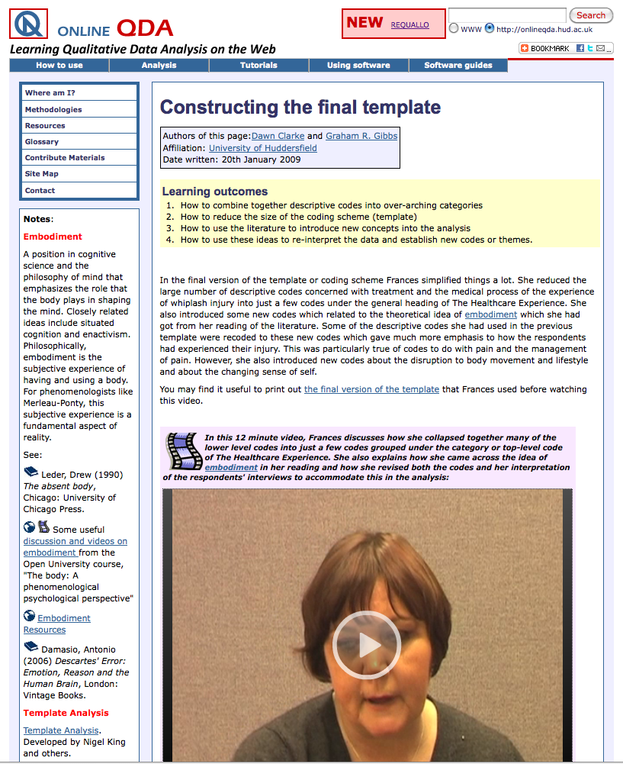
Figure 2. Screen shot from one of the Frances Rogers resources

Case 4 - Nicola Swan
Undertook a PhD in business studies on the topic of "Corporate Interventions in Rural Communities that lead to Sustainable Development". She undertook a thematic analysis of interview and ethnographic data with the help of Atlas.ti software.
Nicola's research examines the practicalities of how companies address their corporate responsibilities in partnership and taking a long-term approach. In many cases they don't act directly in the society, but rather by giving support to other organisations that are working with communities. Typically these are NGOs - non-governmental organisations - such as charities and development companies which are already working in the field to address social and environmental needs. Nicola realised that there was little evidence in the business and social literature of what the outcomes of these interventions look like from a community perspective.
The learning materials are video interviews where she discusses the nature of her research and establishing a research question, her choice of sample and participants, the use of Atlas.ti to code and analyse the data and how she developed a key thematic analysis of her data.

Case 5 - Karl Kitching
Undertook a PhD in education on the topic of "Justifying school- and self: an ethnography on race, recognition and viability in Ireland". He undertook an ethnographic investigation of a school in Ireland and analysed his data using discourse analysis.
Highlights of the case in videos where Karl talks about:
Why use discourse analysis
Identifying what cases and examples to look at
A detailed discourse analysis of some short passages from an interview

Evidence of usage
It is hard to get accurate and comprehensive figures on the use of the resources by students and by teachers. In just a few cases teachers and students have written directly to us to congratulate us on the materials, but even then, they rarely say which particular parts of the website they have used.
A selection of e-mails from the last 12 months
I am writing to thank you for all the useful information you have included on your site. I am new to coding and Online QDA has been infinitely helpful in informing my introduction to this topic. I really appreciate all the work you have put into this site. ...
Sincerely,
Name withheld
Research Fellow
Lucknow, Uttar Pradesh, India

This is Dr. Name withheld and I am an Associate Professor at Name withheld University, United States. I am currently teaching a doctoral course in qualitative research and I have found your site to extremely helpful--better than any textbook I have utilized in the class. I would like your permission to use some of the coding information you have presented on your site as examples for my students. Your resources do such a nice job of demystifying the qualitative analysis of data. I will give full credit to the site and to Graham Gibbs for specific content. I would really appreciate this because, as I have stated, your site is outstanding and contains the best information I have seen on the topic of coding and data analysis. Thank you very much for your consideration.

I have to deliver a one-day training programme next Friday … to a group of people in the public sector who are new to qualitative research who are due to conduct a Home Care Survey. I am experienced in training in people/interview skills but am not a specialist in the field of qualitative research and analysis. I am delivering this training on behalf of a local College of Further Education.
During my research for this, I have found your invaluable website and would like to ask permission to use a selection of resources from the website to support the training ...
Could you please let me know as soon as possible if I have your permission to use this resource next Friday, given the appropriate acknowledgements. Whatever your reply, I will certainly be directing the participants to your website for further research.
With thanks
Name withheld

I am starting my MBA program at Name withheld University and I am currently doing an introductory course on research Methodology.
I came across your videos about the grounded theory and found it very useful … I would like to thank you for making them publicly available …
Kind regards,
Name withheld

Thank you for sharing all the videos related to research methods on Youtube.
I have learned a lot from watching them and also think that this is a good media for self-learning. I am a surgeon from Taiwan and doing a PhD related to surgical education in Name withheld university. Using a qualitative approach is a new and big challenge for me. Your effort makes my life easier.
Thank you so much!
Best Wishes,
Name withheld
Department of Medical Education
Department of Surgery
Name withheld Hospital

My name is Name withheld, a post graduate research student …
As I searched for reading materials on GT, I came across a YouTube lecture you did on GT, a very helpful resource, prior to that, I have had difficulty finding a way to understand GT because it is an approach I have not used before…
I am still listening to the sessions, learning and replaying them because I know I will soon be equipped enough to carry out my study.
I am sending this email to 'THANK' you for a good job well done ...
Kind Regards,
Name withheld
PhD Student
Centre for Health and Social Care Research
University of Name withheld

I am completing a Masters in Public Services Commissioning at Name withheld University and am currently writing up my dissertation, which is based on qualitative research. Not understanding anything about coding, I have been watching your videos on Online QDA and they have been very informative and anxiety reducing. So thank you very much - I can go forward with confidence.
Best Wishes
Name withheld

I teach qualitative methods on our EMBA programme and have just come across your videos on YouTube as I update my data analysis lecture. I'd like to thank you for the material which contains one of the best explanations of grounded theory that I've come across. I've put links to your videos on Blackboard so that my students can take advantage of your material.
So, many thanks for this very useful teaching resource.
Best wishes,
Name withheld
Programme Leader BAHRM
Business School
University of Name withheld

Those who have got in touch appreciate the resources and the small number of academics who have made contact have found the text, audio and video resources useful. On two occasions, US publishers have got in touch to request permission to use the text materials (though not directly the audio and video materials) in dedicated university textbooks they are assembling. (The most recent was for The Rhetoric of Inquiry, a custom reader for the University of Tennessee-Knoxville)

Probably the best way of judging usage is via website analytics and we have both Google Analytics for the main OnlineQDA site and analytics from the YouTube Channel that holds many of the videos. Figure 3 shows recent general statistics from the OnlineQDA site.

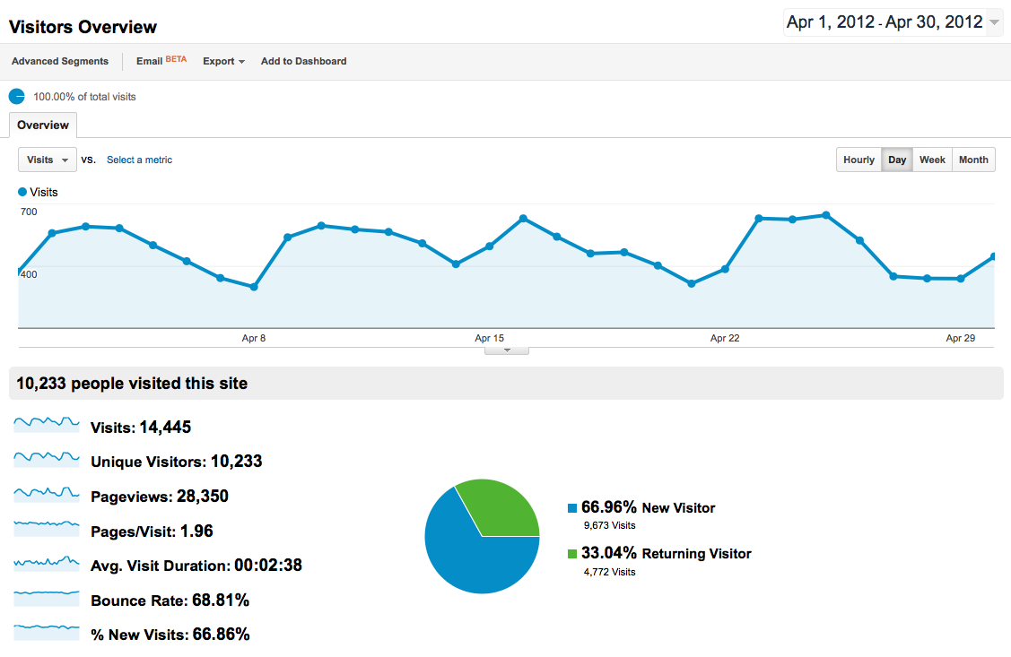
Figure 3. Visitors overview for the OnlineQDA.hud.ac.uk website.

Visits to the website vary around an average of about 500 per day and visitors inspect an average of around 2 pages. As is common on such website a high proportion of these visitors bounce directly away from the website. However, around a third are returning visitors.

Most of the visitors arrive via a search engine (64%), however, significant numbers do arrive by a link from some other website (13%) and the remainder (23%) come directly. The most common referring websites are in the US but there are common referrals (i.e. links) from the Universities of Surrey, Hertfordshire, Glasgow and Edinburgh, and Herriot Watt, Middlesex, Robert Gordon, and Liverpool Hope Universities. Several of referrals are from within the institution’s VLE.

Page usage shows that the text pages on OnlineQDA remain very popular and, although less often used, the figures suggest that the audio and video material is being watched. The average duration of a visit is just 2 min 38 seconds over all users (and most don’t stay) but of those who visit the REQUALLO pages and the pages with audio and video the duration times are much longer (4, 5, or 6 minutes, on average) and clearly indicate that visitors are watching or listening to the materials. Videos are receiving around 30 to 40 visits per month; the REQUALLO text and audio pages are getting between 10 and 20 visits per month.

Analytics from YouTube for the video materials on the Qualitative Data Analysis channel give much more focussed data on individual videos. The channel has now been running for about 2 years and the videos in it have had around 117,000 views. There are over 370 subscribers. The most popular videos receive between 4,000 to 11,000 views per year. A country-by-country analysis shows that the largest number of viewers comes from the UK (27%) with a large proportion from the USA (26%). Other common countries of origin are elsewhere in Europe, Australasia and South Africa. However, there is no way of knowing who these viewers are and whether they come from academic institutions.

Data on individual videos suggests that they are commonly viewed to the end. Retention rates tend to be higher than average for videos of similar length. There have been a small number of comments on the videos and these are usually thankful for the resource. There is some indication from these comments that the viewers are researchers or research students who need to learn about aspects of qualitative analysis.

Feedback from user sessions
The results of the user testing with students at Huddersfield and Greenwich gave us valuable information about the kinds of material students found useful and then way in which it needed to be given context. In the main, students (both undergraduate and postgraduate) preferred to use material that linked in some way with what they were learning in class.
“I’m new to coding and the simple explanations and tests really helped me.” (Undergraduate)
“I could not understand anything [to do with coding] and now I get it!” (Undergraduate)
“The stuff on coding saved my dissertation- I was having a massive panic attack because I couldn't get to grips with analysing my data.” (Undergraduate)
Of course this reflects the common focus of students on what they need in order to pass the course, but in addition it was clear that they preferred resources that reinforced or clarified material and ideas that they were addressing in their classes.
“I found the video very useful as it helped reinforce what what we had learned in our class.” (Postgraduate)
So there was a clear need for our materials to address the kind of issues that students would encounter, for example in undertaking research projects. One consequence of this is that we widened the focus of the materials from narrow consideration of analytics techniques to the wider issues of planning and managing research, sampling and deciding about analysis approaches. In general, undergraduate users wanted materials that address their basic needs of getting started in analysis. A similar separation of undergraduate and postgraduate needs came out of our feedback sessions after the workshops. Undergraduate needed web designs that were friendly, allowed a range of ways into the material and a range of ways of determining its relevance to their needs. Postgraduates were much more concerned with their status as advanced learners and wanted page designs and materials that more closely echoed the advanced academic world of journal papers and careful research analysis. We addressed these divergent needs by designing web pages that could be used quickly and directly by undergraduates (just read the content or watch the video) or could be used in a much more exploratory fashion by postgraduates (with cross links to related material, definitions etc. and external links to further material.

Results of the online survey
Although the response rate was disappointing (see discussion above) there were some interesting results that could be obtained from the survey. For a start it confirmed the diversity and variability of qualitative research and research methods. The main disciplines using the approach were, as might be expected, Education, Psychology, Sociology, Health related areas, Anthropology and Business studies. But there were in fact 28 different disciplinary areas that respondents mentioned. At least this confirmed that the case studies we had collected reflected the most common disciplines (one or more of them address, education, business studies, psychology, health issues and sociology). There was also a considerable range of analytic approaches that were being taught, but the most common were as in Table 1.

Ethnography (incl visual ethnography) | 71
Interviews (unstructured) | 71
Grounded theory | 65
Participant observation | 64
Narrative analysis / interviewing | 61
Action Research | 57
Mixed methods | 54
Thematic Analysis | 43
Phenomenology | 42
Discourse analysis | 41
Document use | 40
IPA | 37
Table 1. Numbers of respondents teaching the specified methods. (Respondents may teach more than one approach.)

Again, most of these approaches are discussed in one or more of the case studies, though ethnography and participant observation are the methods least explicitly dealt with in them. One case does adopt a partially ethnographic approach, though the researcher also used interviews and focus groups.

Level | UK | Elsewhere in the EU | USA or Canada
Undergraduate first year | 32 | 33 | 11
Undergraduate second year | 57 | 44 | 23
Undergraduate final year | 35 | 44 | 37
Undergraduate dissertation / extended paper | 49 | 44 | 14
Postgraduate taught course | 78 | 89 | 37
Masters dissertation | 62 | 78 | 49
Training during the course of a PhD | 68 | 44 | 51
Table 2. Percentage of users from three regions teaching qualitative research at the specified level.

Table 2 shows at what level qualitative research was being taught in the UK (n=37), elsewhere in Europe (n=9) and in the USA and Canada (n=35). In the UK at least the picture was that for undergraduates qualitative methods are most likely to be taught in the second year but there was an overall tendency in all countries for qualitative methods to be taught at postgraduate level.

We also asked about sizes of the classes where respondents were teaching qualitative methods. There was a clear tendency for class sizes to be smaller the more advanced the students. Around half the classes at postgraduate level were no larger than 19 students, whereas around a third of the classes at undergraduate level were had over 100 students. Large classes were even more prevalent in the first year, undergraduate level. The overall picture, even for postgraduates, was a far cry from the one-to-one apprenticeship model of teaching qualitative methods that existed in the mid 20th century.

Outcomes

The project had seven major aims. They are listed below with an explanation of how we addressed each.

- Develop six case study exemplars of QDA learning resources derived from existing research projects. These will represent a range of analytic techniques and will cover a range of disciplines.
Changed to 5 case studies of PhD students. Discussed in section 5, above.

- In at least two of these, show how the analysis may be supported using CAQDAS software.
Two of the case study/exemplars used NVivo software and one used Atlas.ti. The materials we created do not show the detail of how to use the software – the manufacturers of these programs have excellent videos on their websites that do this (see references on the OnlineQDA website). But what the materials do show is actually how the researchers used and did not use the software. Two of them ‘went outside’ the software at one stage of their analysis and the materials explain why they did this.

- Include, in each exemplar, the raw data, video interviews with the respective researchers, examples of different stages of the analysis with step-by-step instructions and interactive exercises.
As explained in section 5, complete sets of raw data were hard to get because of the researcher’s desire to preserve anonymity of participants in their research. But selections have been included where appropriate. We thus do not have complete sets of data but we do have documents that are discussed in the learning materials.

- Make the material available at various levels of granularity for different learning and teaching uses ranging from lecture examples to full, self-directed learning, Thus each exemplar could be used as a whole (for example as the basis for a full term course on QDA), or parts of it could be used independently as exercises targeting different stages of the analysis.
Within each case study, the materials are divided into smaller units (web pages with audio or short videos). Each case study can be followed through for a full ‘course’ along with the contextual material and the cross linking to other material both on the OnlineQDA website and other websites and academic books and papers. Good, confident, self-directed learners could use all this material to learn independently. However, we think that best use of the materials is when they are used in a blended manner or as supplementary material to other teaching.

- Make the material useable at a range of student levels, from first year undergraduate to taught postgraduate. Create subsets of the materials (in terms of size or of analytic scope) and identify, for teachers and students, what level they are intended for.
Access to the tutorials on the website distinguishes whole cases (the narratives) and the many stages of analysis. The latter can be selected for use with beginners. As many of these stages would not be relevant to, say, an undergraduate just undertaking a thematic analysis of a given text they could be omitted. On the other hand, for a PhD student, just starting out, some of the details of the false starts and blind alleys that real research often involves will be of real interest and use. These are included in the full narratives.

- Incorporate the resources developed into the existing Online QDA website and RLO repositories (e.g. Jorum). For teaching use they will have ‘wrappers’ indicating possible teaching uses and learning outcomes.
All the materials are included in the OnlineQDA website. Some links have been included in Jorum, but as we discussed above in section 7, we found that depositing the video material in YouTube increased the chances of potential users (both teachers and students) finding it and using it. When we looked at creating ‘wrappers’ to indicate possible teaching use, as guidance for teachers, we found it hard to do this without detracting from the use of the materials by students. We thus retained the use of learning outcomes with the materials, but moved any pedagogic or teaching advice away from the materials themselves.

- Investigate and evaluate and then report what makes a good RLO design in QDA, what works best in creating awareness of the resources amongst teachers and students and what affects their decision to use the RLO.

What affects the decision to use educational resources
As we have discussed above, our investigations, the results of the online survey and the research literature on open educational resources (OERs) all suggest that with the rapid growth of online video material the use of standard search engines, and in particular Google, is the major way that both teachers and students look for and find such resources. In addition, research we have carried out in a related project on the discovery of OERs has shown that, at least in the case of teachers, it is important to be able to make quick judgements about whether the material found will be relevant and of good quality . To that end we have used both the OnlineQDA website and YouTube to store our materials as that way Google searches will show the kind of contextual information searchers need and, crucially, will enable them rapidly to preview the materials. We have taken measures to ensure that Google searches show the materials and the contextual information. In the OnlineQDA website, we have ensured that the pages include plenty of relevant textual information that the search engine can display. Use of appropriate heading styles on the page and page names (we have used CSS throughout the website) ensure that if searchers use significant keywords in their search then the OnlineQDA site is displayed high up in the results listing. Working from a long lasting website with lots of cross-links to and from other website helps here too.

In the case of the video material on YouTube, a key factor is to use both good naming of the video and good metadata. This requires some estimation of what kinds of things potential viewers will enter into the YouTube search engine. This information is also used by YouTube to determine what videos appear to be viewed next when a user has finished watching a video. Another control we have adopted here is to use playlists to group videos (both those we have produced, and good quality ones others have deposited on YouTube). Playlists can be set up to play all the videos automatically sequentially.

Our work with student users and with teachers’ focus groups has given us some indication of how we should present the materials to make them attractive to users. A key issue we identified here was striking the balance in the design of the web interface between visual attractiveness, friendliness and conviviality on the one hand and seriousness, quality and reliability on the other. To address the former, we have made some use of images and video and, at least on the top-level pages, we have tried to restrict the amount of text that appears. The menu system has also been designed to reflect the kind of interests that the range of users might have. On the other hand, feedback from postgraduates especially, suggested that using a style of presentation that to some degree mimicked or was redolent of the standard academic journal paper or research text corresponded with their self-image as serious researchers at a different level from undergraduates. We have thus been careful to keep to standard ways of referencing materials and to display both the provenance of materials (their authors and their institutions) and to highlight the sources of funding (HEA and ESRC) that supported the work. Once again, our research in the related project on the discovery of OER materials demonstrated how important judgements of provenance, quality and reliability were to potential academic users of the resources.

Another issue that came out of the student users groups was the use of tests. Postgraduates reacted against them and considered them to be indicative of lower level (i.e. undergraduate) work. They felt they already had the learning skills to know when they had properly understood point without the need for a test. On the other hand, use of the materials with some students groups suggested that some of the very basic exercises we had created on the site were useful in getting them started in analysis. However, they were fairly neutral about quizzes or test at later levels. On these grounds we have given a much lower priority to creating tests and quizzes. This also fitted with our move from creating reusable learning objects – which can be expected to include elements of testing or interactivity – to creating open educational resources – which are much more varied in nature and often do not include such interactivity.

Dissemination
The most difficult issue for projects such as this is direct dissemination of the outputs. Aside from the HEA subject centres and conferences they run, there are relatively few networks in the disciplines that focus on teaching materials – most conference in the social sciences focus on research issues and our experience over decades of trying to promote teaching and learning issues at such events is that there is commonly very little interest. It is very encouraging that since the re-organisation there has been a conference and a summit, both of direct relevance to this project and at both of which this work was presented.
However, we have presented at HEA subject centre run conferences and we have run workshops and similar sessions for postgraduates and for qualitative research methods teachers. Again, our research on the discovery of OERs is instructive. See Appendix 3 for details. The general pattern of searching for OERs was not that teachers were constantly on the lookout for good materials. Rather, the most common situation was that teachers had some kind of specific need, perhaps at the start of the teaching year, when they needed to update some sessions or to design new courses and that is when they looked for OERs. The role of dissemination is thus one of establishing the resource as something that is recognised as good quality when it is found at such times of need. In this respect, one area where we could have been more active is in the writing of short articles on our resources for HEA centre, and professional body newsletters.

Conclusions

1. The production of multimedia educational materials takes a lot of work and involves lots of skills. Video production needs technical skills (camera work, lighting etc. and editing skills) but above all creating video needs directing and writing skills. In an educational context directing includes understanding how the overall skills and tasks learners need to grasp can be divided into stages or parts and how a variety of materials can be combined in the video itself. Writing needs someone who is a subject expert (in our case in qualitative research) who can distil lengthy material into short lessons or topics. Both directing and writing require the knowledge and skills that subject experts in academia have.

2. During the period of the project there was a very rapid growth in the interest in and support for OERs. Although we started with intentions to produce reusable learning objects, it soon became clear that creating the more general OERs was a more flexible and usable approach. This also clarified for us some of the intellectual property issues and now, where possible we use a Creative Commons (CC) licence.

3. In our view, the main need is for supplementary material, that is, educational resources that can be used in blended learning or as student used resources alongside formal teaching and lessons. If it is directly relevant to a course then the material can be used in class (part of a lecture or before a practical exercise). This suggests giving more focus to stand-alone video materials and less on text-based RLOs.

4. Sustainability. The OnlineQDA website has been operating for 7 years and has a good web presence (e.g. on Google search). But it relies on constant updating to make it appear fresh and alive. We have been approached by the ESRC Restore project about archiving the OnlineQDA website, but at the moment we are still adding materials (especially from this project), so it did not seem appropriate to archive it.

5. In another project (funded by Jisc/HEA as part of the OER programme) we discovered that in the case of research methods academic staff find resources mainly by searching using popular tools like Google and do not tend to approach OER repositories directly. When looking for video material, staff tended to go directly to YouTube or Vimeo. Alongside this has been the rapid growth of Internet video on sites like YouTube and Vimeo and in particular the popularity of shorter, 10-15 minute videos. We believe that there will be a major role for video materials in OER. There are implications for how such materials are archived and found and we believe that developments like the new Jisc site EdMediaShare are moving in the right direction.

Implications

1. Sustainability
There are two aspects to this. The first is the maintenance of the OnlineQDA website. At the moment I support it on a voluntary basis. It is hosted by the University of Huddersfield. In the longer term we need an exit strategy (when I am no longer able to curate the site). One possible approach here is to fragment the contents of the site and transfer them to other repositories and websites. For example the video material might be transferred completely and exclusively to YouTube. Other material might be transferred, in sections, to the University of Huddersfield repository.

2. Technical change
This is very rapid. Even during the three years of the project, the common format for video on YouTube moved from SD to HD. In addition smart phones and especially accessing the web on smart phones expanded rapidly. One consequence has been a problem with Flash-based materials and the need to implement pages in HTML5 that will work on iPads and similar devices. Another change has been the growth of video on YouTube outside the original conception of short entertainment use and in particular its use in higher education.

3. Longevity
Aside from the datedness of fashions and formats, the materials we have produced will probably have a relatively long life. One of the features of social research methods is that they change relatively slowly, at least compared with substantive issues in the social sciences. We envisage them being useful and acceptable to users for around 10 years. Of course this only re-emphasises the sustainability issue.

4. Finding resources
We need some good mechanisms for promoting and disseminating OERs. There are now many repositories of different kinds in the UK. What is needed is some way of allowing resources to be quickly found and appraised. One suggestion here is some kind of portal, rather like the Intute (formerly Sosig) site. Rather than the expensive cataloguing and curation that Intute demanded perhaps some kind of Web 2.0 community-resourced site with users recommendations could provide the discoverability that is currently found by users in Google.

Recommendations

There is tremendous scope for capturing with video the outputs from key research projects, especially where research teams are still accessible. But this needs planning very early on to ensure collaboration and ethical clearance. The best examples would be research projects that students might use in the other modules they are studying. But, of course, it is hard to predict these in advance of the research having been done.

Most academics and teachers do not have the technical skills for video production, or for that matter the time to do it. So video creation requires the pairing up technical teams (for cinematography and editing) with subject expert teams in the social sciences who can contact researchers, undertake interviews etc. and especially, write the scripts for OERs. The model developed by the Open University is a good one here. But with the democratisation of video, the cheapening of the technical equipment needed and the enormous explosion of the availability of video through the Internet there needs to be ways that academics can be linked with university or non-university technical expertise in video production so that more and better OERs can be created. We suspect that equipment costs will soon become negligible and that most universities already have the technical expertise. What are needed are some mechanisms of staff training and some promotion of the ideas that will create the links between the teachers with ideas for OERs and the production teams able to help them create them.

YouTube has demonstrated the usefulness and popularity of short videos for training, self-education and higher education. Fortunately this fits in very well with a blending of OER with formal teaching. The small granularity of such OERs is no barrier if tutors and teachers design courses and modules that integrate them into a coherent curriculum. This suggests that OER programmes have not only to promote the creation and deposition of OERs but also to encourage thinking about new forms of curriculum design that can incorporate available OERs.

Appendix 1

Synopses of the five case studies and interviews carried out.

Case 1 - Frances Rogers

Undertook a PhD in social psychology on the topic of "The Personal Experience of Whiplash Injury". For analysis she used Template Analysis, a form of thematic analysis that involves coding the text.

Audio interviewed on two occasions (about 2.5 hours each session) and videoed on one occasion (about 2 hour session)

Case 2 - Emma Turley

Undertook a PhD in social psychology with the title "‘It started when I barked once when I was licking his boots!’: A phenomenological study of the experience of bondage, discipline, dominance & submission, and sadism & masochism (BDSM)." The research explored the lived experience of participating in consensual bondage, discipline, dominance & submission and sadism & masochism (BDSM).

Audio interviewed on two occasions (about 2.5 hours each session)

Case 3 - Sally Jones

Undertook a PhD in education and business studies on the topic of "The gendering of entrepreneurship in higher education : a Bourdieuian approach". For her approach to analysis she used an essentially grounded theory approach.

Audio interviewed on one occasion (about 2.5 hours) and videoed on one occasion (about 2.5 hour session)

Case 4 - Nicola Swan

Undertook a PhD in business studies on the topic of "Corporate Interventions in Rural Communities that lead to Sustainable Development". She undertook a thematic analysis of interview and ethnographic data with the help of Atlas.ti software.

Audio interviewed on one occasion (about 2.5 hours) and videoed on one occasion (about 2 hour session)

Case 5 - Karl Kitching

Undertook a PhD in education on the topic of "Justifying school- and self: an ethnography on race, recognition and viability in Ireland". He undertook an ethnographic investigation of a school in Ireland and analysed his data using discourse analysis.

Videoed on one occasion (about 2 hour session)

Appendix 2

Additional video materials included in the website

Prof. Nigel King on Template Analysis
(http://onlineqda.hud.ac.uk/_REQUALLO/FR/Template_Analysis/Index.php)

In this interview, Nigel King describes the key stages of Template Analysis, how the themes are arranged into templates and how these templates are revised. In particular he discusses how these thematic ideas can be used to follow the development of thinking about the data being analysing and how they contribute to the final write-up of research.

Sections

1. Constructing the Template
2. Coding
3. Comparison with other coding approaches
4. Descriptive and interpretative coding
5. Revising the template
6. Interpretation
7. How many themes?
8. Other relationships between themes in the template
9. Doing the write-up
10. Comparison with other analytic approaches

Talks on aspects of qualitative data analysis
(http://onlineqda.hud.ac.uk/movies/ESRC_RMF_2010/index.php)

Videos recorded at one of the What is...? sessions at the 2010 ESRC Research Methods Festival, July 2010, St.Catherines College, University of Oxford. Each is concerned with an aspect of qualitative data analysis.

Talk 1: Ann Lewins on CAQDAS (PowerPoint)
Talk 2: Matt Barnard on Framework Analysis (PowerPoint)
Questions from the audience to Matt Barnard about Framework Analysis.
Talk 3: Stephanie Taylor on Discourse Analysis (PowerPoint)

Five short videos from a lecture on Grounded Theory
(http://onlineqda.hud.ac.uk/movies/Grounded_Theory/index.php)
Sections
Core elements of Grounded Theory
Stages of coding: 1. Open Coding
Approaches to Open Coding, Line-by-line Coding
2. Axial Coding and 3. Selective Coding
Grounded Theorists and critiques of Grounded Theory

Appendix 3

Presentations about or including reference to the REQUALLO project
Where possible, there are links to the PowerPoint files used in the presentations or to video recordings of the sessions.

2012 Video based OER: Production, discovery, dissemination. In: Higher Education Academy Social Sciences Teaching and Learning Summit: Teaching Research Methods , 21 - 22 June 201, Radcliffe House, Warwick Conferencing Centre, University of Warwick.
http://eprints.hud.ac.uk/14002/

2012 The dissemination and discovery of open educational resources. A case study of research methods. In: Social Sciences: Ways of Knowing, Ways of Learning HEA Social Sciences Conference, 28-29 May 2012, Crowne Plaza Hotel, Liverpool, UK
http://eprints.hud.ac.uk/13999/

2011 Symposium on Research Methods OERs in the Social Sciences, OER11, University of Manchester. (with Silver, C., Gruszczynska, A., Brent, I. Clarke, D. and Crowley, C.)
http://eprints.hud.ac.uk/11898/

2011 “Supporting CAQDAS users via the Web – What researchers need” Qualitative Innovations in CAQDAS conference, U. Reading.

2010 Workshop on online resources on QDA and CAQDAS, University of Manchester – Twice
http://www.methods.manchester.ac.uk/events/2010-11-29/index.shtml

2010 ‘Learning Theory and RLOs: The REQUALLO Experience’ C-SAP e-Learning Conference, London. (with Clarke, D., Teal, A., Lewins, A. and Crowley, C.)
http://eprints.hud.ac.uk/8882/

2010 ‘Open Educational Resources in the Social Sciences: Evaluation Issues’, C-SAP e-Learning Conference, London.

2009 Multimedia contributions to e-learning projects. In: ESRC NCRM e-learning event, 2009, Institute of Education, University of London. (Unpublished) (with Lewins, Ann, Silver, Christina, Fielding, Nigel and Bryman, Alan)
http://eprints.hud.ac.uk/8881/

2009 “E-learning as apprenticeship for large numbers” The Virtual University? C-SAP E-learning conference, London, Jan 2009. With, Clarke, D., Teal, A., Lewins, A. and Crowley, C.
http://eprints.hud.ac.uk/5785/

References

Boeije, H. (2010). Analysis in Qualitative Research. Los Angeles: Sage.
Boyle, T. (2006) “The design and development of second generation learning objects”. Invited talk given at Ed Media 2006, World Conference on Educational Multimedia, Hypermedia & Telecommunications, Orlando, Florida, June 28 2006.
British Psychological Society (2002). Revised syllabus for the Qualifying Examination. Membership and Qualifications Board, Board of Examiners for the Qualifying Examination. Leicester: BPS.
Brent, I., Gibbs, G. R., & Gruszczynska, A. (2012). Obstacles to creating and finding OERs: A case study of social science research methods. Journal of Interactive Media in Education.
Charmaz, K. (2006). Constructing Grounded Theory: A Practical Guide Through Qualitative Analysis. London, Thousand Oaks, New Delhi: Sage.
Gibbs, G R, Taylor, C, Fielding, N and Lewins, A (2006) “Qualitative phase of the formative evaluation of learning training needs in computer assisted qualitative data analysis.” Working paper, The Research Methods Programme. [http://www.ccsr.ac.uk/methods/publications/documents/WP28.pdf Accessed 19.10.06]
Gough, B., Lawton, R., Madill, A., and Stratton, P. (2003) Guidelines for the Supervision of Undergraduate Qualitative Research in Psychology. HE Academy Psychology Subject Centre [http://www.psychology.heacademy.ac.uk/html/miniproject_details.asp?id=11 Accessed 2.3.07]
Grbich, C. (2007). Qualitative data analysis: An introduction. London: Sage Publications Ltd.
Koutsopoulou, G., Todd, Z., and Forrester, M. (2006) Teaching Qualitative Research Methods at Undergraduate Level. Survey results of current provision in UK Psychology Departments. HE Academy Psychology Report [http://www.psychology.heacademy.ac.uk/html/qual_res_methods.asp Accessed 3.3.07]
Lave, J., and Wenger, E. (1991). Situated learning. Legitimate peripheral participation. Cambridge: Cambridge University Press.
Pailing, M (2002) ‘E-learning: is it really the best thing since sliced bread?’ Industrial and Commercial Training, 34(4) pp. 151-155.
QAA: Quality Assurance Agency for Higher Education (2002). Subject benchmark statements: Academic standards – Psychology. Gloucester: QAA.

