The Sage Handbook of Applied Social Psychology
The psychogeographical turn in social psychology

Alexander J. Bridger, Sophia Emmanouil and Rebecca Lawthom

Just as none of us is outside or beyond geography, none of us is completely free from the struggle over geography. That struggle is complex and interesting because it is not only about soldiers and cannons but also about ideas, about forms, about images and imaginings (Said, 1993, 7).

INTRODUCTION

The question of how we come to make sense of our place in the world and where we locate ourselves in the world continues to be an important area of research not only in social psychology but also in other academic disciplines such as human geography, philosophy and art. Social psychological research on place has enabled us to think about the relation of individuals to place and how human beings create identities in context. The premise of that research has been extremely important in aiming to reduce social conflict and for building positive relations between different communities. However, other writers have argued that the sense of who we are in the world has become ‘emplaced’ (Manzo, 2003) and that fixation of identities in specific places with subsequent causal effects needs re-examining. Whilst the focus of social psychological research more generally has been on studying attitudes in peoples’ heads and analysing language, there has been scant focus on the practices of wandering through different places and what the impacts are of overarching social systems such as neoliberalism and consumer culture. Current social psychological research on place could therefore be usefully extended by considering the impacts of the wider political system of neoliberalism and consumerism upon peoples’ everyday experiences of the world and by encouraging community reflections to build greater awareness of contemporary social conditions and to generate new avenues for social action. Taking such a stance requires a reconceptualization of methods and theory and a psychogeographical turn in social psychological research is presented as one way in which to do further research.
In this chapter we will explain why a psychogeographical turn in social psychology is needed and how such an approach can be drawn on to consider the commodification of everyday life.

We will then provide a critical review of key studies of place from quantitative and qualitative social psychology. The strengths and limits are of such work will then be assessed and the reasons why a turn to psychogeographical research will be explored. After having discussed the main theoretical and historical arguments, we will then focus on explaining the psychogeographical approach in relation to the work of the situationists and their approach to analysing place and context. Reference will be made to the main research exemplar of a psychogeographical community group work project undertaken at the Hoot mental health drop-in centre in Huddersfield. Reference will also be made to the project activities as well as documenting the experiences of participants and the impact to those involved and the host organisation. Themes explored through such work in relation to the project participants include the effects of neoliberal gentrification, the idea of consumer citizenship, inclusion and participation.
The last section of this chapter will focus on the challenges and obstacles encountered through doing such work and we will point to the multiplicity of ways in which to do psychogeographical work.
In this chapter reflexivity, ethics and professional conduct in relation to taking a caring approach to doing community work will also be discussed. Such a stance we hope further enhances the validity of this applied social psychological approach. Other challenges and issues that encountered include discussion of dealing with multiple subject positions as an academic, doing community work and considering the question of what changes can be enabled as a result of doing such work. Having introduced what this chapter will be about, it is necessary to now move onto a critical review of current social psychological research on place, what psychogeography is and why it is necessary to take a psychogeographical turn in social psychology.

FROM A SOCIAL PSYCHOLOGY OF PLACE TO A PSYCHOGEOGRAPHICAL TURN IN SOCIAL PSYCHOLOGY

It’s important to begin with outlining and reviewing the social psychological research on place to present the case for a psychogeographical turn in social psychology. Readers will most likely be aware that the social psychological research on place is vast, ranging from studies on place identity, to intergroup conflict, the contact hypothesis and community based research. Social psychological and environmental psychological research has explored the relations of people to place. Altman’s (1993) work on activity settings is important to start off with here. He argued that social relationships are always situated in which he referred to as activity settings. Within these settings, individuals draw on behaviours which are appropriate and normative to the context. For example, it would be an appropriate practice to queue in line to order a coffee in a coffee shop but it would be perceived as bizarre by other people to queue for a coffee and when ready to place an order to then go to the back of the queue and to engage with the whole process again. The example referred to here was an example of a social intervention by a delegate at the Territories Reimagined: International Perspectives conference in Manchester many years ago. I’m still not sure what the purpose of the intervention was though it does seem somewhat relevant to considering the notion of normative behaviours in social settings and what is appropriate and not appropriate behaviour. This work is thus important in terms of consideration of norms that govern social behaviour in specific settings. However, such work needs to be extended in relation to considering questions of identity, place and belongingness which will be discussed next.
Who we are and how we come to define our sense of place in the world is often bound up with where live and what we do in our everyday lives. For this reason, social psychologists have applied social identity research in relation to belongingness, home and place. The relation of place in relation to identity moves us beyond the notion of identity tied simply to groups and to social processes. Any notion of identity therefore needs to be considered in relation to where identity is situated rather than with previous social identity work which presents its findings in an a-contextualised landscape. Indeed, two authors argued that:

Like people, things and activities, places are an integral part of the social world of everyday life, as such, they become important mechanisms through which identity is defined and situated (Cuba and Hummon, 1993, 112).

Individuals create many associations of place with home with specific memories (Cuba and Hummon, 1993)) and through being in specific places we formulate and create new identities (Twigger and Uzzell, 1996). Dixon and Durrheim (2004: 456) are quite critical of the mainstream experimental social psychological research on identity and place and argue that context should not be treated simply as an ‘inert backdrop to social relations’ or as having a ‘negligible impact on the social psychological processes it frames’. Moreover, they also draw on arguments by Billig et al., (1988) in arguing that how people identity with places is essentially dilemmatic. Those arguments make sense and serve as an important way in which to extend previous research in social psychology. It is even the case that some health, social and community psychological researchers have also made similar claims that In considering a social psychology of place, environments should not be viewed simply as ‘backdrops to social processes’ (Hodgetts et al. 2010: 287). Quite rightly, those writers state that such a focus takes us away from the located-ness of place, how people derive meaning from being in different places both on their own and with others and in terms of preventing consideration of what social processes may keep people together or apart. That work foregrounds the importance of place-identity and associated processes of social change. The link between place identity and social change is key here and is echoed not only in the work of Dixon and Durrheim (2004), Dixon et al. (2008) but also with reference to the seminal work of Proshansky et al. (1983). With the arguments made here in terms of moving beyond the a-contextualised study of individuals and social processes, we now turn to research on segregation and intergroup conflict.
Allport (1954) argued that increased contact between groups would reduce conflict and prejudice. He developed what is known as the contact hypothesis. His work laid the foundations for other psychologists to consider how to reduce conflict and to increase harmony between groups. In more recent research, social psychologists such as Dixon et al. (2004) have considered the spatial relations of segregation in relation to Black and White South African communities at a beach resort in KwaZulu Natal called ‘Sunshine Coast’. They argued that desegregation changes the relations between individuals and others and to specific places. They also indicated that dominant groups often resist processes of change in their communities. In contrast, other writers have argued that if people feel a positive affiliation with place then they are more likely to get involved with actions which would be for the good of the community (Nowell et al., 2006). The aims of intergroup conflict research, as well as place identity research and work on activity settings, is of paramount importance in reducing conflict between people in society. However, a case can be made here for focusing out from conflict between groups in context to consider how the wider context itself can cause conflict. Here the focus is on neoliberalism and of everyday life as being increasingly commodified, to which we now turn to discuss.
Keith and Pile (1993) argued that the academic study of place identity must be related to relations of power and to the study of ideology. Importantly, in other critical research on place identity, Dixon and Durrheim (2004) also make the case for studying landscapes of meaning and of studying relations of power and power struggles between people in places. Merrifield (1993: 522) discusses capitalist spaces and explains how ‘place is where everyday life is situated’. He also argues that place should not be simply seen as a blank slate onto which meanings can be written but rather that contemporary places are written on via processes of capitalism and commerce and this in turn shapes peoples’ subjective experiences of places (Merrifield, 1993). Lefebvre (1976) discusses how capitalism is a geographical endeavour:

What has happened is that capitalism has found itself able to attenuate (if not resolve) its internal contradictions for a century, and consequently, in the hundred years since the writing of Capital, it has succeeded in achieving ‘growth. We cannot calculate at what price, but we do know the means: by occupying space, by producing a space (1976: 21) (original emphasis).

Lefebvre argues that it is necessary to understand, read and consider what spaces may mean (1976). Examples of how everyday social spaces can be read via social psychological methods can be exemplified in relation to work by Hodgetts et al. (2010). In their book titled Social Psychology and Everyday Life, they draw on the motif of everyday life to consider topics such as place, health and the media. Miles (2010: 8) indicates that consumerism is such a ‘thoroughly cultural phenomenon that serves to legitimate capitalism on an everyday basis’.
Here then can be seen an interface between psychology and place which could be termed as psychogeography. However, the term psychogeography and what that may mean in the domain of social psychology needs unpicking and explaining. Indeed, the term psychogeography was even discussed in an early issue of the Journal of Environmental Psychology by Wood (1987) to refer to the relations of psychology to geography and political issues. However, what we are dealing with here are conceptually very different ways of understanding the relations and impacts of people in relation to social context. The Debordian formulation of psychogeography is rather different to that provided by social psychologists. The definitions provided by social psychologists have tended to focus upon the causal impact of environments on peoples’ attitudes and behaviours. Sadler, a writer on the situationists, explains that psychogeography can be viewed as a type of self ‘therapy’ and as a way of ‘exciting the senses and the body’ in order to ‘rescue drifters from the clutches of functionalism’ (Sadler, 1999: 80). It is important thus to problematise the fixation of experimental social psychologists on behavioural variables and situational context. What I want to do here is extend critical psychological work on place to consider broader social, structural and political issues relating to spaces and places. Indeed, if one turns to work by Cherry (1995) it is indeed that more complex explanations of violence are needed rather than the quite simplistic explanations provided by the landmark bystander intervention studies. Debord, along with other situationists were concerned with capitalist gentrification and they envisioned a world beyond the capitalist order of things. Whereas social psychologists aims are to understand social process and individual behaviour, the situationists were focused on intervening and creating situations in order to lead to ‘permanent change’(Khatib, 1958: para. 2). These aims are rather different to social psychologists with more moderate intentions to study the internal workings of the mind and why people behave in the ways that they do based on social context and casual factors.
Mainstream social psychological research has also tended to reinforce Euro-American notions of individualism and capitalist achievement (Corral-Verdugo and Pinheiro, 2009). This is a problem because other writers have argued that peoples’ experiences need to be located into specific social contexts and such accounts are arguably underpinned via discourses of ‘capitalism, rationalism, modernisation, the Puritan work ethic and spectacle’ (Sader, 1998: 96). Such concerns with capitalism and the spectacle are evidently not really considered with mainstream psychology or indeed for that matter in social psychology applied or not. Therefore, what is needed in social psychology are methods and approaches which are sensitive to such focus.
The methods of research in social psychology research can tend to be quite sedentary means of investigation (Sheller and Urry, 2000) and there is not much work that documents how walking can be used as a means to document peoples’ experiences (Sheller and Urry, 2006). In this work, I want to set out an agenda for mobile methods of research in social psychology and believe that it's important to consider such work as by Anderson (2004) on bimbling, photo methods of elicitation by Hodgetts et al (2010), go-along methods by (Kusenbach (2003), walking methods research by Radley et al. (2010) and Hodgetts et al. (2010) and my recent work in this area on psychogeographical walking (Bridger, 2009-present). Other writers in neighbouring disciplines such as Cultural, Urban and Visual Studies have also called for a ‘new mobilities paradigm’ (Sheller and Urry, 2006) with Brown and Durrheim in Social Psychology (2009: 916) explaining that knowledge is always ‘constructed in and through mobile interactivity’.
Early signs of reference to ‘psychogeography’ can be evidenced in psychology journals such as the Journal of Environmental Psychology, where writers such as Wood (1987) refer to the relation of psychology to geography and to key political issues of the time. However, the reference to psychogeography within the arena of Environmental Psychology is very different to that which has been considered by others. Definitions of psychogeography previously provided by social psychologists have tended to focus on the causal impact of environments on peoples’ attitudes and behaviours.

This then brings us to the work of the situationists as it is important to consider the extent to which their work can contribute to a workable psychogeographical approach for social psychologists. The situationists were deeply concerned with capitalist gentrification and they envisioned a world beyond the capitalist order of things. The aims of experimental social psychologists tend not to be focused on political concerns but rather their aims are generally to understand social processes and individual behaviour. In contrast to experimental social psychologists, the situationists’ focus on place was on intervening and creating situations to lead to ‘permanent change’ (Khatib, 1958: para. 2). Those ideas underpinned both their written work and their practical actions in urban contexts. The aims of the situationists are thus quite different to social psychologists and their more moderate intentions to study the internal workings of the mind and why people behave in the ways that they do based on social context and casual factors.
The situationists created the group name of the ‘Situationist International’ which comprised intellectuals, artists and activists whom were committed to the cause of revolutionary social change and to the overthrow of consumer capitalism. They were not actually academics and they opposed the institutionalisation of their ideas and practices and would have been against the world of academia. During the late 1950s and early 1960s, Paris was undergoing tremendous gentrification of the inner-city districts and whole areas were being destroyed and rebuilt. It was noted by the situationists that many working-class areas were also being demolished and they were both dismayed and upset at what was happening to the everyday spaces and places in which they lived, worked and partook in leisure activities (Chtcheglov, 1958; Khatib, 1968).
The situationists’ approach to their work was a critique of everyday life in relation to the capitalist formation of the built environments in which they lived, worked and played. They believed they had planted the seeds of revolt in those people that had engaged in rioting during May 1968.
In the late 1950s and early 1960s, the situationists coined the term psychogeography to explore and critique the rapidly changing towns and cities under consumer capitalist social conditions (Debord, 1958). Sadler, a historian on the situationist movement explained that psychogeography could be viewed as a self ‘therapy’ and as a way of ‘exciting the senses and the body’ to ‘rescue drifters from the clutches of functionalism’ (Sadler, 1999: 80). Such concerns are not the focus of social psychologists operating within a mainstream experimental focus on studying behavioural variables and situational contexts though arguably the psychogeographical approach could produce potentially interesting and illuminating findings and implications.
The situationists conducted many psychogeographical walks around Paris and other towns and cities to critique the changing form of such places and spaces (Khatib, 1958). They referred to psychogeographical walks as dérives or drifts which were meant to have a dream-like quality (Wollen, 2001) and which aimed to deliberately disorientate people. The aims of such walks were meant to break from the usual habitual patterns of movement across spaces and places (Debord, 1958; Kotanyi and Vaneigem, 1961). Readers should note here that this doesn't mean that the walks were pointless and aimless, but rather that the certain ‘unplanned and unstructured’ element to such actions (Jenks and Neves, 2000: 7) was meant to lead to chance encounters, insights and observations. Indeed, spontaneity was central to the process of doing dérives, as Wollen rightly points out that, ‘Debord’s basic idea is that this project of wandering through the city should be determined not by any preconceived plan, but by the attractions or discouraging counter-attractions of the city itself’. The concept of the dérive can be described as:

Dérives involve playful constructive behaviour and awareness of psychogeographical effects, and are thus quite different from the classic notions of journey or stroll. In a dérive, one or more persons during a certain period drop their relations, their work and leisure activities and all other motives for movement and action, and let themselves be drawn by the attractions of the terrain and the encounters they find there. Chance is a less important factor in this activity than one might think: from a dérive point of view, cities have psychogeographical contours, with constant currents, fixed points and vortexes that strongly encourage and discourage entry into or exit from certain zones (Debord, 1958: n.p).

Debord (1958: n.p) defined psychogeography as ‘the study of the precise laws and specific effects of the geographical environment, consciously organised or not, on the emotions and behaviours of individuals’. Such a definition does not look dissimilar to arguments provided by environmental psychologists and social psychologists interested in the psychological study of spaces (Moser and Uzzell, 2003), the impact of context upon peoples’ behaviour and the relations between individuals and social processes (Gifford, 2014). However, as has already been discussed, there are indeed clear differences in the use and application of that term in relation to experimental social psychologists and situationists. It has been argued that experimental social psychological research have reinforced Euro-American notions of individualism and capitalist achievement (Corral-Verdugo and Pinheiro, 2009). This is a problem because other writers have argued that peoples’ experiences need to be located in specific social contexts and those accounts are underpinned via discourses of ‘capitalism, rationalism, modernisation, the Puritan work ethic and spectacle’ (Sader, 1998: 96). Such concerns with capitalism and the spectacle are not considered within experimental social psychological research. Therefore, what is needed in social psychology are methods and approaches which are sensitive to such focus. It is necessary here to consider arguments by Parker (2007: 136) to thread through a rationale for why a psychogeographical approach is needed:

Now it is necessary to find a way to open up new ways of thinking about the domain of the ‘psychological’ – perhaps by refocusing on such things as ‘experience’, ‘subjectivity’ or ‘interaction’ – so that the methodologies we develop follow from the research question.

Some of the current methods of research in social psychology research can be sedentary (Sheller and Urry, 2000) and there is not much work that documents how walking can be used to document peoples’ experiences (Sheller and Urry, 2006). An argument can therefore be made for mobile methods of research in social psychology and to consider work by Anderson (2004) on bimbling, photo methods of elicitation by Hodgetts et al (2010), go-along methods by (Kusenbach (2003), walking methods research by Radley et al. (2010) and Hodgetts et al. (2010) and psychogeographical walking (Bridger, 2016). Other writers in neighbouring disciplines such as Cultural, Urban and Visual Studies have also called for a ‘new mobilities paradigm’ (Sheller and Urry, 2006) with Brown and Durrheim in Social Psychology (2009: 916) explaining that knowledge is always ‘constructed in and through mobile interactivity’. However, such a plan is not simply to generate new methods for social psychologists to use but rather to produce new methodological approaches to consider the commodification of places and why a political analysis of places is important via the approach of psychogeography.

PROJECT EXEMPLAR – PSYCHOGEOGRAPHICAL COMMUNITY WORK AT A LOCAL ARTS AND HEALTH CENTRE

In the section that now follows, will be discussed one main project exemplar involving academic colleagues, Sophia Emmanouil from the Architecture Division at the University of Huddersfield and Professor Rebecca Lawthom from the Psychology Division at Manchester Metropolitan University.

he first phase of my psychogeographical work has involved conceptualising the practice as a walking research. In the first few years post PhD, I wrote several papers which provided a detailed theoretical outline of what a psychogeographical approach in social psychology could look like (Bridger, 2010, 2011, 2014, 2015, forthcoming). I don't believe that one can jump straight to doing applied research without a thorough consideration of the theoretical apparatus that one wishes to use in one’s work. Writing such papers has now meant that there is hopefully a more solid theoretical and practical basis to my psychogeography research. It also enabled me to theorise which core questions should underpin the study of environments and to achieve that I drew on questions raised by Khatib (1958) and his drifts around inner city Paris, which were:

Do you notice any notable changes in ambience?
What do you think of the environment?
What do you think needs to be changed in the environment?

This is part of a more recent phase in the past two years of work with colleagues which has involved considering how psychogeographical work can be applied in and beyond an academic arena. It involved using psychogeography techniques and concepts in relation to doing community group work with members of an arts and health organisation. In formulating an applied way of doing psychogeographical work, it has been useful to make links with others doing similar applied and community based research in areas including community psychology, health and social psychological research (Hodgetts et al. 2010, Radley et al. 2010). That work has been most useful in terms of considering a social psychological study of place and with conceptualising psychogeographical community group work.

T

he project involved members of an arts and health organisation with the aims being: to do community group work in order to create contributions both inside and outside academia, to use a psychogeographical approach to playfully challenge everyday life in a consumer capitalist world and to consider the extent to what conditions of possibility there are for personal and social changes. The project idea came about via discussions between Emmanouil and Bridger whom were seeking to do psychogeographical work in a non-University educational setting. The project took place at the Hoot community centre in Huddersfield which is run in association with an organisation called Out of the Blue (OOB). The Hoot centre is a community organisation which is run for the public as well as for adults with mental health needs and involves sessional activities, consultancy and training programmes (Http://www.hootcreativearts.co.uk/en/index/a1). Hoot and OOB focus on arts, music and other creative means in which to facilitate individuals to enhance their mental health and well-being. Such activities at the Hoot centre include yoga, dance workshops, photography and music production. Emmanouil contacted the management team at Hoot and OOB and obtained ethical clearances from that centre as well as from the University of Huddersfield ethics committee. Necessary risk assessment documentation were also completed along with plans for the activities that were submitted to the management team at Hoot. All the materials were approved by the relevant authorities and the activities took place over a period of three months. It is an essential part before any activities take place at Hoot that all organisers of activities undergo Criminal Records Bureau checks as well as gain approval for the work they plan to do site.
Emmanouil and Bridger designed the psychogeographical activities to take place at the Hoot centre and it was a central premise that such activities would be differentiated from sessional activities at Hoot because they would be underpinned by the approach of psychogeography and the focus on the exploration of peoples’ reflective responses to place. The proposed outcomes were to produce an archive of work which would be exhibited at the Huddersfield Art Gallery as well as to produce a paper to discuss the work and represent the Hoot centre. Five psychogeographical workshops were planned to take place once every two weeks for two months and included: the spirit of place, sculpting paths, dice walk, scavenger hunting and map making. In this chapter the focus will be on explanation of the scavenger hunting and map making workshops. For readers that are interested in finding out more about the specific methodological aspects of the project as well as the other workshop sessions, they could refer to the paper by Bridger et al. (2016). This chapter focuses in a specifically different manner on the social psychological aspects of that project and the psychogeographical turn in doing such social psychological community group work.
The scavenger hunt workshop began with going for a walk outside the Hoot centre to collect items which would be exhibited in a cabinet. Items that participants collected included stamps, driftwood, leaves and buttons. Once we had returned to the Hoot centre, we then put the items into jars, labelled the jars and wrote narrative accounts about our walks and why we had chosen those items. The idea for the scavenger hunt workshop had evolved from inspiring work by Smith (2008), whom had used the process of scavenger hunting to explore his local environment to break out of habitual patterns of behaviour in the everyday places in which he encountered. Such principles connect with the ideas of situationist psychogeography. The process of collecting items for the scavenger hunt and then creating a piece of artwork for the exhibition could be viewed as a form of ‘participatory creativity’, as evidenced in figures one and two.

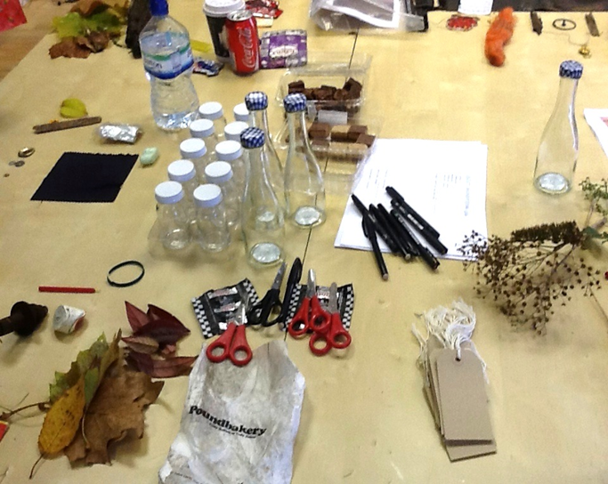
Figure 1. Materials for the scavenger hunt workshop

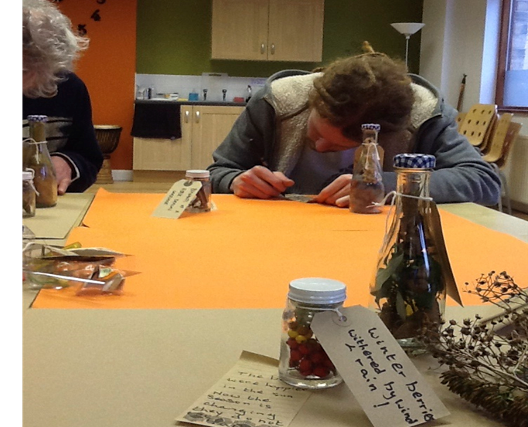
Figure 2. Terry Barnes and Dave Jordan at the Scavenger Hunt workshop

The scavenger hunt workshop was then followed two weeks later by a ‘do it yourself’ map making workshop. Most participants returned for that final workshop and got to work in collating materials from all the workshops to create artistic maps. Suggestions were provided by Emmanouil and Bridger on how participants could create artistic maps and they were provided with maps of Huddersfield and situationist quotes which could be used to produce art. The point of the final session was to reflect on all the psychogeographical workshops and to put into practice some of the concepts used by the situationists in relation to their practice of psychogeography. Figure three is an example of one participant’s map of the Huddersfield area produced in the map making workshop. This serves as an example of putting into practice the situationist concept of ‘detournement’, whereby pre-existing elements are re-arranged to produce new meanings, in this case with reference the participant made to the built-up landscape of Huddersfield, the dominance of shopping and how he didn't perceive the town centre as a place for him.

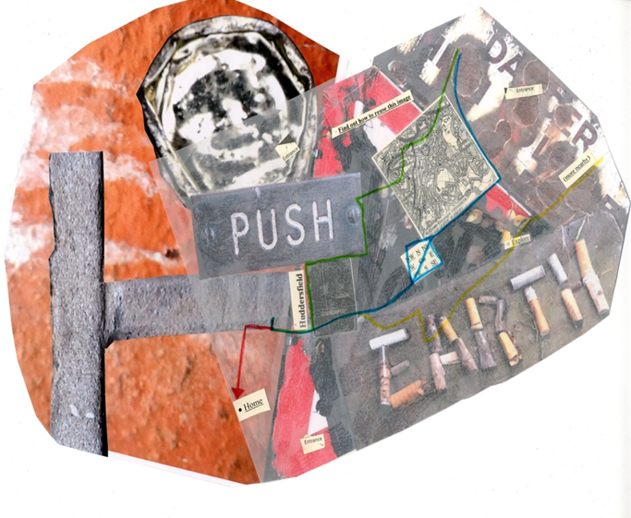
Figure 3. Map produced by anon

In order that the activities we had planned would be different to any other community activities at the centre, we ensured that there was always a distinctive theoretical underpinning to what we did. To underpin the activities at the centre, we drew on four key tenets of situationist theory to underpin the work, which were: psychogeography, participatory creativity, detournement and provocation. These tenets come from Barbrook’s (2014) book where the four concepts are used to critique consumer capitalism and to begin to think about a world beyond the current capitalist order of things. However, readers should be alerted here that these tenets are not strictly methodological rules but are rather playful strategies to consider and critique everyday life under consumer capitalist conditions. The first tenet on psychogeography has already been covered in this paper and refers to the overarching framework through which the activities at Hoot had been designed. The second tenet here is participatory creativity and refers to how we as facilitators in the project wanted to enable participation and creativity in relation to the workshop activities which will henceforth be discussed. The third tenet is detournement which refers to a process whereby elements of texts are reused in new and different ways as a way to question the dominant order of things with a view to creating new and subversive ideas and practices (International, 1959), which can be evidenced via the construction of artistic maps as will be explained later on in this chapter. The fourth and last tenet here is referred to as provocation and relates to ultra-left ideas on political agitation with one example being sloganeering on the streets of Paris in the 1950s and 60s, ‘Be realistic! Demand the impossible!’ The extent to which provocation could be enabled through the psychogeographical activities at Hoot will be evidenced later in this chapter in relation to a short talk at the launch night for the exhibition, by one of the participants, Terry Barnes.
The work at the Hoot centre produced numerous outcomes and a plethora of reflective, ethical and political issues. In this section of the chapter, I will discuss some of the key threads from that work. It is important to begin with the notion of subject positions in that project in relation to researcher roles as ‘scholar-activists’ wishing to do community based research. It is important to draw affiliation with other scholar-activists such as Kagan, Burton, Duckett, Lawthom and Siddiquee (2011) as well as with Parker (2007, 2015). It was not an aim to simply jet into that community context and conduct research as ‘experts’ as it was important to establish social relationships both with users of the centre as well as with the general staff and management team. The relational aspect of working with participants at Hoot was important and we wanted to present ourselves as working alongside rather than on the group.

The second core theme is related to the idea of working ethically, sustainably and with moral principles. Arguably these are threads that underpin all social psychology research, particularly that of the applied variety. In working with people with mental health needs (Bridger et al. 2016) and with homeless people (Radley et al. 2010), it is clearly important to address issues of ethics and morals. In our study, we endeavoured to create a safe and comfortable for our participants. Emmanouil worked with the group at the Hoot centre for several months before introducing the idea for a psychogeography community project. During the psychogeographical activities at the Hoot centre, participants took a range of photographs of places to document the walks and activities conducted. Ethics was clearly important as some participants wished to remain anonymous and so we did not make use of all the photographs produced. The use of the photographs in the map making and story workshops was useful to form bonds between participants and researchers and again is something which other researchers have also indicated (Hodgetts et al. (2007, 2011).

A third core theme relates to the question of intellectual theory and accessibility. Often it is the case that the use of unfamiliar terminology and language can alienate other people, so it was important for us as researchers in the project to explain things in ways that would make sense to them. We aimed to do the work tactfully and sensitively and would hope that our roles as teachers would give us the means to do that for a wide range of people.
Next, it was important what the outcome of these workshop activities at Hoot led to and so it was necessary to discuss the exhibition of participants’ work at the local Huddersfield Art Gallery. Sophia Emmanouil was involved in planning the exhibition at that gallery and ensured that everyone’s work would be presented at that place. Emmanouil sought consent from the participants to showcase their work at the gallery and gained approval from the management team at Hoot and OOB.

Not many of the participants did actually come to theThe launch of the exhibition (http://transdisciplinarydialogueanddebate.com) was not attended by many of the participants but one participant, Terry Barnes, delivered a short speech discussing the elitism and non-accessibility of art in relation to everyday people and explained that certain voices are not always represented in places such as Art Galleries. His talk could be considered as a situationist political intervention in an art space. Figure four represents a section of the exhibition cabinet at the Huddersfield art gallery, whereby Emmanouil collected and arranged participants’ work in relation to the scavenger hunt activity.

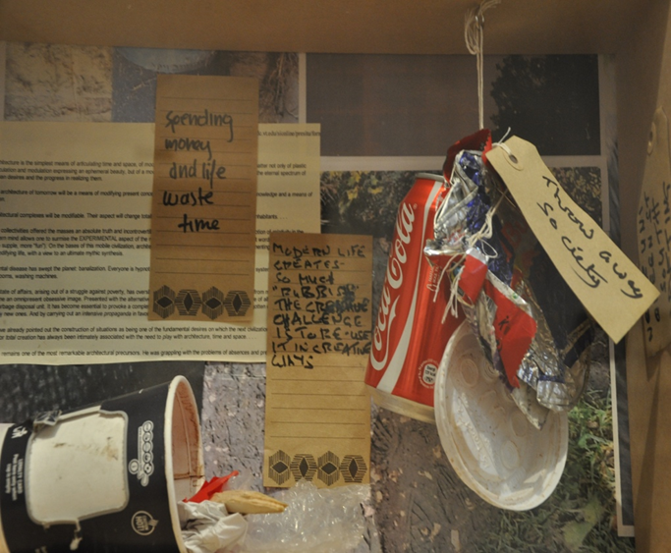
Figure 4. Exhibition cabinet – the Scavengers Hunt

Figure five depicts the exhibition at the Huddersfield art gallery with video footage, textual accounts of participants’ work and an exhibition cabinet.

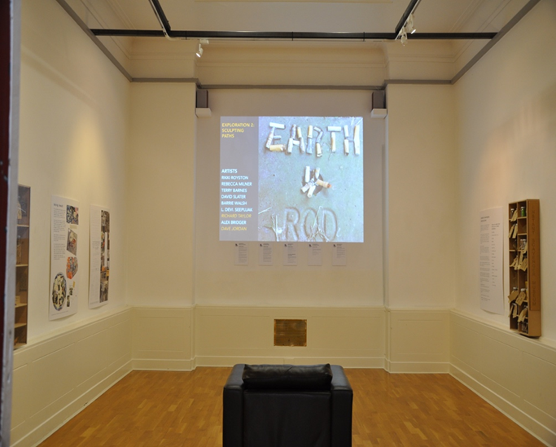
Figure 5. Psychogeography exhibition at the Huddersfield Art Gallery

During and after the process of the workshops at Hoot, Emmanouil and I gained feedback from the participants about the psychogeographical workshops. We were pleasantly surprised with how they found the workshops, as ‘playful and interesting’ and ‘nothing similar to what they had done before’. Another participant indicated that using dice methods in the walking workshop had enabled him to think about different perspectives on the social world. One participant stated that they found the relaxation practices as ‘highly enjoyable and set them in the mood for creating’, whilst another person indicated that he had gained ‘tools and skills to work with in future projects’. Another person said that ‘from the moment we stepped out, our mind was collecting ideas, we had a collective mind and awareness was increased. We felt we were leaving our mark. We felt like we were pushing our boundaries, creating events within events within events. We had a trigger to be creative and have fun’. Emmanouil and I did indeed design the activities in a way that would be straightforward to pick up and do for those involved. The feedback from most of the participants was overwhelmingly positive. Emmanouil also spoke with the Management team at Hoot to see what their views were on the psychogeographical project and they were also pleased with what we had organised. In fact, the Hoot Management team asked if further similar activities could be organised and Emmanouil duly did so over the following summer period.
As part of researcher reflections on that project work, Emmanouil and Bridger arranged to do a ‘go-along’ interview (Kusenback, 2003) to talk about the work we had conducted at Hoot as well as to discuss the participants’ feedback and the Hoot Management team feedback. That type of interview approach fitted with what we wanted to do because we wished to trace the routes that we had wandered through during the psychogeographical workshops in and around the Hoot centre. We discussed key topics and themes such as our academic standpoints, the legacy of the project and feedback from the participants. At that point we had also just received additional feedback from some participants about the activities where they had indicated that the activities had ‘changed their perspective on things’ and that it had ‘changed the way they look at the town, Huddersfield town’. It would appear then that the psychogeographical activities had been not only interesting and thought provoking but also perspective changing. As to whether the activities have created longer lasting changes would need to be discerned with follow up work, which Emmanouil and Bridger plan in the future. Furthermore, the Management team at Hoot were also pleased about the exhibition at the Huddersfield Art Gallery in relation to a published paper about the project by Bridger et al. (2016). The Management team at Hoot indicated that it had put the Hoot centre more firmly ‘on the map’ and the sorts of activities that take place at that site.

CONCLUSIONS, REFLECTIONS AND IMPLICATIONS

The following questions and themes, informed by Khatib’s work (1958: n.p) are arguably of relevance to doing psychogeographical research in social psychology in terms of: how environments make us feel and what the effects are of particular places, consideration of the extent to which psychogeographical work can facilitate changes in terms of methodological innovation and subsequent research ‘findings’, what particular personal and political changes are possible through doing such work and to imaginatively consider what future environments look like. The psychogeographical ‘turn’ is deployed to critique the consumer capitalist landscape and to build reflective awareness in communities about how neoliberal commodification impacts on our everyday lives. The point of such work is to produce collective routes for action to take place in order to change situations.

Arguably, there are no fixed answers to the themes and questions above as it is dependent on those that carry out the work and what their aims and objectives may be. The situationists were not concerned with producing answers as they argued that people could collectively consider, plan and put into practice the sort of future societies in which they wished to live in. However, in working with what may arguably be marginalised communities (i.e. people facing mental health issues, poverty and other hardship), we do have a duty of care as social psychologists to act ethically and to protect the welfare of others according to the code of conduct and ethical guidelines set out by the British Psychological Society (2009). Individuals that may struggle to fight for better living and working conditions should be supported to do so by social psychologists, other professionals, the public, families and friends. We should use our knowledge and working practices as social psychologists to support those that experience distress in all forms. Whilst people experiencing distress, poverty and discrimination may not be focused on the overthrow of capitalism, it is still possible to at least draw on the playful elements of psychogeography to consider day to day life under consumer capitalist conditions and to think about the impacts of neoliberalism and the consumer spaces upon our everyday lives. A situationist psychogeographical approach in social psychology can be focused on a political analysis of environments and can be used to consider the extent to which social change is possible. The question of what change can research enable is important to address and the authors of this paper not proclaim to be able to make those changes ourselves. If one is serious about doing applied social psychological research, then it is important to create and maintain relations with a range of communities to consider what environments we want and to do so as part of a process of considering peoples’ wellbeing and health in socio-political contexts.
It is important to do critical and community based research that connects with people from all walks of life. There are other social psychologists on the Left whom are also concerned with doing psychology differently and with engaging in action based research and with various forms of social action and political alliances with Mad Pride, Asylum, Left Unity and the Stop the War Coalition. Parker (2007) argues for the importance of working in, against and beyond institutions, social systems and structures and that is a necessary part of striving for social change in society. This then brings us to a very different consideration of what the term ‘applied’ should mean in the context of applied social psychology. It is important to hold to account and reflect on the work that we do in the discipline. It would be a great shame to only produce papers on psychogeography for an academic audience. For such work to have proper value and to be applied and of relevance to communities beyond academia it is therefore necessary to work in and beyond academia. One way to do this is to organise events for both academic and non-academic audiences, as has been done with recent conferences and festivals including the World Congress of Psychogeography hosted at the Heritage Quays Archive space in Huddersfield (http://4wcop.org), the Loiterers Resistance Festival hosted at the Peoples’ History Museum in Manchester (http://www.phm.org.uk/whatson/loitering-with-intent/) and Territories Reimagined: International Perspectives Conference (https://trip2008.wordpress.com) hosted at Manchester Metropolitan University and also at the Green Room, the Zion Centre and the Urbis Museum in Manchester. Collaboration is key here in terms of constructing solidarity with those outside of academia, in order that we ‘use our own academic position to transform the cultural practices that we participate in’ (Parker, 2015: 7), so that we can start to create new connections of work with political practice. In alliance with Hodgetts, Stolte and Goot (2014: 164), ‘We need to embrace the long history in psychology of working in partnership with communities to challenge inequitable social structures and to affect change’. The question then is not simply to consider which methods to use in social psychological research about place and context, but rather to draw on whatever approach and associated methods will best enable us to tackle issues such as social inequalities in place and to consider the consumer capitalist landscape.
The aims of such work should be to draw together ideas and practices from situationist psychogeography in relation to working with people in and beyond academia. This work does not necessarily create social change but it can shift the ways that we as researchers and participants think about everyday life and can enable us to reconsider and think about what future conditions of possibility could be. Plant (1992: 76) raises the problematic issue of appearing to do ‘revolutionary critique’ whilst at the same time ‘reproducing the specialisation of knowledge and the lucrative elitism’ of such ‘roles’. Debord, a leading member of the Situationist International, wanted to avoid the institutionalisation of situationism into academia. His fear was that radical ideas could become ‘watered down’ and devoid of the potential to effect changes in capitalist society. Any critical academic work is to some extent recuperated into the dominant sphere though the challenge is to continue to do work that detourns, subverts and calls into question the capitalist order of things. One should take seriously the argument made by Vaneigem (1975: 186-199), where he argues that group activities can enable the ‘self-realisation’ of each person and that such realisations can lead to wider social changes in society. Parker (2007) has also argued for working in, against and beyond capitalist social systems and institutions. Hopefully this chapter has lain the foundations for future development and innovation in the use of psychogeography as a social psychological approach to critique the consumer capitalist landscape and to open up and enable avenues for collection action and social change.

AUTHOR BIOGRAPHIES

Alexander John Bridger is a senior lecturer in psychology at the University of Huddersfield. His teaching and research interests include psychogeography and qualitative approaches such as psychoanalysis and discursive theory. He is involved in various psychogeographical groups in the North of England, including the Huddersfield Psychogeographical Network.

Sophia Emmanouil is an Architect and Independent Scholar. She is also a participatory arts facilitator and runs a range of projects in partnership with schools, community groups and other Voluntary and Community Collectives. Her research, which incorporates Situationist approaches to space, place and mapping, transgresses architecture, design and education, and takes experimental approaches to sustainability and psychogeography. Sophia’s work also considers art, design and architecture from a public engagement perspective.

Rebecca Lawthom is a Professor in Community Psychology at Manchester Metropolitan University. She uses community participatory methods and is interested in areas such as migration, disability and community work.

REFERENCES

Allport, G.W. (1954). The nature of prejudice. Reading, MA: Addison-Wesley.
Altman, I. (1993). Challenges and opportunities of a transactional world view: Case study of contemporary Mormon polygamous families. American Journal of Community Psychology, 21, 135-163.
Anderson, J. (2004). Talking whilst walking: A geographical archaeology of knowledge. Area 36(3), 254-261.
Barbrook, R. (2014). Class wargames: Ludic subversion against spectacular capitalism. New York: Minor Compositions.
Barnes, T.J and Duncan, J.S. (1992). Writing worlds: Discourse, text and metaphor in the representation of landscape. Routledge: London.
Benjamin, W. (1999). The arcades project. Harvard University Press: Harvard.
Billig, M., Condor, S., Edwards, D., Ganr, M., Middleton, D. and Radley, Al. (1988). Ideological dilemmas: A social psychology of everyday thinking. London: Sage.

Bridger, A.J. (2014). Visualising Manchester: Exploring new ways to study urban environments with reference to situationist theory, the and qualitative research. Qualitative Research in Psychology, 11 (1), 78-97.

Bridger, A.J., Emmanouil, S. and Lawthom, R. (2016). trace.space: a psychogeographical community project with members of an arts and health organisation. Qualitative Research in Psychology, 1-17.
British Psychological Society (2009). Code of Ethics and Conduct: Guidance published by the Ethics Committee of the British Psychological Society. The British Psychological Society: Leicester.
Brown, L. and Durrheim, K. (2009). Different kinds of knowing: Generating interview data through mobile interviewing. Qualitative Inquiry 15(5), 911-930.
Cherry, F. (1995). The stubborn particulars of social psychology. Routledge: London.
Chtcheglov, I. (1958). Formulary for a New Urbanism. Situationist International. <
http://www.cddc.vt.edu/sionline/presitu/formulary.html> [accessed 12 November 2012].
Corral-Verdugo, V. and Pinheiro, J.Q. (2009). Environmental psychology with a Latin
American taste. Journal of Environmental Psychology, 29, 366-374.
Cuba, L. and Hummon, D.M. (1993). A place to call home: Identification with dwelling, community and region. The Sociological Quarterly, 34, 111-131.
Debord, G. (1958). Theory of the dérive. Situationist International, < http://www.cddc.vt.edu/sionline/si/theory.html [accessed 26 November 2014].
Debord, G. (1989). Panegyric, Debordiana, < http://debordiana.chez.com/debordiana.htm>
[accessed 18 February 2015].
Dixon, J. and Durrheim, K. (2004). Dislocating identity: Desegregation and the transformation of place. Journal of Environmental Psychology, 24, 455
Dixon, J., Tredoux, C., Durrheim, K., Finchilescu, G. and Clack, B. (2008). ‘The inner citadels of the color line’: Mapping the micro-ecology of racial segregation in everyday life spaces. Social and Personality Psychology Compass, 2(4), 1574-1569.
Ellis, C. (2000). The ethnographic I. California: Alta Mira.
Ellis, C. and Bochner, A.P. (2000). Auto-ethnography, Personal Narrative, Reflexivity:
Researcher as Subject. In Denzin, N. and Lincoln, Y., editors, The handbook of qualitative research. Thousand Oaks: Sage.
Gifford, R. (2014). Environmental psychology matters. Annual Review of Psychology, 65,
541-579.
Hayes, G. (2003). Walking the streets: Psychology and the flâneur. Annual Review of Critical Psychology, 1 (3), 50-66.
Haslam, A. (2007). DVD1. DD307 Social Psychology: Critical Perspectives on Self and Others. The Open University: Milton Keynes.
Hodgetts, D., Chamberlain, K. and Radley, A. (2007). Considering photographs never taken during a photo-production project. Qualitative Research in Psychology, 4, 4, 263-280.
Hodgetts, D., Stolte, O., Chamberlain, K., Radley, A., Nikora, L., Nabalura, E and Groot, S. (2008). A trip to the library: Homelessness and social inclusions. Social and Cultural Geography 9(8), 933-953.
Hodgetts, D., Stolte, O., Chamberlain, K., Radley, A., Groot, Shiloh and Nikora, Linda Waimarie. (2010). The mobile hermit and the city: Considering links between places, objects and identities in social psychological research on homelessness. British Journal of Social Psychology, 49, 285-303.
Hodgetts, D., Drew, N., Sonn, C., Stolte, O., Nikora, L.W. and Curtis, C. (2010). Social psychology and everyday life. Palgrave MacMillan: Basingstoke.
Hodgetts, D., Chamberlain, K. and Groot, S. (2011). Reflections on the visual in community research and action. In Reavey, P. (Ed.) Visual methods in psychology: Using and interpreting images in qualitative research. London: Routledge.
Hodgetts, D. and Stolte, O. (2012). Case-based research in Community and Social Psychology: Introduction to the special issue. Journal of Community and Applied Social Psychology, 22, 379-389.
Hodgetts, D., Stolte, O. and Groot, S. (2014). Towards a relationally and action-orientated social psychology of homelessness. Social and Personality Psychology Compass, 8, 4, 156-164.
Ingold, T. (1993). The temporality of the landscape. World Archaeology, 25(2), 152–74.
International, S. (1958). Preliminary problems in constructing a situation. Nothingness: The library. [Electronic Version] Accessed at: <http://library.nothingness.org/articles/SI/en/display/313> on 25 November 2004.
Jenks, C. and Neves, T. (2000). A walk on the wild side: Urban ethnography meets the flâneur. Journal for Cultural Research 4(1), 1-17.
Kagan, C., Burton, M., Duckett, P.S., Lawthom, R. & Siddiqque, A. (2011). Critical community psychology. Oxford: Wiley-Blackwell.
Keith, M. and Pile, S. (1993). (Eds.) Place and the politics of identity. New York: Routledge.
Khatib, A. (1958). Attempt at a psychogeographical description of Les Halles. Situationist International, < http://www.cddc.vt.edu/sionline/si/leshalles.html> [accessed 26 November 2014.
Kotanyi, A. and Vaneigem, R. (1961). Basic programme of the bureau of unitary urbanism.
Situationist International. Accessed at: http://www.cddc.vt.edu/sionline/si/bureau.html on 28 September 2004.
Kusenbach, M. (2003). Street phenomenology: The go-along as ethnographic research tool. Ethnography, 4, 3, 455-485.
Lefebvre, H. (1976). The survival of capitalism. London: Allison and Busby.
Manzo, L. C. (2003). Beyond house and haven: Toward a revisioning of emotional relationships with places. Journal of Environmental Psychology, 23, 47-61.
Merrifield, A. (1993). Place and space: a Lefebvrian reconciliation. Transactions of the British Institute of Geographers, 18, 516-531.
Miles, S. (2010). Spaces for consumption. London: Sage.
Moser, G. and Uzzell, D. (2003). Environmental psychology. In I.B. Weiner (Series Ed.), Th.
Milon, M.J. Lerner (Vol. Ed.), Handbook of psychology: Vol 5. Personality and social
psychology (pp. 419-445). New York: Wiley.
Nowell, B.L., Berkowitz, S.L., Deacon, Z. and Foster-Fishman, P. (2006). Revealing the cues with community places: Stories of identity, history and possibility. American Journal of Community Psychology, 37, 29-46.
Parker, I. (2007). Revolution in psychology: From alienation to emancipation. London: Pluto Press.
Parker, I. (2015). Psychology after discourse analysis: Concepts, methods, critique. London: Routledge.
Pinder, D. (2005). Visions of the city: Utopianism, power and politics in twentieth century Urbanism. Edinburgh: Edinburgh University Press.
Plant, S. (1992). The most radical gesture: The situationist international in a postmodern age. London: Routledge.
Proshansky, H., Fabian, A.K. and Kaminoff, R. (1983) Place-identity: Physical world socialization of the self. Journal of Environmental Psychology, 3, 57-83.
Radley, A., Chamberlain, K., Hodgetts, D., Stotle, O. and Groot, S. (2010). From means to occasion: Walking in the life of homeless people. Visual Studies 25(1), 36-45.
Sadler, S. (1999). The situationist city. London: MIT Press.
Said, E. (1993). Culture and imperialism. New York: Knopf.
Sheller, J. & Urry, J. (2000). The city and the car. International Journal of Urban and Regional
Research, 24, 737–57.
Sheller, M. & Urry, J. (2006). The new mobilities paradigm. Environment and Planning A 28,
207-226.
Smith, S. (2008). How to be an explorer of the world. New York: Penguin Group Inc.
Twigger-Ross, C.L. and Uzzell, D.L. (1996). Place and identity processes. Journal of Environmental Psychology, 16, 205-220.
Vaneigem, R. (1967). The revolution of everyday life. Nothingness: The library. [Electronic Version] Accessed at: <http://library.nothingness.org/articles/SI/en/pub_contents/5> on 24 November, 2004.
Wollen, P. (2001). Situationists and architecture. New Left Review, 8 (1), 123-139.
Wood, D. (1987). I don’t feel that about environmental psychology today. But I want to.
Journal of Environmental Psychology, 7, 417-424.

