Integrated electrical machine-compressor

Electrical machines with silent rotor

In the recent decades, substantial developments on the electrical machines with silent rotors resulted in increase their performance, reliability and ease their manufacturability as well as reduce their cost. Silent rotor machines include magnet-less topology (switched reluctance) [1], flux reversal permanent magnet topologies (flux switching/switched flux, doubly silent and flux reversal) [2] and variable flux topologies also known as hybrid AC/DC machines [3].
All the above-mentioned electrical machines have the same rotor structure shown in Figure 1. The rotor is gear-shaped made of one solid piece of ferromagnetic material. The rotor does not consist of any magnets or winding. Therefore, it is simple, easy to manufacture and these topologies are characterised by easy heat removal since all the active parts (magnets and winding) are located in the stator.

Cross-section | 3D-model
Figure 1 Silent rotor.

Developments in ferromagnetic materials with high mechanical properties

Due to the high demand for high-speed electrical machines, several ferromagnetic materials with high mechanical properties have been proposed. In [4], steel material series M300- has been proposed to accommodate high stress with a reasonable ferromagnetic capability. Moreover, soft magnetic composite (SMC) material grade Somaloy is proposed for high-speed applications, unlike other ferromagnetic materials used for electrical machine [5], SMC has inherently significantly reduced electromagnetic losses without the need to use lamination, i.e. solid structure. Furthermore, several high mechanical strength ferromagnetic steel materials are described and compared in [6].

Proposed integrated electrical machine-compressor

The proposed integrated system consists of an electrical machine with a silent rotor, where the rotor shape is altered to replicate the shape of an axial flow compressor, Figure 2. The electrical machine can be used as a motor to drive or assist the operation of the compressor or it can operate as a generator derived by airflow. Compared to the conventional electrically derived or assisted compressor systems, the proposed system is expected to decrease the overall size.

Full view | Side view
Top view | Bottom view
Figure 2 Silent rotor-compressor.

Initial integrated electrical machine-propeller design

Figure 3 shows the conventional and proposed switched flux permanent magnet machine (SFPM) with compressor rotor. The design is based on an optimized SFPM. The rotor shape has been altered to replicate an axial flow compressor wheel, the dimensions of the wheel blades are initially decided based on general knowledge of compressors.

Conventional SFPM machine | Proposed SFPM machine with rotor-propeller
Figure 3 Conventional and proposed SFPM machines.

Sensitivity study

Moreover, a sensitivity study has been conducted to estimate the performance changes, in particular, the torque with the change of the rotor blades dimensions. The investigated parameters are rotor blade skew angle, tip length, thickness and width, Figure 4.
Blade skew angle sensitivity study is performed by rotating the blade around its centre by 5, 25 and 45 degrees. Moreover, blade tip length study is made by using a blade tip length of 5, 10 and 15mm. Furthermore, 8, 12 and 16mm blade thicknesses are tested, this is done by changing the back-iron of the rotor accordingly. Finally, the influence of the blade width is investigated by testing three different values, i.e. 15mm 7.5mm and 2mm. It is worth mentioning the selected parameters for sensitivity study are chosen due to their high influence on the aerodynamic performance.

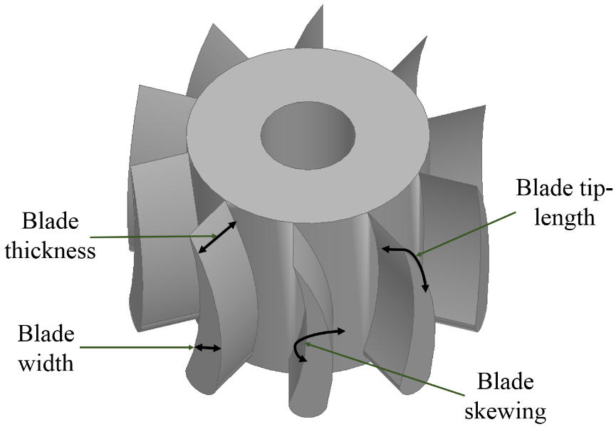
Figure 4 Parameters of sensitivity study.

Table 1 lists the average torque at different blade skew angle, tip length, width, and thickness. It is noticeable that the blade skew angle can significantly reduce the torque, this is since the skewed blade reduces the interaction surface between the rotor and stator and creates a wide short circuit path for the stator magnet flux, and therefore a reduction and phase shift in the back-EMF waveform is found. This can be solved by skewing the stator accordingly. Skewing rotor and stator poles are widely addressed in literature since it helps reducing cogging torque and consequently acoustics (noise and vibration) [7]. Similar to the skewed rotor blade, increased blade tip can also create a short circuit path however since it is smaller compared to the rotor blade, the reduction in the torque is, therefore, small. Furthermore, the changes in the blade thickness have a small influence on the torque. Finally, smaller blade width reduces the torque due to the reduction in the rotor magnetic circuit.

Table 1 Average electromagnetic torque of the integrated electrical machine-compressor at different rotor design parameters (values presented are normalized to the initial design torque value).
Blade skew angle |  | Blade tip-length
Angle (degree) | Torque | Tip-length (mm) | Torque
5 | 0.933 | 5 | 1
25 | 0.4 | 10 | 0.89
45 | -0.15 | 15 | 0.81
Blade thickness |  | Blade width
Thickness (mm) | Torque | Width (mm) | Torque
8 | 0.96 | 2 | 0.23
12 | 0.96 | 7.5 | 0.73
16 | 0.96 | 15 | 1

Other possible designs

The rotor of the conventional surface-mounted permanent magnet (SPM) machine can also be integrated with a compressor. By adding permanent magnets around the silent rotor-compressor, the blades and back-iron will rotor yoke to provide a path for the magnetic flux, Figure 5. This rotor topology allows for more rotor blades with narrow space between the blades.
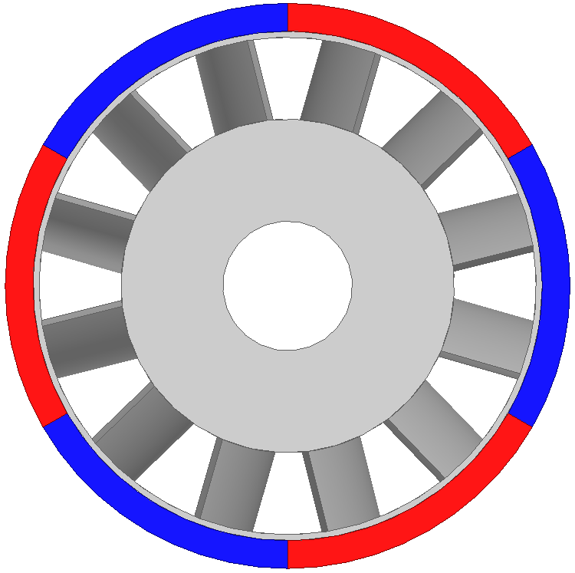 | 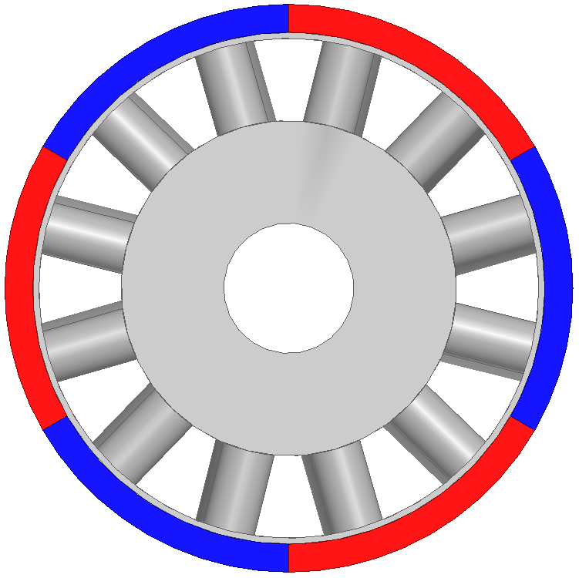
Top view | Bottom view
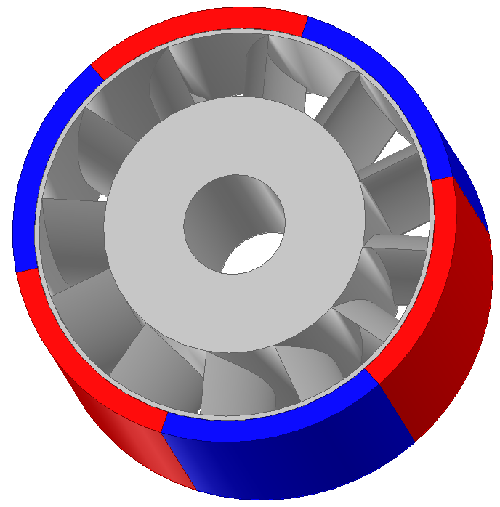
Full view
Figure 5 PM rotor-compressor.

Radial flow-axial field electrical machine

Radial flow compressors used in turbochargers and other turbo-machinery can also be integrated with a rotor of an axial field electrical machine. This will help reduce the need to assemble three different rotating components (turbine wheel, compressor, and electrical machine rotor). Figure 6 and 7 present two proposed radial flow-axial field integrated rotor. In Figure 6, the compressor and the rotor are made of one solid piece, although this design has a good mechanical integrity, a compressor wheel made of high strength ferromagnetic material might not be an attractive approach. On the other hand, Figure 7 presents an alternative design where the compressor and the rotor are made of separately and held together by a sleeve/belt.
Figure 6 Radial flow-axial field rotor (solid)

Figure 7 Radial flow-axial field rotor (separated)

Future work

Since there are several salient rotor machine topologies as stated in section 1, it is desirable to test each with the proposed integrated compressor rotor and compare their results to find the optimum topology. Moreover, the optimization of such machine will require a multiphasic iterative process where the electromagnetic, mechanical, thermal and aerodynamic performance of the machine need to be optimized simultaneously.

References

[1] Y. Ohdachi, Y. Kawase, Y. Miura and Y. Hayashi, "Optimum design of switched reluctance motors using dynamic finite element analysis," in IEEE Transactions on Magnetics, vol. 33, no. 2, pp. 2033-2036, Mar 1997.
[2] J. Zhang, M. Cheng, Z. Chen and W. Hua, "Comparison of Stator-Mounted Permanent-Magnet Machines Based on a General Power Equation," in IEEE Transactions on Energy Conversion, vol. 24, no. 4, pp. 826-834, Dec. 2009.
[3] Z. Azar and Z. Q. Zhu, "Performance Analysis of Synchronous Reluctance Machines Having Nonoverlapping Concentrated Winding and Sinusoidal Bipolar With DC Bias Excitation," in IEEE Transactions on Industry Applications, vol. 50, no. 5, pp. 3346-3356, Sept.-Oct. 2014.
[4] http://cogent-power.com/cms-data/downloads/m300-35a.pdf
[5] https://www.hoganas.com/globalassets/media/sharepoint-documents/BrochuresanddatasheetsAllDocuments/Somaloy_Technology_for_Electric_Motors.pdf
[6] M. Tietz, F. Herget, G. von Pfingsten, S. Steentjes, K. Telger and K. Hameyer, "Effects and advantages of high-strength non grain oriented (NGO) electrical steel for traction drives," Electric Drives Production Conference (EDPC), 2013 3rd International, Nuremberg, 2013, pp. 1-6.
[7] C. Gan, J. Wu, M. Shen, S. Yang, Y. Hu and W. Cao, "Investigation of Skewing Effects on the Vibration Reduction of Three-Phase Switched Reluctance Motors," in IEEE Transactions on Magnetics, vol. 51, no. 9, pp. 1-9, Sept. 2015.

