**CNC vertical machining centre (VMC) feed drive modelling using the transmission line technique**

Ford DG, Castaneda VYM, Longstaff AP, Pislaru C, Myers A

Centre for Precision Engineering

University of Huddersfield

**Abstract**

This study presents a novel application of the Transmission Line Matrix Method (TLM) for the modelling of the dynamic behaviour of non-linear hybrid systems for CNC machine tool drives. The application of the TLM technique implies the dividing of the ball-screw shaft into a number of identical elements in order to achieve the synchronisation of events in the simulation, and to provide an acceptable resolution according to the maximum frequency of interest. This entails the use of a high performance computing system with due consideration to the small time steps being applied in the simulation. Generally, the analysis of torsion and axial dynamic effects on a shaft implies the development of independent simulated models. This study presents a new procedure for the modelling of a ball-screw shaft by the synchronisation of the axial and torsion dynamics into the same model. The model parameters were obtained with equipments such as laser interferometer, ball bar, electronic levels, signal acquisition systems etc. The MTLM models for single and two-axis configurations have been simulated and matches well with the measured responses of machines. The new modelling approach designated the Modified Transmission Line Method (MTLM) extends the TLM approach retaining all its inherent qualities but gives improved convergence and processing speeds. Further work since, not the subject of this paper, have identified its potential for real time application.

**Keyword**

Machine Tool, Feed Drive Modelling; TLM, MTLM, model optimisation

1. **Background**

Ford [1] proposed that the design process of any high precision CNC machine tool must embrace error avoidance, error measurement, and error compensation techniques in order to achieve an ever increasing demand for greater accuracy and therefore a more stringent performance specification. The measurement of the repeatable time and spatial errors can allow compensation methods to be applied to the machine for correction of those errors provided sufficient resolution has been allowed for in the design, with the absolute limit on accuracy for a particular machine being defined by its measured repeatability figures and the responsiveness of its compensating axes. The main areas of concern affecting component accuracy are environmental effects, user effects and the machine tool static and dynamic accuracy. The sources of error confined to a machine tool are geometrical inaccuracies, thermally induced errors and load errors.

**1.1** **Machine tool feed drive modelling and system identification**

Pislaru et al **[2**] stated that the modelling used for designing high performance CNC machine tool feed drives should accurately represent the system consisting of three cascaded closed loops for acceleration, velocity and position control. They utilised a modular approach and a hybrid modelling techniquewhich included for distributed load, explicit damping coefficients, backlash and friction. The model was a combination of distributed and lumped elements described by partial differential equations and ordinary differential equations as proposed by Bartlett and Whalley [3].

Holroyd et al [4] modelled the dynamic behaviour of a ball-screw with moving nut using a finite element approach. The ball-screw was divided into a large number of elements and contact/boundary conditions for each element and adjacent ones were studied. An important conclusion was that the natural frequencies of the ball-screw system vary in time due to two causes: (a) the lateral restraint produced by the nut when the screw was transversally vibrated and (b) the relation between screw torsion, axial motion and worktable/saddle tilt.

* 1. **Transmission line matrix method**

The transmission line matrix method (TLM) belongs to the general class of differential time domain numerical modelling methods. It is used to solve time dependent or transient problems, thus involving ordinary and partial differential equations (PDE).

The application of TLM to the modelling of fluid systems by Boucher and Kitsios [5]; and mechanical systems by Partridge et al [6] implies the same representation used in the hybrid approach by Pislaru, [2] i.e. lumped parameter modules, components with localised dynamic effects, and distributed parameter modules. The difference resides on the fact that transmission line equations introduce natural time delays between components due to the wave propagation speed in a transmission line. Therefore, distributed components must be divided into a number of identical elements in order to: achieve the synchronisation of events in the simulation, and to produce acceptable resolution according to the maximum frequency of the simulation. This characteristic gives the possibility to include the effect of the nut movement suggested in Holroyd’s et al [4] approach.

Johns and Beurle [7] described the two equivalent circuits used in the TLM technique: the stub and the link circuits. TLM links are two port one dimensional building blocks that can be used for one-, two- or three dimensional modelling. TLM stubs are one-port units which can be used for solving circuits and equations, and are used in multi-dimensional modelling to complement TLM links. Links are used for modelling distributed parameter elements and stubs for lumped parameter elements.

Christopoulis [8] stated that any electrical circuit could be represented as a network of transmission line circuits by simply replacing the reactive elements with corresponding stubs. Variables such as voltage and current are regarded as discrete pulses bouncing at a velocity to and from nodes of these stubs at each time step. The voltage and current in each element are determined from the incident and reflected pulses in each stub. He demonstrated the transmission line and its Thevenin equivalent.

The MTLM stub, taking into account changes of sample time was applied to the modelling of a rotor shaft arrangement by Partridge et al [6], where Castaneda [9] demonstrated improved robustness and accuracy of the simulation. A reduction of 40% in the number of mathematical operations and almost 35% reduction in the mean square modelling error figures were achieved. This method of approach was utilised for this application.

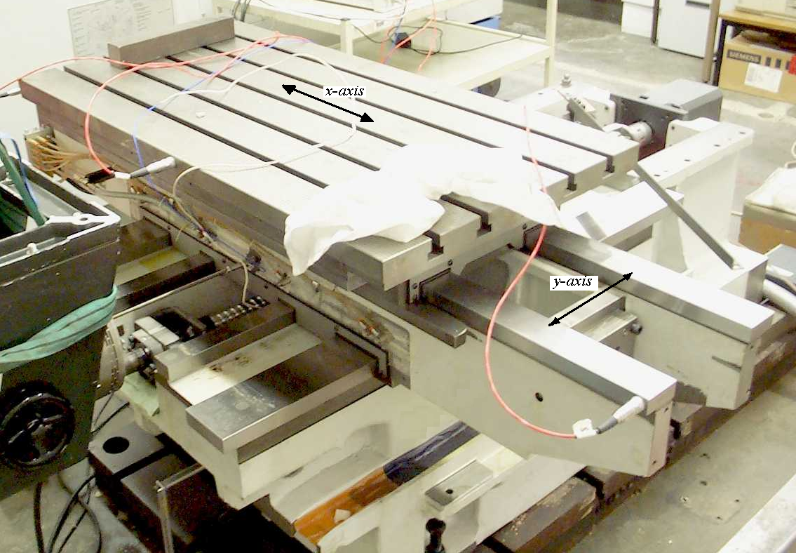 **

**Figure 1a: Test rig Figure 1b: Test rig block model**

**2.0 Single axis CNC test rig**

The single-axis test rig (Figure 1a) represents the y-axis of a vertical machining centre (VMC). The single axis is fitted with a Heidenhain TNC-426PB motion controller, a SIMODRIVE-611 Siemens inverter, and a ball- screw arrangement directly coupled to a permanent magnet synchronous motor.

The Heidenhain [10] TNC-426PB motion controller offers digital control of functions such as interpolation, position control, speed control, current control and provides PWM signals to the inverter unit. The control of each axis is implemented with an algorithm following the principle of cascade control in conjunction with velocity and acceleration feed forward.

The SIMODRIVE-611 consists of a common feed module that provides the DC voltage link from the power supply mains and a set of drive modules that activate each motor. In the case of the test rig, the drive module consists of a power module (inverter) and an interface card that communicates with the TNC-426PB motion controller.

The nut of the ball-screw system is preloaded and the screw shaft is mounted on preloaded bearings in a fixed-fixed configuration.

The model of the axis feed drive is built by interconnecting the TLM models of the rig elements. The dynamics acting on the axis feed drive are defined by the interrelation of three blocks: The motion controller, the inverter & motor electrical equations, and motor mechanical equations & mechanical transmission elements as illustrated in Figure 1b. Table 1 contains the test rig specification.

**3. TLM method applied to CNC machine tool feed drive**

**3.1 Motion controller**

Heidenhain [10] operates with position and velocity control in cascade with feed forward capability as shown in Figures 2 and 3. Seborg et al [11] concluded that feed forward control improves trajectory tracking compensating for the effect of disturbances before they affect the response of the controlled system. The velocity feed forward path connects the reference position to the velocity loop through the gain, *kff* (Figure 3). When the position profile changes, the velocity feed forward transfers immediately that change to the velocity command. This speeds up the system response, thus not relying solely on the position loop. The primary shortcoming of velocity feed forward is that it induces overshoot when changes on the velocity direction occur. Acceleration feed forward eliminates the overshoot caused by velocity feed forward without reducing loop gains. The basic principle of feed forward control is to inject the position and velocity set points and their correspondent first derivatives at appropriate points in the control loops. Heinemann & Papiernik [12] demonstrated that the following errors are minimised thus achieving a significant increase in the dynamic response to position and velocity set point changes.

Altinas [13] demonstrated that the interpolator (Figure 2) calculates a velocity profile *v* (*t*), according to defined motion commands: feed rate (*fr*), maximum acceleration (*amax*), maximum jerk (*jmax*), and desired displacement (*d*). The velocity profile is then used to generate the set of reference positions in order to achieve a smooth velocity transition.

Koren [14] and Bullock [15] demonstrated that linear and circular interpolation respectively are performed to keep the tool path velocity constant at the given feed rate along a straight line in a plane of motion.

If the system has multiple axes, the motions of individual axes are co-ordinated. When the individual axes are not co-ordinated, each of the axes will start moving at the same time, but finish at separate times producing slew motion as defined by Hugh [16].

**Table 1: Test rig specification**

|  |  |
| --- | --- |
| Motion Controller | HEIDENHAIN TNC 426PB (280 476-24) |
| Electrical Drive | SIEMENS Simodrive 611 (6SN1123-1AA00-0CA1) |
| Motor | SIEMENS 1FT6082-1AF7-1AG1 |
| Guide ways | THK SNS45-LC |
| Front bearing | Double Row Angular Contact Ball Bearing ZKLF 3080.2RS PE |
| Rear bearing | Double Row Angular Contact Ball Bearing ZKLF 3080.2RS PE |
| Ballscrew | THK BIF (BNFN) 4016-5 RRG0S-1346(1065)L-C3-E |
| Coupling | ROBA – ES 28 940.000 |
| Rotary encoder | HEIDENHAIN ERN 1387 |
| Linear encoder | HEIDENHAIN AE LS486C ML620 |
| Transverse | 500 mm |
| Rapid Traverses | 30000 mm/min |
| Feed Rates | 100 – 12000 mm/min |
| Table Size | 115mm x 58 mm |
| Table mass | 312 Kg |
| Saddle mass | 524 Kg |
| Load mass | 854 Kg |
|  | |

The interpolator overcomes this effect. The filtered values constitute the reference position signals for the position controllers.

The Heidenhain TNC426PB [17] motion controller (Figure 3) was implemented in software featuring the algorithms for position, velocity and current control at different using an interpolation technique. Position values from the interpolator can be filtered in order to obtain a smoother motion profile sampling rates [10]. That is:

* The interpolator generates a reference position value *de* every 3 ms.
* The position controller generates a reference velocity value *vref* every 3 ms.
* The velocity controller generates a reference current value *iqref* every 0.6 ms.
* The current controller gives a reference voltage value *edqref* to the PWM generator at a rate of 0.2 ms.
* The dynamic response-matching filter (1st order delay filter) was used to delay the position profile signal according to the transient response during acceleration and deceleration (the equivalent position time constant of the closed position control loop). Delay values can be set in the interval 1 to 255 ms.
* The jerk limitation filter was used to adapt the position profile to the machine dynamics in order to attain high machining velocity. The coefficients of the filter were calculated according to the minimum order of the filter and the tolerance for contour transitions.
* The PT2, second order element was used to include a delay in the reference current (i*ref*) to damp the frequency interference oscillations (circa: 0.3 to 2 ms)
* Sliding friction was compensated within the range of the velocity controller by compensating the sliding friction at low velocity and at the rated velocity of the motor. The compensation at low velocity was achieved by feeding forward the reference current value (measured at approximately 10 rpm) at every change in direction. The compensation at the rated velocity was achieved by feeding forward the current *iff_rv* according to the value of the reference velocity (equation 2). A delay filter was included to prevent overcompensation when the traverse direction was reversed at high feed rates.

 (1)

 **(2)**

Where:

*iffm* is the reference current measured at the rated velocity of the motor; *iff_l* is the reference current at 10 rpm; and *kiff* is the scaling factor.



**Figure 2: Motion controller block model**

**3.1.1 Position controller with velocity feed forward**

The position controller evaluates the difference between the reference and actual position value *dact* (from the rotary or linear encoder) to calculate the position error *de.* A reference velocity value (*vref*) is then generated every *ts* seconds according to the following:

** (3)**

** (4)**

** (5)**

The signal *dact* is calculated by equation (6) if the linear encoder is used as a position feedback system. Equation (7) gives the value for *dact* when the rotary encoder is used instead.

** (6)**

** (7)**

where:

*kb* is the force to torque constant of the ball-screw.

The TLM model for this module is represented by equations (3 to 7) for a sample time *ts*=3 ms.

By a combination of Christopoulis [8] and Castaneda [9] theory:

** (8)**

** (9)**

** (10)**

** (11)**

Where:  and

*Zvff* is the characteristic impedance of the stub and *Eivff* (*k*) is the incident pulse.



**Figure 3: Motion controller flow model**

**3.1.2 Velocity controller with acceleration feed forward**

The velocity controller evaluates the difference between the reference and actual velocity value (*vact*) measured with a rotary encoder attached to the motor*.* A reference current value (*iref*) is generated every *ts* seconds by a Proportional-Integral-Differential (PID) strategy.

Acceleration feed-forward is used in parallel with the velocity controller in order to minimise the spikes caused by changes in velocity direction. A signal *iht* (holding current) is added to the acceleration feed forward to counterbalance the axis load when the axis in the vertical position.

Equations (13 to 18) represent the TLM model for this module (*ts*= 0.6 ms).The following relationship calculates the reference current signal

** (12)**

where: ** (13)**

** (14)**

** (15)**

** (16) (17)**

Here *kp*, *ki*, *kd* are the proportional, integral, and derivative gains of the velocity error *ve*, respectively. *kaff* is the acceleration feed forward gain. Applying the Castaneda [9] TLM transform (equations 19 to 26) for the cycle time *ts* gives:

** (18)**

** (19)**

** (20) (21)**

** (22)**

** (23)**

** (24)**

** (25)**

** (26)**

where:

**; ;** and 

**3.1.3 Band-stop filter**

Heidenhain [17] state a filteris generally used in the velocity feedback to damp the fundamental frequency of the control system, when it is higher than 500 Hz. A first-order low-pass filter is used when the oscillation frequency is between 500 and 700 Hz. A second-order low-pass filter is used if the oscillation frequency is higher than 700 Hz.

When the controlled system is insufficiently damped, it will be impossible to attain a sufficiently short settling time without inducing oscillations in the step response of the velocity controller. The step response will oscillate even with a low proportional factor. A second-order lag element (PT2) is used to include a delay in the reference current (i*ref*) to damp the frequency interference oscillations.

A band-rejection filter is included in series with the PT2 element to damp oscillations that cannot be compensated by the differential factor of the velocity controller, the PT2 element, or the low-pass filter.

Mathworks [18] state these digital filters are generally modelled as implementations of the standard difference equation

 **(27)**

where:

*b* and *a* represent the numerator and denominator coefficients of the filter and *N* is the order of the filter.

The band-stop filter was implemented as indicated by Mathworks [19] in the transposed direct-form II structure of equation (27). This is a canonical form that has the minimum number of delay elements. At sample k, the routine computes the difference equations as follows

 (28)

 (29)

 (30)

 (31)

 (32)

*len* = *len0*+1 (33)

Where: *len0* isthe filter order, and *num* and *den* represent the numerator and denominator filter coefficients. The delay outputs *z*zi(1), i = 1, ..., len0 are initialised to 0. This is equivalent to assuming both past inputs and outputs are zero.

**3.1.4 Current controller**

The current controller is an implementation of the model when the integral term *kci* is equal to zero.

Castaneda [9] developed the model shown and converted to the TLM transform of equations which are presented as

** (34)**

** (35)**

** (36)**

** (37)**

**3.2 Inverter and motor (electrical)**

Moreton [20] describes the voltage relationships and provided the general equation for a permanent magnet synchronous motor (PMSM). Simon [21] explained the Clarke /Park transformation and their inverse relating the vector currents used for the generation of electromagnetic torque (Figure 4a).



**(a): Motor electrical equations (b): TLM model of the motor and coupling**

 

**(c) Reduced TLM model (d) Thevenin equivalent circuit**

**Figure 4: TLM model for the motor and coupling**

The equations of performance for a PMSM in the d-q coordinate system representation are

** (38)**

** (39)**

In which, *λ* signifies the amplitude of the flux induced by the permanent magnets of the rotor in the stator phases; *Ld* and *Lq* are the *d* and *q* axis inductances. Subscripts and  are used to identify the direct and quadrature currents/voltages respectively. The generated electromagnetic torque *Te*, is defined as

** (40)**

If the current**, **; hence the generated electromagnetic torque can be approximated using the torque constant of the motor, *kT*:

** (41)**

Castaneda [9] considered a motor with a round rotor and a simulation time step *ts*, and derived the TLM transforms of equations (38, 39, and 41) giving:

** (42)**

Where: ** (43)**

** (44)**

** (45)**

** (46)**

** (47)**

Rearranging equations (43) and (45) provides

** (48)**

** (49)**

For simulation purposes, it can be assumed that the terms on the left side of equations (48) and (49) are the resultants of the operations on the right side of the equations. Thus, these equations are rewritten as

** (50)**

** (51)**

where:

** (52)**

**3.3Motor mechanical equations and coupling**

The inertias of the rotary encoder and the coupling (hub 1) can be added to the inertia of the motor to simplify the calculations. Hence,

** (53)**

where:

*Jmc* = motor plus coupling inertia; *Jm*= motor inertia; and *Jre* = rotary encoder inertia

This reduction of the model is possible because those inertias are modelled as lumped parameter elements. The resultant TLM model is illustrated in Figure 4c (reduced from Figure 4b).This electric circuit is solved finding the Thevenin equivalent [8] with respect to *Tcs* (Figure 4d), thus

** (54)**

** (55)**

where

** (56)**

and

** (57)**

and

** (58)**

** (59)**

** (60)**

** (61)**

** (62)**

** (63)**

** (64)**

** (65)**

** (66)**

where

** (67)**

and

** (68)**

and

** (69)**

Equations (54 –69) represent the TLM model of the motor mechanical equations & coupling.

**3.4 Screw shaft torsional model**

From the theory outlined by Partridge et al [6], Holroyd et al [4], and Castaneda [9] the following model was derived:

The presence of the supporting bearings in the TLM model of the shaft generates the reflection of pulses arriving to the sections where they are placed. In that case, the propagation of pulses in the TLM model takes place on two specific zones (loops) as it is graphically represented in Figure 5a. The front bearing is placed on section *fb*, the nut is on section *nt* and the rear bearing is on section *ht*, where:

** (70)**

** (71)**

** (72)**

** (73)**

** (74)**

The inclusion of the nut in the model will cause the reflection of pulses arriving to section *nt*, and therefore splitting the *zone 2* in two loops as shown in Figure 5b. The model is then reduced to the calculation of the angular velocity on sections one, *fb*, *nt* and *ht*; and the propagation of pulses on the other sections.

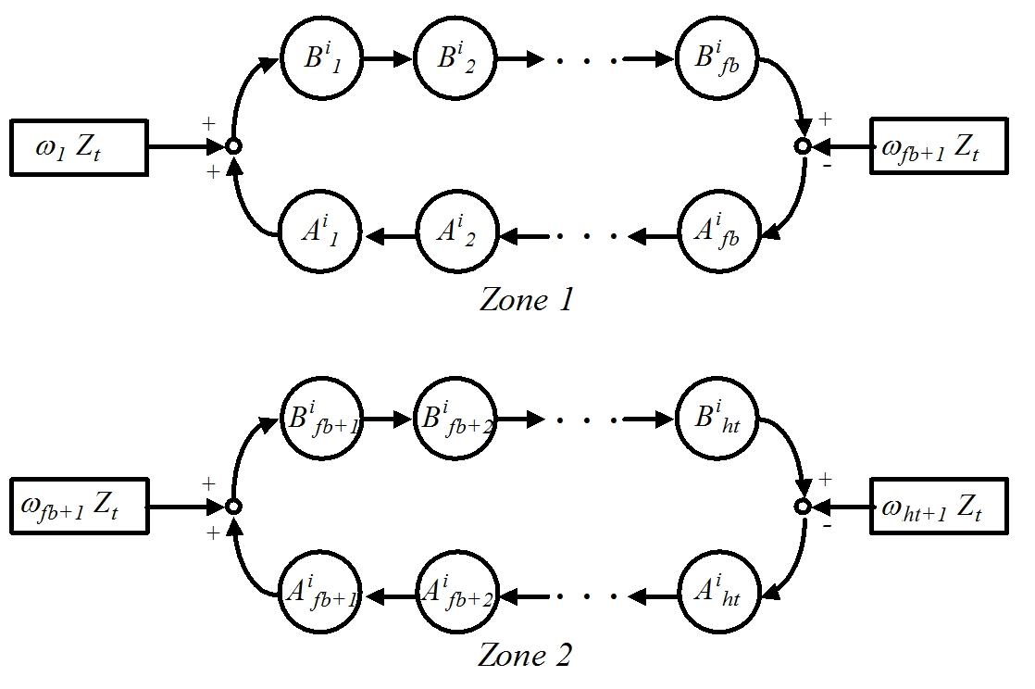

a) Without nut



b) *Zone 2* including the nut

**Figure 5: Pulses propagation model for the screw shaft torsional model with moving nut**

The velocity of the front bearing (*ωfb+1*) is calculated including the TLM model derived for the bearing's friction [22] (see Figure 6a), thus

** (75)**

** (76)**

where

** (77)**

** (78)**

next pulses

** (79)**

The angular velocity *ωnt+1* is calculated according to the procedure specified in section 3.6

The pulse propagation is defined by:

** (80)**

** (81)**

 

**Figure 6a: Section *fb* of the torsional model** **Figure 6b: Section *ht* of the torsional model**

The velocity of the rear bearing (*ωht+1*) is calculated using the procedure applied to the front bearing (see Figure 6b).

** (82)**

** (83)**

** (84)**

next pulses

** (85)**

** (86)**

The propagation of  and  pulses on the other sections are given by:

** for *j* = 2,…, *ht* *j* ≠ *fb*+1, *nt*+1 (87)**

** for *j* =1,…, *ht*-1 *j* ≠ *fb*, *nt*, *ht* (88)**

**3.5 Screw shaft axial model**

From the theory outlined by Partridge et al [6] and Holroyd et al [4], Castaneda [9] derived the following model:

The presence of the supporting bearings and the nut generates the reflection of pulses arriving to the sections where they are placed. This leads to the propagation of pulses on one zone (loops) in the axial model as it is graphically represented in Figure 7.





**Figure 7: Pulses propagation model for the screw shaft axial model with moving nut**

The inclusion of the nut in the model will cause the reflection of pulses arriving to section *na*,, and therefore splits the modelin two loops as shown in Figure 7b. The front bearing is placed on the first section, the nut is on section *na*and the rear bearing is on section *ha*, where

** (89)**

** (90)**

** (91)**

** (92)**

** (93)**

** (94)**

The model is reduced to the calculation of the velocities *v1a*, *vna+1* and *vha+1*; and the pulse propagation on the other sections as defined by the procedure presented by Castaneda [9] showing the derivation of the velocity *v1a* ; velocity *vha+1*; and the pulse propagation.

**3.6 Screw shaft, nut and table**

Figure 8 illustrates the connection of the axial and torsional TLM screw shaft models with the nut and table models thus:

** (95)**

** (96)**

 

**(**c)Equivalent model for the connection between nut and screw shaft

**Figure 8: TLM model of the connection between nut and screw shaft**

** (97)**

where

** (98)**

** (99)**

** (100)**

The components of the frictional force *Fgw* are calculated as follows

** (101)**

** (102)**

** (103)**

** (104)**

** (105)**

The velocity of the table (*vl*) is calculated finding the Thevenin equivalent [8] with respect to *Fa* (Figure 8c):

** (106)**

** (107)**

where

** (108)**

** (109)**

** (110)**

** (111)**

** (112)**

where

** (113)**

** (114)**

** (115)**

** (116)**

** (117)**

** (118)**

** (119)**

** (120)**

It must be noted that a new ballscrew with preload is assumed to have no or minimal backlash. Preload is lost over time due to wear of balls and ball races and non-inclusion of backlash term would reduce the value of the model. The model is therefore made applicable to both cases:

* Ball-screw with pretension in the nut (Figure 8) *Backlash* = 0.
* Ball-screw without pretension in the nut (Figure 9) *Tp= 0* and *Backlash* ≠ 0.

The backlash model presented has been reduced to the following two possible states:

* When the screw shaft is not in contact with the nut (Figure 9a).
* When the screw shaft is in contact with the nut (Figure 9b).

The state in which the axis will start at the beginning of the simulation depends on the following conditions:

* Non-contact if
  + *dd* ≠ *da*
  + *dd*= *da* and the direction of motion is negative (nut moving towards the motor).
  + *dd* = *da+Backlash* and the direction of motion is positive.
* Contact if
  + *dd*= *da* and the direction of motion is positive.
  + *dd* = *da+Backlash* and the direction of motion is negative.



**Figure 9: Backlash model**

Variables *Ta* and *Fa*are zero if the screw shaft is not in contact with the nut.  Thus the values for the velocities are given by the following equations

** (121) (122) (123) (124)**

** (125)**

** (126)**

** (127)**

** (128)**

where

** (129)**

** (130)**

** (131)**

** (132)**

The positions *da*, *dd* are calculated by integrating the velocities for the sampling time *ta* (equations (124) and (127)). *dl* is calculated as in the case for preloaded nut. The model remains in this state if 0 < *dd*(*k*) - *da*(*k*) < *Backlash*, otherwise the model changes to the contact state (Figure 9 with *Tp* = 0). The model will switch to the non-contact state when the sign of velocity *vnt+1* changes.

1. **Implementation of two- axis TLM models to a CNC machine tool**

Figure 10c shows the 3- axis vertical machining centre where the unidirectional Z-axis maximum tool travel is 560mm, and the bidirectional machining table X-axis maximum travel and Y-axis maximum travel are both 510mm. The Siemens 840D CNC controls all the machine tool functions. The spindle speed can be controlled from 60RPM to 8000RPM and the maximum axis feed-rates are 12m/min (fast traverse 30m/min). The machine utilises Siemens 611 electrical feed drives with permanent magnet synchronous motors (Types 1FK6063 on X-and Y-axis and Type 1FT6064 on Z-axis). The motors for each axis are flexibly coupled to a ball-screw supported by bearings at both ends and utilise linear bearing guide-ways. The Siemens spindle drive unit provides four quadrant operations through a separately excited Siemens DC motor providing a constant torque range 60RPM to 1500RPM and above 1500RPM constant power range (9KW) to the maximum speed of 8000RPM.



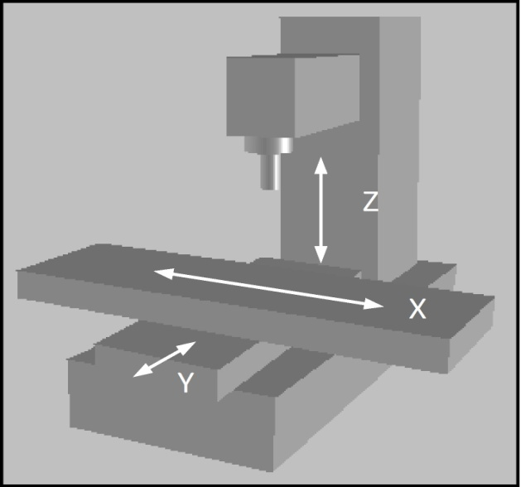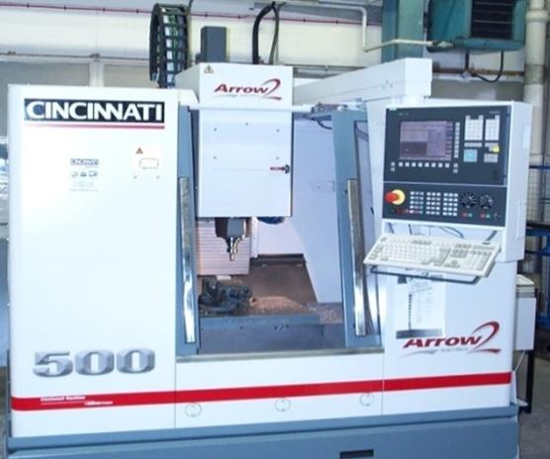

c) Machine tool and coordinate system

**Figure 10: Machine tool**

The VMC-500 is fitted with a Siemens SINUMERIK 840D motion controller, which commands the CNC kernel functions for interpolation and position control. The motion controller is connected to the drives and I/O units via a PROFIBUS-DP interface as shown by Siemens [23]. Each axis integrates a SIMODRIVE-611 Siemens inverter and a ball screw arrangement directly coupled to a permanent magnet synchronous motor. The ball screw systems incorporate a preloaded nut and the screw shaft mounted on a fixed-supported bearing configuration.

The SIMODRIVE-611 unit consists of a common feed module that provides the DC voltage link from the power supply mains and a set of drive modules that activate each motor. Every drive module consists of a power module (inverter) and a closed-loop plug-in unit. The closed-loop plug-in unit is dedicated to velocity control, current control and PWM generation functions. Table 2 contains the technical data for the VMC-500 Machine centre.

**Table 2: VMC-500 machine specifications**

|  |  |  |  |
| --- | --- | --- | --- |
| Specification | X-axis | Y-axis | Z-axis |
| Motion Controller | SIEMENS SINUMERIK 840D (S7-315-2DP) | | |
| Electrical Drive | SIEMENS SIMODRIVE 611D (6SN1123-1AA00-0CA1) | | |
| Motor | SIEMENS 1FK6063-6AF71-1AG2 | | SIEMENS 1FT6064-6AH71-4AB1 |
| Guideways | THK HSR35 A2 SS CO QZ + 1090L H II | | |
| Front bearing | Double Row Angular Contact Ball Bearing NSK BSB 025062 | | |
| Rear bearing | Single-row deep groove ball bearing NSK 6305 TB | Single-row radial ball bearing NSK 6005 – 2RS | Single-row deep groove ball bearing NSK 6305 TB |
| Ballscrew | THK | | |
| Coupling | ROTEX 24 GS spider 98 Shore A | | |
| Rotary encoder | HEIDENHAIN ERN 1387 | | |
| Linear encoder | HEIDENHAIN AE LS186C ML620 | | |
| Transverse | 510 mm | | |
| Rapid Traverses | 30000 mm/min | | |
| Feed Rates | 300 – 12000 mm/min | | |
| Table Size | 700 mm x 520 mm |  |  |
| Table mass | 327 Kg |  |  |
| Saddle mass |  | 160Kg |  |
| Carrier mass |  |  | 212Kg |
| Motor mass |  |  | 152Kg |
| Load mass |  |  | 364 Kg |

Although the control algorithm is distributed in two different units (SINUMERIK 840D and the plug-in control units) the dynamics acting on the x and y axes are modelled as in the single-axis test rig case. The model for the rear bearing mounting has been updated to reproduce the fixed-supported bearing configuration.

The two-axis system is configured as shown in Figure 10a. Linear and circular interpolation methods described in section 3.1 are included in the interpolator to coordinate the movement of the axes.

Ford et al [25] derived algorithms for the real time correction of time and spatial errors in a similar vertical machining centre configuration. Pre-calibrated geometric errors are included in the form of an error map that is used to correct the control movements over the working zone. Figure 10b represents the block diagram for the two- axis model. These errors are measured by using linear interferometers, straight edge, electronic levels, dial gauges, ballbars, and granite squares [25, 26 and 27]

The two-axis equations for the X-Y plane are derived from Postlethwaite [26] considering only the 13 geometric components associated with x- and y-axes, thus:

** (133)**

** (134)**

The procedure presented by Ford et al. [27] was used to isolate the load errors from the effects of the rigid body geometric errors. Table 3 contains the summary of the maximum values of the geometric and non-rigid errors measured from the actual machine.

|  |  |  |  |
| --- | --- | --- | --- |
| **Table 3: Measurements of the geometric and non-rigid errors** | | | |
| **Axis** | **Component** | **Units** | **Geometric effect** |
| X | Pitch: *φ y*(*x*) | μm/mm | 0.0484 |
| Yaw: *φ z*(*x*) | μm/mm | (-5 to 2.8)*10-3 |
| Roll: *φ x*(*x*) | μm/mm | (-7 to 6)*10-3 |
| Linear positioning: *Λx*(*x*) | μm | -0.05 to 9.15 |
| Horizontal straightness: *Λy*(*x*) | μm | -3.46 to 3.5 |
| Vertical straightness: *Λz*(*x*) | μm | -8.84 to –0.64 |
| Y | Pitch: *φ x*(*y*) | μm/mm | –0.0185 |
| Yaw: *φ z*(*y*) | μm/mm | (-5 to 2.8)*10-3 |
| Roll: *φ y*(*y*) | μm/mm | 0 to 0.028 |
| Linear positioning: *Λy*(*y*) | μm | -0.14 to –13.92 |
| Horizontal straightness: *Λx*(*y*) | μm | -0.1 to –6.53 |
| Vertical straightness: *Λz*(*y*) | μm | -0.05 to –3.5 |
|  | XY squareness: θ(x,y) | μm/m | -26 |

**5.0 Simulation approach for TLM models**

**5.1 Choice of simulation method**

One of the aspects that lead to the study of the TLM method for the modelling of feed drives was the possibility of formulation of comprehensive models which would be implemented in real time. MATLAB [28, 29] was used as the computational environment where high-level programming and visualisation functions were integrated for modelling, simulation and analysis of dynamic systems. The models were formulated in SIMULINK [30] and then into a program or as block diagrams using the Graphical User Interface (GUI).

SIMULINK contains a large library of pre-defined blocks that supports the modelling of linear and non-linear systems in continuous time, sampled time, or a hybrid of the two. Systems can also be multi-rate, i.e., have different parts that are sampled or updated at different rates. SIMULINK features a tool called Real Time Workshop (RTW), which automatically generates C code from the SIMULINK models to produce platform-specific code.

**5.2 Simulation method and development**

Five SIMULINK multi-ratesubsystem blocks position controller, velocity controller, current controller, torsional loop, and axial loop (the latter two including for mechanical vibrations and non-linearity’s such as backlash and friction forces) were implemented into the software for each axis. The variables interfacing the multi-rate subsystems were implemented in Data Stored Memory Blocks (DSM). A DSM defines a memory region for use by the data store read and data store write blocks. The feature gives access of the memory region to the different sub-systems in order to read from or write to at predetermined designed variable sample rates.

As an example to the approach, implementation of the single-axis model for the test rig in SIMULINK had to

deal with the multi-rate requirements (section 3.1): (a) position controller: *vref* at a rate *tp* = 3 ms; (b) velocity

controller: *iqref* at a rate *tv* = 0.6 ms; and (c) current controller; *edqref* at a rate *tc* = 0.2 ms.

In addition each PWM signal is composed of seven *edq* voltages (switching states) calculated according to the

expected currents to be induced in the motor. The duration of each *edq* voltage is specified in multiples of the

propagation time for the torsional model (*tt*). To accomplish this, *tt* is made equal to the sampling period on the

PWM signal (*tpwm*). The propagation time on the axial model is a sub-multiple of the torsional propagation time

as defined by the Castaneda [9] method in appendix C of his publication which describes in detail the

synchronisation of the torsional and axial models. These actions result in five multi-rate subsystems per axis

which were implemented in software for multi-axis system application.

5.3 **Model development** .

The modelling development was carried out according to the following methodology:

* The model for the single axis test rig was built in SIMULINK in order to validate the modelling approach. The validation of the model was achieved by comparing simulated results with the experimental data recorded from the controller.
* Following this step, the single and two axis models for the CNC machine were implemented in SIMULINK taking as a basis the TLM model for the test rig. The x and y –axis models were validated against experimental data recorded from the controller and the axis drives. The controller’s facilities included an integrated oscilloscope and the ability to input stimuli such as PRBS, jerk and linear/circular interpolation with an additional capability to perform spectral analysis. The two axis model was validated against experimental data recorded in real time for a ball bar circular test and jerk limited responses (section 6)
* The models to include for the effect of geometric errors measured with specialised equipment such as laser interferometer, ball-bar, electronic precision levels, precision squares etc (table 3). The simulated results were compared with the measured ones (section 6).
* Built in functions on the CNC machine motion controller enabled spectral analysis to be carried out for the optimisation of the position, velocity and current closed loops for each axis. The control frequency characteristics were calculated by entering a PRBS at the set point of each control loop. Four frequency responses were measured i.e. closed position controller loop, closed velocity controller loop, system and mechanical frequency response. The closed loop responses for the position and velocity controller were analysed and used for the optimisation of their parameters. The control system and mechanical frequency responses were used to set up the parameters for the filters that are used to damp the system resonant frequencies. This data measured was included in the system simulation and used also for the identification of axis drive modal parameters.
* Other stimuli waveforms were entered to identify parameters suitable for the model such as step (velocity bandwidth overshooting check), triangular (backlash/ dead band), trapezoidal (position gain/coulomb friction), random white noise/swept sine (resonant frequencies/damping coefficients).
* The x-axis of the CNC machine was further modified in order to explore the possibility of a real time implementation for the models. In this regard, the real time workshop capability of MATLAB/SIMULINK was used to generate a real time application targeting a RTI-1005 dSPACE environment. The RTI-1005 dSPACE platform was selected because it features the possibility for data logging, control and monitoring of systems in real time.

**5.4 MATLAB/SIMULINK programs**

5.4.1 **SIMULINK programs compiled and developed**

* A bench mark MATLAB/SIMULINK program was compiled and applied to a previously simulated rotor shaft already in the public domain which was then used to evaluate the reduction of mathematical operations and mean square modelling errors when comparing TLM and MTLM techniques (section 7).
* Single Axis test rig model simulation (section 3)
* Two axis CNC machine tool model simulation (section 4)
* XY geometric calculation in a SIMULINK block. Developed for insertion of measured geometric errors at the machine into the simulated two axis model (sections 4 and 6)

5.4.2 **MATLAB programs compiled and developed**

* Structure of data for the pulse propagation on the axial model (section 3.5)
* Parameters and initialisation code for the torsional loop subsystem (section 3.4)
* The PWM generating function (sections 3.2 and 3.3)
* Calculation and nut monitoring blocks (section 3.6)
* Parameters and initialisation code for the axial loop subsystem (section 3.5)
* Identification of drive modal parameters using the Continuous Wavelet Transform (CWT) for improved performance when compared to other available analysis techniques
* Automatic modal parameter identification using the CWT
* Reference signal profiles swept sign, sinusoidal, white noise, jerk, linear interpolation, and circular interpolation (for application comparison)
* Axis block parameters and initialisation code (section 3.1)
* Calculation of polynomial coefficients for the geometric errors (section 4)
* Calculation of the dilation parameters associated with CWT
* Identification of damping factors and resonant frequencies to be used for axis control system frequency response.

The complexity and detail required for this section is beyond the scope of this publication. To address this issue we have put all the detail for drive data, measurement methodology, parameter determination, coefficient analysis and a full description of relevant MATLAB/SIMULINK programs on-line. Most of the detail being contained within the appendices of that report [9].

**6.0 Validation**

* Step velocity stimuli were tested for 500mm/min (see figure 11a) and 1000mm/min where the simulated velocity and current responses (red line) match the machine measured values (green line). A 3% error was achieved in the transient area (0-0.02s). The % error increases to 5% when the motor reaches constant velocity (Fig 11b).
* The jerk-limited response was used to verify the performance of the axis drive during acceleration, deceleration and operation at constant velocity. For this purpose, position and velocity responses were measured for different displacements (10, 20, 100, 200, 400, 400 mm) and corresponding feed-rates (500, 1000, 5000, 10,000, 20,000, and 40,000mm/min). Figure 11c shows the comparison between measured and simulated position following error for a displacement of 200mm and a feed-rate of 10,000mm/min. The position versus time measured at the machine and simulated responses matched very well with no significant error but the following error differed minimally by 2µm at its peak in the acceleration zone and 8 µm at its peak in the deceleration zone. Figure 11d shows the comparison between the measured (green line) and simulated (red line) actual velocity signals over the zoom acceleration zone.
* The same reference position and velocity feed-forward signals (radius 150mm, feed-rate of 1000mm/min) were used for the circular interpolation in the X-Y plane at the machine and for the validation of the x- and y- axis TLM model responses (i.e. response to sinusoidal and co-sinusoidal demands).
* The two-axis model was simulated and the model position responses were introduced to produce the trace of x against y. The difference between the trace and the circle is illustrated in figure 11e in the form of a circular plot analogous to that measured using a double ball bar.
* The same stimuli used for the simulation was applied to the machine and the position outputs measured using a Renishaw ball bar system (figure 11f). An angular overshoot of 180deg before and after data capture for a two cycle 360deg operation was utilised to minimise uncertainty of test synchronisation.
* Figure 11e plot has an oval shape as a result of the squareness error (-26μm/m) which is consistent with figure 11f. The TLM model shows that the introduction of the geometric errors generates a progressive error deviation when the machine worktable prescribes a circle. The simulated results do not match the machine measurements on the arcs described in the [45-90deg] and [135-270deg] zones but with sensitivity analysis this could be further improved. The difference may be due to divergences on the straightness measurements for the x-axis. The reversal spikes match closely on both the x- and y-axes.

**7. Conclusions**

* A new MTLM stub was developed which improves the convergence and computational processing speed of the original stub algorithm. A reduction of 40% in the number of mathematical operations and almost 35% reduction in the mean square modelling error figures were achieved over the original TLM stub model
* Comprehensive transmission line models for the elements of a typical arrangement of a CNC feed drive have been described. All non-linear functions including geometric and load errors have been included as calculated and identified by the measurements undertaken. Equipment such as laser interferometer, ball bar, electronic levels, signal acquisition systems and others were used to obtain parameter data.
* A TLM model for a CNC single- axis feed drive including a digital controller has been developed then extended to a two-axis drive of a machining centre including geometric and load errors thus forming the basis for universal CNC machine tool models.
* The simulation of the single- axis and two- axis models to various feed rates and displacements including linear and circular interpolation, match well in comparison with the measured response of the machines under study (section 6).
* The application of the MTLM transform and the torsional/axial model’s synchronisation approach to the modelling of single- and two-axis drives led to a real time implementation of the feed drive models. Subsequent work not reported in this paper has shown the feasibility of developing the model for implementation of the two and three-axis models running in real time.
* The x-axis of the machine was modified later in order to explore the possibility of a real time implementation for the models. In this regard, the real time workshop capability of MATLAB/ SIMULINK was used to generate a real time application targeting a RTI-1005 dSPACE environment. The RTI-1005 dSPACE platform was selected because it features the possibility for data logging, control and monitoring of systems in real time.



1. **Step velocity response (b) Reference current response to step**

** **

1. **Position error response jerk-limited input (d) Velocity response to jerk limited input**

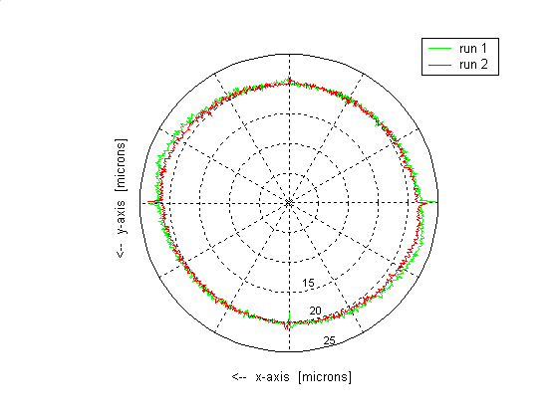 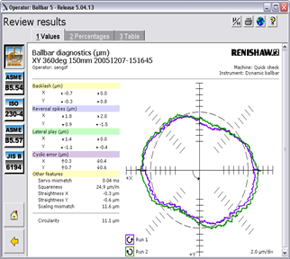

**(e) Simulated ball bar trace (f) Measured machine ball bar trace**

**Figure 11: Validation responses comparing TLM model with measured machine**

**References**

1. Ford DG. Machining to microns- error avoidance or compensation? Conference Proceedings of LAMDAMAP on Laser Metrology and Machine Performance II, pp. 41-52, Computational Mechanics Publications UK, Conference held at Southampton Institute, July 1995 , ISBN codes: 1-853-355-2 and 1-56252-276-0
2. Pislaru C, Ford DG, Holroyd G. Hybrid modelling and simulation of a CNC machine tool axis drive. Proceedings of the Institution of Mechanical Engineers, Part I, Journal of Systems and Control Engineering, Vol. 218, No. 2, pp. 111-120, 2004
3. Bartlett H, Whalley R. The response of distributed-lumped parameter systems. Proceedings of Institution of Mechanical Engineers, Part C, Journal of Mechanical Engineering Science, Part C, Vol. 202, No. 6, pp. 421-429, 1998
4. Holroyd G., Pislaru C., Ford DG. Modelling the dynamic behaviour of a ball-screw system taking into account the changing position of the ball-screw nut. Proceedings of International Conference on Laser Metrology and Machine Tools CMM and Robot Performance LAMDAMAP 2003, pp. 337-348, WIT Press, University of Huddersfield July 2003, ISBN code: 1-85312-990-9
5. RF., Kitsios EE. Simulation of fluid network dynamics by transmission line modelling, Proceedings of Institution of Mechanical Engineers, Part C, Journal of Mechanical Engineering Science, Vol. 200, No.1, pp. 21-29, 1986
6. Partridge GJ, Christopoulos C, Johns PB. Transmission line modelling of shaft system dynamics, Proceedings of Institution of Mechanical Engineers, Part C, Journal of Mechanical Engineering Science, Vol. 210, No. 4, pp. 271-278, 1987.
7. Johns, PB. & Beurle, RL.– Numerical solution of 2-dimensional scattering problems Using A transmission line matrix, Proceedings of IEEE, Vol. 118, pp. 1203-1208, IEEE Press 1971.
8. Christopoulos, C. The transmission line modelling method (TLM). 1st edition. New York. The IEEE/OUP Series on Electromagnetic Wave Theory, IEEE Press/Oxford University Press 1995.
9. Castaneda VYM, Transmission line modelling applied to non-linear control systems, PhD thesis, TLM axial model, University of Huddersfield, 2006. (Thesis on-line)
10. Heidenhain . Technical manual TNC 426PB – NC software 280 472, Section 4.8: The control loop, pp 166 – 189, 2000. On line: Heidenhain technical manual tnc 426/CB/PB/MNC Software 280 476, Section 6.8 The Control Loop/usr/hosting_files5/main/previews/doc 906058839/preview (first downloaded 2002) dc217.4 shared.com/doc/iQPmofjp/preview.html. N**ote:** This input to the Google chrome search engine produced this preview on August 1st 2014. Our original contact was made and data obtained was in 2002. “MNC” is different from the original. [www.heidenhain.uk](http://www.heidenhain.uk) if further enquiry required.
11. Seborg DE, Edgar TF, Mellichamp DA. Process dynamics and control, John Wiley& Sons, New York, 1989.
12. Heinemann G, Papiernik W. Direct linear servo drives for machine tool applications, Intelligent Motion Proceedings. PCIM 97 Germany, pp. 93-102, 1997.
13. Altintas Y. Manufacturing automation, 1st ed. Cambridge University Press, New York , pp 179-203, 2000.
14. Koren Y. Computer control of manufacturing systems, McGraw Hill, Singapore, 1983.
15. Bullock T. Command generation. [On-line]: Available: [*www.control.com/*](http://www.control.com/) control_com/Papers/Command Generation_html Accessed: 24 October 2003, (2000).
16. Hugh J. Integration and automation of manufacturing systems - Chapter 13: Motion control, Grand Valley state University, Michigan, 2002.
17. Heidenhain. Technical manual TNC 426/CB/PB/N – NC Software 280 476, Section 6.8: The control loop, pp 109 – 149, 2002. Ref: [www.heidenhain.uk](http://www.heidenhain.uk)
18. The Math Works Inc. filter design toolbox for use in MATLAB- Chapter 10: Quantized filtering analysis examples, User’s Guide version 2. pp 3-11, 2002, t
19. The MathWorks Inc. , processing toolbox for use in MATLAB, User’s Guide version 3, 2002, MA., USA
20. Moreton, P. Industrial brushless servomotors, 1st edition, Newnes, Oxford (UK). pp. 101-115. ISBN: 0 7506 3931 8, 2000.
21. Simon, N. Implementation of a speed field oriented control of 3-phase PMSM motor using TMS320F240, Texas Instruments- Digital control systems, application report SPRA588, 1999.
22. INA. Bearings for screw drives, ZAE publications, Herzogenaurach, pp. 11-20, 1999.
23. Siemens - simodrive 611 6SN1123-1AA00-0CA1[On-line]: Available: mall.ad.siemens .com./ Accessed: 20 March 2004.
24. Siemens - 1FT6082-1AF7-1AG1, [On-line]: Available: mall.ad.siemens.com Accessed: 25 March 2004.
25. Ford DG. Postlethwaite SR, Allen JP, Blake MD, Compensation algorithms for the real time correction of time and spatial errors in a vertical machining centre, Proceedings of the IMechE, Vol.214, Part B, pp. 221-235, 2000.
26. SR, Blake MD. The identification of non-rigid errors in a vertical machining centre, Postlethwaite SR. Dynamic calibration of CNC machine tools, International Journal of Machine Tools Manufacturing. Vol. 37, No.3, pp 287 -294, Elsevier 1997.
27. Ford DG, Postlethwaite Proceedings of Institution of Mechanical Engineers, Part B, Vol. 213, pp. 555-566, 1999.
28. MATLAB, System identification toolbox for use with MATLAB, the Mathworks Inc., MA, USA, 1998. On Line: [www.mathworks.co.uk/help/matlab](http://www.mathworks.co.uk/help/matlab) search documentation
29. Control System Tool Box, for use with MATLAB, users guide version 4, the Mathworks, Inc., MA, USA , 1998. On Line: [www.mathworks.co.uk/help/matlab](http://www.mathworks.co.uk/help/matlab) search documentation
30. SIMULINK. Dynamic system simulation for MATLAB, using SIMULINK version 2. The Mathworks, Inc., MA, USA, 1997

**Appendix**

**A1. List of Abbreviations**

|  |  |  |  |
| --- | --- | --- | --- |
| C | C-programming language | PT1 | First order lag element |
| CNC | Computer numerical control | PT2 | Second order lag element |
| DC | Direct current | PWM | Pulse width modulation |
| GUI | Graphical user interface | RPM | Revolutions per minute |
| MATLAB | Matrix laboratory | RTI | Real time interface |
| MTLM | Modified transmission line method | RTW | Real time workshop |
| PDE | Partial differential equation | SIMULINK | Simulation linking interface |
| PI | Proportional integral controller | TFDTLM | Transient frequency domain transmission line matrix |
| PID | Proportional integral differential controller | TLM | Transmission line matrix |
| PMSM | Permanent magnet synchronous motor |  |  |

**A2. Notation**

**A2.1 Lower case Latin**

|  |  |  |  |
| --- | --- | --- | --- |
| *aff* | Acceleration feed forward [m/s2] | *ki* | Velocity controller integral gain [A/rad] |
| *amax* | Maximum acceleration [m/s2] | *kn* | Nut rigidity [N/m] |
| *bgw* | Guideway friction coefficient [N-s/m] | *kp* | Velocity controller proportional gain [A-s/rad] |
| *bm* | Coefficient of friction (motor bearings) [N-m-s/rad] | *krb* | Bearing stiffness |
| *d* | Displacement [m] | *krbh* | Bearing housing stiffness |
| *da* | Displacement of the end *d* of the nut [m] | *krn* | Resulting rigidity of the preloaded nut with mounting bracket [N/m] |
| *dact* | Actual position value ( rotary or linear encoder) [mm] | *kT* | Torque constant of the motor [N-m/A] |
| *db* | Displacement of the end *b* of the bearing [m] | *kv* | Gain of the position controller [m/min-mm] |
| *dbh* | Displacement of the end *bh* (bearing housing) [m] | *kvff* | Feed forward velocity gain [rad/mm] |
| *dd* | Displacement of the end *d* of the nut [m] | *l* | Length [m] |
| *de* | Position error [mm] | *laxial* | Length of each section in the axial model [m] |
| *den* | Denominator filter coefficients vector | *len* | Number of filter coefficients |
| *dl* | Actual table position (from linear encoder) [mm] | *len0* | Filter order |
| *dnom* | Reference position signal (before position filter) | *lend* | Length end portion of the screw shaft [m] |
| *dprof* | Axis-drive position profile | *lf* | Positions of the front bearing [m] |
| *dref* | Reference position (position demand) [mm] | *ln* | Positions of the nut [m] |
| *eβ* | *β* motor voltage [V] | *lo* | Absolute reference point for the nut movement [m] |
| *eα* | *α* motor voltage [V] | *lr* | Positions of the rear bearing [m] |
| *ea, eb, ec* | Motor line voltages [V] | *ls* | Ball screw stroke length [m] |
| *ed* | Direct motor voltage [V] | *lss* | Screw shaft length [m] |
| *edqref* | Reference voltage to PWM [V] | *ltor* | |  | | --- | | Length of each section in the torsional model [m] | |
| *em* | Motor inertia effort | *nla* | Number of sections on the left (second zone axial model) |
| *eq* | Quadrature motor voltage [V] | *nm* | Number of sections second zone (torsional model) |
| *eqref* | Reference voltage *q*-component [V] | *nma* | Number of axial sections per torsional section |
| *f1* | Bearing load coefficient | *nt* | Number of axial sections per torsional section |
| *fo* | Bearing lubrication method | *num* | Numerator filter coefficients vector |
| *fr* | Feed rate [mm/min] | *nf* | Number of sections first zone (torsional model) |
| *h* | Number of sections | *nfa* | Number of sections first zone (axial model) |
| *ha* | Number of sections of the axial model | *nl* | Number of sections on the left (second zone torsional model) |
| *ht* | Number of sections torsional model | *ta* | Propagation time of axial waves [s] |
| *i* | Electric current [A] | *tc* | Current control loop cycle time [s] |
| |  | | --- | | *iβ* | | *β* motor current [A] | *ti* | Time [s] |
| *iα* | Motor current *α*-component [A] | *tp* | Position control loop cycle time [s] |
| *ia, ib, ic* | Motor phase currents [A] | *ts* | Simulation time step |
| *id* | Direct motor current [A] | *tt* | Propagation time for torsional waves [s] |
| *idact* | Actual current *d*-component [A] | *tv* | Velocity control loop cycle time [s] |
| *ide* | Current error *d*-component [A] | *u* | Propagation velocity [m/s] |
| *ider* | Derivative component of *iref* [A] | *ua* | Velocity of propagation of axial waves [m/s] |
| *idref* | Reference current *d*-component [A] | *ut* | Velocity of propagation of torsional waves [m/s] |
| *iht* | Holding current [A] | *v* | Velocity [m/s] |
| *iint* | Integral component of *iref* [A] | *va* | Velocity of the screw shaft point *a* [m/s] |
| *ip* | Proportional component of *iref* [A] | *vact* | Actual velocity [rad/s] |
| *iq* | Quadrature motor current [A] | *vb* | Displacement of the end *b* of the bearing [m/s] |
| *iqact* | Actual current *q*-component [A] | *vbh* | Displacement end *bh* of the bearing housing [m/s] |
| *iqe* | Current error *q*-component [A | *vbmb* | Relative velocity between bearing ends [m/s] |
| *iqref* | Reference current *q*-component [A] | *vd* | Velocity of the end *d* of the nut [m/s] |
| *iref* | Reference current (current demand) [A] | *ve* | Velocity error [rad/s] |
| *j* | Jerk [m/s3] | *vfb* | Front bearing velocity [m/s] |
| *jmax* | Maximum jerk [m/s3] | *vff* | Velocity feed forward [rad/s] |
| *k* | step number | *vha* | Rear bearing velocity [m/s] |
| *kaff* | Acceleration feed forward gain [A-s2/rad] | *vl* | Load velocity [m/s] |
| *kb* | Ball screw force to torque constant | *vm* | Maximum possible velocity [m/s] |
| *kci* | Integral gain current controller [V/A-s] | *vn* | Nut velocity (relative velocity between ends ) [m/s] |
| *kcp* | Proportional gain current controller [V/A] | *vna* | Velocity of the nut contact point [m/s] |
| *kcs* | Torsional stiffness of the coupling [N-m/rad] | *vref* | Reference velocity value (velocity demand) [rad/s] |
| *kd* | Velocity controller derivative gain [A-s2/rad] | *x* | Distance [m] |
| *ke* | Electric constant of the motor [V-s/rad] | *x* | x-coordinate [mm] |
| *keq* | Bearing mounting stiffness | *y* | y-coordinate [mm] |
| *kff* | Feed forward gain | *zzi* | Filter delay output |

**A2.2 Higher case Latin**

|  |  |  |  |
| --- | --- | --- | --- |
| *Ai, B i* | Incident pulse (link) | R | Resistance [ohm] |
| *Aij , Bij* | Incident voltages associated to *Zt* | *T* | Torque [N-m] |
| *Aija , Bija* | Incident voltages associated to *Za* | *Ta* | Torque due to external load [N-m] |
| *Ar, Br* | Reflected pulse (link) | *Tb* | Bearing frictional torque [N-m] |
| *Dx* | x-axis position [mm] | *Tc* | Input torque first section (torsional model) [N-m] |
| *Dy* | y-axis position [mm] | *Te* | Generated electromagnetic torque [N-m] |
| *Dz* | z-axis position [mm] | *Tf0* | *Tb* velocity-dependent component [N-m] |
| *Ei* | Incident pulse (stub) | *Tf1* | *Tb* load-dependent component [N-m] |
| *Eiaff* | Incident pulse associated to *Zaff* | *Tfb* | Front bearing frictional torque [N-m] |
| *Eic* | Incident pulse associated to *Zc* | *Tld* | Load torque [N-m] |
| *Eics* | Incident pulse associated to *Zcs* | *Tm* | Motor load torque [N-m] |
| *Eid* | Incident pulse associated to *ZL* (*d*-component) | *Tp* | Nut pre-loading torque [N-m] |
| *Eide* | Incident pulse associated to *Zci* (*d-*component) | *Trb* | Rear bearing frictional torque [N-m] |
| *Eidl* | Incident pulse for *dl* calculation | *Za* | Characteristic impedance axial model |
| *Eiend* | Incident pulse associated with *Zend* | *Zaff* | Characteristic impedance associated to *kaff* |
| *Eifbh* | Incident pulse associated with *Zfbh* | *Zc* | Characteristic impedance associated to *Jc* |
| *Eii* | Incident pulse associated to *Zi* | *Zci* | Characteristic impedance associated to *kci* |
| *Eil* | Incident pulse associated to *Zl* | *Zcs* | Characteristic impedance associated to *kcs* |
| *Eim* | Incident pulse associated to *Zm* | *Zd* | Characteristic impedance associated to *kd* |
| *Eimfb* | Incident pulse associated with *Zmfb* | *Zend* | Characteristic impedance associated with *Jend* |
| *Eimrb* | Incident pulse associated to *Zmrb* | *Zfbh* | Characteristic impedance associated with *kfbh* |
| *Eins* | Incident pulse associated to *Zns* | *Zi* | Characteristic impedance associated to *ki* |
| *Eiq* | Incident pulse associated to *ZL* (*q*-component) | *ZL* | Characteristic impedance associated to *L* |
| *Eiqe* | Incident pulse associated to *Zci* (*q-*component) | *Zl* | Characteristic impedance associated to *m* |
| *Eirb* | Incident pulse associated to *Zrb* | *Zm* | Characteristic impedance associated to *Jm* |
| *Eirbh* | Incident pulse associated to *Zrbh* | *Zmfb* | Characteristic impedance associated with *mfb* |
| *Eithm* | Incident pulse for *θ m* calculation | *Zmrb* | Characteristic impedance associated to *mrb* |
| *Eivff* | Incident pulse associated to *Zvff* | *Zns* | Characteristic impedance associated to *kn* |
| *Er* | Reflected pulse (stub) | *Zo* | Characteristic impedance |
| *Ex* | Actual error movement of the x-axis [μm] | *Zrb* | Characteristic impedance associated to *krb* |
| *Ey* | Actual error movement of the y-axis [μm] | *Zrbh* | Characteristic impedance associated to *krbh* |
| *Ez* | Actual error movement of the z-axis [μm] | *Zt* | Characteristic impedance torsional model |
| *F* | Force [N] | *Zvff* | Characteristic impedance associated to *kvff* |

**A2.3 Lower case Greek**

|  |  |  |  |
| --- | --- | --- | --- |
| *θ l* | Coupling displacement at the screw shaft side [rad] | *φ y*(*x*) | x-axis rotation about y-axis [μm/mm] |
| *θm* | Actual [rad] | *φ y*(*y*) | y-axis rotation about y-axis [μm/mm] |
| *θm* | Mechanical position (from rotary encoder) [rad] | *ω1* | Coupling velocity at the screw shaft side [rad/s] |
| *θxy*(*x*, *y*) | Squareness in the XY plane [μm/mm] | *ωm* | Mechanical velocity (motor angular velocity) [rad/s] |
| *θxz*(*x*, *z*) | Squareness in the XZ plane [μm/mm] | *ω a* | Angular velocity of the screw shaft point *a* [rad/s] |
| *θyz*(*y*, *z*) | Squareness in the YZ plane [μm/mm] | *ωc* | Coupling angular velocity [rad/s] |
| *φ* | Incremental position for a rotary encoder | *ωe* | Electrical velocity [rad/s] |
| *φ x*(*x*) | x-axis rotation about x-axis [μm/mm] | *ω fb* | Front bearing angular velocity [rad/s] |
| *φ x*(y) | y-axis rotation about x-axis [μm/mm] | *ω h* | Rear bearing angular velocity [rad/s] |
| *φ x*(*z*) | z-axis rotation about x-axis [μm/mm] | *ω n* | Angular velocity of the nut contact point [rad/s] |

**A2.4 Higher case Greek**

|  |  |  |  |
| --- | --- | --- | --- |
| Λ*x*(*x*) | x-axis linear positioning error [μm] | Λ*y*(*z*) | z-axis straightness in the y-axis direction [μm] |
| Λ*x*(*y*) | y-axis straightness in the x-axis direction [μm] | Λ*z*(*x*) | x-axis straightness in the z-axis direction [μm] |
| Λ*x*(*z*) | z-axis straightness in the x-axis direction [μm] | Λ*z*(*y*) | y-axis straightness in the z-axis direction [μm] |
| Λ*y*(*x*) | x-axis straightness in the y-axis direction [μm] | Λ*z*(*z*) | z-axis linear positioning error [μm] |
| Λ*y*(*y*) | y-axis linear positioning error [μm] |  |  |

**Acknowledgement**

We would like to give our thanks in the initial investigations to the financial support from the EPSRC Ref. No: GR/S07827/01 and to the collaborating companies. Also to the University of Huddersfield for additional financial support to make further progress.