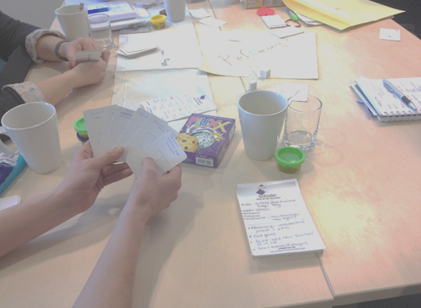
Game Based Learning for Information Literacy Instruction. ECIL, 2013
Andrew Walsh,
Academic Librarian / Teaching Fellow
@andywalsh999 http://innovativelibraries.org.uk
Today’s slides and some links
You can find today’s slides at http://eprints.hud.ac.uk/18825
Lemontree at the University of Huddersfield (which I showed briefly) can be found at http://library.hud.ac.uk/lemontree - most of the activity is public, so you see can how it works!
Printing games
If you create a game and want to print it so it looks “professional”, consider going to a company like Game Crafter (www.thegamecrafter.com/) who specialise in small print runs of custom board and card games (traditional printers want you to produce 10s of 1,000s at a time!), or www.spielematerial.de (who also do lots of components you can use in prototyping), or even business card printers for card games (companies like http://uk.moo.com/ allow you to have a different design on each card).
You should be able to turn a prototype card or board game into a finished product for very little money – but what it does take is time…
Using other peoples’ ideas
It’s much easier to take ideas for games that other people have created and adjust them for your own needs than to come up with something completely new. Try looking on places like:
Jorum – re-usable learning objects for FE & HE. www.jorum.ac.uk/
OER Commons – Open Educational Resources, including game based learning. www.oercommons.org/
My Games 4 Libraries blog – I’ve run quite a few of the making games for libraries workshops now and I’ve put as many prototypes as I’m allowed on here so that others can share! http://gamesforlibraries.blogspot.co.uk/
More stuff from me
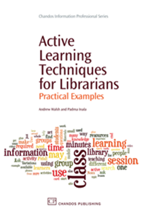
You can find lots more material from me via http://innovativelibraries.org.uk
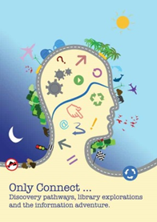
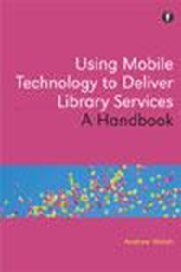
My books! The latest is ‘Walsh, A. and Coonan, E. (2013). Only Connect … Discovery pathways, library explorations, and the information adventure. Huddersfield: Innovative Libraries.’ Paperback ISBN: 978-0-9576652-1-7. It’s about the richness of Information Discovery Journeys and Information Literacy, so directly appropriate to you all at this conference.
The eBook is available free via http://innovativelibraries.org.uk and the print book (available worldwide) is reduced by 25% on www.lulu.com at the moment, plus get an extra 5% discount using coupon code ‘FAST5’ when checking out.
Further Reading
Barash, M., & Caillois, R. (2001). Man, play, and games. Urbana: University of Illinois Press.
Classic work on play!

Danforth, L. (2011a). Gamification and Libraries. [Article]. Library Journal, 136(3), 84-84.
Danforth, L. (2011b). Why Game Learning Works. [Article]. Library Journal, 136(7), 67-67.
A couple of library orientated short articles on games / gamification and libraries

Huizinga, J. (1999). HOMO LUDENS: A Study of the Play-Element in Culture: Routledge.
Another classic philosophical treaty on play!

Kapp, K. M. (2012). Gamification of Learning and Instruction: Game-Based Methods and Strategies for Training and Education. Hoboken: Pfeiffer.
A comprehensive text on gamification in learning - that is, using game elements in education.

McGonigal, J. (2011). Reality is broken: why games make us better and how they can change the world. London: Jonathan Cape.
Jane is one of the biggest voices on using games for positive social change. An easy, but thought provoking read.

Schell, J. (2008). The art of game design: a book of lenses. Amsterdam: Morgan Kaufmann.
This goes along with a pack of cards (sold seperately but free as an app for mobile devices) with the "lenses" printed on them. Probably more for serious games designers than us, though it's written in such an accessible way we can take some really useful tips from this book!

Smale, M. (2011). Learning Through Quests and Contests: Games in Information Literacy Instruction. Journal of Library Innovation, 2(2), 20.
Worth reading to see what other libraries are doing around games and information literacy in particular.

Squire, K., Gee, J. P., & Jenkins, H. (2011). Video games and learning: teaching and participatory culture in the digital age. New York: Teachers College Press.
A key work on games and learning. Focusses on video games, but lots of the material applies just as well to non-digital games.

Sutton-Smith, B. (2001). The ambiguity of play. Cambridge, Mass: Harvard University Press.
The third of the "serious" works on play!

Vaughan, C. C., & Brown, S. L. (2010). Play: how it shapes the brain, opens the imagination, and invigorates the soul. New York: Avery.
A really good, accessible read. I particularly like the idea it introduces of a "play deficit" similar to a "sleep deficit" many of us have. Read, enjoy, then start climbing more trees, playing more games, and address your play deficit!

Whitton, N., & Moseley, A. (2012). Using Games to Enhance Learning and Teaching : A Beginner's Guide: A Beginner's Guide. Hoboken: Taylor and Francis.
Lots of short chapters in this book that cover a range of ideas on using games in teaching and learning. The contributers include a fair proportion of UK researchers working in the area of game based learning, definitely worth getting a copy for the library to share…

Zichermann, G., & Cunningham, C. (2011). Gamification by design: implementing game mechanics in web and mobile apps. Sebastopol: O'Reilly.
A key text on gamification - if you're thinking of" gamification" rather than a full blown game, read this before you do anything…

